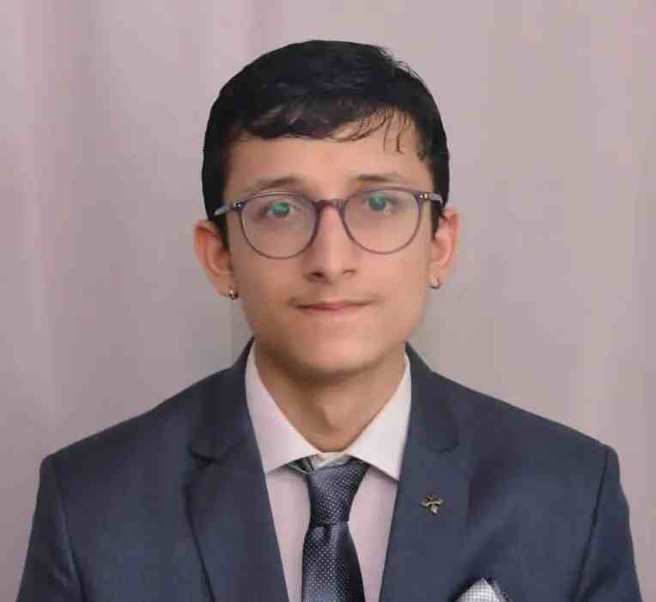**ABHISHEK JOSHI (102105032)**

**Email id:** [joshiabhi229@gmail.com](mailto:joshiabhi229@gmail.com)

**Contact No:-** +91-8218466898 ,8475877678

**Linked in:**- www.linkedin.com/in/abhishek-joshi-050b33280

**CAREER OBJECTIVE:**

To work in a dynamic environment that provides me a wide spectrum of experience and exposure. To bring a dynamic and versatile portfolio of skills at work place and to serve the organization with a positive attitude.

**EDUCATION :**

|  |  |  |
| --- | --- | --- |
| **BE Electronic &Instr. (2021-2025)** | 8.91 (CGPA) | Thapar Institute of Engineering and Technology, Patiala |
| 015)**k 12th(2019-2021)** | 94% | St. Lawrence School, Haldwani |
| **10th (2018-2019)** | 99% | The Shivalik International School, Haldwani |



**TECHNICAL SKILLS:**

• **Languages:** C++,Python ,R , My SQL , Matlab , Power BI

•**Familiar Environment and Tools:** Dev C++ ,MS excel , Numpy,Etl ,Plotly

•**Core Subjects:** Data Analytics, DSA , Cybersecurity ,Electronics, Artificial Intelligence, Probability and Statistics

**PROJECTS:**

•**Analyzing Moon Mission 2023 Data:** *using* Power Bi,Python,Matlab/Catia Simulink- [*link*](https://drive.google.com/drive/folders/1zbma8yRjZL6WE9bDytZI1B-ColoF7Qwi)

* *Designed dashboard to analyse various moon mission,type of operator,mission outcome of countries using Bi.*
* *Moon mission landing analysis of* ***Chandrayan-3*** *using python and Live 3D Rover Design Project using Matlab.*

*Lander Battery Capacity and Rover Power requirement analysis of LVM3-M4/CHANDRAYAAN-3 MOON MISSION by ISRO*

*Data cleaning,visz using* ***Regular exp library*** *and* ***Plotly.Simulink*** *to simulate movement,terrain interaction of pragyan rover.*

•**Amazon Dashboard Creation:** *using*Power Bi, My SQL- [*link*](https://drive.google.com/drive/folders/1kraLp8COZ3Zt85lFLTHvC0gZ9GWzMYB4)

* *Designed amazon dashboard to analyse sales of segment,sales projections,sales by market,top-5 profit product.*

•**Whatsapp Chat Analysis:** *using* Python**-** *link*

* *analyzed number of messages and users,images,links,shared in the group and sentiment through emojis.*
* *Emoji library for sentiment analysis.Seaborn,Plotly library for pie chart and data visualization.*

•**IPL Dashboard and winning probability predictor :** *using* Power Bi,My SQL,Pycharm,Python- *link*

* *Analysis of IPL season data ,sesasonwise run score by team*, *total wickets,top ten batsmen and bowler using Bi.*
* *IPL win probability predictor using python and Pycharm for predicitive data analysis.*

*Scikit learn library to remove string and logistic regression for predictive data analysis to predict the winner.*

**CERTIFICATIONS:**

• **Simplilearn** **SQL** course

• **AWS Data Analytics**  fundamental course[link](https://drive.google.com/file/d/1dE1jhTQga3W1VyaWN2wq4BbzP6ZXjEaM/view?usp=sharing)

• **Google Analytics** course

**ACHIEVEMENTS AND LEADERSHIP:**

•**Gold Medallist** of **electronics and instrumentation** branch in 2nd year batch of (2021-2025).

•**State topper** in ***class 10th*** and secured ***7th rank*** in Uttarakhand (conducted by C.B.S.E Board).

• Two times **Merit-cum-scholarship-3** holder (worth more than ***one lakh rupees)***.

•Won district level quiz competion (BKJ) and 20+ medals in extra-cirrcular activities(debate,painting,table tennis).

•Secretary Interact club(**Rotaract club**):- *ran awareness program on importance of hygiene in govt. school*

•**Discipline** Head of Senior- High School.

**SOFT SKILLS:**

• Good Communication skills. • Loves to read Newspaper.

• Hardworking and Compassionate. • Problem solving Skills.