**Airdrop : Smart Contract Address:**

**Airdrop is available only on BSC and ETH chain.**

Airdrop contract address: https://bscscan.com/address/0x7ce5b47beb9716bccffaafc37aa35616afd3b652#code

ETH contract address <https://etherscan.io/address/0x6a404e6f2e376c35d6035f0cccba9fdb7aef7bae#code>

1. When user enters the Golden Duck tokens in the Enter Golden Duck, we have to add Nine Zeros suffix to it and pass it to getAmountOut function.

For example: User Entered 975, then we have to pass 975000000000 (added nine zeros )

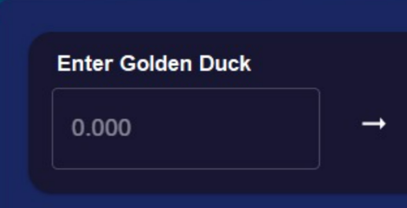

Then it returns the amount which should be converted in Wei format and display under To Receive

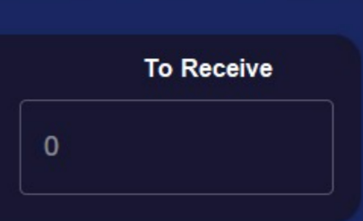

Whatever the user enters, display under Golden Duck Tokens to Deposit



Whatever the value we display under To Receive, also display here.



**Approve:** Fetch the oldToken Address from the contract and go to old Token contract address and pass the SpenderAddress and the Amount that user entered followed by nine zeros.

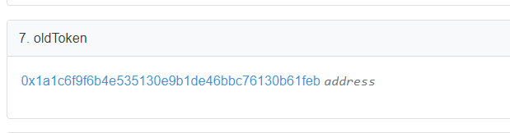

Below is the old contract address, where we have to pass the Airdrop contract address as SpenderAddress and the Amount entered by user in the UI by suffixing Nine Zeros.

BSC Airdrop Address: 0x7ce5b47beb9716bccffaafc37aa35616afd3b652

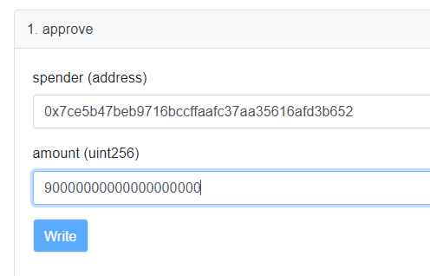

**Claim GolduckDAO:** Once Approved, then display this button. When user clicks on button, call the function claimTokens by passing the amount entered by user followed by Nine Zeros.

For example: User Entered 975, then we have to pass 975000000000 (added nine zeros )