**Get a new EC2 Ubuntu instance**

Step 1: Select Ubuntu AMI on the launch instance page.

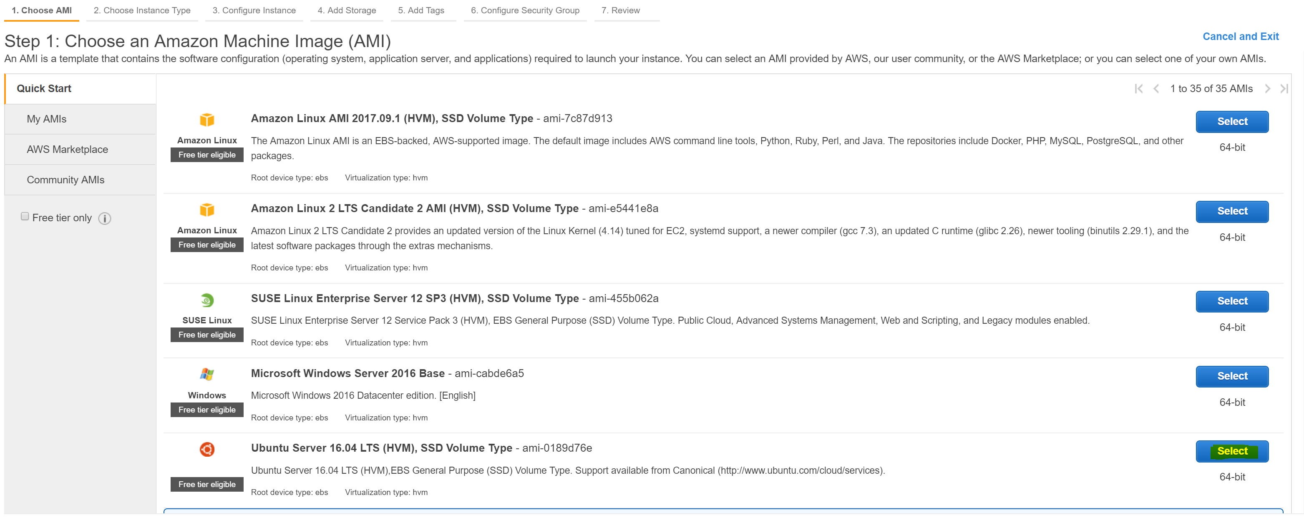

Step 2: All configuration is set to default with the following Security Group config

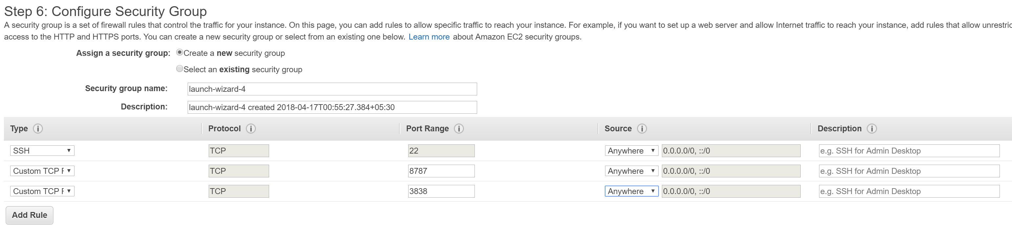

Step 3: Launch instance

Step 4: [Configure SSH connection to EC2 instance](https://docs.aws.amazon.com/AWSEC2/latest/UserGuide/putty.html)

**Setup MySQL Server on the EC2 instance**

Step 1: Once SSH connection is setup, update linux package

sudo apt-get update

Step 2: Install Mysql Server

sudo apt-get install mysql-server

Step 3: Confirm mysql server is installed and the service is running on the EC2 server.

mysql -u root -p

**Connect to MySQL Server from local MySQL Workbench**

Setup the below connection on workbench. Use the *.pem key file received from aws instance. Once the connection is setup, use this as regular DBMS.

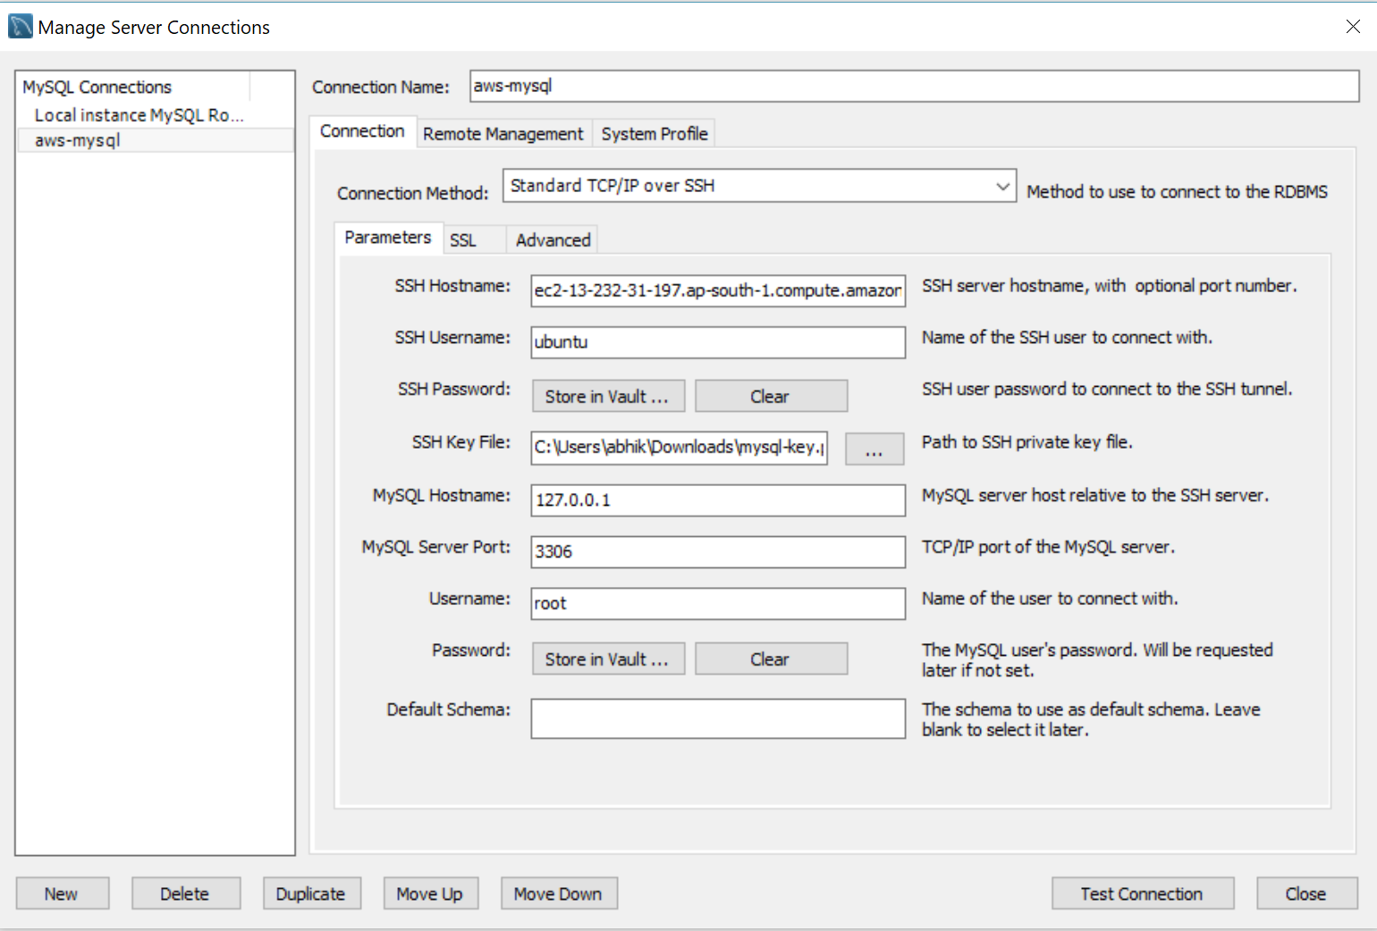

**Install R and RStudio on EC2 Instance**

Step 1: Make sure EC2 instance running ubuntu. Make SSH connection

Step 2: install R

sudo apt-get update

sudo apt-get install r-base

sudo apt-get install r-base-dev

Step 3: Install RStudion Server

sudo apt-get install gdebi-core  
wget https://download2.rstudio.org/rstudio-server-1.1.442-amd64.deb  
sudo gdebi rstudio-server-1.1.442-amd64.deb

Step 4: Create Password for existing user

sudo passwd ubuntu

Step 5: RStudio Dir

mkdir /home/ubuntu/.rstudio

mkdir /home/ubuntu/.rstudio/graphics-r3

sudo chown -R ubuntu: .rstudio

Step 6: Access RStudio from anywhere with this url - http://<ip-address>:8787; login with ubuntu/pass