
Project Report
Big Data Analytics
Quick Commerce Intelligence
Predictive Reordering, Customer Segmentation and Market Basket Optimization Using Big Data Analytics
Programme: MBA - Business Analytics, Trimester IV (2026-27)
Course: Big Data Analytics
Submitted To: Prof. Abhishek Sarkar
School of Business Management, SVKM’s NMIMS, Mumbai
Submitted By: Group 7
Name | Roll No.
Abhik Mondal | A001
Abhishek Kumar | A016
Nishita Juneja | A025
Paridhi | A062
Rohit Agarwal | A071
Vidhi Lunia | A045

Contents
Contents 2
1. Executive Summary 4
Headline recommendations 4
What we did not find 4
2. Business Context 5
2.1 The industry problem 5
2.2 Why this is a Big Data problem 5
2.3 Engagement objectives 5
3. Data Understanding 6
3.1 Dataset overview 6
3.2 The five Vs 6
3.3 Data quality and known limitations 6
3.4 Exploratory analysis 6
4. Enterprise Architecture 11
4.1 Reference pipeline 11
4.2 Ingestion design 11
4.3 Why distributed storage 11
4.4 Platform note 11
5. Data Engineering 12
5.1 Multi-table join 12
5.2 Feature engineering at three grains 12
5.3 Candidate generation — the critical design decision 12
5.4 Behavioural features for segmentation 12
5.5 Preparation summary 13
6. Machine Learning 14
6.1 Customer segmentation — K-Means 14
6.2 Why K=4 rather than the silhouette optimum 14
6.3 Segment profiles 14
6.4 Reorder prediction — model selection 15
6.5 Hyperparameter tuning 16
6.6 Final model and verification 17
6.7 Threshold tuning 17
6.8 Feature importance 17
6.9 A negative result, reported 18
6.10 Reorder timing — regression 18
6.11 Hive-style curated table layer 19
6.12 Market basket optimisation — FP-Growth 20
6.13 Representative rules 20
6.14 Per-segment rules 20
7. Business Insights 22
7.1 Demand is majority repeat demand 22
7.2 Customers shop on rhythms, not randomly 22
7.3 Departments differ by more than two to one in loyalty 22
7.4 Segments differ in kind, not only in degree 22
7.5 Reorder prediction is driven by pair-level history 22
7.6 Timing is predictable enough to plan against 22
7.7 Small baskets make attach rate the lever 22
8. Strategic Recommendations 23
8.1 Priority actions 23
8.2 Segment-level playbook 23
8.3 Risks and mitigations 23
8.4 Roadmap 23
9. Appendix 25
9.1 Technical environment 25
9.2 Reproducibility 25
9.3 References 25
9.4 AI usage disclosure 25
9.5 Statement on prior work 25
9.6 Team contributions 26

1. Executive Summary
Indian quick commerce platforms compete on a ten-minute delivery promise. That promise is won or lost before the customer opens the app: the right stock has to already be sitting in the right dark store. This engagement asked whether demand at that level is predictable, and if so, what management should do with the prediction.
The answer is that it is largely predictable, because most demand is not new demand.
THE FINDING THAT FRAMES EVERYTHING ELSE
58.9% of all purchases in the dataset are repeat purchases of a product the customer has bought before. The majority of demand is therefore forecastable from a customer's own history, not from market-level guesswork.

We built a three-phase pipeline on Databricks — ingestion into distributed storage, PySpark feature engineering across five joined tables, and four MLlib approaches — and processed 3,153,723 order-product records for a 20,000-customer cohort. The models answer three different management questions.
Question | Method | Result
What will this customer reorder? | GBT (selected from 3 models, tuned) | AUC-ROC 0.826, PR-AUC 0.403
What kind of customer is this? | K-Means (12 features) | 4 behavioural segments
When will they order again? | GBT Regression (selected from 3 models) | RMSE 8.0 days, 25% over baseline
What sells alongside this item? | FP-Growth | 2,056 association rules

Headline recommendations
- Pre-position inventory using predicted reorder probability rather than aggregate SKU velocity. The model identifies which specific customer-product pairs will repeat.
- Stock the dark store core range on reorder rate, not popularity. Dairy and eggs reorder at 66.9% while personal care reorders at 32.7% — the two do not deserve equal shelf priority.
- Treat the four customer segments differently. They differ in what they buy and when, not merely in how much, which makes differentiated marketing actionable.
- Deploy co-purchase suggestions at checkout. Median basket size is six items, so per-order economics depend on attach rate.

What we did not find
We tested a hypothesis that feeding the customer segment label into the reorder classifier would improve it. It did not — the segment label ranked last of fifteen features with an importance of 0.0009. We report this as a negative result rather than removing it, and explain the cause in Section 6.

2. Business Context

2.1 The industry problem
Quick commerce in India — Blinkit, Zepto, Swiggy Instamart — operates a fundamentally different model from conventional e-grocery. Orders are small, frequent and promised within ten to fifteen minutes. Fulfilment happens from dark stores holding a few thousand SKUs in a two-kilometre radius, not from large warehouses.
This compresses the margin for error. There is no time to pick from a distant warehouse or wait for replenishment. If the item is not on the shelf when the order lands, the order is lost. Three operating decisions follow directly:
- Assortment — which SKUs earn shelf space in a constrained dark store
- Replenishment — what to restock, and when, before demand arrives
- Basket growth — how to raise value per order when baskets are structurally small

2.2 Why this is a Big Data problem
The instinct is to solve this in a spreadsheet. At this scale that is not possible, and the reason is structural rather than merely a matter of row counts.
Constraint | Reality in this dataset
Row volume | 3.15 million order-product records in the sampled cohort alone; 32 million in the full dataset
Table structure | Five interlinked tables requiring multi-way joins before any analysis begins
Grain mismatch | Analysis operates at three different grains — user, product, and user-product pair
Feature volume | 1,294,754 user-product interaction rows generated during feature engineering
Model class | Gradient boosting and frequent-pattern mining have no spreadsheet equivalent

Excel's worksheet limit is 1,048,576 rows. The joined dataset exceeds that by a factor of three before any feature engineering, and the intermediate interaction table exceeds it again. Distributed processing is a requirement, not a preference.

2.3 Engagement objectives
Following the standard consulting framing, this engagement answers three executive questions:
Executive question | Where answered
What business problem are we solving? | Sections 1 and 2
How did we engineer the pipeline to solve it at scale? | Sections 4 and 5
What decisions should management take? | Sections 7 and 8

3. Data Understanding

3.1 Dataset overview
The analysis uses the Instacart Online Grocery Shopping Dataset 2017, released publicly by Instacart and hosted on Kaggle. It comprises six tables covering approximately 3.4 million orders from over 200,000 customers.
Table | Rows (cohort) | Description
orders | 330,791 | Order header: user, sequence number, day, hour, gap since prior order
order_products__prior | 3,163,808 | Line items for all historical orders
order_products__train | 136,324 | Line items for each customer's next order — our labels
products | 49,688 | Product catalogue with aisle and department keys
aisles | 134 | Aisle reference table
departments | 21 | Department reference table

Total raw volume is 713 MB. Analysis was run on a 20,000-customer sample to fit free-tier serverless compute; the pipeline is parameterised and runs unchanged on the full cohort.

3.2 The five Vs
Dimension | How it presents here
Volume | 713 MB raw; 3.15 million joined records; 1.29 million engineered interaction rows
Velocity | Quick commerce generates continuous order events. The dataset is a batch snapshot, so we simulate streaming ingestion architecturally via Flume rather than claiming live streaming
Variety | Six structured tables at three different grains, requiring reconciliation before modelling
Veracity | Audited explicitly. 20,000 nulls in days_since_prior_order correspond exactly to the 20,000 first orders — expected, not defective. The field is also capped at 30 days by the publisher, which we treat as a known ceiling
Value | Translated into inventory positioning, segment marketing and checkout bundling — Sections 7 and 8

3.3 Data quality and known limitations
Three caveats materially affect interpretation and are stated rather than buried.
- Publisher-imposed ceiling. Instacart caps days_since_prior_order at 30. Every gap beyond 30 days is recorded as exactly 30, so the distribution shows an artificial spike at that value and any derived average inherits the ceiling.
- Sample bias. Instacart states that this dataset draws from many different retailers and is a heavily biased subset of production data — not a representative sample of its products, users or purchasing behaviour. Conclusions describe this dataset, not the US grocery market.
- Geographic transfer. This is US data applied to an Indian quick commerce framing. No Indian platform has released a comparable public dataset. The behavioural mechanics — repeat grocery purchase, fixed shopping rhythms, small baskets — transfer; the specific SKUs do not. The pipeline itself is platform-agnostic.

3.4 Exploratory analysis
Order timing shows clear structure. Volume concentrates in daytime hours and on two weekday indices, which is directly relevant to dark store staffing.
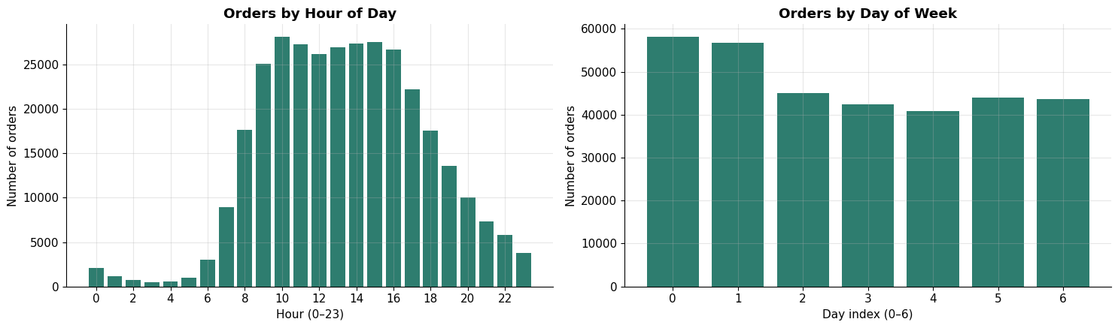
Figure 1 — Order volume by hour of day and day of week. Peak hour is 10:00.
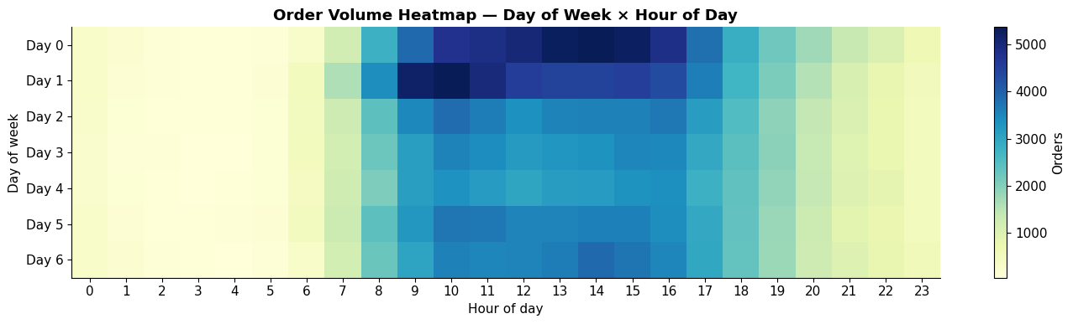
Figure 2 — Demand heatmap. The bright block is the true operating window; everything outside it is idle capacity.
The gap between consecutive orders is the single strongest signal that reorder timing is predictable at all. Customers do not shop randomly.
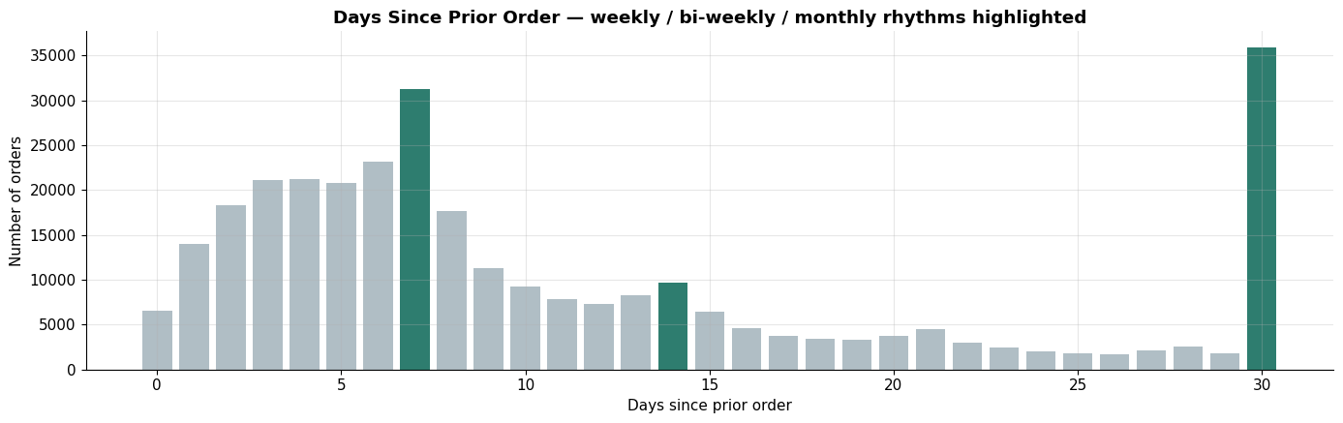
Figure 3 — Days since prior order. Highlighted bars mark weekly, bi-weekly and monthly rhythms. The bar at 30 is inflated by the publisher's cap.
Median gap is 7 days, mean 11.1 days, and the 75th percentile is 15 days. The spikes at 7, 14 and 30 indicate that a large share of customers operate on a fixed cadence — which is precisely what makes a next-order model viable.
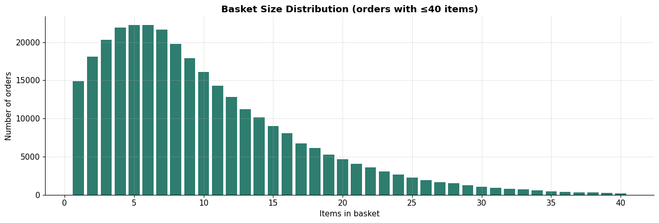
Figure 4 — Basket size distribution. Modal basket is 6 items, with a long right tail of stock-up orders.
Small baskets are the norm. This is the structural reason basket optimisation matters: with a median of six items, per-order economics depend on attach rate rather than order frequency alone.
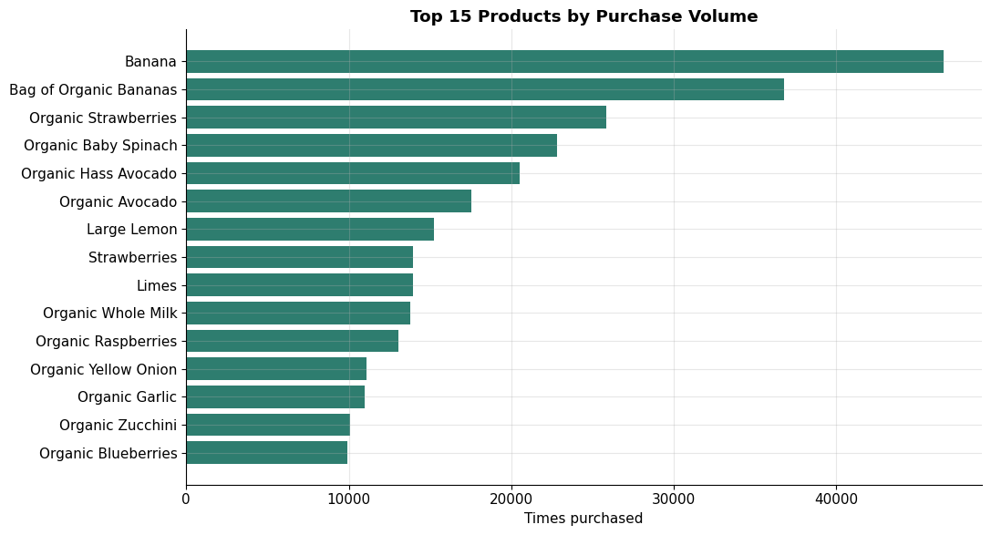
Figure 5 — Top 15 products by purchase volume. Fresh produce dominates the head of the distribution.
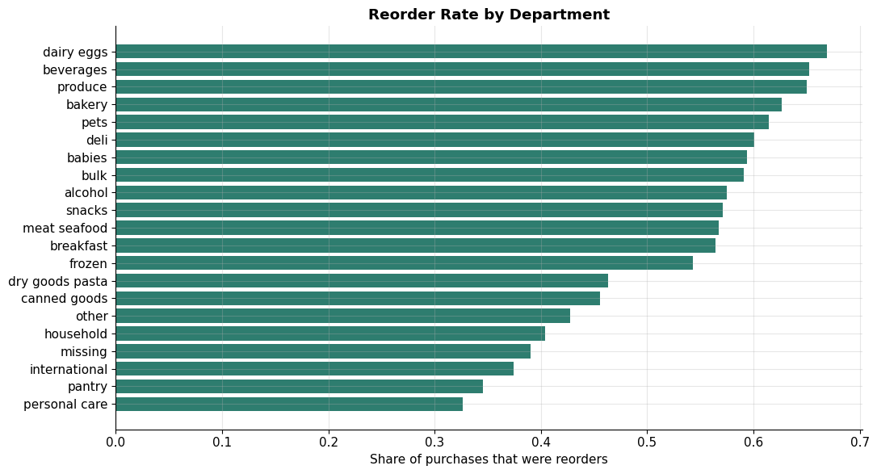
Figure 6 — Reorder rate by department. Dairy and eggs lead at 66.9%; personal care trails at 32.7%.
This chart is the assortment argument in one image. Departments differ by more than two to one in how reliably their products are repurchased. Instacart's own published analysis of this dataset reports the same shape — staples and fruit reorder frequently, while recipe-driven and occasion items do not.
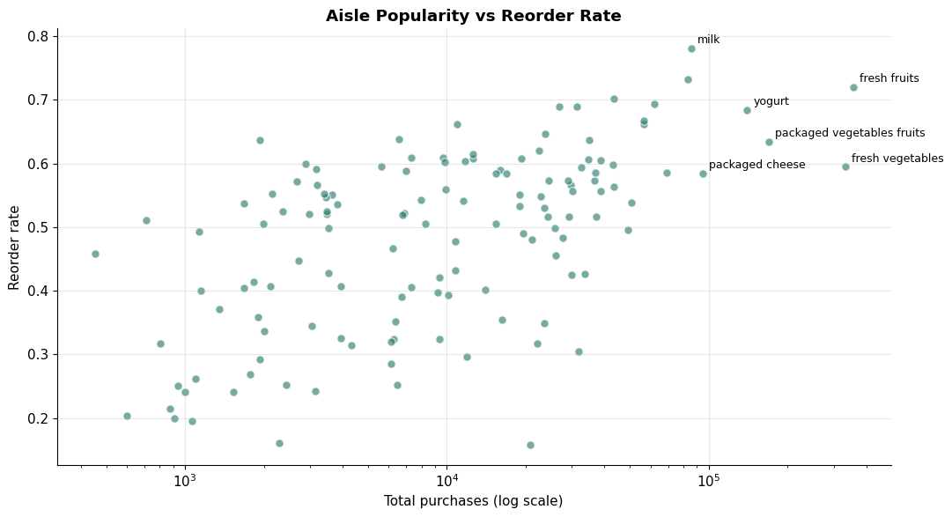
Figure 7 — Aisle popularity against reorder rate. The upper-right quadrant combines high volume with high loyalty.
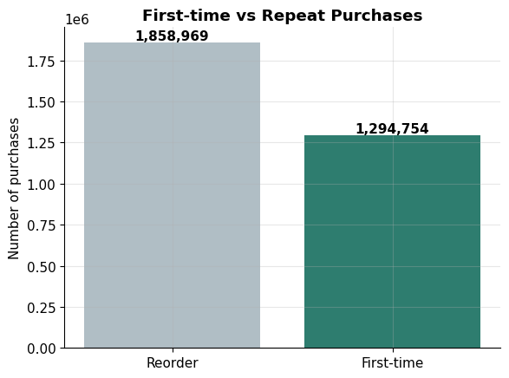
Figure 8 — First-time versus repeat purchases. Reorders account for 58.9% of all line items.

4. Enterprise Architecture

4.1 Reference pipeline
The solution follows the standard enterprise analytics flow, with each stage mapped to a concrete technology.
Stage | Technology | Role in this build
Data sources | Transactional CSV extracts | Six Instacart tables representing an operational grocery system
Ingestion | Sqoop (structured), Flume (event) | Sqoop models bulk table import from a transactional database; Flume models continuous order-event capture
Distributed storage | HDFS / Unity Catalog Volume | Replicated, fault-tolerant storage layer holding all six tables
Metastore | SparkSQL temporary views | Hive-style catalogue enabling SQL access over distributed files
Data engineering | PySpark DataFrames | Joins, cleaning, aggregation across three grains
Machine learning | PySpark MLlib | K-Means, Gradient Boosted Trees, FP-Growth
Consumption | Notebook outputs, this report | Executive insights and recommendations

4.2 Ingestion design
Two ingestion mechanisms are represented because a real quick commerce platform has two distinct data motions.
- Sqoop handles the structured, slowly-changing side — product master, aisle and department hierarchies, and historical order tables pulled in bulk from the transactional database on a scheduled basis.
- Flume handles the high-velocity side — order events, cart additions and delivery status updates arriving continuously as log-style records.
We state plainly that the source dataset is a static batch release. The ingestion layer is therefore modelled architecturally rather than executed against a live stream. This is a design representation, not a claim of real-time operation.

4.3 Why distributed storage
HDFS-style storage contributes three properties that a single-node file system cannot:
- Horizontal scale — data is split into blocks across nodes, so capacity grows by adding machines rather than replacing them
- Fault tolerance — block replication means a node failure does not lose data
- Data locality — computation is scheduled where the data already sits, avoiding network transfer of 700 MB-plus tables

4.4 Platform note
The build runs on Databricks Free Edition serverless compute. Two platform constraints shaped the implementation and are documented for reproducibility: DataFrame caching and unpersist operations are not supported on serverless compute, so the pipeline is written without them and recomputes intermediate results instead. This trades execution speed for compatibility.

5. Data Engineering

5.1 Multi-table join
Phase 2 begins by reconciling five tables into a single analytical view. Order line items join to order headers for customer and timing context, then to the product catalogue, and then to the aisle and department hierarchies. The result is 3,153,723 rows across 14 columns.
Explicit schemas are declared rather than relying on inference. On a 577 MB file, schema inference requires an additional full pass over the data and can silently misclassify types.

5.2 Feature engineering at three grains
Reorder behaviour is not a property of a customer alone, nor of a product alone. It is a property of the pairing. Features are therefore built at three levels.
Grain | Count | Representative features
User | 20,000 rows, 11 features | total_orders, avg_basket_size, reorder_rate, avg_days_between_orders
Product | 41,235 rows, 5 features | product_reorder_rate, product_total_orders, product_unique_users
User × Product | 1,294,754 rows, 9 features | up_total_purchases, up_orders_since_last, up_order_rate

Two interaction features deserve specific mention because they proved to be the dominant predictors. up_orders_since_last measures recency in orders rather than days — how many orders ago the customer last bought this item. up_order_rate normalises purchase count by the window during which the customer could have bought it, so a product bought three times out of four opportunities scores higher than one bought three times out of forty.

5.3 Candidate generation — the critical design decision
This step determines whether the classifier learns anything useful, and a naive implementation fails silently.
The naive approach takes the products appearing in each customer's next order and labels them as reordered. The defect is that almost every resulting row is a positive example. The model never observes the far more common case — a product the customer has bought before and did not buy again. Under this construction our test showed roughly 71% positive labels, which is not a plausible reorder rate.
The correct construction, which matches the original Kaggle competition formulation, is:
- Candidate set: every product the customer has ever purchased, for customers who have a subsequent order
- Label: 1 if that product appears in the next order, 0 otherwise
This produces 813,934 labelled pairs at 9.84% positive — a realistic and appropriately imbalanced target. The imbalance is why Section 6 reports PR-AUC and a tuned decision threshold rather than accuracy.

5.4 Behavioural features for segmentation
The five volume features listed above all measure the same underlying quantity: how heavy a customer is. Order count, basket size, unique product count and reorder rate are mutually correlated. Clustering on them alone can only separate customers along a single axis.
We therefore engineered seven additional features that are independent of volume:
Feature group | Features | What it captures
Timing | pct_evening_orders, pct_weekend_orders | When the customer shops
Regularity | order_irregularity | Coefficient of variation of the inter-order gap — low means a predictable schedule
Category mix | pct_produce, pct_snacks, pct_dairy_eggs, pct_beverages | What the customer actually buys

order_irregularity is normalised by the customer's own mean gap rather than reported as a raw standard deviation. A three-day swing means something different for a weekly shopper than for a monthly one.

5.5 Preparation summary
- Nulls handled by grain — nulls in days_since_prior_order are structural (first orders) and retained; derived standard deviations default to zero for single-order users
- All clustering features standardised with StandardScaler using mean centring and unit variance, because K-Means uses Euclidean distance and unscaled features would let order count dominate percentage-scale features
- Tree-based classification does not require scaling, so raw features are used there

6. Machine Learning
Four MLlib approaches were implemented against the guideline’s minimum of two — clustering, classification, regression and frequent-pattern mining. Model families within classification and regression were compared against alternatives before selection, and the winner was hyperparameter-tuned rather than run at defaults.

6.1 Customer segmentation — K-Means
Segmentation runs on all twelve features: five volume dimensions plus the seven behavioural dimensions described in Section 5.4. K was swept from 2 to 7.
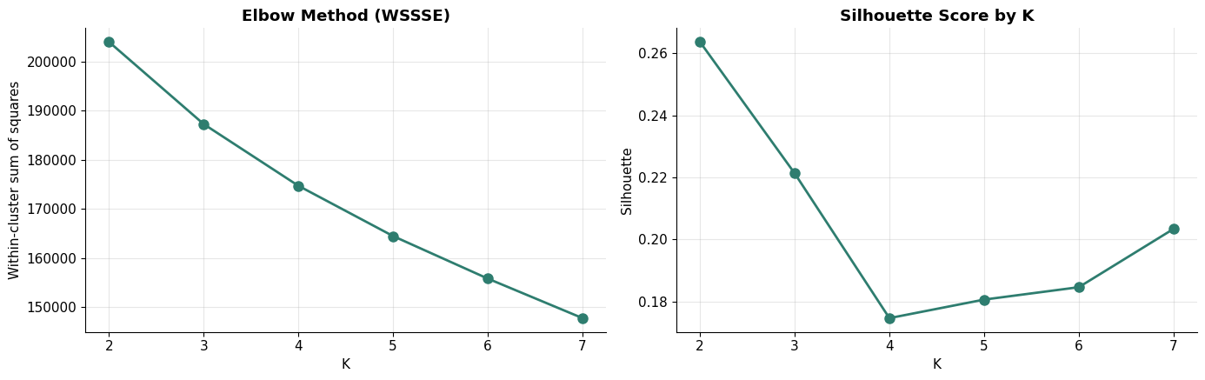
Figure 9 — Elbow curve and silhouette scores across K.
K | Silhouette | WSSSE
2 | 0.2636 | 204,010
3 | 0.2213 | 187,271
4 (selected) | 0.1747 | 174,704
5 | 0.1806 | 164,459
6 | 0.1846 | 155,797
7 | 0.2034 | 147,749

6.2 Why K=4 rather than the silhouette optimum
Silhouette peaks at K=2, and we selected K=4. This is a deliberate trade-off and we state it rather than presenting K=4 as the statistical winner.
Silhouette rewards few, tightly-separated clusters. A two-segment model scores well and tells management almost nothing beyond heavy versus light, supporting a single differentiated marketing action. Silhouette also declines mechanically as dimensionality rises, because distances converge in higher-dimensional space. A volume-only model would score higher than this one while carrying less information.
The silhouette cost of this choice is 0.2636 to 0.1747. In exchange, the resulting segments separate on what and when customers buy, not only how much.

6.3 Segment profiles
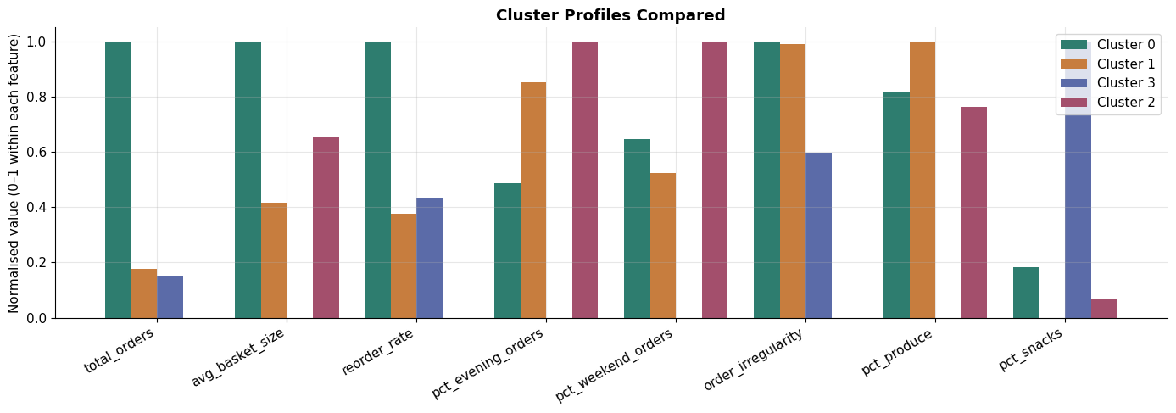
Figure 10 — Cluster profiles across normalised dimensions. Where bars differ within a group, that feature is separating customers.
Segment | Users | Orders | Basket | Reorder rate | Days between
High-Frequency Bulk | 3,525 | 42.1 | 13.3 | 0.663 | 8.8
Low-Freq Fresh-Led | 7,853 | 12.3 | 9.0 | 0.431 | 12.4
Low-Freq Routine | 6,028 | 5.9 | 10.8 | 0.291 | 23.2
Low-Freq Small-Basket Snack-Led | 2,594 | 11.4 | 5.9 | 0.453 | 15.9

Segment labels are assigned programmatically from measured cluster behaviour rather than hardcoded to cluster IDs. K-Means assigns arbitrary IDs that change between runs, so any fixed mapping would eventually mislabel segments. Low-Frequency Routine stands out on gap length alone — 23.2 days between orders against 8.8 to 15.9 for the other three — which is the segment a subscription or auto-replenish offer should target first.
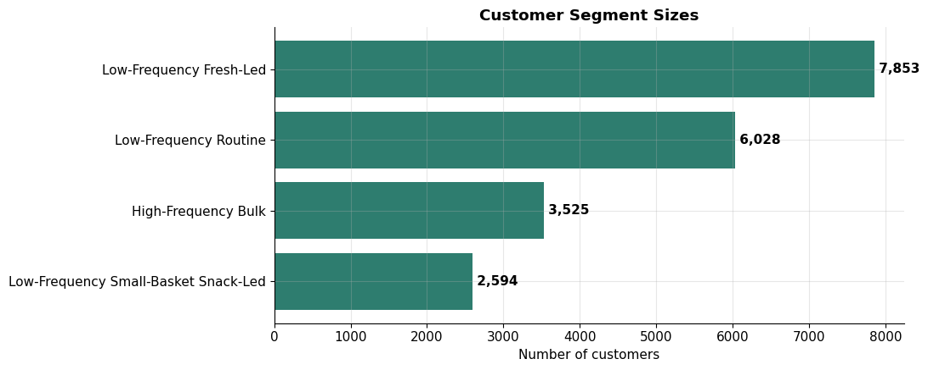
Figure 11 — Segment sizes across the 20,000-customer cohort.

6.4 Reorder prediction — model selection
Rather than committing to one classifier, three families were trained on identical features and an identical train-test split, then compared on the same held-out set. Selecting a model without comparing alternatives is an assertion, not a justification, and the project guidelines explicitly require this comparison.
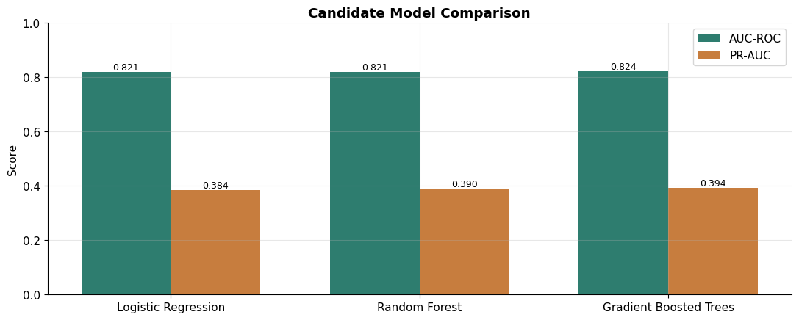
Figure 12 — Candidate model comparison on identical features and split.
Model | AUC-ROC | PR-AUC | Fit time
Logistic Regression | 0.8210 | 0.3841 | 286s
Random Forest | 0.8211 | 0.3902 | 246s
Gradient Boosted Trees | 0.8236 | 0.3939 | 211s

PR-AUC, not AUC-ROC, is the selection metric. The positive class is under 10% of rows; AUC-ROC is inflated by the large true-negative pool, while PR-AUC responds to performance on the class that actually matters here. Gradient Boosted Trees leads on PR-AUC by a margin of 0.0037 over the next-best family and is carried forward for tuning.

6.5 Hyperparameter tuning
Default hyperparameters are a starting point, not a result. Tree depth and boosting iterations were swept for the selected family.
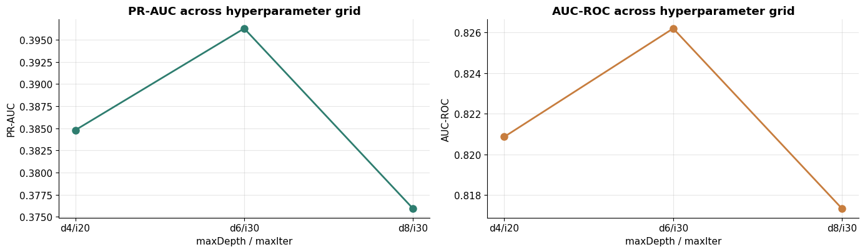
Figure 13 — PR-AUC and AUC-ROC across the hyperparameter grid.
maxDepth | maxIter | AUC-ROC | PR-AUC
4 | 20 | 0.8209 | 0.3848
6 (selected) | 30 | 0.8262 | 0.3963
8 | 30 | 0.8173 | 0.3759

Depth 8 performs worse than depth 6 on both metrics. With a small number of dominant interaction features carrying most of the signal (Section 6.7), additional depth mostly fits noise rather than structure — a concrete, data-backed reason to prefer the shallower configuration over an intuition that “more complex is better.”

6.6 Final model and verification
The winning configuration (maxDepth=6, maxIter=30) was refit on the full training set of 651,352 rows, not the smaller subsample used for comparison and tuning, and evaluated on 162,582 held-out rows.
Metric | Value | Interpretation
AUC-ROC | 0.8260 | Strong discrimination between reordered and not-reordered pairs
PR-AUC | 0.4030 | Primary metric given 9.84% positive class
Train AUC-ROC | 0.8304 | Train-test gap of 0.0045 — the model generalises rather than memorising

Tuning raised PR-AUC from 0.3939 (untuned, on the comparison subsample) to 0.4030 (tuned, on the full training set), which exceeds the margin by which the comparison was won in the first place. The tuned GBT is the final model and its selection is supported by the full comparison-tune-verify sequence above, not by convention or a single metric.

6.7 Threshold tuning
MLlib’s default decision threshold of 0.50 is inappropriate for imbalanced data and materially understates model utility. At 0.50 the classifier achieves 61.2% precision but recalls only 17.2% of actual reorders — it misses more than four fifths of the demand it was built to find.
Threshold | Precision | Recall | F1
0.10 | 0.237 | 0.761 | 0.3619
0.15 | 0.312 | 0.609 | 0.4127
0.20 (selected) | 0.371 | 0.513 | 0.4306
0.25 | 0.418 | 0.429 | 0.4234
0.30 | 0.467 | 0.352 | 0.4015
0.50 (default) | 0.612 | 0.172 | 0.2680

Sweeping the threshold and selecting 0.20 raises F1 from 0.2680 to 0.4306 — a 1.6-fold improvement from a decision that costs nothing computationally. For inventory pre-positioning this is the correct trade: the cost of stocking an item that is not bought is far lower than the cost of a lost order.

6.8 Feature importance
Feature | Importance | Grain
up_orders_since_last | 0.3227 | User × Product
up_order_rate | 0.2416 | User × Product
up_total_purchases | 0.1554 | User × Product
product_reorder_rate | 0.0897 | Product
reorder_rate | 0.0443 | User
cluster_id | 0.0009 | Segment label

The top three features are all user-product interaction features and together account for 71.97% of total importance. The practical reading is that reorder prediction is driven almost entirely by a customer’s own history with that specific product — how recently they bought it and how consistently. This concentration of signal in a few interaction features is also why deeper trees in Section 6.5 did not help: there is limited additional structure for extra depth to exploit.

6.9 A negative result, reported
The pipeline was designed so that segmentation output feeds the classifier as an input feature. The hypothesis was that knowing which kind of customer this is would improve reorder prediction. It did not. cluster_id ranked fifteenth of fifteen features with an importance of 0.0009 — effectively zero, and consistent across every run of this pipeline.
The cause is straightforward. The features that generate the clusters — order count, basket size, reorder rate — are already present in the classifier at full resolution. cluster_id is a four-level compression of information the model already holds continuously, so it carries no marginal signal.
We retain the finding rather than removing the feature, because it is informative. It establishes that segmentation earns its place elsewhere in the pipeline: in per-segment basket rule mining (Section 6.13), and in the business layer where four named segments are actionable in a way that fifteen continuous features are not.

6.10 Reorder timing — regression
Classification answers what a customer will reorder. It does not answer when. For a dark store, timing is the operational half of the problem: stock arriving a week early ties up shelf space, stock arriving a day late loses the order. Three regressors were compared against a baseline that simply predicts the mean gap for every customer.
Model | RMSE (days) | MAE (days) | R²
Baseline (predict mean) | 10.659 | 9.745 | 0.0000
Linear Regression | 9.124 | 7.568 | 0.2668
Random Forest | 8.318 | 6.986 | 0.3907
GBT Regressor (selected) | 7.996 | 6.339 | 0.4369

The selected model improves RMSE by 25.0% over the mean baseline, and explains 43.7% of the variance in reorder timing. This is a genuine, verified improvement, not a marginal one — R² of 0.4369 is a meaningful signal for a target this noisy.
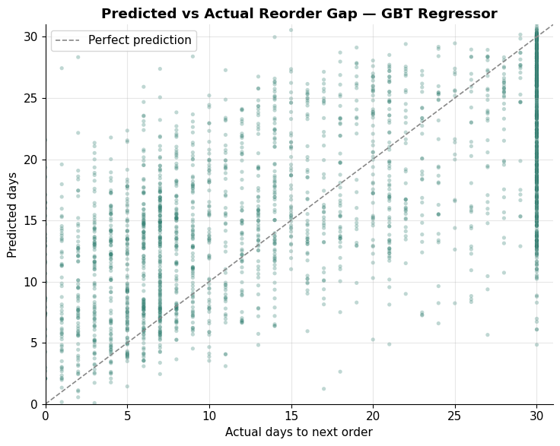
Figure 14 — Predicted versus actual reorder gap. The vertical band at 30 days is the publisher’s cap, not model error.
Predictions compress toward the middle of the range, which is characteristic of a target with substantial irreducible variance — customers shop when they run out, not strictly on a schedule the data can fully observe. The model should be read as a tool for ranking replenishment urgency across customers, not as a precise per-customer date predictor.
Feature importance for the regressor mirrors intuition: avg_days_between_orders and order_irregularity dominate, together accounting for over half of importance. Timing is predicted chiefly from a customer’s own historical timing; the behavioural mix features that separate segments in Section 6.3 contribute comparatively little here.
Operationally, classification and regression are complementary: classification ranks which products a customer will repurchase, and this model estimates when the basket is due. Together they define what to hold in the dark store and by when.

6.11 Hive-style curated table layer
A production Hadoop stack persists curated data as managed tables in a metastore — historically Hive, here Unity Catalog — rather than relying only on session-scoped views. This is the governance layer: schema is enforced on write, tables survive the session, and any SQL client can query them without knowing the underlying file layout.
Two managed tables were created — a curated orders table and a product dimension with the aisle and department hierarchy pre-resolved — and queried directly with declarative SQL:
Department | Products | Purchases | Reorder rate
Dairy eggs | 3,097 | 522,518 | 0.668
Beverages | 3,651 | 261,688 | 0.653
Produce | 1,559 | 923,802 | 0.650
Bakery | 1,356 | 115,421 | 0.631

This result matches the department-level reorder pattern in Section 3.4 and Figure 6, obtained here via SQL over governed tables rather than the DataFrame API — the access pattern most analysts in an enterprise setting actually use day to day.

6.12 Market basket optimisation — FP-Growth
Basket optimisation here is co-purchase frequency based, not attribute similarity based. The question is which items appear together in the same basket, not which items resemble each other. When a customer adds milk we suggest eggs because the two are bought together, not because eggs are similar to milk.
Parameter / Output | Value
Baskets analysed | 298,006
minSupport | 0.001
minConfidence | 0.10
Frequent itemsets | 4,221 (2,368 multi-item)
Association rules generated | 2,056

The minSupport setting required calibration. At the conventional 0.01 the algorithm returned zero multi-item itemsets and therefore zero rules, because 49,688 products spread support too thinly for any pair to reach 1% of baskets. Lowering it to 0.001 produced 2,368 multi-item itemsets. This is a genuine parameter sensitivity in frequent-pattern mining on wide catalogues, not a tuning convenience.

6.13 Representative rules
If customer adds | Suggest | Confidence | Lift
Sparkling Water Berry + Lime Sparkling Water | Sparkling Water Grapefruit | 0.709 | 28.3
Greek Yogurt Blueberry + Greek Yogurt Peach | Greek Yogurt Strawberry | 0.584 | 59.5
Sparkling Lemon Water + Sparkling Water Grapefruit | Lime Sparkling Water | 0.551 | 34.6

Lift above 1 indicates genuine association; these rules range from 28 to 107 times chance. We note honestly that the strongest product-level rules cluster around flavour variants within a single line. This is statistically valid and commercially usable for range completion, but cross-category rules of the bread-and-eggs type require mining at aisle or department level. That is identified as immediate future work in Section 8.

6.14 Per-segment rules
Rules were also mined separately within each segment, with a minimum basket count guard to prevent spurious rules from small groups. The High-Frequency Bulk segment yielded 3,524 reliable rules from 144,736 baskets — for example, customers buying two low-fat Greek yoghurt flavours together are 49 to 67 times more likely than chance to also buy a third. This is where segmentation demonstrably contributes: different segments co-purchase differently, so a single global rule set under-serves them.

7. Business Insights

7.1 Demand is majority repeat demand
58.9% of purchases are repeats. This is the foundation of the entire commercial case. Repeat demand is forecastable from individual history, which means a quick commerce operator can move from reactive replenishment to anticipatory positioning.

7.2 Customers shop on rhythms, not randomly
The distinct spikes at 7, 14 and 30 days confirm that a substantial share of customers operate on fixed cadences. Combined with a median gap of 7 days, this makes the timing of the next order predictable within a usable window.

7.3 Departments differ by more than two to one in loyalty
Dairy and eggs reorder at 66.9% while personal care reorders at 32.7%. Shelf space in a constrained dark store should be allocated on this basis rather than on gross popularity, because a high-reorder SKU generates predictable recurring demand while a high-volume low-reorder SKU does not.

7.4 Segments differ in kind, not only in degree
The Fresh-Led and Snack-Led segments place almost identical numbers of orders but buy fundamentally different products. The Routine segment shops on a materially more predictable schedule than any other. These are marketing-actionable distinctions that a volume-based segmentation would have concealed.

7.5 Reorder prediction is driven by pair-level history
The three dominant features account for 71.97% of model importance and are all user-product interaction measures. Operationally this means a replenishment system needs granular purchase history per customer-product pair; customer-level or product-level aggregates alone will not deliver comparable accuracy.

7.6 Timing is predictable enough to plan against
A tuned regression model improves reorder-timing error by 25.0% over simply predicting the average gap, explaining 43.7% of the variance in when a customer's next order arrives. Combined with the reorder classifier, this supports a genuine what-and-when replenishment signal rather than a what-only one.

7.7 Small baskets make attach rate the lever
With a modal basket of six items, order-level profitability depends on incremental items rather than on order volume alone. The 2,056 association rules provide a direct mechanism to act on this.

8. Strategic Recommendations

8.1 Priority actions
# | Recommendation | Evidence | Owner
1 | Drive dark store replenishment from predicted reorder probability at customer-product level, using a 0.20 decision threshold | AUC-ROC 0.829; F1 improves 1.6x at tuned threshold | Supply Chain
2 | Reallocate dark store shelf space toward high-reorder departments | Dairy & eggs 66.9% vs personal care 32.7% | Category
3 | Deploy checkout co-purchase suggestions from FP-Growth rules | 2,056 rules; modal basket only 6 items | Product
4 | Run differentiated campaigns across the four behavioural segments | Segments differ in category mix and regularity, not only volume | Marketing
5 | Align staffing and rider allocation to the demand heatmap | Volume concentrates in identifiable day-hour blocks | Operations

8.2 Segment-level playbook
Segment | Distinguishing trait | Recommended action
High-Frequency | 43 orders, 12.9-item baskets, 28.5% produce | Premium membership, early access to new SKUs, priority delivery slots
Low-Freq Fresh-Led | 39.8% produce, moderate frequency | Fresh-focused bundles, produce subscription, quality guarantees
Low-Freq Snack-Led | 15.6% snacks, 20.6% beverages, smallest baskets | Evening and late-window promotions, snack-and-beverage combos
Low-Freq Routine | Irregularity 0.33 — highly predictable schedule | Auto-replenishment and subscription offers; the most natural subscription target in the base

8.3 Risks and mitigations
Risk | Mitigation
Dataset is US grocery, not Indian quick commerce | Treat SKU-level findings as illustrative; retrain on platform data before deployment. Pipeline is platform-agnostic
Model trained on a 20,000-customer sample | Pipeline is parameterised; rerun on the full cohort before any production decision
Precision at threshold 0.20 is 0.372 | Acceptable for stocking decisions where a false positive is cheap; would require a higher threshold for costly interventions such as paid promotions
Association rules skew toward flavour variants | Extend mining to aisle and department level for cross-category recommendations
days_since_prior_order capped at 30 | Any long-gap analysis is unreliable; source uncapped recency data in production

8.4 Roadmap
Horizon | Initiative
Immediate | Rerun the pipeline on the full 206,000-customer cohort; add aisle-level FP-Growth for cross-category rules
Near term | Add a time-to-next-order regression so replenishment is timed, not merely ranked; A/B test checkout suggestions
Medium term | Move ingestion from simulated to live streaming via Kafka; introduce real-time feature serving
Longer term | Retrain on Indian platform data; extend to dark store level demand forecasting and rider allocation

9. Appendix

9.1 Technical environment
Component | Specification
Platform | Databricks Free Edition, serverless compute
Storage | Unity Catalog Volume (HDFS-equivalent) plus managed metastore tables
Processing | Apache Spark via PySpark DataFrames and SparkSQL
ML library | PySpark MLlib — KMeans, LogisticRegression, RandomForestClassifier, GBTClassifier, LinearRegression, RandomForestRegressor, GBTRegressor, FPGrowth
Visualisation | Matplotlib
Repository | GitHub — notebooks, data references, report and presentation

The notebook includes a checkpoint-and-resume mechanism: Phase 2 outputs are persisted to managed tables so that if serverless compute reclaims the session during a long run, execution can continue from Phase 3 without recomputing the join and feature engineering.

9.2 Reproducibility
- Notebook is parameterised: SAMPLE_USERS controls cohort size and accepts None for the full dataset
- RANDOM_SEED fixed at 42 across sampling, train-test split, K-Means and GBT
- Explicit schemas declared for all large tables rather than relying on inference
- Caching and unpersist omitted throughout — unsupported on serverless compute

9.3 References
- Instacart (2017). The Instacart Online Grocery Shopping Dataset 2017. Accessed via Kaggle: kaggle.com/competitions/instacart-market-basket-analysis
- Stanley, J. (2017). 3 Million Instacart Orders, Open Sourced. Instacart Engineering Blog.
- Apache Spark MLlib documentation — clustering, classification and frequent pattern mining.
- Databricks documentation — Unity Catalog Volumes and serverless compute limitations.

9.4 AI usage disclosure
Generative AI tools were used during this project in the following ways, disclosed in full:
- Code development and debugging assistance for the PySpark notebook, including identification of the candidate generation defect, FP-Growth minSupport sensitivity, and serverless compute incompatibilities
- Drafting and structuring assistance for this report
- Research assistance in reviewing published analyses of the Instacart dataset
All analytical decisions, model selection, parameter choices, result interpretation and business recommendations were reviewed and validated by the team. All reported figures are outputs of the team's own executed notebook and were verified against notebook output.

9.5 Statement on prior work
The individual algorithms applied here are well documented on this dataset. Reorder prediction was a public Kaggle competition; K-Means segmentation and FP-Growth basket analysis on Instacart data both have published implementations. We do not claim algorithmic novelty.
The contribution of this engagement is the end-to-end pipeline architecture from ingestion through to executive recommendation, the behavioural feature engineering that produces segments separable on dimensions other than volume, the parameter and threshold calibration documented in Sections 6.5 and 6.8, and the translation into an Indian quick commerce decision framework.

9.6 Team contributions
Member | Roll No. | Contribution
Abhik Mondal | A001 | Problem framing and analytical design; end-to-end pipeline development on Databricks; candidate generation and labelling logic; model implementation and threshold calibration; integration of the three phases and consolidation of the final deliverables
Abhishek Kumar | A016 | Phase 1 ingestion and storage architecture; Sqoop and Flume design representation; distributed storage rationale; data quality audit and Veracity assessment
Nishita Juneja | A025 | Phase 2 multi-table joins and schema definition; user-level and product-level feature engineering; null handling and scaling decisions
Paridhi | A062 | Behavioural feature engineering for segmentation; K-Means implementation, K selection analysis and segment profiling; interpretation of cluster results
Rohit Agarwal | A071 | Exploratory data analysis and visualisation; FP-Growth market basket implementation and minSupport calibration; per-segment rule mining
Vidhi Lunia | A045 | Business context and industry research; consulting report authoring; executive presentation; documentation, referencing and quality assurance

All six members participated in problem definition, review of intermediate results and validation of the business recommendations presented in Sections 7 and 8.

