WEEK-4

SDLC

SDLC is the acronym of Software Development Life Cycle.

Software Development Life Cycle (SDLC) is a process used by the software industry to design, develop and test high quality software.

A typical Software Development Life Cycle consists of the following stages −

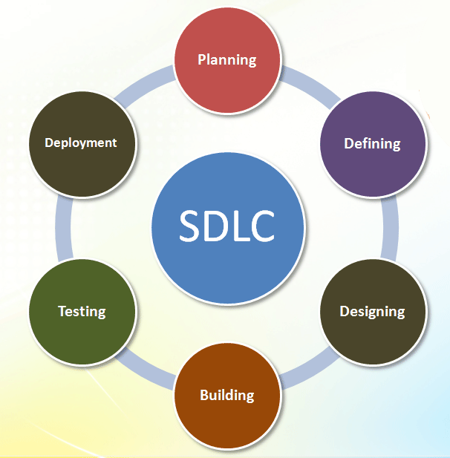

### **Stage 1: Planning and Requirement Analysis**

* It is the most important stage in SDLC lifecycle.
* Here we do all the planning related to risk management, economical, technical, etc.

### **Stage 2: Defining Requirements**

* Once the requirement analysis is done the next step is to clearly define and document the product requirements and get them approved from the customer or the market analysts.
* This is done through an **SRS (Software Requirement Specification)** document.

### **Stage 3: Designing the Product Architecture**

* SRS is the reference for product architects to come out with the best architecture for the product to be developed.
* Here based on SRS more than one design architecture is proposed.

### **Stage 4: Building or Developing the Product**

* In this stage of SDLC the actual development starts and the product is built.
* Code is generated as per the design architecture.
* Developers must follow the coding guidelines defined by their organization and programming tools like compilers, interpreters, debuggers, etc.

### **Stage 5: Testing the Product**

* Here Testing is done on our product and fixed, retest until the product reaches the quality standards defined in the SRS.

### **Stage 6: Deployment in the Market and Maintenance**

* Once the product is tested and ready to be deployed it is released formally in the appropriate market.
* Sometimes product deployment happens in stages as per the business strategy of that organization.

## **SDLC Models**

There are various software development life cycle models defined and designed which are followed during the software development process. These models are also referred as Software Development Process Models".

* Waterfall Model
* Iterative Model
* Spiral Model
* V-Model
* Agile Model

##### Waterfall Model vs. Agile Model

# Waterfall Model

* Waterfall Model methodology which is also known as Liner Sequential Life Cycle Model.
* When all the requirements are clear before starting the project at that time waterfall model is use.
* Mostly waterfall model is used for short project.
* Waterfall Model followed in the sequential order, and so project development team only moves to next phase of development or testing if the previous step completed successfully.
* Waterfall model is simple and easy to understand and use
* Customer has no idea about how much product development is complete till the last phase. So no customer interaction happen after requirement phase till the end.

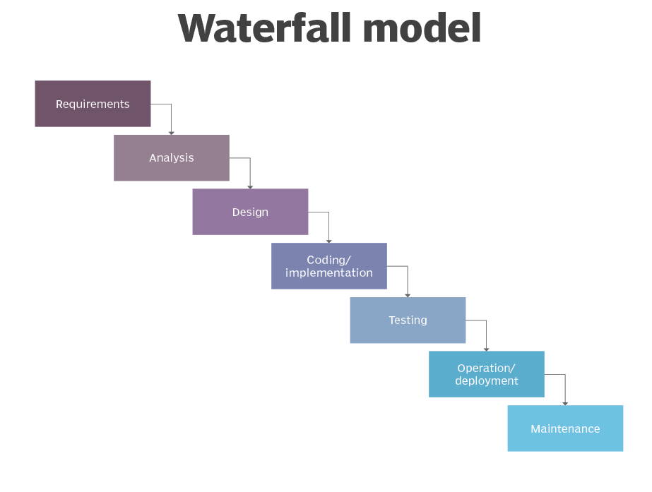

# Agile Model

* When requirement is not clear at the starting at that time we can use agile model.
* Here customer interaction is high compare to waterfall model and new changes are accept after requirement stage because customer, developer and tester are constantly interact with each other.
* After completion of a module product is released so customer have idea of how product is working and if there is any change is require than it will be done in next release. So customer is satisfied with final product.

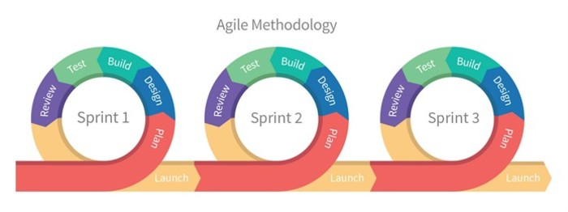

**Example:**

**Watefall model:**

* If we want to develop ant project that time if we chose waterfall model than first of all we have to collect all the requirement at the starting of our project.
* After collect all the requirement we now move to next stage and start analyse, design and that start code our project.
* Here after move to next stae we cannot go back to previous stage.
* After code testing is performed and after succesful testing product is ready for deployement.
* Here no customer interectin happen after requirement stage, so customer have no idea about the product.
* So it is possible that final product doesnot match some features that customer expexted to be in product.

**Agile Model:**

* If we want to develop ant project that time if we chose agile model than no need to get all the requirement at the starting.
* Here customer interection is happen throughout all the stages.
* Here project is divide into sprint (A sprint is a set period of time during which specific work has to be complete and made ready for review.).
* After the review if there is any change is required than that will be done in upcoming sprints.
* Here customer is aware of how much product is developed and all work is done as per the requirement.
* So here more chance that developed product is match all the customer requirement.

###### Service

* In ITIL PRACTITIONER GUIDELINE publication offer up the following guidelines,
* “A service is a means of delivering ***value*** to customers by facilitating ***outcomes*** that customers want to achieve without the ownership of specific ***costs*** and ***risks***.”
* In simple word we can consider SERVICE as complete the requirement of the customer in given cost and with minimum risk.

##### Service Now Tool

* ServiceNow is a Platform-as-a-service provider.
* ServiceNow is a ticketing tool that processes and catalogs customer service requests.
* You can raise requests that deal with incidents, changes, problems, and other services using tools like ServiceNow.
* It can automate repetitive tasks for your IT so they can spend more time contributing to your core business.
* Work of service down can be define in 3 stages,

1. **Reporting issue**

* User/ Employee can reporting an issue in multiple ways.
* They can call a service desk, use the chat feature, email the issue, or create an incident themselves in ServiceNow using the service catalogue or service portal.

1. **Managing issue**

* Once the incident is reported then it is prioritized based on its impact and urgency.
* Using AI service now can automatically route an issue to the best suited employee for handle particular type of issue.
* While issue is being managed you can its status and track its progress in real time.

1. **Resolving issue**

* After an issue is resolved, it has to be closed with all relevant information (time-taken to fix, attaching relevant information in the Knowledge Base, etc.).
* In case an issue remains unsolved, escalation rules come into play.

**ITSM**

* **ITSM** stands for “Information Technology Service Management”
* **ITSM** is a set of policies, procedure that are performed by an organized to design, plan, deliver, operate and control IT service offered to customers.
* ITSM includes all the discrete activities and processes that support a service throughout its lifecycle.

**Terms used in ITSM:**

* Incident
* Problem
* Change Request (CR)
* Service Request (SR)

**Incident:**

* We can say that incident is an unplanned interruption to an IT service.
* In simple words in our existing system functionality is not work as expected it is called incident.
* In Incident management Process try to fix the system and restore the service as soon as possible.
* For example login functionality is not working, Button click is not work as expected, etc.

**Problem:**

* Problem is an incident of similar issue occur multiple times.
* So when incident is solved and after some time same incident occur multiple times after solved it then it is called a problem.
* Problem is more serious than incident and need deeper level process to avoid future incident.
* In problem management the root cause of problem needed to find and fix it. So incident do not reoccur.

**Change Request:**

* When we want to add some new functionality or change in our existing system at that time change request is generated.
* Change request states what need to be accomplished, but doesn’t provide any instruction or path how to complete it.
* For example in our existing application we want to add login with authcode functionality.

**Service Request:**

* Service request is a formal request by a user for any service they require such as the installation of new software, change of hardware or replacement of a component, password reset, etc.
* Sometimes service request have a higher possibility of including pre-approved.
* For example user request for password reset.

**Some benefits of ITSM:**

* Reduce IT Cost
* Improve the quality of service
* Efficient analysis of IT problems to reduce repeat incidents.
* Improved efficiency of IT help desk teams.
* Ability to establish well-defined, repeatable, and manageable IT processes
* Well-defined roles and responsibilities

**ITIL**

**What is ITIL?**

* **ITIL** stands for ‘Information Technology Infrastructure Library’.
* ITIL is a framework of best practises for delivering IT services to customer.
* ITIL contains detailed process descriptions, flows, success factors, metrics and implementation guidance that organizations can adapt to work in their environment.
* By using ITIL, organization can improve their overall IT service management capability.
* The current version (V4) of ITIL launched in 2019.