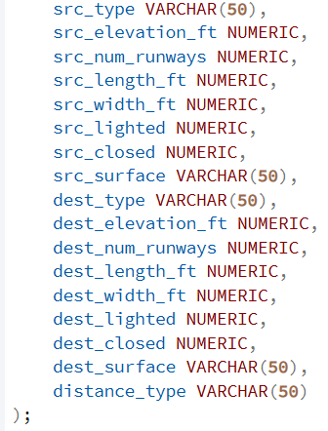
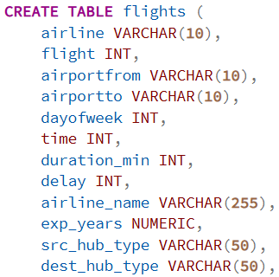
Created table and imported data via excel/csv file

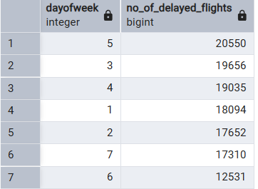
1. Determine the number of flights that are delayed on various days of the week

2. Determine the number of delayed flights for various airlines

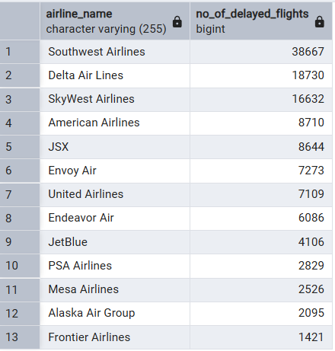

3. Determine how many delayed flights land at airports with at least 10 runways

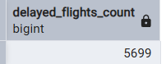

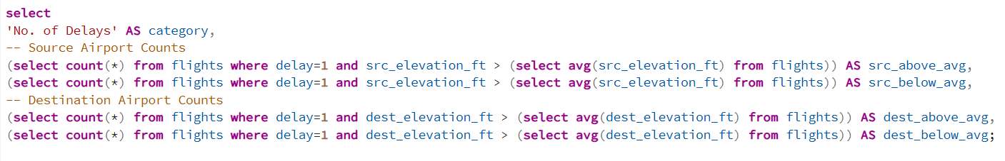
4. Compare the number of delayed flights at airports higher than average elevation and those that are lower than average elevation for both source and destination airports
