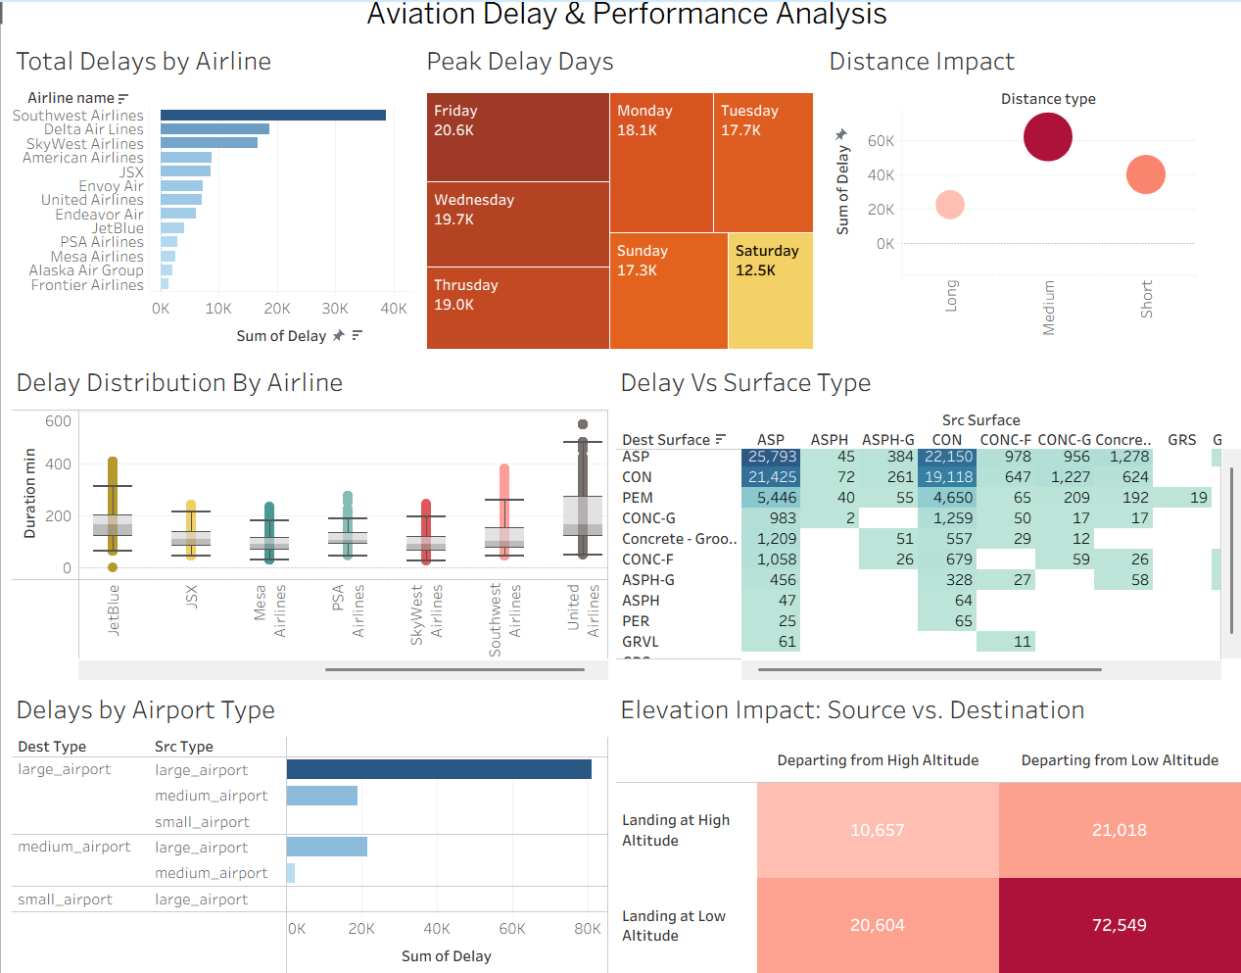
1. Total Delays by Airline
Southwest Airlines has the highest delays. Frontier Airlines has the least delays.

2. Peak Delay Days
Friday has the most delays at 20.6K. Saturday has the least delays at 12.5K.

3. Distance Impact
Medium distance flights have the most delays. Long distance flights have less delays.

4. Delay Distribution By Airline
United Airlines has the most delay time. Mesa Airlines has less delay time.

5. Delay Vs Surface Type
Asphalt (ASP) surface has the most delays. Gravel (GRVL) surface has the least delays.

6. Delays by Airport Type
Large source airport to large destination airport has the most delays. Small airports have less delays.

7. Elevation Impact: Source vs. Destination
Source with low altitude to destination with low altitude has the highest delays at 72549. Source with high altitude to destination with high altitude has the least delays at 10657.

