**LAB EXERCISE – 16**

**Perceptron**

1. **Aim of the Experiment:**

Implement and demonstrate perceptron model, a linear binary classifier used for supervised learning.

1. **Reference to Text book for Algorithms:**

Refer to Section 10.4 in Chapter 10 Artificial Neural Networks to understand the working of the algorithm.

**Listing 1:** Figure 10.6 in the Chapter 10 - Artificial Neural Networks

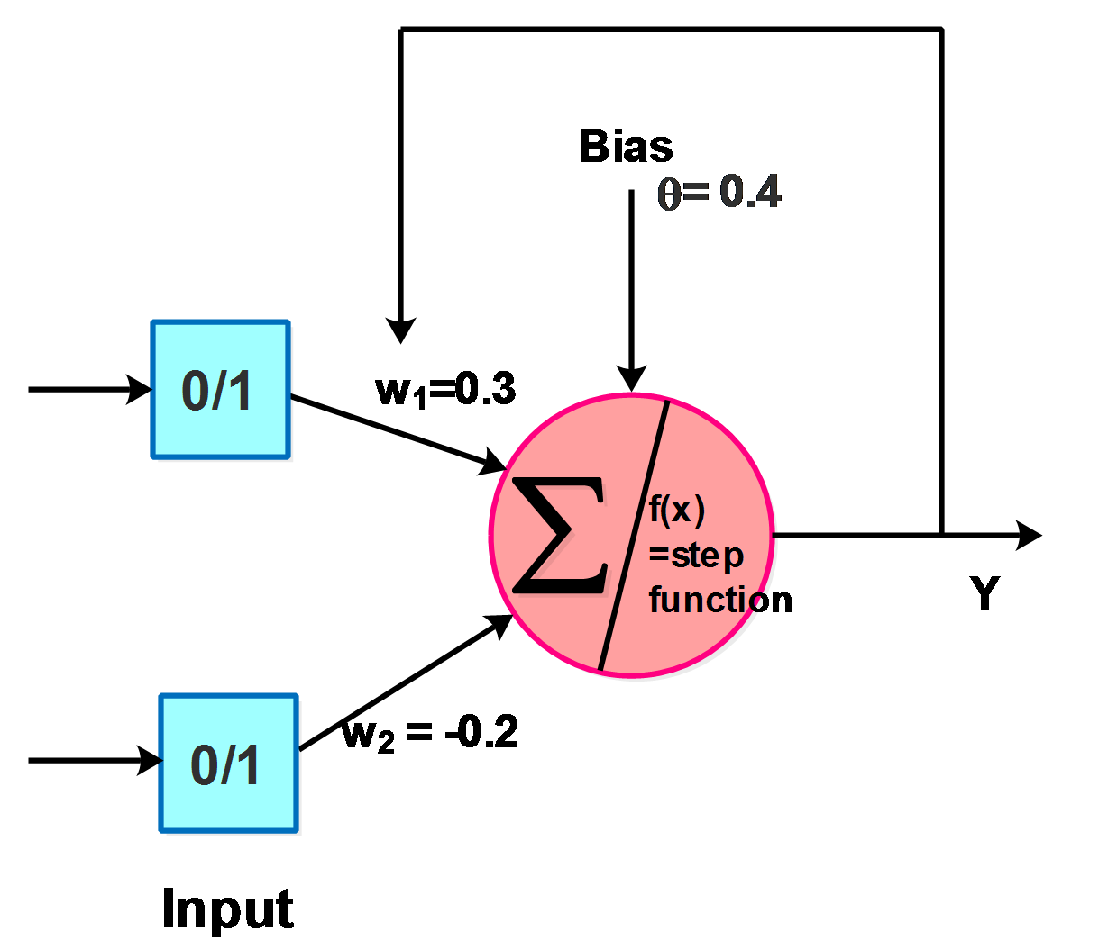

**Figure 10.6:** Perceptron for Boolean Function AND

Desired output for Boolean function AND is shown in Table 11.1.

**Table 11.1:** AND Truth Table

|  |  |  |
| --- | --- | --- |
| X1 | X2 | Ydes |
| 0 | 0 | 0 |
| 0 | 1 | 0 |
| 1 | 0 | 0 |
| 1 | 1 | 1 |

Consider the perceptron to represent the Boolean function AND with the initial weights W1 = 0.3, W2 = -0.2, learning rate $∝$ = 0.2 and bias $θ$ = 0.4 as shown in Figure 11.6. The activation function used is the Step function f(x) which gives the output value as binary i.e., 0 or 1. If value of f(x) is greater than or equal to 0, it outputs 1 or else it outputs 0.

We design a perceptron that performs the Boolean function AND. The weights are updated until the Boolean function gives the desired output.

**3. Python Program with Explanation:**

1. Import numpy, array-processing package to work with the arrays.

import numpy as np

2. Create a Perceptron class to implement a perceptron network. Define the built-in __init__() function that takes learning rate of 0.2 and number of epochs of 4 to initialize the object. The initial weight vector is set as [0.3, -0.2].

class Perceptron(object):

def __init__(self, input_size, lr=0.2, epochs=4):

self.W = np.array([0.3,-0.2])

self.epochs = epochs

self.lr = lr

3. Define the activation function as Step function f(x) which gives the output value as binary i.e., 0 or 1. If value of f(x) is greater than or equal to 0, it outputs 1 or else it outputs 0.

def activation_fn(self, x):

return 1 if x >= 0 else 0

4. Define the predict function to compute the weighted sum ‘z’ by multiplying the inputs with the weights and add the products. Then subtract $θ$. Round the value to 2 decimals. Then call the activation function.

def predict(self, x, theta):

z = self.W.T.dot(x)-theta

z=round(z,2)

a = self.activation_fn(z)

return a

5. Define the learning function fit() passing all inputs X, the desired output d, bias $θ$ and

count.

Update the weights for epochs, until the perceptron can correctly classify all inputs.

def fit(self, X, d,theta ,count):

for _ in range(self.epochs):

print("Epoch: ", count, "\n")

count = count+1

for i in range(d.shape[0]):

x = X[i]

print("input", x , "\t", "Weight:",self.W )

print("\n")

Call the predict function, passing the input value x and theta. The function returns the predicted output value ‘y’.

y = self.predict(x,theta)

Calculate error as the difference between the desired output d[i] and the predicted output y.

e = d[i] – y

Update the weight vector.

self.W = self.W + self.lr * e * x

6. Define the main function with input array X, desired output array d. This function is the entry point of the program.

if __name__ == '__main__':

X = np.array([

[0, 0],

[0, 1],

[1, 0],

[1, 1]

])

d = np.array([0, 0, 0, 1])

Create perceptron object. When the object is created, the __init__() function is called and the object is initialized.

perceptron = Perceptron(input_size=2)

theta=0.4

count =1

Call the learning function of the perceptron passing training input X, desired output d, theta and count.

perceptron.fit(X, d, theta, count)

Finally print the learned weights for the AND gate which gives the desired output.

print(perceptron.W)

**Complete Program:**

import numpy as np

class Perceptron(object):

def __init__(self, input_size, lr=0.2, epochs=4):

self.W = np.array([0.3,-0.2])

self.epochs = epochs

self.lr = lr

def activation_fn(self, x):

return 1 if x >= 0 else 0

def predict(self, x,theta):

z = self.W.T.dot(x)-theta

z=round(z,2)

a = self.activation_fn(z)

return a

def fit(self, X, d,theta ,count):

for _ in range(self.epochs):

print("Epoch: ", count)

count = count+1

for i in range(d.shape[0]):

x = X[i]

print("input", x , "\t", "Weight:",self.W )

y = self.predict(x,theta)

e = d[i] - y

self.W = self.W + self.lr * e * x

if __name__ == '__main__':

X = np.array([

[0, 0],

[0, 1],

[1, 0],

[1, 1]

])

d = np.array([0, 0, 0, 1])

perceptron = Perceptron(input_size=2)

theta=0.4

count =1

perceptron.fit(X, d,theta, count)

print(perceptron.W)

**Output:**

Python 3.8.3 (tags/v3.8.3:6f8c832, May 13 2020, 22:37:02) [MSC v.1924 64 bit (AMD64)] on win32

Type "help", "copyright", "credits" or "license()" for more information.

>>>

========== RESTART: C:\Users\ADMIN\pythonpgms\final\jnf perceptron.py ==========

Epoch: 1

input [0 0] Weight: [ 0.3 -0.2]

input [0 1] Weight: [ 0.3 -0.2]

input [1 0] Weight: [ 0.3 -0.2]

input [1 1] Weight: [ 0.3 -0.2]

Epoch: 2

input [0 0] Weight: [0.5 0. ]

input [0 1] Weight: [0.5 0. ]

input [1 0] Weight: [0.5 0. ]

input [1 1] Weight: [0.3 0. ]

Epoch: 3

input [0 0] Weight: [0.5 0.2]

input [0 1] Weight: [0.5 0.2]

input [1 0] Weight: [0.5 0.2]

input [1 1] Weight: [0.3 0.2]

Epoch: 4

input [0 0] Weight: [0.3 0.2]

input [0 1] Weight: [0.3 0.2]

input [1 0] Weight: [0.3 0.2]

input [1 1] Weight: [0.3 0.2]

[0.3 0.2]

>>>

It is observed that with 4 epochs, the perceptron learns, and the weights have been updated to 0.3 and 0.2 with which the perceptron gives the desired output of a Boolean AND function.

**Screenshot of the Output:**

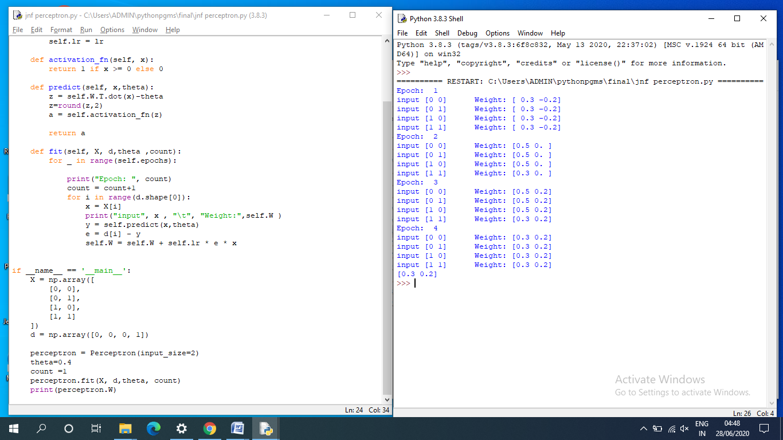

**Programming Exercises:**

1. Consider the perceptron taking two inputs x1 and x2 with weights w1 = 1.0, w2= 1.0 and θ = 1.5. Determine the outputs for different combination of the inputs and plot them in graph x1 vs. x2.
2. Design a simple classification problem to classify the gender of a person based on two input parameters height and weight using perceptron.