**LAB EXERCISE – 3**

**Graphics Plots**

**Aim of the Experiment**

To Explore the Univariate and Bivariate Graphs

**Textbook reference and Explanations**

Chapter 2 and Appendix 2

A csv file is created for this Lab Exercise as shown below and is available in marks.csv file.

The command df['physics'].hist() plots the histogram of the dataset. The generic form is df[column name].hist(). The command plt.scatter(chemistry1,marks1,alpha=0.5) plots the scatter diagram of chemistry and physics examination. df.plot.box(title="Box and whisker plot of Marks", grid=False) can plot the box and whisker plot. df.plots() and pd.plotting.scatter_matrix() can plot for the entire dataset.

**Program Listings**

**Listing - 1**

import pandas as pd

from matplotlib import pyplot as plt

col_list=['id','name','gender','physics','chemistry','maths','biology','language','selected']

df = pd.read_csv('marks1.csv',usecols=col_list)

print(df)

# Create a histogram for physics marks

marks1 = df['physics'].values.tolist()

marks_scored = df['physics'].hist()

plt.title('Histogram for Physics Marks')

plt.xlabel('Physics Marks')

plt.ylabel('Frequency of Physics Marks')

plt.show()

# Create a scatter plot for Physics Vs Chemistry marks

chemistry1 = df['chemistry'].values.tolist()

print (chemistry1)

plt.scatter(chemistry1,marks1,alpha=0.5)

plt.title('Scatter plot chemistry vs physics')

plt.xlabel('Chemistry')

plt.ylabel('Physics')

plt.show()

# Create a Box plot

df.plot.box(title="Box and whisker plot of Marks", grid=False);

plt.show(block=True);

# Create a pie chart for selected based on Gender

sums = df.selected.groupby(df.gender).sum()

plt.pie(sums,labels=sums.index);

plt.show()

# Multiplots

# Box Plot for the dataset

df.plot(kind='box',subplots=True,layout=(3,3),sharex=False,sharey=False)

plt.show()

# Multiplot

# drop columns id,name,gender,selected

cols=df[['id','name','gender','selected']]

df2 = df.drop(cols, axis=1)

pd.plotting.scatter_matrix(df2, alpha=0.2)

plt.show()

**Output**

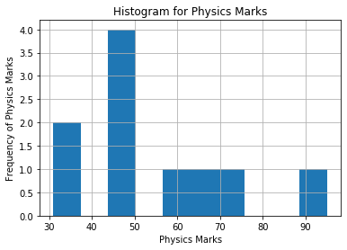

**Listing 2**

**Explain Charts the using Iris dataset.**

import pandas as pd

df = pd.read_csv("iris.csv")

data = df.iloc[1:20]

data.plot.scatter('sepal.length','sepal.width')

data.hist(column='variety',by='variety')

data.boxplot(column='sepal.length',by='variety')

**Output**

