Grain Quality Prediction Using Hyperspectral Imaging
Final year minor project study notes and viva preparation
Group 2 Project
Abhay Kumar
Mihir Karsale
Ayush Tiwari

What this project is about
We want to estimate grain protein content, and optionally moisture content, by analysing light reflected from grains. A hyperspectral camera records many wavelength bands. A regression model learns the connection between these spectral measurements and laboratory measurements of the same samples.
These notes explain both supplied research papers and propose a manageable student project. No Group 2 dataset, implementation or experimental results were supplied. All numerical research results below belong to the cited authors. The project title and work plan are suggested.

Quick revision in ten points
- Problem: laboratory testing is slow and may destroy the tested sample.
- Solution idea: scan grains and use a trained model to estimate chemical content.
- Input: calibrated hyperspectral data, not an ordinary RGB photograph.
- Training labels: laboratory protein values and, where available, moisture values.
- Rice paper: MSC preprocessing, SPA wavelength selection and MLR regression.
- Sorghum paper: CLNet combines a one dimensional CNN with an LSTM.
- CNN learns nearby spectral patterns. LSTM learns relationships along an ordered sequence.
- Outputs: a number in percent or g/100 g, and an optional predicted colour map.
- Evaluation: compare predictions with unseen laboratory labels using R², RMSE and RPD.
- First action: secure usable data, then build a simple baseline before a deep model.

How to use these notes
Read pages 1–2 for revision, pages 3–10 for methods and implementation, pages 11–13 for figure explanations, and pages 14–18 for planning, viva practice and references.

The two research papers
Item | Rice study [R1] | Sorghum study [R2]
Publication | Xuan et al., 2024 | Hu et al., 2025
Prediction target | Protein | Protein and moisture
Samples | 144 samples, 4 cultivars, 2 harvest years | 240 samples, 12 varieties
Sample unit | About 0.5 g of rice per sample | 90 g of sorghum per dish
Spectral range | 400–1000 nm | About 900–1700 nm after trimming
Split in paper | 96 calibration, 48 validation | 192 calibration, 48 prediction
Main method | MSC–SPA–MLR | CNN + LSTM = CLNet
Data availability | Paper states data are confidential | Paper states data available on request

Rice paper in simple words
- The researchers scanned rice and measured its protein using the Kjeldahl method.
- They compared preprocessing, wavelength selection and linear regression methods. MSC–SPA–MLR performed best in the reported comparison.
- They applied the model to pixel spectra to create estimated protein distribution maps.

Sorghum paper in simple words
- The researchers measured protein using Kjeldahl testing and moisture using drying.
- They compared PLSR, CNN, LSTM and CLNet. CLNet performed best in their reported experiment.
- They additionally report an external set of 48 samples from 12 new varieties. The supplementary files and underlying data are not included in the supplied PDFs.

How the studies fit our project
Use the rice paper to understand a simpler baseline and the sorghum paper to understand a more complex model. Use one crop and one compatible dataset first. Different crops, wavelength ranges and evaluation sets make a direct ranking of the two papers unfair.

Hyperspectral imaging in simple words
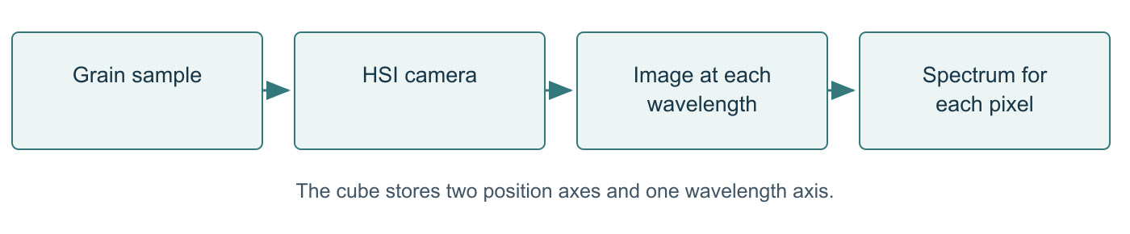
Diagram 1. Simplified hyperspectral measurement concept, based on [R1] and [R2].

Explanation of Diagram 1
- Grain sample: the physical material placed under controlled lighting.
- HSI camera: a camera that records many narrow wavelength bands. Each band shows how much light the sample reflects at that wavelength.
- Image at each wavelength: imagine stacking many images of the same scene. Together they form a data cube with height, width and wavelength dimensions.
- Spectrum for each pixel: choose one location in the image and read its reflectance across the bands. The resulting curve is that pixel’s spectrum.

Key ideas to explain aloud
- RGB usually supplies three broad colour channels. HSI supplies many narrow bands and can include invisible near infrared wavelengths.
- A wavelength tells us which part of the light spectrum we measured. Nanometres, written nm, are the unit used in the papers.
- Molecular bonds absorb light differently. The model learns statistical relationships between spectra and composition. A single peak does not uniquely measure protein.
- A spectrum is like a light response pattern. Similar patterns may indicate similar composition, but lighting, surface texture and other constituents can also affect it.
- The model predicts a continuous quantity, so this is a regression problem. Crop identification would be classification.

Important distinction
The papers mainly train on the mean spectrum of each physical sample. Although HSI records spatial information, these models do not automatically learn the full three dimensional cube. Pixel maps are a later application of the trained spectral model.

Image correction and sample preparation
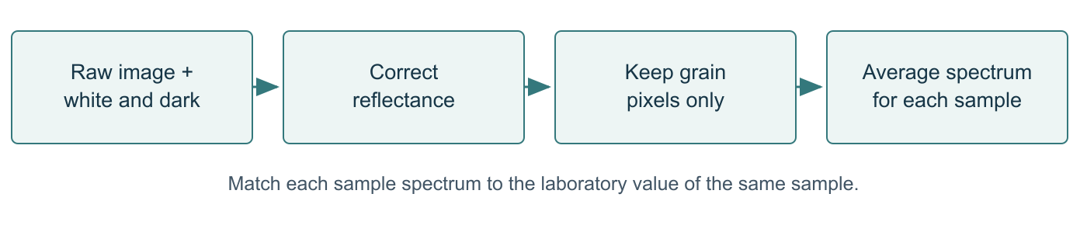
Diagram 2. Image preparation and sample spectrum extraction.

Explanation of Diagram 2
- Raw image plus references: collect the sample scan, a white reference and a dark reference using consistent acquisition settings.
- Correct reflectance: subtract the dark signal from the sample and divide by the white signal after dark subtraction. This reduces sensor offset and illumination effects.
- Keep grain pixels only: build a mask that excludes the tray and other background. ROI means region of interest.
- Average spectrum: average the retained pixels at each wavelength to create one spectral vector per sample. Join it to the correct laboratory label using sample_id.

What the papers actually used
- Rice [R1, p. 3]: 800 nm image, threshold 0.16, followed by masking. This threshold belongs to that acquisition setup and must not be assumed to work on our data.
- Sorghum [R2, pp. 2–5]: a circular ROI smaller than the dish, centred automatically. The paper removes 8 initial and 21 final bands, leaving 483 bands.
- Rice labels average three Kjeldahl measurements. Sorghum labels include protein and drying based moisture measurements. Laboratory measurements provide the reference, often called ground truth.

Checks we must implement
- Check for missing files, duplicate sample IDs, saturated pixels, invalid reference values and empty masks.
- Keep wavelength values and their order. A model expects the same number and meaning of bands at prediction time.
- Record whether input files already contain corrected reflectance. Avoid applying the correction twice.
- Inspect a few masks and spectra manually before training. A wrong mask can make the model learn the tray or lighting.

The simpler regression solution
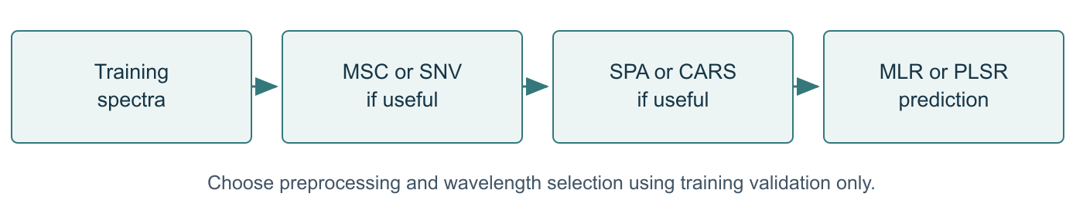
Diagram 3. Conventional modelling route. The exact method depends on validation results.

Explanation of Diagram 3
- Training spectra: start with matched sample spectra and laboratory values. Keep the final test set separate.
- MSC or SNV: reduce unwanted spectral differences caused by scattering and scale. Select a method only if training validation improves.
- SPA or CARS: select useful wavelengths and reduce redundant inputs. Selection must happen inside the training folds.
- MLR or PLSR: fit a mathematical relationship between selected spectral inputs and measured composition. Apply the saved pipeline to new samples.
Term | Plain meaning | Why it is useful
MSC | Multiplicative scatter correction | Adjusts a spectrum relative to a reference spectrum.
SNV | Standard normal variate | Centres and scales each individual spectrum.
First derivative | Change in reflectance along wavelength | Highlights changes and reduces baseline effects, but can amplify noise.
SG | Savitzky–Golay smoothing | Smooths a spectrum using local polynomial fitting.
SPA | Successive projections algorithm | Selects less redundant original wavelengths.
CARS | Competitive adaptive reweighted sampling | Selects variables using repeated model based selection.
MLR | Multiple linear regression | Combines inputs using learned coefficients.
PLSR | Partial least squares regression | Compresses correlated inputs using their relation to the target.
PCR | Principal component regression | Regresses the target on components formed from input variation.

Rice detail: the reported MSC–SPA route selects 11 wavelengths: 413, 423, 433, 457, 585, 720, 738, 766, 792, 805 and 917 nm. These are evidence from [R1, Table 2], not universal bands for every crop or sensor.

CLNet and deep learning
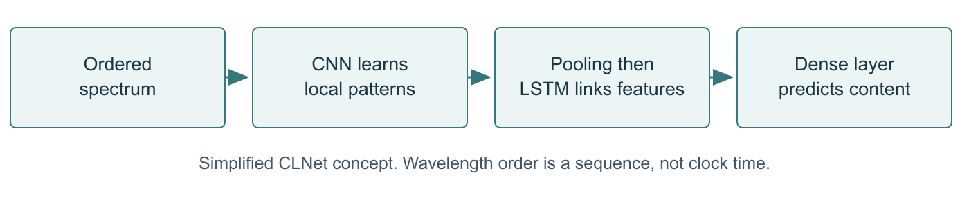
Diagram 4. A simplified conceptual explanation of CLNet [R2, Fig. 3].

Explanation of Diagram 4
- Ordered spectrum: reflectance measurements enter in wavelength order. In the sorghum paper there are 483 retained bands.
- CNN: filters scan nearby spectral values and learn useful local patterns. Different filters can respond to different shapes.
- Pooling: reduces the feature representation. LSTM: keeps and updates information while processing the feature sequence.
- Dense layer: combines learned features into a continuous protein or moisture estimate. The paper evaluates the two prediction tasks separately.

What each neural network term means
- Convolution: reuse a small filter across nearby positions to detect a pattern. A one dimensional CNN operates along a sequence.
- ReLU: an activation that outputs zero for negative inputs and keeps positive inputs. It helps the network learn nonlinear relationships.
- Batch normalization: normalizes intermediate activations using training statistics and learned adjustments.
- Max pooling: retains the strongest response within a local region. Adaptive average pooling creates a chosen output size.
- LSTM gates: the forget gate controls retained memory, the input gate controls new information, and the output gate controls the exposed hidden state.
- Fully connected layer: mixes the final features to produce the numeric output. Training adjusts weights to reduce prediction loss.

How to implement this honestly
The paper describes three CNN blocks with kernel sizes 7, 5 and 3, and an LSTM with hidden size 128. Some structural details are in missing supplementary tables, and the LSTM input description is ambiguous. We must document tensor dimensions and distinguish our implementation from an exact reproduction.
For a student prototype, preserve the wavelength sequence into the LSTM. In PyTorch notation, a CNN can use [batch, 1, bands], followed by features reshaped to [batch, sequence length, channels] for an LSTM with batch_first enabled. Do not accidentally reduce the sequence to one step and then claim long wavelength relationships.

What Group 2 has to build
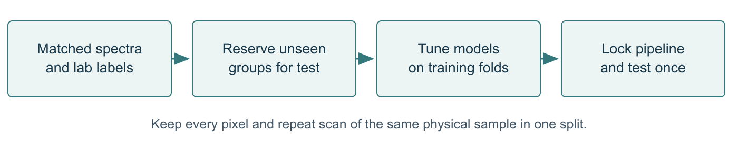
Diagram 5. Recommended training and evaluation workflow for Group 2.

Explanation of Diagram 5
- Matched data: collect one spectral record and the corresponding laboratory label for every independent sample. Record crop, variety, batch and acquisition conditions.
- Reserve unseen groups: hold out complete samples or batches before model selection. All pixels and repeated scans from one sample stay together.
- Tune models: compare a mean predictor, PLSR and optional MLR pipeline. Add CNN, LSTM and CLNet if data and time support the comparison.
- Lock and test: choose settings using training validation, fit on the development data, then evaluate on the untouched test set once. Report all relevant metrics.

Minimum achievable scope
- One grain type and protein prediction from real labelled spectra.
- A reproducible data loader, input validation, a PLSR baseline and held out evaluation.
- A simple interface that accepts a compatible spectrum and returns a labelled estimate.
- A report with data provenance, sample split, model settings, results and limitations.

Extensions if resources allow
- Add moisture only when genuine matched moisture labels exist.
- Compare CNN, LSTM and CLNet on exactly the same held out samples.
- Add pixel maps only if full cubes and appropriate masks are available.
- Test a new batch or variety and measure inference time on the actual computer.

If we cannot obtain the dataset
First ask the supervisor about an HSI facility and an existing labelled dataset. The rice paper says its data are confidential. The sorghum paper offers data on request, so access is possible but unconfirmed. An alternative labelled spectral dataset can support a clearly renamed experiment. Synthetic values can demonstrate interface operation, but cannot establish prediction accuracy.

Software modules and prediction flow
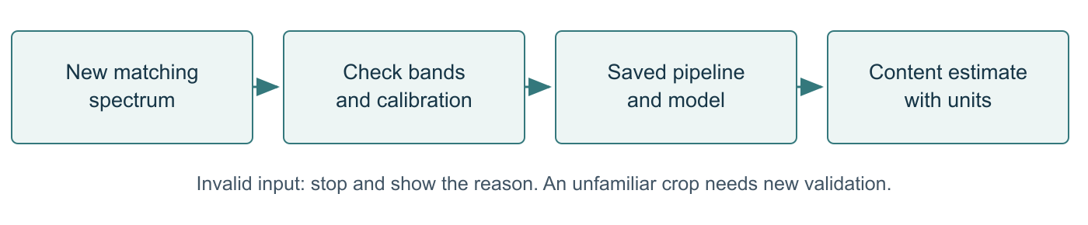
Diagram 6. Prediction workflow after training. Invalid input must stop before inference.

Explanation of Diagram 6
- New spectrum: obtain data from the same type of crop and compatible measurement process. A saved example can demonstrate this flow.
- Check input: validate dimensions, band order, wavelength coverage, missing values and calibration metadata. Reject incompatible input with a clear message.
- Saved pipeline: reuse the fitted preprocessing and model. Never refit them on a single uploaded sample.
- Estimate: show the target name and units, crop and model version. Include a suitability warning when input falls outside validated conditions.
Module | What we implement
Data loader | Read spectral arrays or a CSV of sample spectra and a label file.
Quality checks | Validate IDs, units, shapes, wavelength order and missing values.
Preparation | Correct raw cubes if required, mask grains and extract spectra.
Training | Fit baselines and optional neural networks with reproducible splits.
Evaluation | Save metrics, prediction tables and error plots for held out samples.
Prediction interface | Upload compatible input and display a numeric estimate.
Optional mapping | Predict each retained pixel and display an estimated colour map.

Suggested tools and records
A possible stack is Python with NumPy and pandas for data, scikit-learn for baselines, PyTorch for neural networks, and a small Streamlit interface. These are proposed implementation choices, not confirmed project software. Pin versions once the environment works.
Store sample_id, crop, variety, batch_id, spectrum_file, protein_g_per_100g and optional moisture_g_per_100g. Keep wavelength_nm in a shared metadata file. Also save the split IDs, random seeds, training configuration, model weights and prediction outputs.

Evaluation and published results

Metrics in simple words
- R² measures how predictions compare with using the observed mean. A value near 1 is better. It is not percentage classification accuracy, and it can be negative on poor predictions.
- RMSE is the square root of the average squared prediction error. Smaller is better. It has the same units as the target.
- MAE is the average absolute error. It is a useful extra metric for explaining typical error.
- RPD compares the spread of reference measurements with prediction error. State the exact definition used. It depends on the test set variation and does not prove universal reliability.
Published experiment | R² | RMSE | RPD
Rice MSC–SPA–MLR [R1] | 0.8998 | 0.1725 pp | 3.16
Sorghum protein PLSR [R2] | 0.9492 | 0.1199 g/100 g | 4.4364
Sorghum protein CNN [R2] | 0.9632 | 0.0933 g/100 g | 5.2115
Sorghum protein LSTM [R2] | 0.7204 | 0.2571 g/100 g | 1.8912
Sorghum protein CLNet [R2] | 0.9807 | 0.0676 g/100 g | 7.1949
Sorghum moisture PLSR [R2] | 0.9802 | 0.1165 g/100 g | 7.1134
Sorghum moisture CNN [R2] | 0.9864 | 0.0890 g/100 g | 8.5825
Sorghum moisture LSTM [R2] | 0.8155 | 0.3280 g/100 g | 2.3282
Sorghum moisture CLNet [R2] | 0.9983 | 0.0313 g/100 g | 24.3681

All values are published results, not Group 2 results. Rice uses its validation set; sorghum uses its prediction set. pp means percentage points on the reported percent protein scale. PLSR refers to SNV–SPA–PLSR for protein and first derivative–CARS–PLSR for moisture. Sources: [R1, Table 4] and [R2, Table 4].

Important source discrepancy
The sorghum abstract and conclusion report protein R² = 0.987, while Table 4 and Section 3.4 report 0.9807. These notes use Table 4 for consistency. Several prose improvement calculations also conflict with the table. Do not repeat them as verified calculations.
The external validation described in [R2, Section 3.5] reports protein R² = 0.9786, RMSE = 0.0657 and moisture R² = 0.999, RMSE = 0.026. These are separate results, not values from the original 48-sample prediction set.

Colour maps and limits of the solution

How a predicted colour map works
- Start with a corrected HSI cube and a grain mask.
- Read the spectrum of each grain pixel and run the saved model.
- Put each predicted value back at its original image position.
- Use a colour scale with units, where each colour corresponds to a predicted content range.
- Keep the same colour limits when comparing samples. Hide the background and show invalid pixels separately.

What the map does and does not establish
The colours are estimates produced by the model. They are not an ordinary colour photo or a separate laboratory measurement at each pixel. A model trained with a sample average label has not automatically been validated for chemical accuracy at every pixel. Local ground truth or additional validation would strengthen that claim.

Problem and solution pairs
Problem | Our proposed response
No HSI camera or labelled data | Use an accessible labelled spectral dataset or arrange laboratory access.
Expensive acquisition | Begin with existing spectra and a software prototype.
Small sample count | Use simple baselines, grouped validation and restrained model complexity.
Lighting and background errors | Calibrate, inspect masks and standardize the acquisition setup.
Overfitting or leakage | Keep test groups separate and fit preprocessing inside training folds.
Different crop or camera | Validate separately and retrain or recalibrate when needed.
No full image cubes | Deliver sample level estimates without claiming spatial maps.
Impossible output values | Flag unreliable outputs and inspect data or model issues. Avoid silently hiding errors.

Claims we can defend
This approach can support nondestructive screening after training and validation. Reference labels still require laboratory testing. The supplied studies do not establish a guaranteed low cost, universal accuracy, real time speed on our hardware, or replacement of every laboratory test. Our report should state the tested crop, range, batch conditions and sample count.

Every rice paper figure explained
Figure numbers below refer to Group 2_.pdf, the rice paper [R1]. Keep the source PDF open beside these notes when revising.
Figure 1 on page 2 Image processing flow
Panel a shows sample images. Panel b shows the calibrated image stack. Panel c shows a binary mask. Panel d keeps regions belonging to grains. Panel e shows spectra extracted from those regions. Explain it as “find the grain pixels, then read their light response.” The caption says barley, but the paper studies rice. Treat that as an apparent caption error.
Figure 2 on page 3 Average spectral curves
The horizontal axis is wavelength and the vertical axis is reflectance. Each curve summarizes one rice cultivar. Similar shapes show shared spectral behaviour, while differences can help a model. The plot alone does not prove that protein caused every difference.
Figure 3 on page 4 Preprocessing effects
The panels show spectra after MSC and derivative processing. MSC adjusts scatter related differences. A derivative emphasizes changes along wavelength. The best looking curves do not automatically produce the best predictions; model validation decides.
Figure 4 on page 4 SPA wavelength selection
The curves relate a selected subset size to error. The aim is a small, informative subset with low validation error. The paper reports 15 wavelengths for raw spectra, 11 for MSC and 10 for derivative spectra. This selection error is different from the final held out model error.
Figure 5 on page 5 CARS selection process
Across sampling runs, CARS removes variables and checks cross validation error. More removals do not always help. An intermediate subset may preserve useful information better than the smallest subset. Read the panels together as variable count, error and coefficient behaviour.
Figure 6 on page 5 Predicted versus reference protein
Each point compares a laboratory value with a model prediction. Points close to the equality line indicate small errors. Calibration and validation points represent different subsets. Look for scatter, bias and unusual points, not only the printed R².
Figure 7 on page 6 Individual grain maps
The figure pairs grain appearance with predicted protein colours. Read the colour bar to interpret content. The figure suggests spatial variation, but pixel estimates inherit the limitations of the trained model.
Figure 8 on page 6 Multiple grain maps
The model produces maps for many grains from the cultivars. Compare colours only using the displayed scale. The figure supports an explanation of spatial prediction, not an independent chemical measurement of every coloured location.

Every sorghum figure explained part one
Figure numbers below refer to Group 2.pdf, the sorghum paper [R2].
Figure 1 on page 4 One dimensional CNN
Three convolution blocks learn spectral features. Each block includes convolutional layers and max pooling. Average pooling and flattening prepare the features for fully connected layers. The final output is a content estimate. Explain a filter as a small pattern detector moving across a spectrum.
Figure 2 on page 4 LSTM cell
The input x enters alongside the previous hidden state. The forget gate chooses what old memory to retain. The input gate controls what new information enters the cell state. The output gate controls the hidden output. The repeated index describes sequence position; here we care about spectral ordering rather than elapsed time.
Figure 3 on page 4 CLNet structure
The CNN portion extracts local spectral patterns. Its processed features pass to an LSTM, and a fully connected part creates the prediction. The intended benefit is combining local pattern extraction with sequence relationships. Exact tensor shapes require care because the supplied description and missing supplement do not fully settle the implementation.
Figure 4 on page 6 Sorghum spectra
Panel a contains spectra for the 240 samples. Panel b contains the averages for the 12 varieties. The horizontal axis is wavelength in nm and the vertical axis is reflectance. Different compounds and physical conditions can influence the broad overlapping bands.
Figure 5 on page 7 Preprocessing comparison
Radar panels compare R² and RMSEP for preprocessing options used with PLSR. Higher R² is better, while lower RMSEP is better. Therefore a larger radar area does not always mean a better model. The selected preprocessing is SNV for protein and a first derivative for moisture.

How to explain a network diagram in the review
- Begin with the input and its dimensions. Explain what each stage changes.
- Point to the arrows to show the direction of data movement.
- Explain the final number, its units and how laboratory labels supervise training.
- Separate the conceptual diagram from unverified implementation details.

Every sorghum figure explained part two
Figure 6 on page 8 Feature extraction comparison
The radar plots compare feature extraction methods combined with the selected preprocessing and PLSR. SPA gives the preferred protein result and CARS gives the preferred moisture result in this experiment. PCA creates component features; it does not directly choose original wavelengths in the same way as SPA.
Figure 7 on page 9 Protein prediction plots
Panels a, b, c and d show SNV–SPA–PLSR, CNN, LSTM and CLNet. Each point compares a measured value with a predicted value. CLNet has the tightest reported fit. Use Table 4 for the numerical comparison and mention the abstract discrepancy if asked.
Figure 8 on page 9 Moisture prediction plots
The four panels compare first derivative–CARS–PLSR, CNN, LSTM and CLNet. The reference line represents equal predicted and measured values. CLNet reports the smallest prediction error, while LSTM alone is weaker in this experiment.
Figure 9 on page 10 Protein distribution maps
The paper visualizes 12 sorghum varieties using pixel predictions. Cooler colours show lower estimates and warmer colours higher estimates on its colour bar. Discuss them as model predicted distribution maps. A high protein estimate is not automatically the best value for every end use.
Figure 10 on page 10 Moisture distribution maps
The images show estimated moisture distributions across the same set of varieties. The observed pattern differs from the protein maps. This does not establish a universal inverse relationship between moisture and protein in all sorghum.

Supplementary material mentioned but not supplied
- Supplementary Figure S1: sample preparation and dish arrangement.
- Supplementary Figure S2: automated ROI extraction.
- Supplementary Figure S3: spectra from external validation samples.
- Supplementary Figure S4: external validation prediction results.
- Supplementary Table S1: detailed CNN structural parameters.
The descriptions above come from the main paper’s references to supplementary material. The actual supplementary images and tables are absent from the supplied PDFs, so their detailed contents cannot be independently inspected here.

Work plan and presentation preparation
The following six week schedule and responsibility split are suggestions. Confirm them with your supervisor and adjust to the submission deadline.
Week | Work | Evidence to produce
1 | Confirm crop, target and dataset access | Scope note and sample metadata inventory
2 | Load data and inspect spectra and masks | Clean sample list and fixed split IDs
3 | Train mean, PLSR and optional MLR baselines | Validation metrics and saved pipelines
4 | Add CNN, LSTM and CLNet if feasible | Comparable runs with documented dimensions
5 | Evaluate and build the demonstration | Held out predictions and interface
6 | Complete report and rehearse | Final slides, limitations and viva practice

Member | Suggested primary responsibility
Abhay Kumar | Data pipeline, scope explanation and demonstration integration
Mihir Karsale | Baseline models, metrics and fair model comparison
Ayush Tiwari | Neural model experiments, visualization and presentation assembly
All members | Check results, understand the whole workflow and rehearse counter questions

Demonstration checklist
- Show the source and format of a real sample spectrum. Explain its matching laboratory label.
- Load a saved model and produce one estimate with units.
- Show an invalid input and the validation message.
- Show held out predictions and errors, not only a successful individual example.
- If using a prepared recording or synthetic demo, label it clearly.
- Keep a working local backup and record model and data versions.

One minute project introduction
“Good morning. We are Group 2: Abhay Kumar, Mihir Karsale and Ayush Tiwari. Our proposed minor project studies grain quality prediction using hyperspectral imaging. Laboratory tests provide reliable labels but take time and can destroy the tested sample. We plan to learn the relationship between grain spectra and protein content, with moisture as an optional extension. We will first build a regression baseline, then compare a CNN and LSTM based CLNet model if suitable data are available. We will evaluate on unseen samples and report the limits of the system honestly.”

Viva questions on the main idea
1. What is the project in one sentence?
We use hyperspectral measurements and a regression model to estimate grain protein, with moisture as an optional labelled target.
2. What problem does it solve?
It explores faster nondestructive screening after a model has learned from paired spectral and laboratory measurements.
3. Why not use an ordinary camera?
RGB images do not provide the narrow spectral bands used in these studies. An RGB approach would need a separate dataset, method and validation.
4. Is this classification or regression?
Regression, because the output is a continuous content value. Predicting a grain class would be classification.
5. Why are laboratory measurements still necessary?
They provide training and evaluation labels. Nondestructive prediction does not eliminate the need to build and check the calibration.
6. What is your input and output?
The core input is a calibrated spectrum with known band order. The output is a content estimate in percent or g/100 g. Full cubes permit optional maps.
7. What is the novelty of your project?
Our proposed contribution is a reproducible student implementation, fair model comparison and usable demonstration. CLNet itself belongs to the paper authors.
8. Have you achieved the paper’s accuracy?
No Group 2 results were supplied. We must report our measured results after implementation and testing, separately from literature values.
9. Which crop will you use?
The proposed minimum scope is one crop with accessible labelled spectra. The final choice depends on data access; we will not silently mix rice and sorghum.
10. Can this replace all chemical tests?
The cited work supports prediction under tested conditions. Replacement for a particular application needs acceptable error limits and independent validation.

Viva questions on data and models
11. What is a hyperspectral cube?
A data array with two spatial dimensions and a wavelength dimension. Each pixel contains a spectrum.
12. What is an ROI and why remove background?
ROI means region of interest. Removing the tray keeps the model focused on grain spectra and reduces irrelevant signals.
13. Why use white and dark references?
They correct illumination scaling and sensor dark response. We also check whether supplied data have already been corrected.
14. Why PLSR before deep learning?
PLSR is a useful baseline for correlated spectral inputs and a small sample count. A complex model must demonstrate improvement on the same unseen data.
15. What is the difference between SPA and PCA?
SPA selects original wavelengths with less redundancy. PCA transforms inputs into new component features based on variance.
16. Why combine CNN and LSTM?
CNN detects local patterns. LSTM can connect information across an ordered feature sequence. The benefit must be verified experimentally.
17. Why use LSTM if this is not time series data?
An LSTM processes ordered sequences. Here the meaningful order comes from wavelengths or derived features, not time.
18. Does CLNet need no preprocessing at all?
The paper omits additional spectral preprocessing and feature selection for deep models. It still corrects images, extracts ROI spectra and removes noisy edge bands.
19. What causes overfitting?
The model may memorize patterns specific to a small training set. Use simpler models, validation, early stopping and independent test groups.
20. What is data leakage?
It is information from test samples entering training or model selection. Splitting pixels from the same physical sample across sets is one example.

Viva questions on results and challenges
21. Does R² = 0.98 mean 98 percent accuracy?
No. It describes a regression fit relative to variation in measured values. We also need errors in meaningful units.
22. What does an error of 0.2 mean for a percent target?
An absolute difference between 8.0 percent and 8.2 percent is 0.2 percentage points. RMSE summarizes squared errors over many samples.
23. Why is high RPD not enough?
RPD depends on sample spread and the error definition. Report the test design, units, bias and error distribution as well.
24. Can you compare rice R² with sorghum R² directly?
The datasets, targets, spectral ranges and test conditions differ. Compare methods fairly on the same target and held out samples.
25. Why does the paper give two protein R² values?
Its abstract says 0.987 and Table 4 says 0.9807. We use the table value and flag the discrepancy rather than guessing the intended number.
26. Is every heatmap pixel chemically verified?
No. Applying a model trained on sample averages to pixels creates estimates. Pixel level truth would require additional validation.
27. What if you have no camera or dataset?
We first seek existing labelled spectra or laboratory access. Without real matched labels, we can demonstrate software flow but cannot claim scientific accuracy.
28. What if the model fails on a new variety?
That is a generalization limit. Record the failure, collect representative labelled samples and evaluate a revised model on another untouched set.
29. What if PLSR beats CLNet in your experiment?
We report it. For our data, a simpler model may be the better solution. Deep learning superiority is an experimental question.
30. Can you claim real time and low cost?
Only after measuring end to end acquisition and inference time, and documenting actual equipment costs. The current plan makes no such measured claim.

Final revision and references

Additional counter questions to rehearse
- How many independent physical samples do you have, and why is that different from the pixel count?
- Which operations learn parameters, and exactly where are they fitted during cross validation?
- What are the tensor shapes before the CNN, before the LSTM and at the output?
- What does your baseline predict, and how much does your chosen model improve its error?
- What protein and moisture ranges appear in training, and what happens outside those ranges?
- What part did each member actually implement? Show the relevant module and explain one design choice.
- How would you test a different camera, harvest year or batch?
- What evidence would demonstrate that a predicted heatmap is locally reliable?

Terms to remember
HSI: hyperspectral imaging. NIR: near infrared. ROI: region of interest. ML: machine learning. DL: deep learning. CNN: convolutional neural network. LSTM: long short term memory. FC: fully connected. SPXY: sample partitioning using joint spectral and target distances. Calibration: model fitting data in these papers. Prediction or validation set: held out evaluation data, using the authors’ terminology.

References and evidence boundaries
[R1] Xuan, G., Jia, H., Shao, Y., and Shi, C. (2024). Protein content prediction of rice grains based on hyperspectral imaging. Spectrochimica Acta Part A: Molecular and Biomolecular Spectroscopy, 320, 124589. https://doi.org/10.1016/j.saa.2024.124589. Supplied file: Group 2_.pdf, 7 pages.
[R2] Hu, X., et al. (2025). CLNet: A fusion network capturing spectral features and wavelength relationships for predicting sorghum protein and moisture content. Journal of Food Composition and Analysis, 142, 107412. https://doi.org/10.1016/j.jfca.2025.107412. Supplied file: Group 2.pdf, 12 pages.
Published methods, sample counts and results are attributed to these papers. The six simplified diagrams are explanatory redrawings. The proposed scope, software modules, split strategy, six week schedule, role allocation and viva answers are study guidance for Group 2, not evidence of completed experiments.
Other source cautions: the rice text contains a contradictory cultivar ranking sentence, so these notes do not repeat it as a reliable ranking. RPD conventions and some reported numerical relationships differ within the papers. Compute our metrics directly from our own saved predictions using one documented definition.

