next →← pr

Java Swing
Java Swing is a part of Java Foundation Classes (JFC) that is used to create window-based applications. It is built on the top of AWT (Abstract Windowing Toolkit) API and entirely written in java.
Unlike AWT, Java Swing provides platform-independent and lightweight components.
The javax.swing package provides classes for java swing API such as JButton, JTextField, JTextArea, JRadioButton, JCheckbox, JMenu, JColorChooser etc.

Difference between AWT and Swing
There are many differences between java awt and swing that are given below.
No. | Java AWT | Java Swing
1) | AWT components are platform-dependent. | Java swing components are platform-independent.
2) | AWT components are heavyweight. | Swing components are lightweight.
3) | AWT doesn't support pluggable look and feel. | Swing supports pluggable look and feel.
4) | AWT provides less components than Swing. | Swing provides more powerful components such as tables, lists, scrollpanes, colorchooser, tabbedpane etc.
5) | AWT doesn't follows MVC(Model View Controller) where model represents data, view represents presentation and controller acts as an interface between model and view. | Swing follows MVC.

Hierarchy of Java Swing classes
The hierarchy of java swing API is given below.
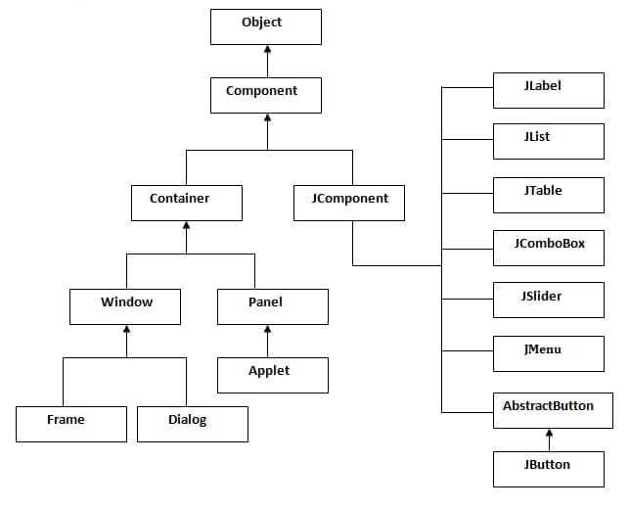

Commonly used Methods of Component class
The methods of Component class are widely used in java swing that are given below.
Method | Description
public void add(Component c) | add a component on another component.
public void setSize(int width,int height) | sets size of the component.
public void setLayout(LayoutManager m) | sets the layout manager for the component.
public void setVisible(boolean b) | sets the visibility of the component. It is by default false.

Java Swing Examples
There are two ways to create a frame:
- By creating the object of Frame class (association)
- By extending Frame class (inheritance)
We can write the code of swing inside the main(), constructor or any other method.

Simple Java Swing Example
Let's see a simple swing example where we are creating one button and adding it on the JFrame object inside the main() method.
File: FirstSwingExample.java

import javax.swing.*;
public class FirstSwingExample {
public static void main(String[] args) {
JFrame f=new JFrame();//creating instance of JFrame

JButton b=new JButton("click");//creating instance of JButton
b.setBounds(130,100,100, 40);//x axis, y axis, width, height

f.add(b);//adding button in JFrame

f.setSize(400,500);//400 width and 500 height
f.setLayout(null);//using no layout managers
f.setVisible(true);//making the frame visible
}
}

- 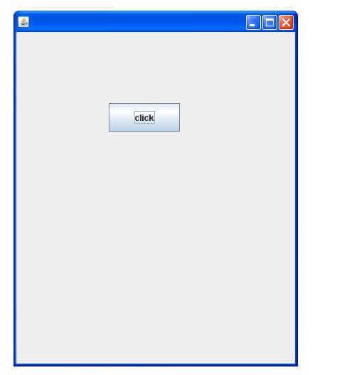

Example of Swing by Association inside constructor
We can also write all the codes of creating JFrame, JButton and method call inside the java constructor.
File: Simple.java

- import javax.swing.*;
- public class Simple {
- JFrame f;
- Simple(){
- f=new JFrame();//creating instance of JFrame

- JButton b=new JButton("click");//creating instance of JButton
- b.setBounds(130,100,100, 40);

- f.add(b);//adding button in JFrame

- f.setSize(400,500);//400 width and 500 height
- f.setLayout(null);//using no layout managers
- f.setVisible(true);//making the frame visible
- }

- public static void main(String[] args) {
- new Simple();
- }
- }
The setBounds(int xaxis, int yaxis, int width, int height)is used in the above example that sets the position of the button.

Simple example of Swing by inheritance
We can also inherit the JFrame class, so there is no need to create the instance of JFrame class explicitly.
File: Simple2.java
- import javax.swing.*;
- public class Simple2 extends JFrame{//inheriting JFrame
- JFrame f;
- Simple2(){
- JButton b=new JButton("click");//create button
- b.setBounds(130,100,100, 40);

- add(b);//adding button on frame
- setSize(400,500);
- setLayout(null);
- setVisible(true);
- }
- public static void main(String[] args) {
- new Simple2();
- }}

Java JButton
The JButton class is used to create a labeled button that has platform independent implementation. The application result in some action when the button is pushed. It inherits AbstractButton class.

JButton class declaration
Let's see the declaration for javax.swing.JButton class.
- public class JButton extends AbstractButton implements Accessible

Commonly used Constructors:
Constructor | Description
JButton() | It creates a button with no text and icon.
JButton(String s) | It creates a button with the specified text.
JButton(Icon i) | It creates a button with the specified icon object.

Commonly used Methods of AbstractButton class:
Methods | Description
void setText(String s) | It is used to set specified text on button
String getText() | It is used to return the text of the button.
void setEnabled(boolean b) | It is used to enable or disable the button.
void setIcon(Icon b) | It is used to set the specified Icon on the button.
Icon getIcon() | It is used to get the Icon of the button.
void setMnemonic(int a) | It is used to set the mnemonic on the button.
void addActionListener(ActionListener a) | It is used to add the action listener to this object.

Java JButton Example

import javax.swing.*;
public class ButtonExample {
public static void main(String[] args) {
JFrame f=new JFrame("Button Example");
JButton b=new JButton("Click Here");
b.setBounds(50,100,95,30);
f.add(b);
f.setSize(400,400);
f.setLayout(null);
f.setVisible(true);
}
}

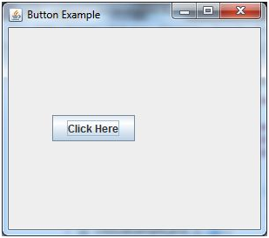

Java JButton Example with ActionListener

- import java.awt.event.*;
- import javax.swing.*;
- public class ButtonExample {
- public static void main(String[] args) {
- JFrame f=new JFrame("Button Example");
- final JTextField tf=new JTextField();
- tf.setBounds(50,50, 150,20);
- JButton b=new JButton("Click Here");
- b.setBounds(50,100,95,30);
- b.addActionListener(new ActionListener(){
- public void actionPerformed(ActionEvent e){
- tf.setText("Welcome to Javatpoint.");
- }
- });
- f.add(b);f.add(tf);
- f.setSize(400,400);
- f.setLayout(null);
- f.setVisible(true);
- }
- }

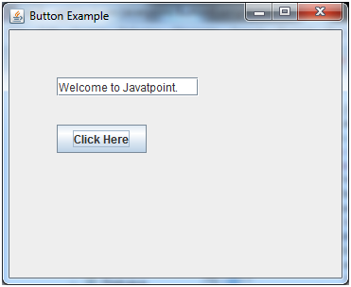

Example of displaying image on the button:

import javax.swing.*;
public class ButtonExample{
ButtonExample(){
JFrame f=new JFrame("Button Example");
JButton b=new JButton(new ImageIcon("D:\\icon.png"));
b.setBounds(100,100,100, 40);
f.add(b);
f.setSize(300,400);
f.setLayout(null);
f.setVisible(true);
f.setDefaultCloseOperation(JFrame.EXIT_ON_CLOSE);
}
public static void main(String[] args) {
new ButtonExample();
}
}

Output:
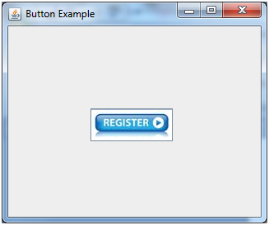

Java JLabel
The object of JLabel class is a component for placing text in a container. It is used to display a single line of read only text. The text can be changed by an application but a user cannot edit it directly. It inherits JComponent class.

JLabel class declaration
Let's see the declaration for javax.swing.JLabel class.
public class JLabel extends JComponent implements SwingConstants, Accessible
Methods | Description
String getText() | t returns the text string that a label displays.
void setText(String text) | It defines the single line of text this component will display.
void setHorizontalAlignment(int alignment) | It sets the alignment of the label's contents along the X axis.
Icon getIcon() | It returns the graphic image that the label displays.
int getHorizontalAlignment() | It returns the alignment of the label's contents along the X axis.

Commonly used Constructors:
Constructor | Description
JLabel() | Creates a JLabel instance with no image and with an empty string for the title.
JLabel(String s) | Creates a JLabel instance with the specified text.
JLabel(Icon i) | Creates a JLabel instance with the specified image.
JLabel(String s, Icon i, int horizontalAlignment) | Creates a JLabel instance with the specified text, image, and horizontal alignment.

Commonly used

Java JLabel Example
import javax.swing.*;
class LabelExample
{
public static void main(String args[])
{
JFrame f= new JFrame("Label Example");
JLabel l1,l2;
l1=new JLabel("First Label.");
l1.setBounds(50,50, 100,30);
l2=new JLabel("Second Label.");
l2.setBounds(50,100, 100,30);
f.add(l1); f.add(l2);
f.setSize(300,300);
f.setLayout(null);
f.setVisible(true);
}
}

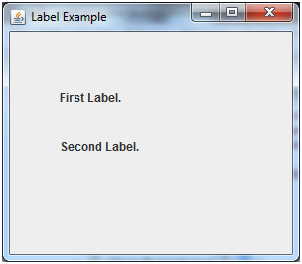

Java JLabel Example with ActionListener

- import javax.swing.*;
- import java.awt.*;
- import java.awt.event.*;
- public class LabelExample extends Frame implements ActionListener{
- JTextField tf; JLabel l; JButton b;
- LabelExample(){
- tf=new JTextField();
- tf.setBounds(50,50, 150,20);
- l=new JLabel();
- l.setBounds(50,100, 250,20);
- b=new JButton("Find IP");
- b.setBounds(50,150,95,30);
- b.addActionListener(this);
- add(b);add(tf);add(l);
- setSize(400,400);
- setLayout(null);
- setVisible(true);
- }
- public void actionPerformed(ActionEvent e) {
- try{
- String host=tf.getText();
- String ip=java.net.InetAddress.getByName(host).getHostAddress();
- l.setText("IP of "+host+" is: "+ip);
- }catch(Exception ex){System.out.println(ex);}
- }
- public static void main(String[] args) {
- new LabelExample();
- } }

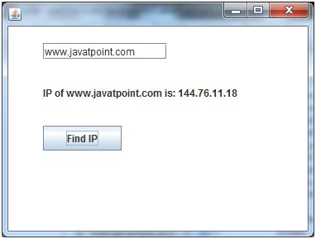

Java JComboBox
The object of Choice class is used to show popup menu of choices. Choice selected by user is shown on the top of a menu. It inherits JComponent class.

JComboBox class declaration
Let's see the declaration for javax.swing.JComboBox class.
public class JComboBox extends JComponent implements ItemSelectable, ListDataListener, ActionListener, Accessible

Commonly used Constructors:

Constructor | Description
JComboBox() | Creates a JComboBox with a default data model.
JComboBox(Object[] items) | Creates a JComboBox that contains the elements in the specified array.
JComboBox(Vector<?> items) | Creates a JComboBox that contains the elements in the specified Vector.

Commonly used Methods:

Methods | Description
void addItem(Object anObject) | It is used to add an item to the item list.
void removeItem(Object anObject) | It is used to delete an item to the item list.
void removeAllItems() | It is used to remove all the items from the list.
void setEditable(boolean b) | It is used to determine whether the JComboBox is editable.
void addActionListener(ActionListener a) | It is used to add the ActionListener.
void addItemListener(ItemListener i) | It is used to add the ItemListener.

Java JComboBox Example
import javax.swing.*;
public class ComboBoxExample {
JFrame f;
ComboBoxExample(){
f=new JFrame("ComboBox Example");
String country[]={"India","Aus","U.S.A","England","Newzealand"};
JComboBox cb=new JComboBox(country);
cb.setBounds(50, 50,90,20);
f.add(cb);
f.setLayout(null);
f.setSize(400,500);
f.setVisible(true);
}
public static void main(String[] args) {
new ComboBoxExample();
}
}

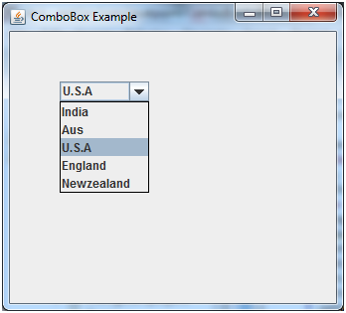

Java JComboBox Example with ActionListener

- import javax.swing.*;
- import java.awt.event.*;
- public class ComboBoxExample {
- JFrame f;
- ComboBoxExample(){
- f=new JFrame("ComboBox Example");
- final JLabel label = new JLabel();
- label.setHorizontalAlignment(JLabel.CENTER);
- label.setSize(400,100);
- JButton b=new JButton("Show");
- b.setBounds(200,100,75,20);
- String languages[]={"C","C++","C#","Java","PHP"};
- final JComboBox cb=new JComboBox(languages);
- cb.setBounds(50, 100,90,20);
- f.add(cb); f.add(label); f.add(b);
- f.setLayout(null);
- f.setSize(350,350);
- f.setVisible(true);
- b.addActionListener(new ActionListener() {
- public void actionPerformed(ActionEvent e) {
- String data = "Programming language Selected: "
- + cb.getItemAt(cb.getSelectedIndex());
- label.setText(data);
- }
- });
- }
- public static void main(String[] args) {
- new ComboBoxExample();
- }
- }

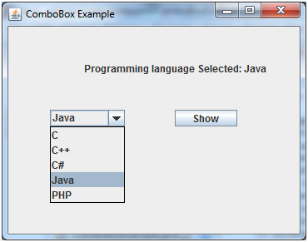

Java JTable
The JTable class is used to display data in tabular form. It is composed of rows and columns.

JTable class declaration
Let's see the declaration for javax.swing.JTable class.

Commonly used Constructors:

Constructor | Description
JTable() | Creates a table with empty cells.
JTable(Object[][] rows, Object[] columns) | Creates a table with the specified data.
import javax.swing.*;
public class TableExample {
JFrame f;
TableExample(){
f=new JFrame();
String data[][]={ {"101","Amit","670000"},
{"102","Jai","780000"},
{"101","Sachin","700000"}};
String column[]={"ID","NAME","SALARY"};
JTable jt=new JTable(data,column);
jt.setBounds(30,40,200,300);
JScrollPane sp=new JScrollPane(jt);
f.add(sp);
f.setSize(300,400);
f.setVisible(true);
}
public static void main(String[] args) {
new TableExample();
}
}

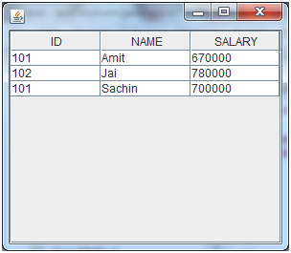

Java JTable Example with ListSelectionListener

import javax.swing.*;
import javax.swing.event.*;
public class TableExample {
public static void main(String[] a) {
JFrame f = new JFrame("Table Example");
String data[][]={ {"101","Amit","670000"},
{"102","Jai","780000"},
{"101","Sachin","700000"}};
String column[]={"ID","NAME","SALARY"};
final JTable jt=new JTable(data,column);
jt.setCellSelectionEnabled(true);
ListSelectionModel select= jt.getSelectionModel();
select.setSelectionMode(ListSelectionModel.SINGLE_SELECTION);
select.addListSelectionListener(new ListSelectionListener() {
public void valueChanged(ListSelectionEvent e) {
String Data = null;
int[] row = jt.getSelectedRows();
int[] columns = jt.getSelectedColumns();
for (int i = 0; i < row.length; i++) {
for (int j = 0; j < columns.length; j++) {
Data = (String) jt.getValueAt(row[i], columns[j]);
} }
System.out.println("Table element selected is: " + Data);
}
});
JScrollPane sp=new JScrollPane(jt);
f.add(sp);
f.setSize(300, 200);
f.setVisible(true);
}
}

Java JList
The object of JList class represents a list of text items. The list of text items can be set up so that the user can choose either one item or multiple items. It inherits JComponent class.

JList class declaration
Let's see the declaration for javax.swing.JList class.
- public class JList extends JComponent implements Scrollable, Accessible

Commonly used Constructors:
Constructor | Description
JList() | Creates a JList with an empty, read-only, model.
JList(ary[] listData) | Creates a JList that displays the elements in the specified array.
JList(ListModel<ary> dataModel) | Creates a JList that displays elements from the specified, non-null, model.

Commonly used Methods:

Methods | Description
Void addListSelectionListener(ListSelectionListener listener) | It is used to add a listener to the list, to be notified each time a change to the selection occurs.
int getSelectedIndex() | It is used to return the smallest selected cell index.
ListModel getModel() | It is used to return the data model that holds a list of items displayed by the JList component.
void setListData(Object[] listData) | It is used to create a read-only ListModel from an array of objects.

Java JList Example

- import javax.swing.*;
- public class ListExample
- {
ListExample(){
JFrame f= new JFrame();
DefaultListModel<String> l1 = new DefaultListModel<>();
l1.addElement("Item1");
l1.addElement("Item2");
l1.addElement("Item3");
l1.addElement("Item4");
JList<String> list = new JList<>(l1);
list.setBounds(100,100, 75,75);
f.add(list);
f.setSize(400,400);
f.setLayout(null);
f.setVisible(true);
}
public static void main(String args[])
{
new ListExample();
}}

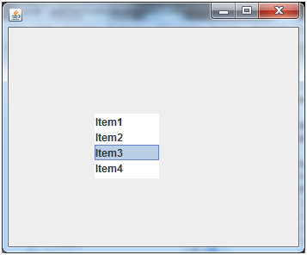

Java JList Example with ActionListener

- import javax.swing.*;
- import java.awt.event.*;
- public class ListExample
- {
- ListExample(){
- JFrame f= new JFrame();
- final JLabel label = new JLabel();
- label.setSize(500,100);
- JButton b=new JButton("Show");
- b.setBounds(200,150,80,30);
- final DefaultListModel<String> l1 = new DefaultListModel<>();
- l1.addElement("C");
- l1.addElement("C++");
- l1.addElement("Java");
- l1.addElement("PHP");
- final JList<String> list1 = new JList<>(l1);
- list1.setBounds(100,100, 75,75);
- DefaultListModel<String> l2 = new DefaultListModel<>();
- l2.addElement("Turbo C++");
- l2.addElement("Struts");
- l2.addElement("Spring");
- l2.addElement("YII");
- final JList<String> list2 = new JList<>(l2);
- list2.setBounds(100,200, 75,75);
- f.add(list1); f.add(list2); f.add(b); f.add(label);
- f.setSize(450,450);
- f.setLayout(null);
- f.setVisible(true);
- b.addActionListener(new ActionListener() {
- public void actionPerformed(ActionEvent e) {
- String data = "";
- if (list1.getSelectedIndex() != -1) {
- data = "Programming language Selected: " + list1.getSelectedValue();
- label.setText(data);
- }
- if(list2.getSelectedIndex() != -1){
- data += ", FrameWork Selected: ";
- for(Object frame :list2.getSelectedValues()){
- data += frame + " ";
- }
- }
- label.setText(data);
- }
- });
- }
- public static void main(String args[])
- {
- new ListExample();
- }}

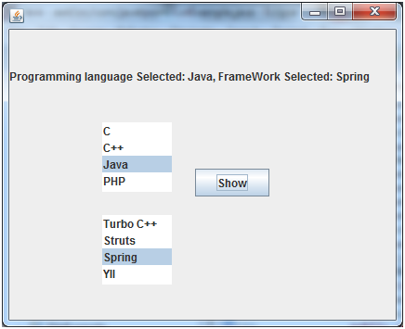

Java JOptionPane
The JOptionPane class is used to provide standard dialog boxes such as message dialog box, confirm dialog box and input dialog box. These dialog boxes are used to display information or get input from the user. The JOptionPane class inherits JComponent class.

JOptionPane class declaration
- public class JOptionPane extends JComponent implements Accessible

Common Constructors of JOptionPane class

Constructor | Description
JOptionPane() | It is used to create a JOptionPane with a test message.
JOptionPane(Object message) | It is used to create an instance of JOptionPane to display a message.
JOptionPane(Object message, int messageType | It is used to create an instance of JOptionPane to display a message with specified message type and default options.

Common Methods of JOptionPane class

Methods | Description
JDialog createDialog(String title) | It is used to create and return a new parentless JDialog with the specified title.
static void showMessageDialog(Component parentComponent, Object message) | It is used to create an information-message dialog titled "Message".
static void showMessageDialog(Component parentComponent, Object message, String title, int messageType) | It is used to create a message dialog with given title and messageType.
static int showConfirmDialog(Component parentComponent, Object message) | It is used to create a dialog with the options Yes, No and Cancel; with the title, Select an Option.
static String showInputDialog(Component parentComponent, Object message) | It is used to show a question-message dialog requesting input from the user parented to parentComponent.
void setInputValue(Object newValue) | It is used to set the input value that was selected or input by the user.

Java JOptionPane Example: showMessageDialog()

import javax.swing.*;
public class OptionPaneExample {
JFrame f;
OptionPaneExample(){
f=new JFrame();
JOptionPane.showMessageDialog(f,"Hello, Welcome to Javatpoint.");
}
public static void main(String[] args) {
new OptionPaneExample();
}
}

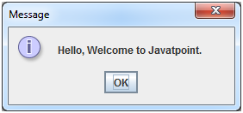

Java JOptionPane Example: showMessageDialog()

- import javax.swing.*;
- public class OptionPaneExample {
- JFrame f;
- OptionPaneExample(){
- f=new JFrame();
- JOptionPane.showMessageDialog(f,"Successfully Updated.","Alert",JOptionPane.WARNING_MESSAGE);
- }
- public static void main(String[] args) {
- new OptionPaneExample();
- }
- }

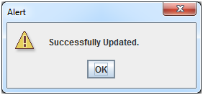

Java JOptionPane Example: showInputDialog()

import javax.swing.*;
public class OptionPaneExample {
JFrame f;
OptionPaneExample(){
f=new JFrame();
String name=JOptionPane.showInputDialog(f,"Enter Name");
}
public static void main(String[] args) {
new OptionPaneExample();
}
}

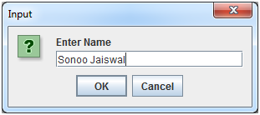

Java JOptionPane Example: showConfirmDialog()

- import javax.swing.*;
- import java.awt.event.*;
- public class OptionPaneExample extends WindowAdapter{
- JFrame f;
- OptionPaneExample(){
- f=new JFrame();
- f.addWindowListener(this);
- f.setSize(300, 300);
- f.setLayout(null);
- f.setDefaultCloseOperation(JFrame.DO_NOTHING_ON_CLOSE);
- f.setVisible(true);
- }
- public void windowClosing(WindowEvent e) {
- int a=JOptionPane.showConfirmDialog(f,"Are you sure?");
- if(a==JOptionPane.YES_OPTION){
- f.setDefaultCloseOperation(JFrame.EXIT_ON_CLOSE);
- }
- }
- public static void main(String[] args) {
- new OptionPaneExample();
- }
- }

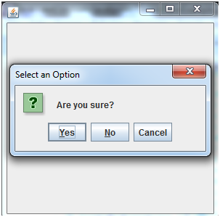

Java JScrollPane
A JscrollPane is used to make scrollable view of a component. When screen size is limited, we use a scroll pane to display a large component or a component whose size can change dynamically.

Constructors
Constructor | Purpose
JScrollPane() | It creates a scroll pane. The Component parameter, when present, sets the scroll pane's client. The two int parameters, when present, set the vertical and horizontal scroll bar policies (respectively).
JScrollPane(Component)
JScrollPane(int, int)
JScrollPane(Component, int, int)

Useful Methods
Modifier | Method | Description
void | setColumnHeaderView(Component) | It sets the column header for the scroll pane.
void | setRowHeaderView(Component) | It sets the row header for the scroll pane.
void | setCorner(String, Component) | It sets or gets the specified corner. The int parameter specifies which corner and must be one of the following constants defined in ScrollPaneConstants: UPPER_LEFT_CORNER, UPPER_RIGHT_CORNER, LOWER_LEFT_CORNER, LOWER_RIGHT_CORNER, LOWER_LEADING_CORNER, LOWER_TRAILING_CORNER, UPPER_LEADING_CORNER, UPPER_TRAILING_CORNER.
Component | getCorner(String)
void | setViewportView(Component) | Set the scroll pane's client.

JScrollPane Example
import java.awt.FlowLayout;
import javax.swing.JFrame;
import javax.swing.JScrollPane;
import javax.swing.JtextArea;

public class JScrollPaneExample {
private static final long serialVersionUID = 1L;

private static void createAndShowGUI() {

// Create and set up the window.
final JFrame frame = new JFrame("Scroll Pane Example");

// Display the window.
frame.setSize(500, 500);
frame.setVisible(true);
frame.setDefaultCloseOperation(JFrame.EXIT_ON_CLOSE);

// set flow layout for the frame
frame.getContentPane().setLayout(new FlowLayout());

JTextArea textArea = new JTextArea(20, 20);
JScrollPane scrollableTextArea = new JScrollPane(textArea);

scrollableTextArea.setHorizontalScrollBarPolicy(JScrollPane.HORIZONTAL_SCROLLBAR_ALWAYS);
scrollableTextArea.setVerticalScrollBarPolicy(JScrollPane.VERTICAL_SCROLLBAR_ALWAYS);

frame.getContentPane().add(scrollableTextArea);
}
public static void main(String[] args) {

javax.swing.SwingUtilities.invokeLater(new Runnable() {

public void run() {
createAndShowGUI();
}
});
}
}

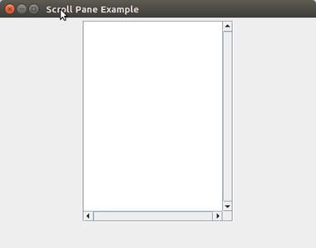

Java JSplitPane
JSplitPane is used to divide two components. The two components are divided based on the look and feel implementation, and they can be resized by the user. If the minimum size of the two components is greater than the size of the split pane, the divider will not allow you to resize it.
The two components in a split pane can be aligned left to right using JSplitPane.HORIZONTAL_SPLIT, or top to bottom using JSplitPane.VERTICAL_SPLIT. When the user is resizing the components the minimum size of the components is used to determine the maximum/minimum position the components can be set to.

Nested Class
Modifier and Type | Class | Description
protected class | JSplitPane.AccessibleJSplitPane | This class implements accessibility support for the JsplitPane class.

Useful Fields
Modifier and Type | Field | Description
static String | BOTTOM | It use to add a Component below the other Component.
static String | CONTINUOUS_LAYOUT_PROPERTY | Bound property name for continuousLayout.
static String | DIVIDER | It uses to add a Component that will represent the divider.
static int | HORIZONTAL_SPLIT | Horizontal split indicates the Components are split along the x axis.
protected int | lastDividerLocation | Previous location of the split pane.
protected Component | leftComponent | The left or top component.
static int | VERTICAL_SPLIT | Vertical split indicates the Components are split along the y axis.
protected Component | rightComponent | The right or bottom component.
protected int | orientation | How the views are split.

Constructors
Constructor | Description
JSplitPane() | It creates a new JsplitPane configured to arrange the child components side-by-side horizontally, using two buttons for the components.
JSplitPane(int newOrientation) | It creates a new JsplitPane configured with the specified orientation.
JSplitPane(int newOrientation, boolean newContinuousLayout) | It creates a new JsplitPane with the specified orientation and redrawing style.
JSplitPane(int newOrientation, boolean newContinuousLayout, Component newLeftComponent, Component newRightComponent) | It creates a new JsplitPane with the specified orientation and redrawing style, and with the specified components.
JSplitPane(int newOrientation, Component newLeftComponent, Component newRightComponent) | It creates a new JsplitPane with the specified orientation and the specified components.

Useful Methods
Modifier and Type | Method | Description
protected void | addImpl(Component comp, Object constraints, int index) | It cdds the specified component to this split pane.
AccessibleContext | getAccessibleContext() | It gets the AccessibleContext associated with this JSplitPane.
int | getDividerLocation() | It returns the last value passed to setDividerLocation.
int | getDividerSize() | It returns the size of the divider.
Component | getBottomComponent() | It returns the component below, or to the right of the divider.
Component | getRightComponent() | It returns the component to the right (or below) the divider.
SplitPaneUI | getUI() | It returns the SplitPaneUI that is providing the current look and feel.
boolean | isContinuousLayout() | It gets the continuousLayout property.
boolean | isOneTouchExpandable() | It gets the oneTouchExpandable property.
void | setOrientation(int orientation) | It gets the orientation, or how the splitter is divided.

JSplitPane Example

import java.awt.FlowLayout;
import java.awt.Panel;
import javax.swing.JComboBox;
import javax.swing.JFrame;
import javax.swing.JSplitPane;
public class JSplitPaneExample {
private static void createAndShow() {
// Create and set up the window.
final JFrame frame = new JFrame("JSplitPane Example");
// Display the window.
frame.setSize(300, 300);
frame.setVisible(true);
frame.setDefaultCloseOperation(JFrame.EXIT_ON_CLOSE);
// set flow layout for the frame
frame.getContentPane().setLayout(new FlowLayout());
String[] option1 = { "A","B","C","D","E" };
JComboBox box1 = new JComboBox(option1);
String[] option2 = {"1","2","3","4","5"};
JComboBox box2 = new JComboBox(option2);
Panel panel1 = new Panel();
panel1.add(box1);
Panel panel2 = new Panel();
panel2.add(box2);
JSplitPane splitPane = new JSplitPane(JSplitPane.HORIZONTAL_SPLIT, panel1, panel2);
// JSplitPane splitPane = new JSplitPane(JSplitPane.VERTICAL_SPLIT,
// panel1, panel2);
frame.getContentPane().add(splitPane);
}
public static void main(String[] args) {
// Schedule a job for the event-dispatching thread:
// creating and showing this application's GUI.
javax.swing.SwingUtilities.invokeLater(new Runnable() {
public void run() {
createAndShow();
}
});
}
}

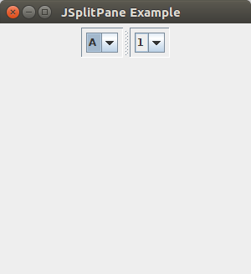

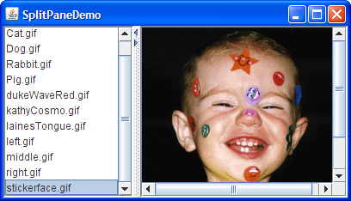

Java JFrame
The javax.swing.JFrame class is a type of container which inherits the java.awt.Frame class. JFrame works like the main window where components like labels, buttons, textfields are added to create a GUI.
Unlike Frame, JFrame has the option to hide or close the window with the help of setDefaultCloseOperation(int) method.

Nested Class
Modifier and Type | Class | Description
protected class | JFrame.AccessibleJFrame | This class implements accessibility support for the JFrame class.

Fields
Modifier and Type | Field | Description
protected AccessibleContext | accessibleContext | The accessible context property.
static int | EXIT_ON_CLOSE | The exit application default window close operation.
protected JRootPane | rootPane | The JRootPane instance that manages the contentPane and optional menuBar for this frame, as well as the glassPane.
protected boolean | rootPaneCheckingEnabled | If true then calls to add and setLayout will be forwarded to the contentPane.

Constructors
Constructor | Description
JFrame() | It constructs a new frame that is initially invisible.
JFrame(GraphicsConfiguration gc) | It creates a Frame in the specified GraphicsConfiguration of a screen device and a blank title.
JFrame(String title) | It creates a new, initially invisible Frame with the specified title.
JFrame(String title, GraphicsConfiguration gc) | It creates a JFrame with the specified title and the specified GraphicsConfiguration of a screen device.

Useful Methods
Modifier and Type | Method | Description
protected void | addImpl(Component comp, Object constraints, int index) | Adds the specified child Component.
protected JRootPane | createRootPane() | Called by the constructor methods to create the default rootPane.
protected void | frameInit() | Called by the constructors to init the JFrame properly.
void | setContentPane(Containe contentPane) | It sets the contentPane property
static void | setDefaultLookAndFeelDecorated(boolean defaultLookAndFeelDecorated) | Provides a hint as to whether or not newly created JFrames should have their Window decorations (such as borders, widgets to close the window, title...) provided by the current look and feel.
void | setIconImage(Image image) | It sets the image to be displayed as the icon for this window.
void | setJMenuBar(JMenuBar menubar) | It sets the menubar for this frame.
void | setLayeredPane(JLayeredPane layeredPane) | It sets the layeredPane property.
JRootPane | getRootPane() | It returns the rootPane object for this frame.
TransferHandler | getTransferHandler() | It gets the transferHandler property.

JFrame Example

import java.awt.FlowLayout;
import javax.swing.JButton;
import javax.swing.JFrame;
import javax.swing.JLabel;
import javax.swing.Jpanel;
public class JFrameExample {
public static void main(String s[]) {
JFrame frame = new JFrame("JFrame Example");
JPanel panel = new JPanel();
panel.setLayout(new FlowLayout());
JLabel label = new JLabel("JFrame By Example");
JButton button = new JButton();
button.setText("Button");
panel.add(label);
panel.add(button);
frame.add(panel);
frame.setSize(200, 300);
frame.setLocationRelativeTo(null);
frame.setDefaultCloseOperation(JFrame.EXIT_ON_CLOSE);
frame.setVisible(true);
}
}

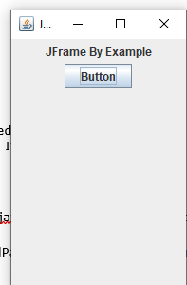

Java JTabbedPane
The JTabbedPane class is used to switch between a group of components by clicking on a tab with a given title or icon. It inherits JComponent class.

JTabbedPane class declaration
Let's see the declaration for javax.swing.JTabbedPane class.
- public class JTabbedPane extends JComponent implements Serializable, Accessible, SwingConstants

Java JTabbedPane
The JTabbedPane class is used to switch between a group of components by clicking on a tab with a given title or icon. It inherits JComponent class.

JTabbedPane class declaration
Let's see the declaration for javax.swing.JTabbedPane class.
- public class JTabbedPane extends JComponent implements Serializable, Accessible, SwingConstants

Commonly used Constructors:
Constructor | Description
JTabbedPane() | Creates an empty TabbedPane with a default tab placement of JTabbedPane.Top.
JTabbedPane(int tabPlacement) | Creates an empty TabbedPane with a specified tab placement.
JTabbedPane(int tabPlacement, int tabLayoutPolicy) | Creates an empty TabbedPane with a specified tab placement and tab layout policy.

Java JTabbedPane Example
- import javax.swing.*;
- public class TabbedPaneExample {
- JFrame f;
- TabbedPaneExample(){
- f=new JFrame();
- JTextArea ta=new JTextArea(200,200);
- JPanel p1=new JPanel();
- p1.add(ta);
- JPanel p2=new JPanel();
- JPanel p3=new JPanel();
- JTabbedPane tp=new JTabbedPane();
- tp.setBounds(50,50,200,200);
- tp.add("main",p1);
- tp.add("visit",p2);
- tp.add("help",p3);
- f.add(tp);
- f.setSize(400,400);
- f.setLayout(null);
- f.setVisible(true);
- }
- public static void main(String[] args) {
- new TabbedPaneExample();
- }}

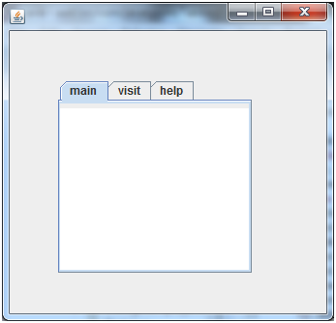

Java JToolBar
JToolBar container allows us to group other components, usually buttons with icons in a row or column. JToolBar provides a component which is useful for displaying commonly used actions or controls.

Nested Classes
Modifier and Type | Class | Description
protected class | JToolBar.AccessibleJToolBar | This class implements accessibility support for the JToolBar class.
static class | JToolBar.Separator | A toolbar-specific separator.

Constructors
Constructor | Description
JToolBar() | It creates a new tool bar; orientation defaults to HORIZONTAL.
JToolBar(int orientation) | It creates a new tool bar with the specified orientation.
JToolBar(String name) | It creates a new tool bar with the specified name.
JToolBar(String name, int orientation) | It creates a new tool bar with a specified name and orientation.

Useful Methods
Modifier and Type | Method | Description
JButton | add(Action a) | It adds a new JButton which dispatches the action.
protected void | addImpl(Component comp, Object constraints, int index) | If a JButton is being added, it is initially set to be disabled.
void | addSeparator() | It appends a separator of default size to the end of the tool bar.
protected PropertyChangeListener | createActionChangeListener(JButton b) | It returns a properly configured PropertyChangeListener which updates the control as changes to the Action occur, or null if the default property change listener for the control is desired.
protected JButton | createActionComponent(Action a) | Factory method which creates the JButton for Actions added to the JToolBar.
ToolBarUI | getUI() | It returns the tool bar's current UI.
void | setUI(ToolBarUI ui) | It sets the L&F object that renders this component.
void | setOrientation(int o) | It sets the orientation of the tool bar.

Java JToolBar Example

- import java.awt.BorderLayout;
- import java.awt.Container;
- import javax.swing.JButton;
- import javax.swing.JComboBox;
- import javax.swing.JFrame;
- import javax.swing.JScrollPane;
- import javax.swing.JTextArea;
- import javax.swing.JToolBar;

- public class JToolBarExample {
- public static void main(final String args[]) {
- JFrame myframe = new JFrame("JToolBar Example");
- myframe.setDefaultCloseOperation(JFrame.EXIT_ON_CLOSE);
- JToolBar toolbar = new JToolBar();
- toolbar.setRollover(true);
- JButton button = new JButton("File");
- toolbar.add(button);
- toolbar.addSeparator();
- toolbar.add(new JButton("Edit"));
- toolbar.add(new JComboBox(new String[] { "Opt-1", "Opt-2", "Opt-3", "Opt-4" }));
- Container contentPane = myframe.getContentPane();
- contentPane.add(toolbar, BorderLayout.NORTH);
- JTextArea textArea = new JTextArea();
- JScrollPane mypane = new JScrollPane(textArea);
- contentPane.add(mypane, BorderLayout.EAST);
- myframe.setSize(450, 250);
- myframe.setVisible(true);
- }
- }

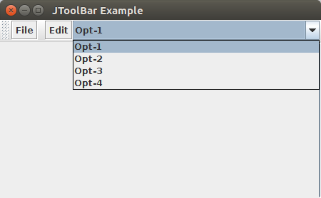

Java JDialog
The JDialog control represents a top level window with a border and a title used to take some
form of input from the user. It inherits the Dialog class.
Unlike JFrame, it doesn't have maximize and minimize buttons.

JDialog class declaration
Let's see the declaration for javax.swing.JDialog class.
public class JDialog extends Dialog implements WindowConstants, Accessible, RootPaneContainer

Java JDialog
The JDialog control represents a top level window with a border and a title used to take some
form of input from the user. It inherits the Dialog class.
Unlike JFrame, it doesn't have maximize and minimize buttons.

JDialog class declaration
Let's see the declaration for javax.swing.JDialog class.
- public class JDialog extends Dialog implements WindowConstants, Accessible,
- RootPaneContainer

Commonly used Constructors:
Constructor | Description
JDialog() | It is used to create a modeless dialog without a title and without a specified Frame owner.
JDialog(Frame owner) | It is used to create a modeless dialog with specified Frame as its owner and an empty title.
JDialog(Frame owner, String title, boolean modal) | It is used to create a dialog with the specified title, owner Frame and modality.

Java JDialog Example
- import javax.swing.*;
- import java.awt.*;
- import java.awt.event.*;
- public class DialogExample {
- private static JDialog d;
- DialogExample() {
- JFrame f= new JFrame();
- d = new JDialog(f , "Dialog Example", true);
- d.setLayout( new FlowLayout() );
- JButton b = new JButton ("OK");
- b.addActionListener ( new ActionListener()
- {
- public void actionPerformed( ActionEvent e )
- {
- DialogExample.d.setVisible(false);
- }
- });
- d.add( new JLabel ("Click button to continue."));
- d.add(b);
- d.setSize(300,300);
- d.setVisible(true);
- }
- public static void main(String args[])
- {
- new DialogExample();
- }
- }
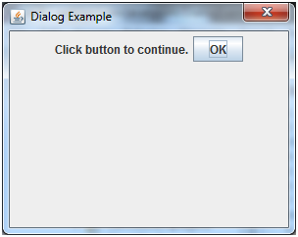

J

JMenu
The object of JMenu class is a pull down menu component which is displayed from the menu bar.
It inherits the JMenuItem class.

JMenu class declaration
- public class JMenu extends JMenuItem implements MenuElement, Accessible

JMenu Example
- import javax.swing.*;
- class MenuExample
- {
- JMenu menu, submenu;
- JMenuItem i1, i2, i3, i4, i5;
- MenuExample(){
- JFrame f= new JFrame("Menu and MenuItem Example");
- JMenuBar mb=new JMenuBar();
- menu=new JMenu("Menu");
- submenu=new JMenu("Sub Menu");
- i1=new JMenuItem("Item 1");
- i2=new JMenuItem("Item 2");
- i3=new JMenuItem("Item 3");
- i4=new JMenuItem("Item 4");
- i5=new JMenuItem("Item 5");
- menu.add(i1); menu.add(i2); menu.add(i3);
- submenu.add(i4); submenu.add(i5);
- menu.add(submenu);
- mb.add(menu);
- f.setJMenuBar(mb);
- f.setSize(400,400);
- f.setLayout(null);
- f.setVisible(true);
- }
- public static void main(String args[])
- {
- new MenuExample();
- }}

Using Text Components
Swing text components display text and optionally allow the user to edit the text.
Programs need text components for tasks ranging from the straightforward (enter a word and press Enter)
to the complex .
Swing provides six text components, along with supporting classes and interfaces that meet even the most
complex text requirements. In spite of their different uses and capabilities,
all Swing text components inherit from the same superclass, JTextComponent,
which provides a highly-configurable and powerful foundation for text manipulation.
The following figure shows the JTextComponent hierarchy.

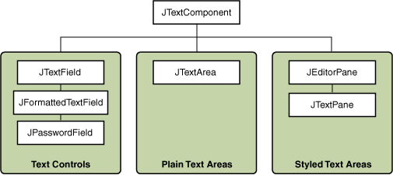

The following table tells you more about what you can do with each kind of text component.
Group | Description | Swing Classes
Text Controls | Also known simply as text fields, text controls can display only one line of editable text. Like buttons, they generate action events. Use them to get a small amount of textual information from the user and perform an action after the text entry is complete. | JTextField and its subclasses JPasswordField and JFormattedTextField
Plain Text Areas | JTextArea can display multiple lines of editable text. Although a text area can display text in any font, all of the text is in the same font. Use a text area to allow the user to enter unformatted text of any length or to display unformatted help information. | JTextArea
Styled Text Areas | A styled text component can display editable text using more than one font. Some styled text components allow embedded images and even embedded components. Styled text components are powerful and multi-faceted components suitable for high-end needs, and offer more avenues for customization than the other text components.  Because they are so powerful and flexible, styled text components typically require more initial programming to set up and use. One exception is that editor panes can be easily loaded with formatted text from a URL, which makes them useful for displaying uneditable help information. | JEditorPane  and its subclass  JTextPane

JTextField, JTextArea,

Java JTextField
The object of a JTextField class is a text component that allows the editing of a single line text. It inherits JTextComponent class.

JTextField class declaration
Let's see the declaration for javax.swing.JTextField class.
- public class JTextField extends JTextComponent implements SwingConstants

Commonly used Constructors:
Constructor | Description
JTextField() | Creates a new TextField
JTextField(String text) | Creates a new TextField initialized with the specified text.
JTextField(String text, int columns) | Creates a new TextField initialized with the specified text and columns.
JTextField(int columns) | Creates a new empty TextField with the specified number of columns.

Commonly used Methods:
Methods | Description
void addActionListener(ActionListener l) | It is used to add the specified action listener to receive action events from this textfield.
Action getAction() | It returns the currently set Action for this ActionEvent source, or null if no Action is set.
void setFont(Font f) | It is used to set the current font.
void removeActionListener(ActionListener l) | It is used to remove the specified action listener so that it no longer receives action events from this textfield.

Java JTextField Example
- import javax.swing.*;
- class TextFieldExample
- {
- public static void main(String args[])
- {
- JFrame f= new JFrame("TextField Example");
- JTextField t1,t2;
- t1=new JTextField("Welcome to Javatpoint.");
- t1.setBounds(50,100, 200,30);
- t2=new JTextField("AWT Tutorial");
- t2.setBounds(50,150, 200,30);
- f.add(t1); f.add(t2);
- f.setSize(400,400);
- f.setLayout(null);
- f.setVisible(true);
- }
- }
Output:
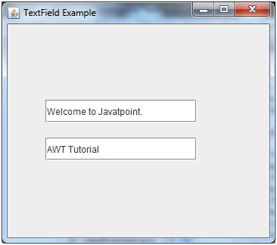

Java JTextField Example with ActionListener
- import javax.swing.*;
- import java.awt.event.*;
- public class TextFieldExample implements ActionListener{
- JTextField tf1,tf2,tf3;
- JButton b1,b2;
- TextFieldExample(){
- JFrame f= new JFrame();
- tf1=new JTextField();
- tf1.setBounds(50,50,150,20);
- tf2=new JTextField();
- tf2.setBounds(50,100,150,20);
- tf3=new JTextField();
- tf3.setBounds(50,150,150,20);
- tf3.setEditable(false);
- b1=new JButton("+");
- b1.setBounds(50,200,50,50);
- b2=new JButton("-");
- b2.setBounds(120,200,50,50);
- b1.addActionListener(this);
- b2.addActionListener(this);
- f.add(tf1);f.add(tf2);f.add(tf3);f.add(b1);f.add(b2);
- f.setSize(300,300);
- f.setLayout(null);
- f.setVisible(true);
- }
- public void actionPerformed(ActionEvent e) {
- String s1=tf1.getText();
- String s2=tf2.getText();
- int a=Integer.parseInt(s1);
- int b=Integer.parseInt(s2);
- int c=0;
- if(e.getSource()==b1){
- c=a+b;
- }else if(e.getSource()==b2){
- c=a-b;
- }
- String result=String.valueOf(c);
- tf3.setText(result);
- }
- public static void main(String[] args) {
- new TextFieldExample();
- } }
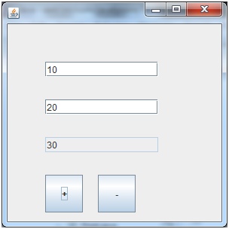

Java JTextArea
The object of a JTextArea class is a multi line region that displays text. It allows the editing of multiple line text. It inherits JTextComponent class

JTextArea class declaration
Let's see the declaration for javax.swing.JTextArea class.
- public class JTextArea extends JTextComponent

Commonly used Constructors:
Constructor | Description
JTextArea() | Creates a text area that displays no text initially.
JTextArea(String s) | Creates a text area that displays specified text initially.
JTextArea(int row, int column) | Creates a text area with the specified number of rows and columns that displays no text initially.
JTextArea(String s, int row, int column) | Creates a text area with the specified number of rows and columns that displays specified text.

Commonly used Methods:
Methods | Description
void setRows(int rows) | It is used to set specified number of rows.
void setColumns(int cols) | It is used to set specified number of columns.
void setFont(Font f) | It is used to set the specified font.
void insert(String s, int position) | It is used to insert the specified text on the specified position.
void append(String s) | It is used to append the given text to the end of the document.

Java JTextArea Example
- import javax.swing.*;
- public class TextAreaExample
- {
- TextAreaExample(){
- JFrame f= new JFrame();
- JTextArea area=new JTextArea("Welcome to javatpoint");
- area.setBounds(10,30, 200,200);
- f.add(area);
- f.setSize(300,300);
- f.setLayout(null);
- f.setVisible(true);
- }
- public static void main(String args[])
- {
- new TextAreaExample();
- }}
Output:
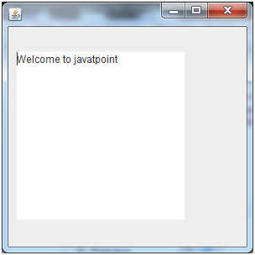

Java JDesktopPane

The JDesktopPane class, can be used to create "multi-document" applications. A multi-document application can have many windows included in it. We do it by making the contentPane in the main window as an instance of the JDesktopPane class or a subclass. Internal windows add instances of JInternalFrame to the JdesktopPane instance. The internal windows are the instances of JInternalFrame or its subclasses.

Fields
Modifier and Type | Field | Description
static int | LIVE_DRAG_MODE | It indicates that the entire contents of the item being dragged should appear inside the desktop pane.
static int | OUTLINE_DRAG_MODE | It indicates that an outline only of the item being dragged should appear inside the desktop pane.

Constructor
Constructor | Description
JDesktopPane() | Creates a new JDesktopPane.

Java JDesktopPane Example

- import java.awt.BorderLayout;
- import java.awt.Container;
- import javax.swing.JDesktopPane;
- import javax.swing.JFrame;
- import javax.swing.JInternalFrame;
- import javax.swing.JLabel;
- public class JDPaneDemo extends JFrame
- {
- public JDPaneDemo()
- {
- CustomDesktopPane desktopPane = new CustomDesktopPane();
- Container contentPane = getContentPane();
- contentPane.add(desktopPane, BorderLayout.CENTER);
- desktopPane.display(desktopPane);

- setTitle("JDesktopPane Example");
- setSize(300,350);
- setVisible(true);
- }
- public static void main(String args[])
- {
- new JDPaneDemo();
- }
- }
- class CustomDesktopPane extends JDesktopPane
- {
- int numFrames = 3, x = 30, y = 30;
- public void display(CustomDesktopPane dp)
- {
- for(int i = 0; i < numFrames ; ++i )
- {
- JInternalFrame jframe = new JInternalFrame("Internal Frame " + i , true, true, true, true);

- jframe.setBounds(x, y, 250, 85);
- Container c1 = jframe.getContentPane( ) ;
- c1.add(new JLabel("I love my country"));
- dp.add( jframe );
- jframe.setVisible(true);
- y += 85;
- }
- }
- }
Output:
