What is Applet?
An applet is a Java program that can be embedded into a web page. It runs inside the web browser and works at client side. An applet is embedded in an HTML page using the APPLET or OBJECT tag and hosted on a web server.
Applets are used to make the web site more dynamic and entertaining.
Important points :
- All applets are sub-classes (either directly or indirectly) of java.applet.Applet class.
- Applets are not stand-alone programs. Instead, they run within either a web browser or an applet viewer. JDK provides a standard applet viewer tool called applet viewer.
- In general, execution of an applet does not begin at main() method.
- Output of an applet window is not performed by System.out.println(). Rather it is handled with various AWT methods, such as drawString().

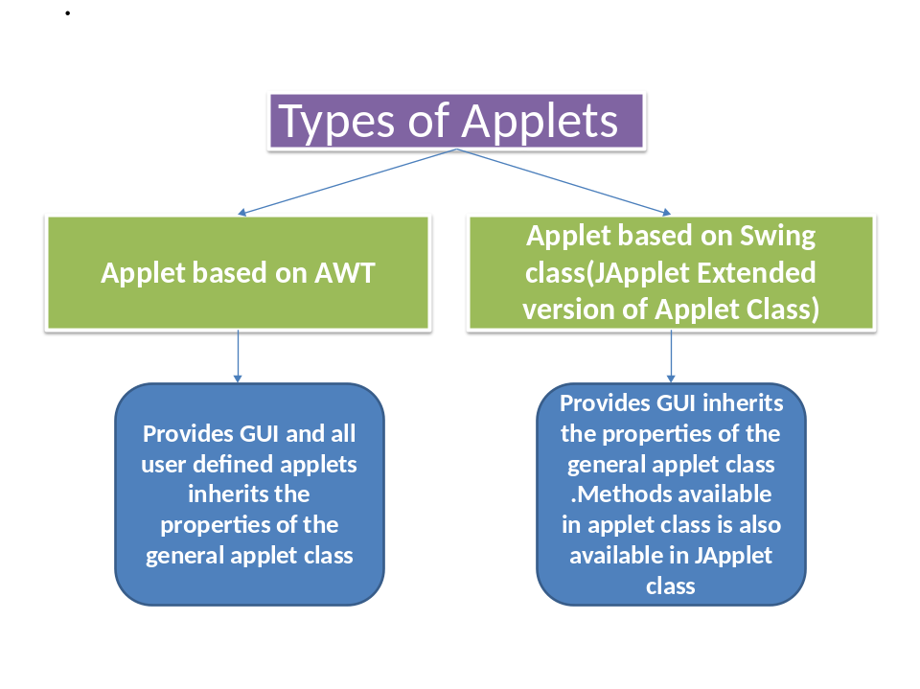

Advantages of Applet
- It is simple to make it work on Linux, Microsoft Windows and Mac OS X i.e. to make it cross platform.
- Applets are supported by most web browsers.
- The same applet can work on "all" installed versions of Java at the same time.
- It can move the work from the server to the client, making a web solution more scalable with the number of users/clients.
- The applet naturally supports the changing user state, such as figure positions on the chessboard.
- An untrusted applet has no access to the local machine and can only access the server it came from.
- Java applets are fast - and can even have similar performance to native installed software.



- It requires the Java plug-in.
- Some applets require a specific JRE.
- There is no standard to make the content of applets available to screen readers. Therefore, applets can harm the accessibility of a web site to users with special needs.
- Some organizations only allow software installed by the administrators. As a result, some users can only view applets that are important enough to justify contacting the administrator to request installation of the Java plug-in.

Simple example of Applet by html file:
To execute the applet by html file, create an applet and compile it. After that create an html file and place the applet code in html file. Now click the html file.
//First.java
import java.applet.Applet;
import java.awt.Graphics;
public class First extends Applet{

public void paint(Graphics g){
g.drawString("welcome to applet",150,150);
} }
/*
<applet code="First.class" width="300" height="300">
</applet>
*/

myapplet.html
<html>
<body>
<applet code="First.class" width="300" height="300">
</applet>
</body>
</html>
To execute the applet by appletviewer tool, write in command prompt:
c:\>javac First.java
c:\>appletviewer myapplet.html

Displaying Graphics in Applet
java.awt.Graphics class provides many methods for graphics programming.

Commonly used methods of Graphics class:
- public abstract void drawString(String str, int x, int y): is used to draw the specified string.
- public void drawRect(int x, int y, int width, int height): draws a rectangle with the specified width and height.
- public abstract void fillRect(int x, int y, int width, int height): is used to fill rectangle with the default color and specified width and height.
- public abstract void drawOval(int x, int y, int width, int height): is used to draw oval with the specified width and height.
- public abstract void fillOval(int x, int y, int width, int height): is used to fill oval with the default color and specified width and height.
- public abstract void drawLine(int x1, int y1, int x2, int y2): is used to draw line between the points(x1, y1) and (x2, y2).
- public abstract boolean drawImage(Image img, int x, int y, ImageObserver observer): is used draw the specified image.
- public abstract void drawArc(int x, int y, int width, int height, int startAngle, int arcAngle): is used draw a circular or elliptical arc.
- public abstract void fillArc(int x, int y, int width, int height, int startAngle, int arcAngle): is used to fill a circular or elliptical arc.
- public abstract void setColor(Color c): is used to set the graphics current color to the specified color.
- public abstract void setFont(Font font): is used to set the graphics current font to the specified font.

Example of Graphics in applet:
- import java.applet.Applet;
- import java.awt.*;
- public class GraphicsDemo extends Applet{
- public void paint(Graphics g){
- g.setColor(Color.red);
- g.drawString("Welcome",50, 50);
- g.drawLine(20,30,20,300);
- g.drawRect(70,100,30,30);
- g.fillRect(170,100,30,30);
- g.drawOval(70,200,30,30);
- g.setColor(Color.pink);
- g.fillOval(170,200,30,30);
- g.drawArc(90,150,30,30,30,270);
- g.fillArc(270,150,30,30,0,180);

- }
- }

myapplet.html
- <html>
- <body>
- <applet code="GraphicsDemo.class" width="300" height="300">
- </applet>
- </body>
- </html>

Life cycle of an applet :

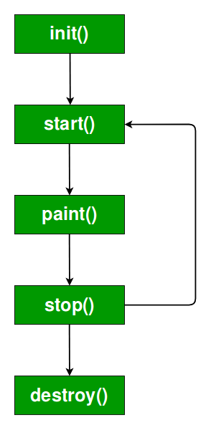

It is important to understand the order in which the various methods shown in the above image are called. When an applet begins, the following methods are called, in this sequence:
- init( )
- start( )
- paint( )
When an applet is terminated, the following sequence of method calls takes place:
- stop( )
- destroy( )
Let’s look more closely at these methods.
- init( ) : The init( ) method is the first method to be called. This is where you should initialize variables. This method is called only once during the run time of your applet.
- start( ) : The start( ) method is called after init( ). It is also called to restart an applet after it has been stopped. Note that init( ) is called once i.e. when the first time an applet is loaded whereas start( ) is called each time an applet’s HTML document is displayed onscreen. So, if a user leaves a web page and comes back, the applet resumes execution at start( ).
- paint( ) : The paint( ) method is called each time an AWT-based applet’s output must be redrawn. This situation can occur for several reasons. For example, the window in which the applet is running may be overwritten by another window and then uncovered. Or the applet window may be minimized and then restored.
paint( ) is also called when the applet begins execution. Whatever the cause, whenever the applet must redraw its output, paint( ) is called.

APPLET SKELETON

An Applet Skeleton
Most applets override these four methods. These four methods forms Applet lifecycle.
- init() : init() is the first method to be called. This is where variable are initialized. This method is called only once during the runtime of applet.
- start() : start() method is called after init(). This method is called to restart an applet after it has been stopped.
- stop() : stop() method is called to suspend thread that does not need to run when applet is not visible.
- destroy() : destroy() method is called when your applet needs to be removed completely from memory.

Example of an Applet Skeleton
import java.awt.*;
import java.applet.*;
public class AppletTest extends Applet
{
public void init()
{
//initialization
}
public void start ()
{
//start or resume execution
}
public void stop()
{
//suspend execution
{
public void destroy()
{
//perform shutdown activity
}
public void paint (Graphics g)
{
//display the content of window
}
}

Example of an Applet
import java.applet.*;
import java.awt.*;
public class MyApplet extends Applet
{
int height, width;
public void init()
{
height = getSize().height;
width = getSize().width;
setName("MyApplet");
}
public void paint(Graphics g)
{
g.drawRoundRect(10, 30, 120, 120, 2, 3);
}
}
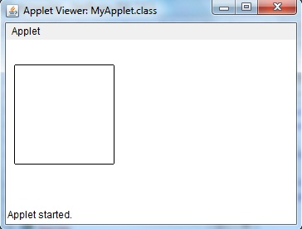

Running Applet using Applet Viewer
To execute an Applet with an applet viewer, write short HTML file as discussed above. If name it as run.htm, then the following command will run your applet program.
f:/>appletviewer run.htm

The Applet Class
Every applet is an extension of the java.applet.Applet class. The base Applet class provides methods that a derived Applet class may call to obtain information and services from the browser context.
These include methods that do the following −
- Get applet parameters
- Get the network location of the HTML file that contains the applet
- Get the network location of the applet class directory
- Print a status message in the browser
- Fetch an image
- Fetch an audio clip
- Play an audio clip
- Resize the applet
Additionally, the Applet class provides an interface by which the viewer or browser obtains information about the applet and controls the applet's execution. The viewer may −
- Request information about the author, version, and copyright of the applet
- Request a description of the parameters the applet recognizes
- Initialize the applet
- Destroy the applet
- Start the applet's execution
- Stop the applet's execution
The Applet class provides default implementations of each of these methods. Those implementations may be overridden as necessary.
The "Hello, World" applet is complete as it stands. The only method overridden is the paint method.

Invoking an Applet
An applet may be invoked by embedding directives in an HTML file and viewing the file through an applet viewer or Java-enabled browser.
The <applet> tag is the basis for embedding an applet in an HTML file. Following is an example that invokes the "Hello, World" applet −
<html>
<title>The Hello, World Applet</title>
<hr>
<applet code = "HelloWorldApplet.class" width = "320" height = "120">
If your browser was Java-enabled, a "Hello, World"
message would appear here.
</applet>
</hr>
</html>
Note − You can refer to HTML Applet Tag to understand more about calling applet from HTML.
The code attribute of the <applet> tag is required. It specifies the Applet class to run. Width and height are also required to specify the initial size of the panel in which an applet runs. The applet directive must be closed with an </applet> tag.
If an applet takes parameters, values may be passed for the parameters by adding <param> tags between <applet> and </applet>. The browser ignores text and other tags between the applet tags.

The HTML APPLET Tag
The syntax for a fuller form of the APPLET tag is shown here. Bracketed items are
optional.
< APPLET
[CODEBASE = codebaseURL]
CODE = appletFile
[ALT = alternateText]
[NAME = appletInstanceName]
WIDTH = pixels HEIGHT = pixels
[ALIGN = alignment]
[VSPACE = pixels] [HSPACE = pixels]
>
[< PARAM NAME = AttributeName VALUE = AttributeValue>]
[< PARAM NAME = AttributeName2 VALUE = AttributeValue>]
. . .
[HTML Displayed in the absence of Java]
</APPLET>

PASSING PARAMETERS TO APPLETS
We can get any information from the HTML file as a parameter. For this purpose, Applet class provides a method named getParameter(). Syntax:
public String getParameter(String parameterName)

Example of using parameter in Applet:
import java.applet.Applet;
import java.awt.Graphics;
public class UseParam extends Applet{
public void paint(Graphics g){
String str=getParameter("msg");
g.drawString(str,50, 50); }}

myapplet.html
<html>
<body>
<applet code="UseParam.class" width="300" height="300">
<param name="msg" value="Welcome to applet">
</applet>
</body>
</html>
import java.applet.Applet;
import java.awt.Graphics;
import java.awt.*;
/*<applet code="AppletLifeCycle.class" width="350" height="150"> </applet>*/
public class AppletLifeCycle extends Applet
{
public void init()
{
setBackground(Color.CYAN);
System.out.println("init() called");
}
public void start(){ System.out.println("Start() called"); }
public void paint(Graphics g){ System.out.println("Paint(() called"); }
public void stop() { System.out.println("Stop() Called"); }
public void destroy() { System.out.println("Destroy)() Called"); }
}

GetDocumentBase and getCodeBase Example

In most of the applets, it is required to load text and images explicitly. Java enables loading data from two directories. The first one is the directory which contains the HTML file that started the applet (known as the document base). The other one is the directory from which the class file of the applet is loaded (known as the code base).

These directories can be obtained as URL objects by using getDocumentBase ()and getCodeBase ()methods respectively.
You can concatenate these URL objects with the string representing the name of the file that is to be loaded.
Here is the java code for the program GetDocumentBase and getCodeBase Example :.*/
import java.applet.*; import java.net.*;
/*
<applet code="Bases" width=300 height=50> </applet>
*/
public class Bases extends Applet {
// Display code and document bases.
public void paint(Graphics g) {

String msg;

URL url = getCodeBase(); // get code base
msg = "Code base: " + url.toString(); g.drawString(msg, 10, 20);

url = getDocumentBase(); // get document base
msg = "Document base: " + url.toString(); g.drawString(msg, 10, 40);
}

}

output
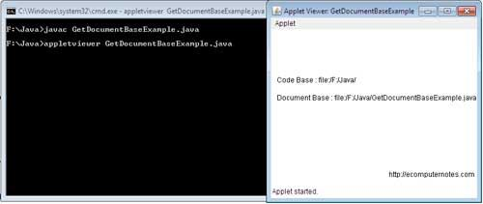

APPLET ARCHITECTURE

- When you write a Java application for time series data, you use the JDBC Driver to connect to the database, as shown in the following figure.

- Figure 1. Runtime architecture for Java programs that connect to a database

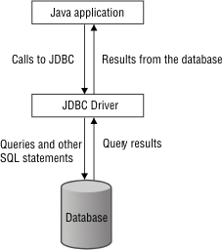

- The Java application makes calls to the JDBC driver, which sends queries and other SQL statements to the database. The database sends query results to the JDBC driver, which sends them on to the Java application.
- You can also use the time series Java classes in Java applets and servlets, as shown in the following figures.

- Figure 2. Runtime architecture for a Java applet
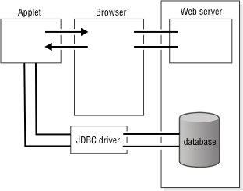

- The database server is connected to the JDBC driver, which is connected to the applet. The applet is also connected to a browser, which is connected to a web server that communicates with the database.

- Figure 3. Runtime architecture for a Java servlet

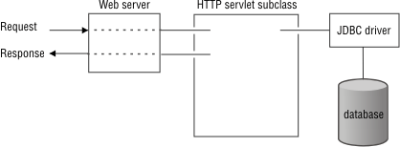

- A request from an application goes through a web server, an HTTP servlet subclass, and the JDBC driver to the database. The database sends responses back along the same path.

APPLET CONTEXT AND SHOW DOCUMENTS()
AppletContext is the interface defined by java.applet. One application of java is to use active images and animation to provide a graphical means for different java based application.
It is used to get information from the applet’s execution environment.

The context of the currently executing applet is obtained by a call to the getAppletContext( ) method defined by Applet.

Methods

Applet getApplet(String appletName)

This method returns the applet specified by appletName if it is within the current applet context. Otherwise, null is returned.

Enumeration getApplets( )

This method returns an enumeration that contains all of the applets within the current applet context.

AudioClip getAudioClip(URL url)

This method returns an AudioClip object that encapsulates the audio clip found at the location specified by url.

Image getImage(URL url)

This method returns an Image object that encapsulates the image found at the location specified by url.

void showDocument(URL url)

This method brings the document at the URL specified by url into view. This method may not be supported by applet viewers.

void showDocument(URL url, String where)

This method brings the document at the URL specified by url into view. This method may not be supported by applet viewers. The placement of the document is specified by where as described in the text.

void showStatus(String str)

This method displays str in the status window
EXAMPLE - AppletContext: showDocument(URL url,String target)
import java.applet.AppletContext;
import java.awt.Graphics;
import java.net.URL;

import javax.swing.JApplet;

public class MainClass extends JApplet {

public void paint(Graphics g) {
AppletContext ac = getAppletContext();
try {
URL url = new URL("http://www.java2s.com");
ac.showDocument(url, "frame2");
} catch (Exception e) {
showStatus("Exception: " + e);
}
g.drawString("ShowDocument Applet", 10, 25);
}
}

