**How to Use this Template**

1. Make a copy [ File → Make a copy... ]
2. Rename this file: “**Capstone_Stage1**”
3. Replace the text in green

**Submission Instructions**

1. After you’ve completed all the sections, download this document as a PDF [ File → Download as PDF ]
2. Create a new GitHub repo for the capstone. Name it “**Capstone Project**”
3. Add this document to your repo. Make sure it’s named “**Capstone_Stage1.pdf**”

Description

Intended User

Features

User Interface Mocks

Screen 1

Screen 2

Key Considerations

How will your app handle data persistence?

Describe any corner cases in the UX.

Describe any libraries you’ll be using and share your reasoning for including them.

Next Steps: Required Tasks

Task 1: Project Setup

Task 2: Implement UI for Each Activity and Fragment

Task 3: Your Next Task

Task 4: Your Next Task

Task 5: Your Next Task

**GitHub Username**: abhikmitra

Humans of The World

# Description

The app provides you a sneak peek into the lives of various Humans of the World. Past year, you would have seen rise of Facebook pages like “Humans of New York”, “Humans of Mumbai”, “Humans of Los Angeles” etc. The app brings all the photos and post from all the various Facebook pages to your phone so that you don’t have to search for it. Each post in the app will talk about a Human and his story in the world. This app would work even without Internet connection. You can mark posts as your favorite and also share them with friends. The app does not post to your facebook.

# Intended User

It’s an app for people who like to know stories of other people and people who would like to read inspirational stories. Also for people who are interested in various cultures.

# Features

* App gets Posts from various Facebook feeds of the pages.
* You can mark the post as favorite
* You can share the post with your friends.
* You can delete the post from your feed.
* You can click to see larger photos.
* The app will automatically update whenever phone is connected to Battery and Wifi.
* The app also has pull to refresh.

# User Interface Mocks

These can be created by hand (take a photo of your drawings and insert them in this flow), or using a program like Photoshop or Balsamiq.

## Screen 1

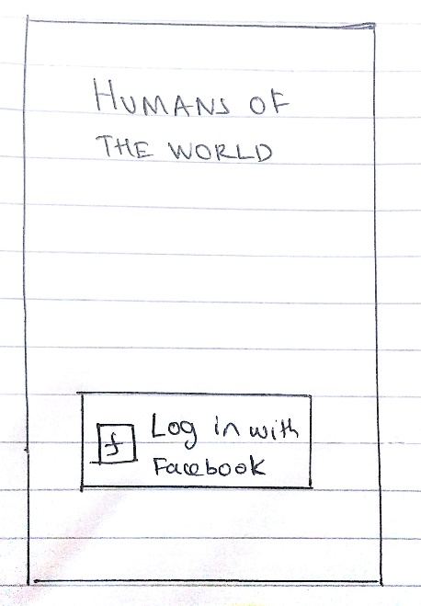

The screen above is the login screen. He needs to login using the Facebook API

## Screen 2

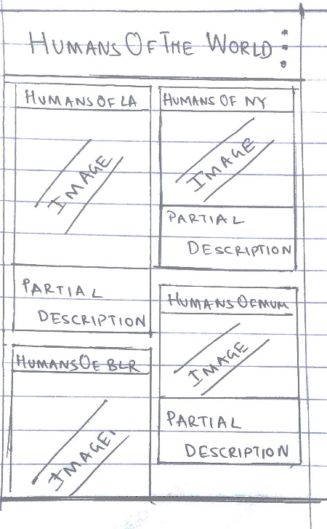

Screen 2 will feature card layout. It will also have pull to refresh. Clicking on each will transition to a different Activity. On click of settings menu , He will have the option of choosing favorites,

Add as many screens as you need to portray your app’s UI flow.

## Screen 3

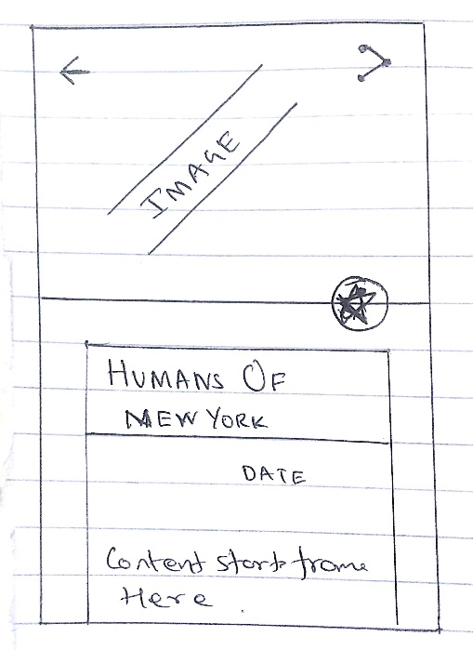

Screen3 will feature details and the image of the post. He can Mark as favorite or Share his post

# Key Considerations

### How will your app handle data persistence?

App will store data in a Database using a content Provider.

### Describe any corner cases in the UX.

I don’t see any corner cases

### Describe any libraries you’ll be using and share your reasoning for including them.

I will be using fresco for the Image handling. It has progressive download and hence Images progressively render even in case of slow connections.

Google Play Services: Ad Mob,

Google Play Services: Analytics

# Next Steps: Required Tasks

This is the section where you can take the main features of your app (declared above) and decompose them into tangible technical tasks that you can complete incrementally until you have a finished app.

## Task 1: Project Setup

Add the proper libraries in build folder

* Configure libraries

## Task 2: Login

List the subtasks. For example:

* Use the facebook login
* Us the facebook login to generate URLs
* Take him to the next activity after successful authentication

## Task 3: Get Data

Fetch data

Describe the next task. List the subtasks. For example:

* Fetch data using SyncAdapters
* Use RxJava for for fetching through multiple calls.
* Use that data to update the UI

## Task 4: Create UI

Describe the next task. List the subtasks. For example:

* Create layout for Screen 2 and 3
* Use cursor loaders to hook into the DB
* Use collapsibleToolbars and android design library

## Task 5: Your Next Task

Describe the next task. List the subtasks. For example:

* Add Ads
* Add Analytics

Add as many tasks as you need to complete your app.

**Submission Instructions**

1. After you’ve completed all the sections, download this document as a PDF [ File → Download as PDF ]
2. Create a new GitHub repo for the capstone. Name it “**Capstone Project**”
3. Add this document to your repo. Make sure it’s named “**Capstone_Stage1.pdf**”