MODULE-3

CASE STUDY-III

class Customer():

    def __init__(*self*,*customerdata*):

*self*.customerdata=customerdata

        titlename=customerdata[1].split('.')

*self*.title=titlename[0]

*self*.fname=titlename[1]

*self*.lname=customerdata[0]

*self*.blacklisted=customerdata[2]

    def title(*self*):

        return *self*.title

    def fname(*self*):

        return *self*.fname

    def lname(*self*):

        return *self*.lname

    def blacklisted(*self*):

        return *self*.blacklisted

def createorder(*val*,*itemname*,*itemcode*):

    if val.blacklisted=="1":

        print(f'title: {val.title}  firstname: {val.fname}  lastname: {val.lname}  blacklisting status: {val.blacklisted}')

        print('Cutomer is blacklisted.Order creation is not possible.')

        raise CustomerNotAllowed()

    elif val.blacklisted=='0':

        print(f'title: {val.title}  firstname: {val.fname}  lastname: {val.lname}  blacklisting status: {val.blacklisted}')

        print('Cutomer is not blacklisted.Creating order.')

        print(f'Order created succesfully.{itemname} with {itemcode} will be delivered.')

    else:

        pass

class CustomerNotAllowed(*Exception*):

    def __init__(*self*):

        pass

file_data= open('FairDealCustomerData.csv','r')

i=0

custdatalist=[]

for data in file_data:

    data=*list*(map(*str*,data.strip().split(',')))

    custdata=Customer(data)

    custdatalist.append(custdata)

    i+=1

file_data.close()

import random

avail_products=['LEDTV','Fridge','AC','Cooker','Laptop','shoes','Mobilephone']

for i in range(0,i):

    try:

        productcode=random.randint(1111,9999)

        product=random.choice(avail_products)

        createorder(custdatalist[i],product,productcode)

        print('\n')

    except CustomerNotAllowed as cne:

        print("Exception Customer NotAllowed handled message", cne)

        print('\n')

print ("End of Program")

print('data is handled.')

print('\n')

OUTPUT

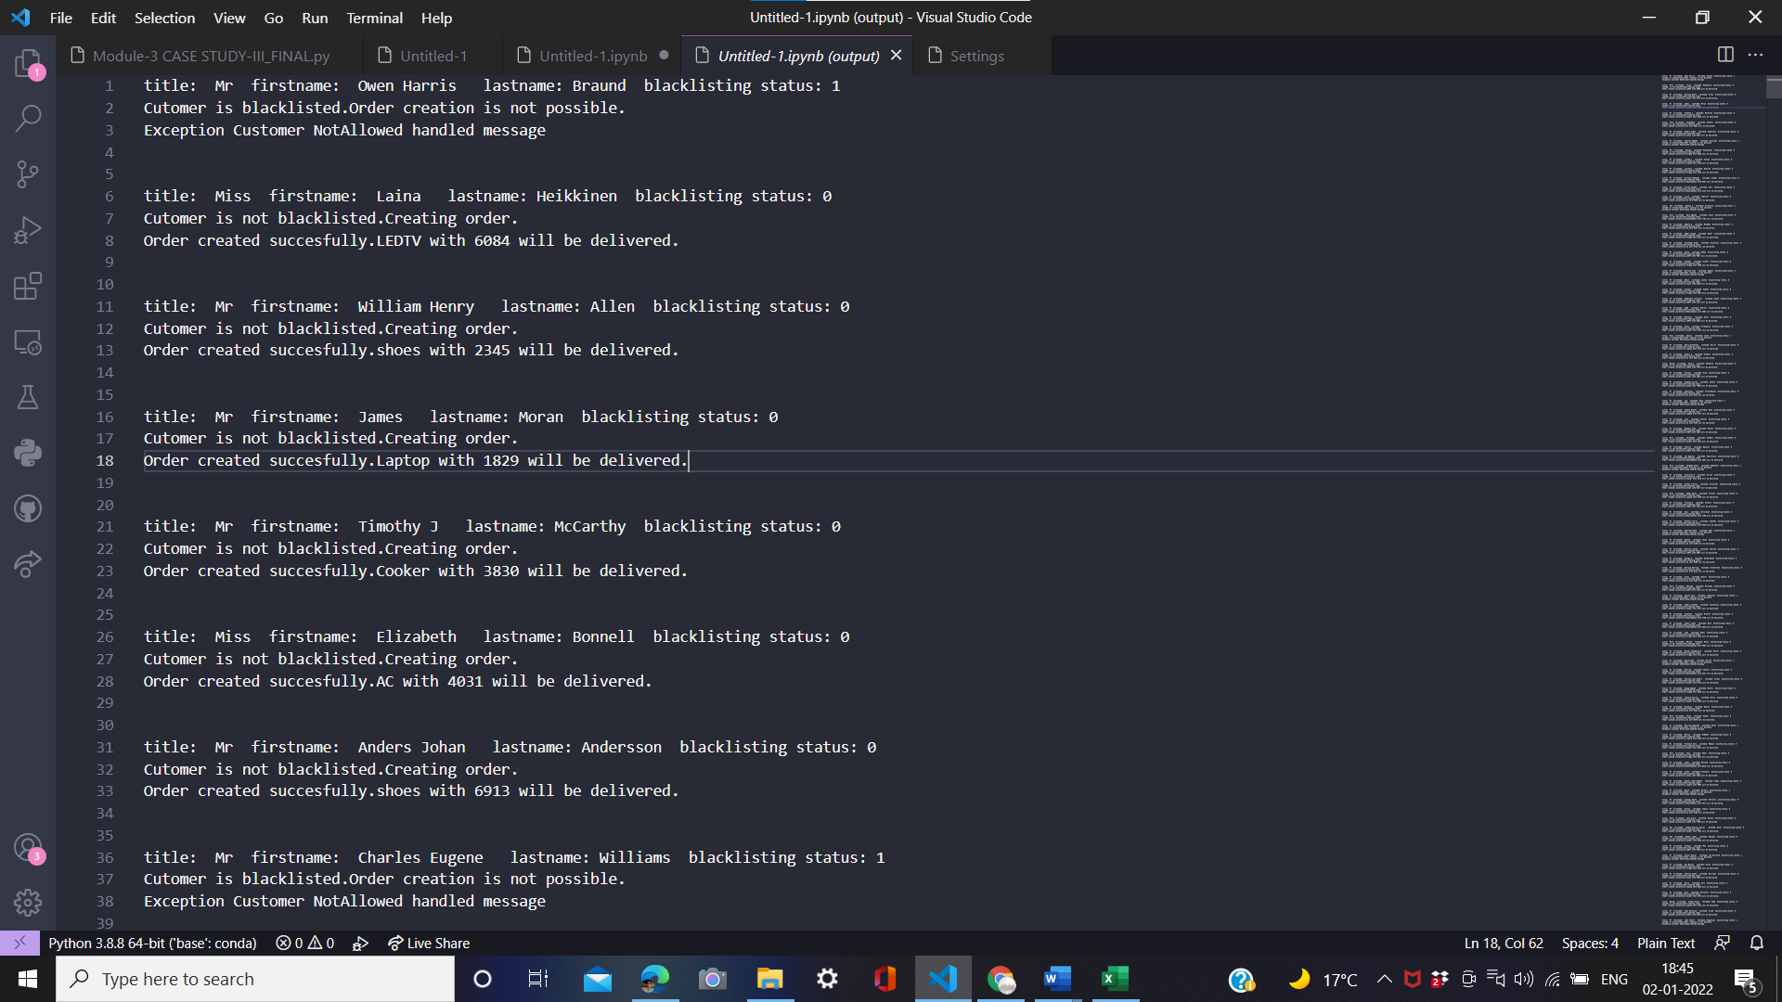

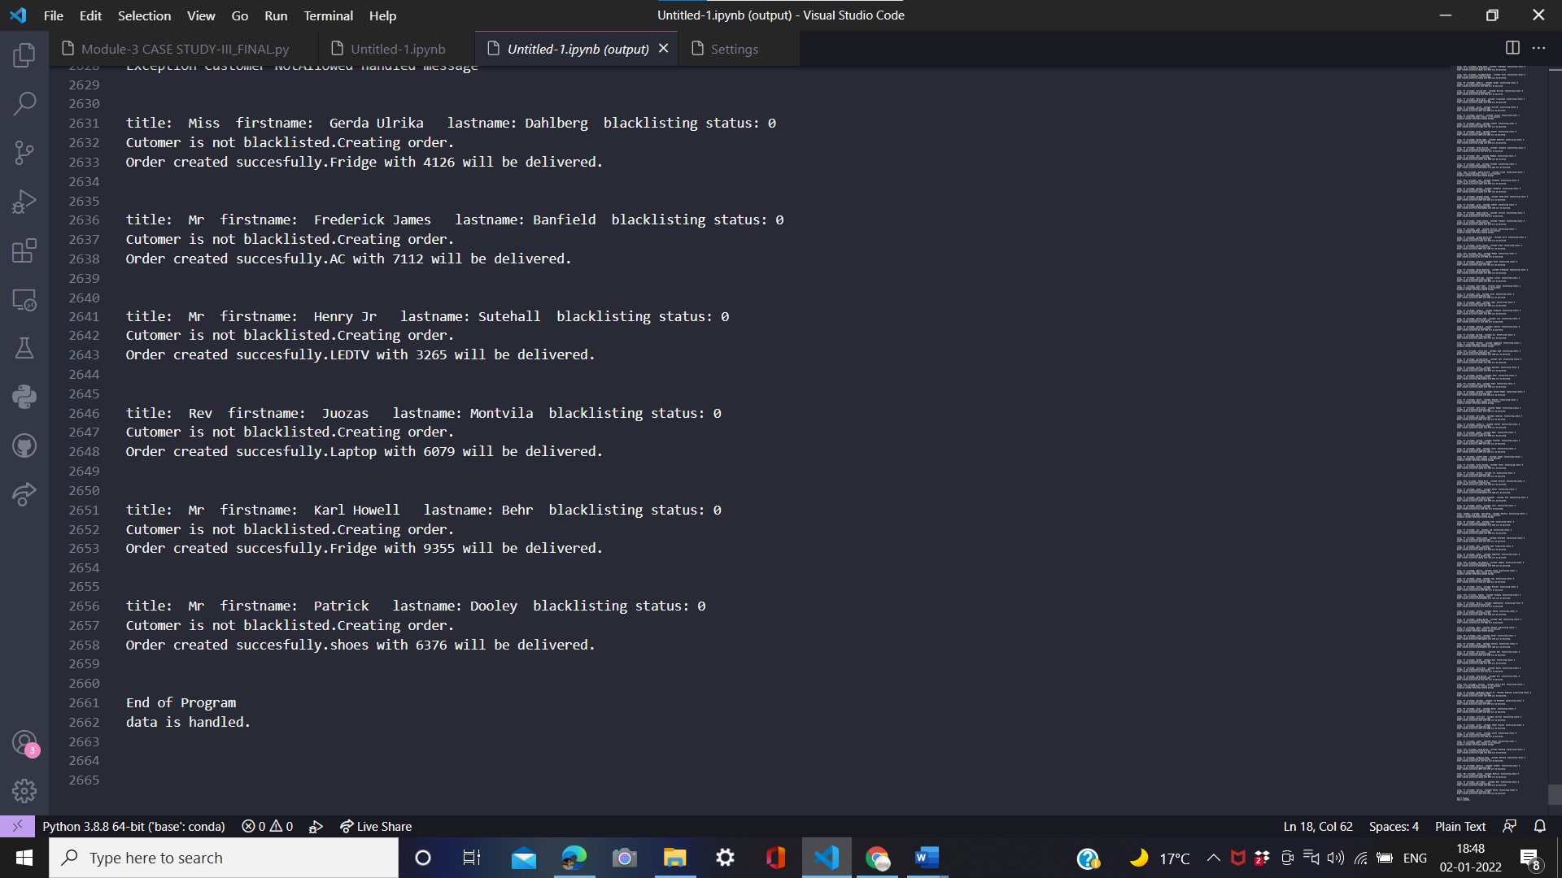

The starting and ending part of output are attached.