K.A.R.M.A
Complete Project Documentation & Examination Study Guide
Cyber Threat Deception • Honeypot • SIEM • Active Defense • AI Threat Intelligence

Project repository: https://github.com/abhikr1436/KARMA-HoneyPot
Sl. | Candidate Name & Project Specialization | Registration / USN No.
1 | ABHIJEET KUMAR (Team Lead & Core Architect) | 470CS24701
2 | KANAKA C (Security Analyst & Frontend Engineer) | 470CS23005
3 | RAGHUNANDAN T V (Backend Engineer & Threat Intelligence) | 470CS23010
4 | SANJAY KASHYAP (Security QA & Penetration Testing Specialist) | 470CS23015
Mentor | Mr. SUBHASH J R (Lecturer, Dept. of Computer Science & Engineering) | The Oxford Evening Polytechnic

Item | Project Detail
Project | K.A.R.M.A Cloud SIEM / Autonomous AI Threat Deception Platform
Academic use | Semester VI Major Project – Cyber Security
Core idea | Deliberately expose realistic decoy services and secrets so malicious activity is attracted, captured, analysed and contained.
Primary backend | Python + FastAPI + Uvicorn + SQLite
Security sensors | Paramiko SSH honeypot, FastAPI web honeypot, raw TCP decoys for FTP/Telnet/RDP ports
Frontend | HTML5 + CSS3 + JavaScript + Leaflet.js + Chart.js
AI | DeepSeek API integration for threat/phishing analysis, with local fallback logic for phishing analysis
Threat model | Reconnaissance, brute force, web exploitation probes, command execution and honeytoken access

Prepared as an examination/viva reference from the current public repository snapshot.

1. How to Use This Document
This is a project-specific study guide, not a generic cybersecurity textbook. It explains the technologies, modules, functions, data flow, security concepts and examination questions that can be asked from the current K.A.R.M.A codebase.
The repository was inspected at the public main branch. The documentation below deliberately distinguishes between what the code actually implements and what the project description claims. This is important during viva: never claim a feature is more advanced than the code that implements it.
- Use Sections 2–12 to understand the complete architecture.
- Use Sections 13–30 to study the technologies and cybersecurity concepts.
- Use Sections 31–38 for function/call-flow understanding.
- Use Sections 39–45 for attack demonstrations and defensive reasoning.
- Use Sections 46–50 for likely viva questions and short answers.
- Use the final checklist before your project demonstration.

Important implementation observations
- The repository contains a FastAPI API gateway on port 8000, an SSH honeypot on port 2222 and a web honeypot on port 8080. The raw decoys listen on ports 21, 23 and 3389 when enabled.
- The geolocation layer in database.py is a demonstration mapping/fallback generator, not a live commercial IP-geolocation service.
- The password tool computes SHA-256 and SHA-512 through the browser WebCrypto API. Its function named generateClientMD5 is not a standards-compliant MD5 implementation; it produces a 32-character custom value. Do not call it a real MD5 hash in viva.
- The DeepSeek phishing module is designed to call an external AI API and also contains a local fallback scanner.
- The current phishing_analyzer.py contains an API-key fallback string in source code. This is a security weakness. A production system should use environment variables or a secret manager only.
- The active-defense module records IPs in a quarantine database. The current implementation does not itself install an operating-system firewall rule; describe it as application-level quarantine/containment unless you add actual firewall integration.
- The project README uses terms such as 'production-grade' and 'cloud SIEM', but the present implementation is primarily a local Python SIEM/deception platform with cloud-AI integration.

2. Project Overview

2.1 What is K.A.R.M.A?
K.A.R.M.A is a cyber threat deception and security monitoring platform. It deliberately exposes fake services, fake login portals, fake credentials and fake API endpoints. The objective is not to protect a real service by making it harder to attack; the objective is to make malicious interaction highly observable and useful for detection, analysis and response.
The system combines deception sensors with a SIEM-style dashboard. An attack is converted into a telemetry event, stored in SQLite, mapped to a MITRE ATT&CK technique, assigned a risk/severity level, optionally quarantined, written to a CSV audit file and pushed to the browser over WebSocket.

2.2 One-line viva answer
“K.A.R.M.A is a Python-based cyber deception and SIEM platform that exposes realistic decoy services and honeytokens, captures attacker behaviour, maps it to MITRE ATT&CK, calculates risk, stores telemetry, streams it to a dashboard and performs application-level quarantine.”

2.3 Why use a honeypot?
- Real production systems generate a large amount of legitimate traffic, making malicious activity harder to isolate.
- A honeypot should normally have little or no legitimate business traffic, so interaction with it is suspicious by design.
- It provides early warning, attacker behaviour, commands/payloads and indicators of compromise.
- It can reveal reconnaissance and attack techniques before the attacker reaches valuable assets.
- It supports cybersecurity education and controlled attack demonstrations.

2.4 Honeypot vs firewall vs IDS vs SIEM
Technology | Main purpose | K.A.R.M.A relationship
Firewall | Allow/deny network traffic based on rules. | K.A.R.M.A records/quarantines attackers at application level; it is not a replacement for a firewall.
IDS | Detect suspicious traffic/activity. | K.A.R.M.A detects interaction with decoys and classifies it.
IPS | Detect and actively block/prevent. | K.A.R.M.A has an active-defense/quarantine concept, but current code records quarantine rather than directly configuring a host firewall.
Honeypot | Attract and observe attackers. | Core deception mechanism.
SIEM | Collect, correlate, store and visualize security events. | Dashboard + SQLite + CSV + MITRE/risk telemetry.
SOC | Operational team/function that monitors and responds to security events. | K.A.R.M.A simulates several SOC functions in software.

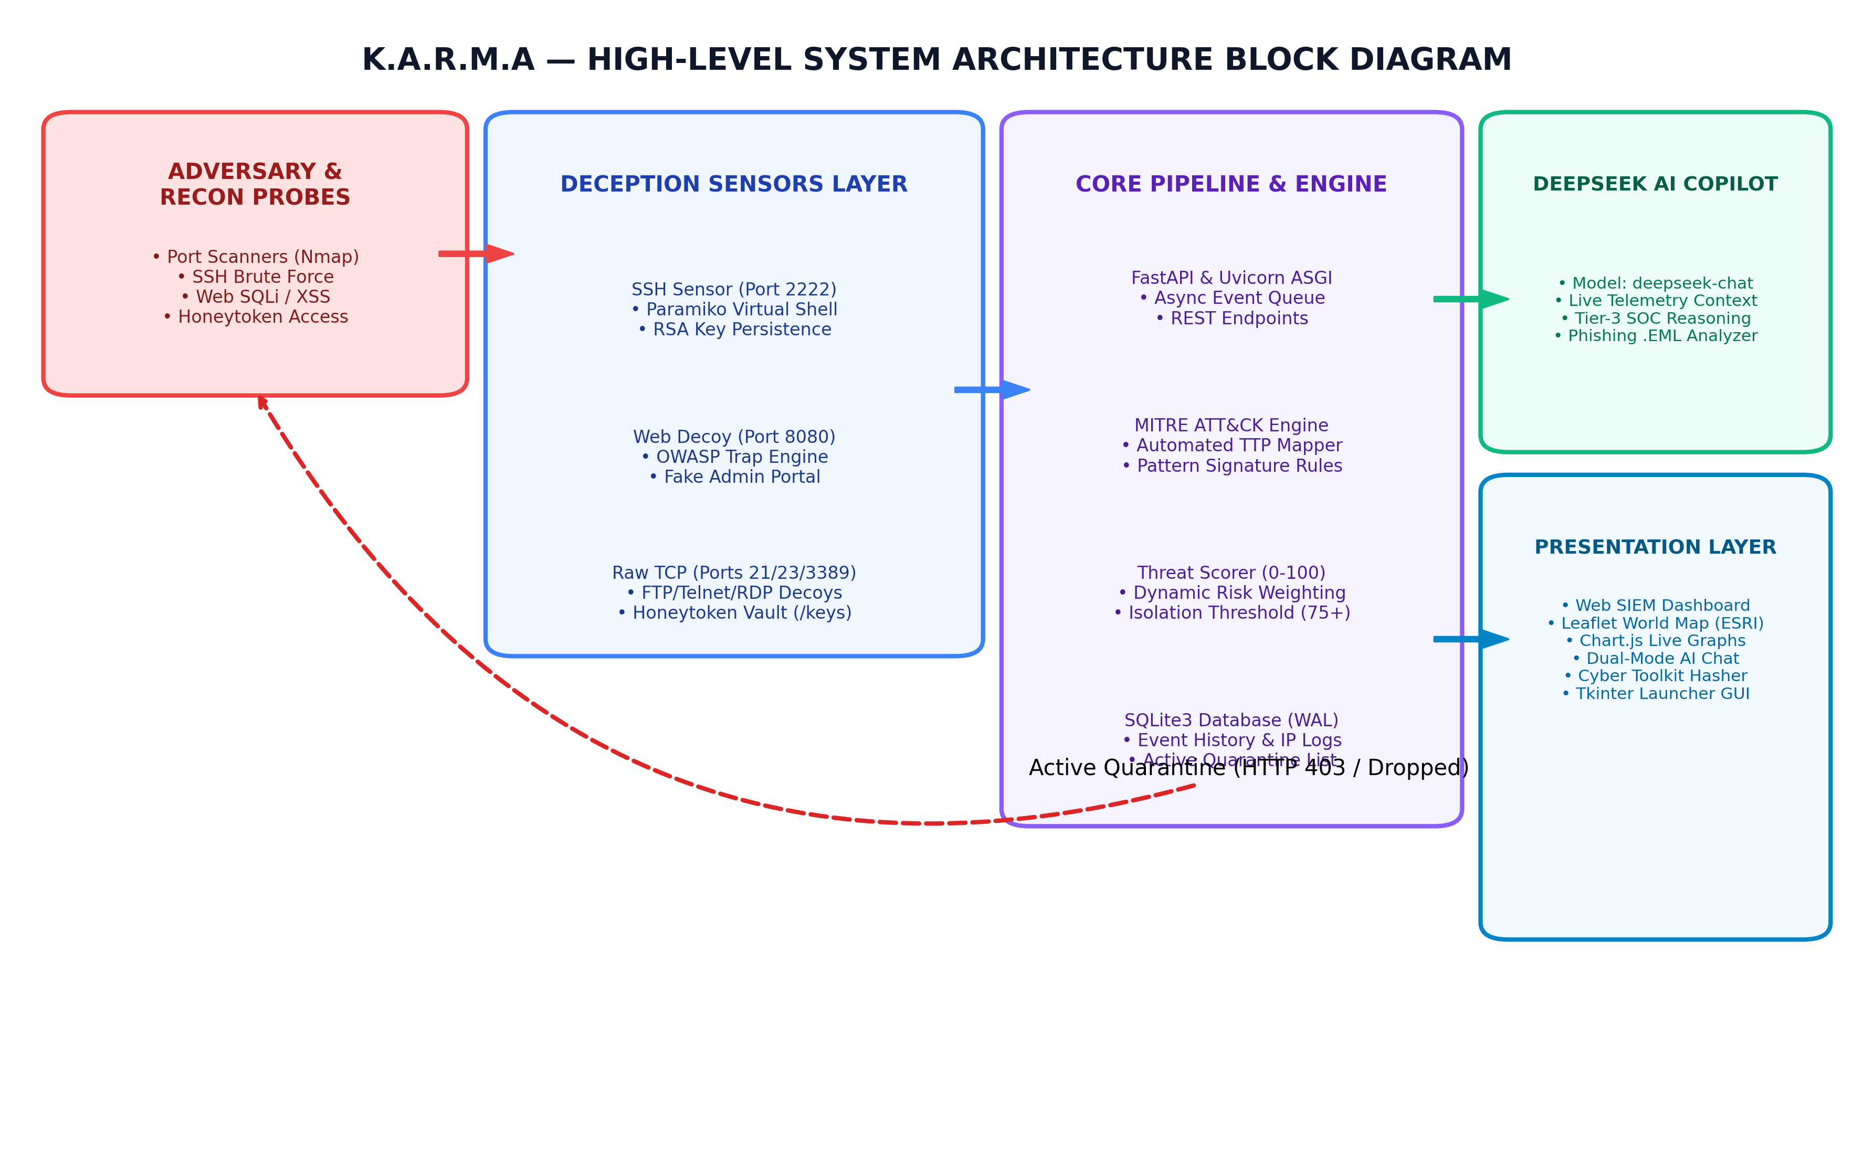
Figure 3.1: K.A.R.M.A High-Level System Architecture Block Diagram
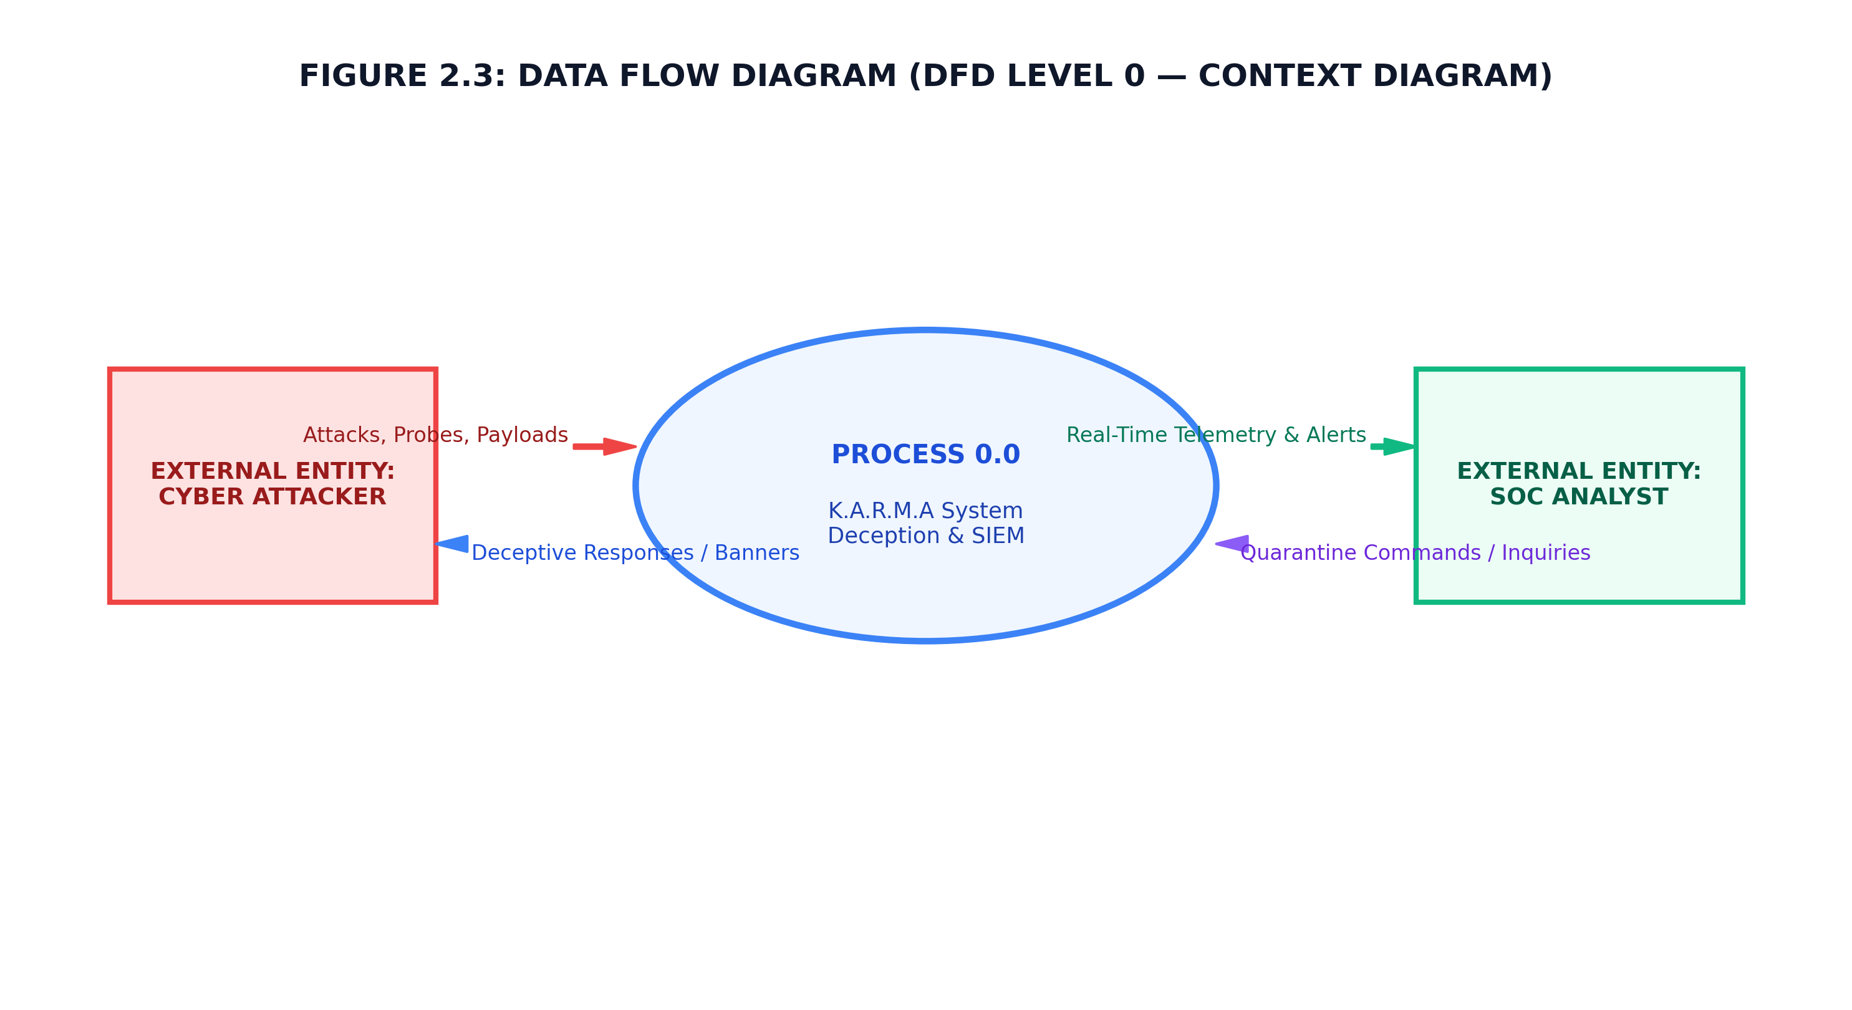
Figure 3.2: Data Flow Diagram (DFD Level 0 — Context Model)
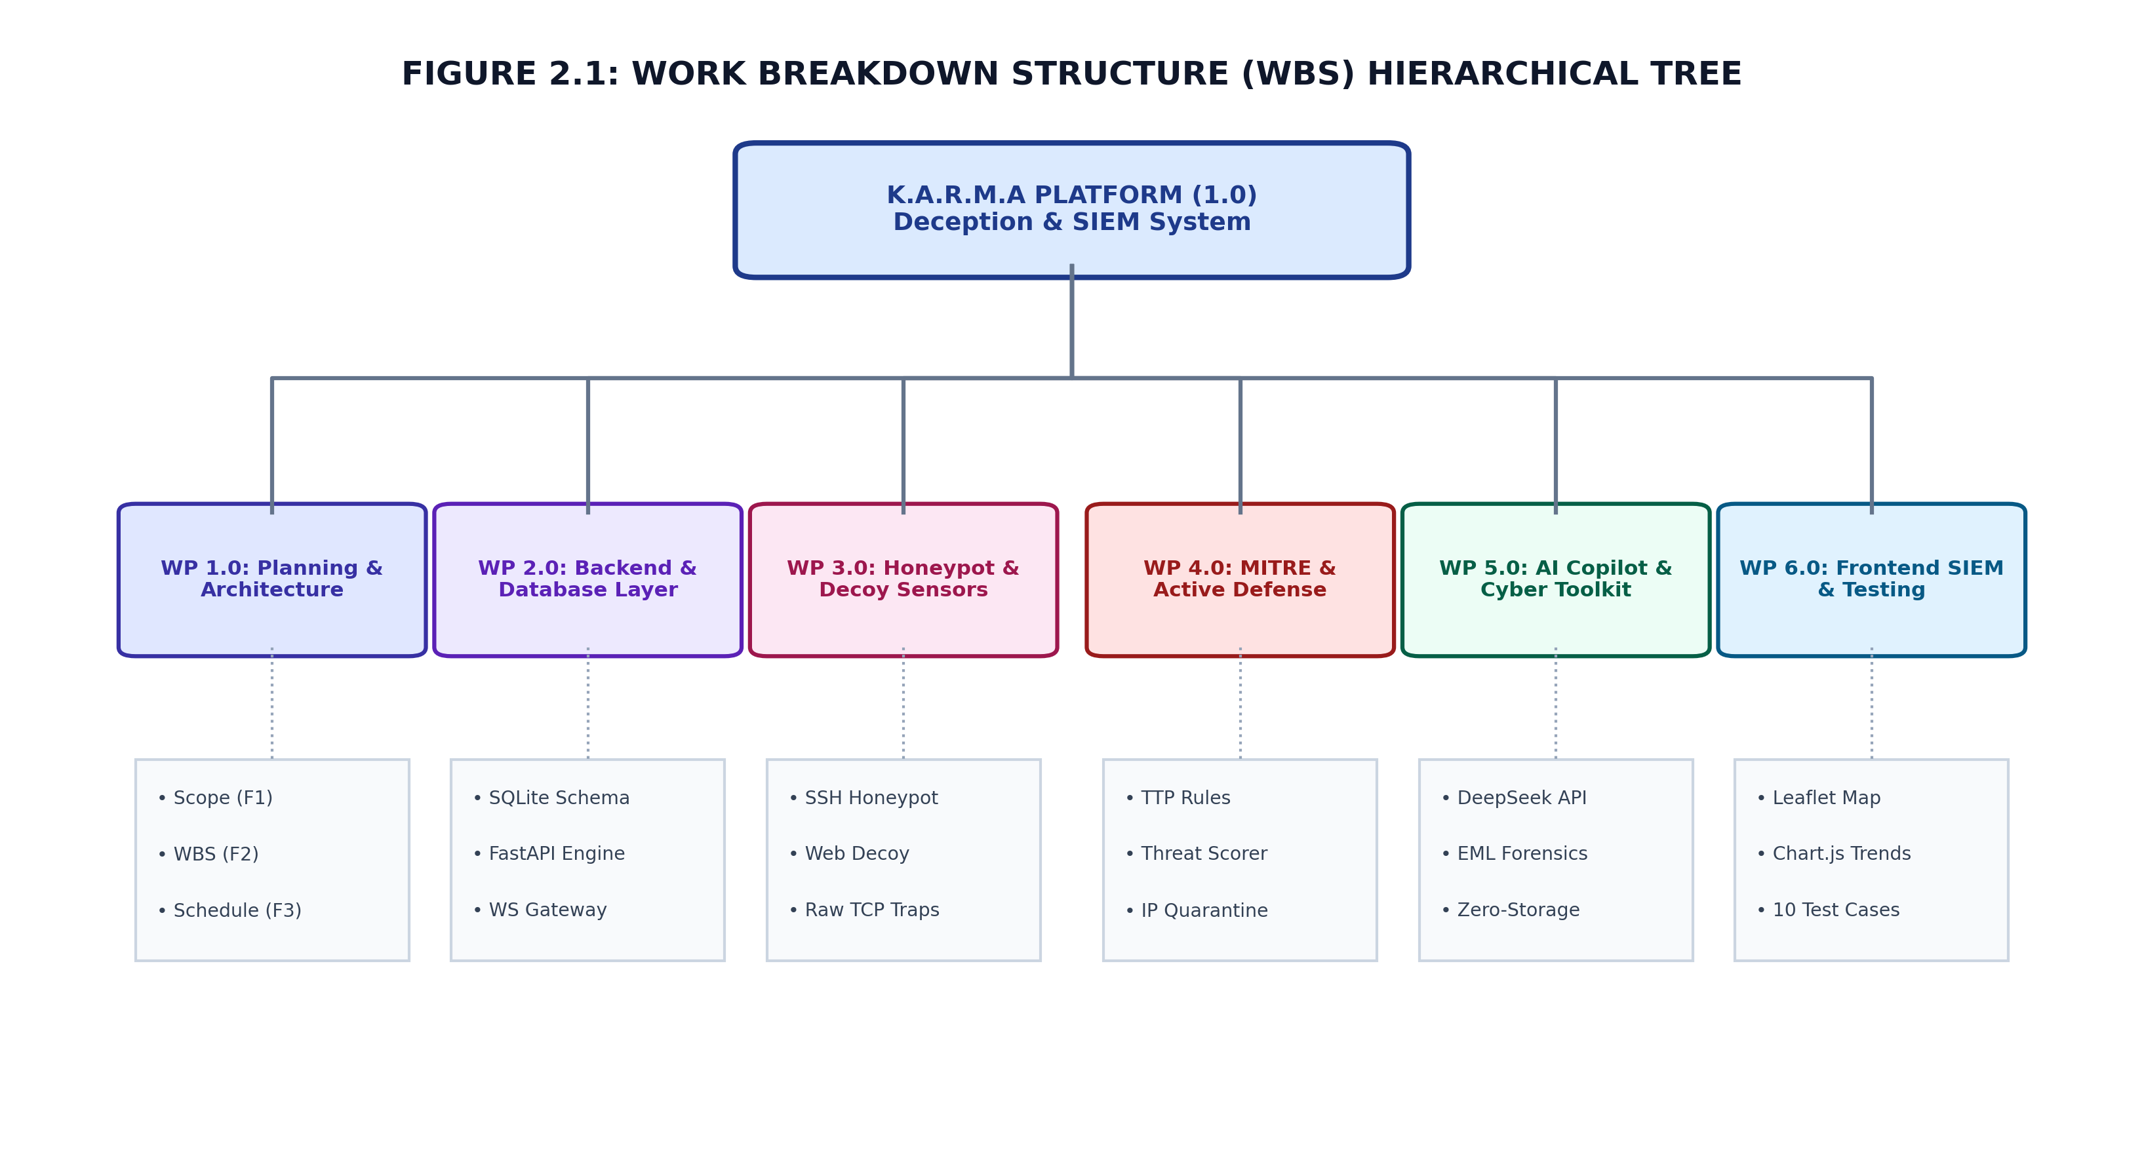
Figure 3.3: Work Breakdown Structure (WBS) Hierarchical Tree

3. Complete System Architecture
Figure 3.1: K.A.R.M.A High-Level System Architecture Block Diagram
Figure 3.2: Data Flow Diagram (DFD Level 0 — Context Model)
Figure 3.3: Work Breakdown Structure (WBS) Hierarchical Tree
┌──────────────────────────────┐
│ ATTACKER / SCANNER │
│ Nmap / SSH client / Browser │
│ Web scanner / FTP / Telnet │
└──────────────┬───────────────┘
│
┌──────────────────────┼──────────────────────┐
│ │ │
▼ ▼ ▼
┌────────────────┐ ┌────────────────┐ ┌────────────────────┐
│ SSH Honeypot │ │ Web Honeypot │ │ Raw TCP Decoys │
│ TCP :2222 │ │ HTTP :8080 │ │ :21 :23 :3389 │
│ Paramiko │ │ FastAPI │ │ socket + threads │
└───────┬────────┘ └───────┬────────┘ └─────────┬──────────┘
│ │ │
└─────────────────────┼───────────────────────┘
▼
┌─────────────────────────┐
│ MITRE Mapper │
│ Payload/Service rules │
└────────────┬────────────┘
▼
┌─────────────────────────┐
│ Threat Score Engine │
│ 0–100 + severity │
└────────────┬────────────┘
▼
┌─────────────────────────┐
│ Active Defense Engine │
│ Threshold = 75 │
│ Application quarantine │
└────────────┬────────────┘
│
┌─────────────────┼─────────────────┐
▼ ▼ ▼
┌────────────────┐ ┌────────────────┐ ┌──────────────────┐
│ SQLite │ │ CSV Audit Log │ │ WebSocket Stream │
│ attack logs │ │ session file │ │ live telemetry │
│ attackers │ │ immediate flush│ │ to browser │
│ honeytokens │ └────────────────┘ └─────────┬────────┘
│ quarantine │ │
└───────┬────────┘ ▼
│ ┌─────────────────────┐
└─────────────────────────────►│ HTML/CSS/JS SIEM │
│ Charts + Map + MITRE│
│ Tables + AI reports │
└─────────────────────┘

Additional path:
.EML upload → FastAPI multipart endpoint
→ RFC822/MIME parser
→ header checks
→ DeepSeek AI / local fallback
→ phishing report

3.1 Major layers
Layer | Components | Purpose
Sensor layer | SSH, Web, Raw TCP decoys | Receive attacker interaction.
Detection layer | MITRE mapper, threat score | Classify behaviour and calculate risk.
Response layer | Active defense/quarantine | Record containment decisions.
Storage layer | SQLite, CSV | Persist telemetry and audit trail.
Transport layer | REST API, WebSocket | Move data between browser and backend.
Presentation layer | HTML, CSS, JavaScript, Leaflet, Chart.js | Display live SOC information.
AI layer | Threat report + phishing analysis | Turn telemetry into analyst-friendly conclusions.

4. Repository Structure and Role of Every File
Path | Role
run.py | Starts the FastAPI application through Uvicorn.
requirements.txt | Lists Python runtime dependencies.
setup.py | Build/packaging helper for standalone distribution.
backend/app.py | Main FastAPI API gateway, WebSocket endpoint, startup/shutdown lifecycle and sensor launcher.
backend/config.py | Ports, database path, quarantine threshold and default honeytokens.
backend/database.py | SQLite schema, CRUD functions, attack logging, attacker profiles, geolocation and quarantine data.
backend/decoy_state.py | In-memory registry for enabled/disabled decoys and custom decoy creation.
backend/honeytokens.py | Creates generated decoy credentials, API keys and URLs.
backend/attack_simulator.py | Generates a controlled sequence of attack events for demonstration.
backend/engine/mitre_mapper.py | Rule-based mapping from service/attack payload to MITRE technique.
backend/engine/threat_score.py | Converts base risk and frequency into final score and severity.
backend/engine/active_defense.py | Automatically/manualy records IP quarantine and containment state.
backend/engine/csv_logger.py | Creates session CSV and flushes each event.
backend/engine/ai_analyst.py | Creates event-level and attacker-level forensic summaries.
backend/engine/phishing_analyzer.py | Parses .eml/.msg-like upload, checks headers and calls DeepSeek/fallback.
backend/sensors/ssh_honeypot.py | Paramiko SSH server/decoy and fake shell.
backend/sensors/web_honeypot.py | Fake corporate login and web attack capture.
backend/sensors/raw_decoy.py | Raw TCP listeners for FTP/Telnet/RDP-style decoys.
backend/sensors/ssh_host_rsa_key | Persistent RSA private host key used by Paramiko.
frontend/index.html | Main SIEM dashboard markup and UI containers.
frontend/css/style.css | Dashboard styling and responsive/theme presentation.
frontend/js/app.js | Main UI logic, API polling, tables, maps, modals and actions.
frontend/js/charts.js | Chart.js visualizations.
frontend/js/mitre.js | MITRE technique catalog and heatmap/grid.
frontend/js/tools.js | Password and phishing tool frontend.
frontend/js/websocket.js | Live telemetry WebSocket client and reconnect logic.

4.1 Dependencies from requirements.txt
Package | Why used in K.A.R.M.A
FastAPI | Python ASGI web framework for REST endpoints, WebSocket endpoint and web honeypot.
Uvicorn | ASGI server used to run FastAPI.
websockets | WebSocket support/dependency for real-time communication.
Paramiko | SSH protocol implementation used by the SSH honeypot.
Pydantic | Validation/data models for API request bodies.
Jinja2 | Template engine dependency; useful for server-side HTML templating.
requests | HTTP client used for DeepSeek API requests.
python-multipart | Multipart/form-data handling for form fields and uploaded .eml files.

5. Program Startup and Lifecycle

5.1 What happens when run.py is executed?
python run.py
│
▼
Import FastAPI application
│
▼
Uvicorn starts ASGI server
│
▼
FastAPI startup_event()
│
├── get_running_loop()
├── manager.set_loop(loop)
├── audit_csv_logger.start()
└── start_sensors(manager.sync_broadcast)
│
├── init_db()
├── set_web_broadcast_callback()
├── SSHHoneypotServer.start()
├── WebHoneypotServer.start()
└── RawDecoyServer.start()

5.2 Ports
Port | Protocol/Role | Meaning
8000 | HTTP | Main SIEM dashboard + REST API + honeytoken/decoy API endpoints.
2222 | TCP/SSH | Paramiko SSH honeypot.
8080 | HTTP | Web application honeypot.
21 | TCP/FTP-style | Raw FTP decoy listener.
23 | TCP/Telnet-style | Raw Telnet decoy listener.
3389 | TCP/RDP-style | RDP port probe decoy.

5.3 Why port 2222 instead of 22?
Port 22 is normally used by a real SSH service. A honeypot can use an alternative port so that it can coexist with a legitimate SSH service and reduce the risk of accidentally intercepting administration traffic. In this project, 2222 is the deliberate SSH trap port.

6. FastAPI, Uvicorn and ASGI

6.1 FastAPI
FastAPI is a modern Python web framework designed for building APIs. It supports asynchronous endpoints, request validation through Pydantic, automatic API documentation and ASGI deployment.
K.A.R.M.A uses FastAPI in two places: the main SIEM application in backend/app.py and the web honeypot in backend/sensors/web_honeypot.py.

6.2 Uvicorn
Uvicorn is an ASGI web server. FastAPI defines the application and routes; Uvicorn provides the runtime that listens on a network interface and passes HTTP/WebSocket requests to FastAPI.
Client
│ HTTP/WebSocket
▼
Uvicorn (ASGI server)
▼
FastAPI application
▼
Route function
▼
Response

6.3 ASGI
ASGI stands for Asynchronous Server Gateway Interface. It is the interface between Python asynchronous web applications and web servers. It extends the older WSGI model and supports long-lived connections such as WebSockets.

6.4 REST API
REST is an architectural style for network services. A REST API exposes resources through HTTP methods such as GET, POST, PUT and DELETE. K.A.R.M.A uses endpoints such as /api/logs, /api/attackers, /api/status and POST /api/quarantine/toggle.

6.5 Important HTTP methods
Method | Meaning | K.A.R.M.A example
GET | Read/retrieve data. | /api/logs
POST | Submit data or request an action. | /api/honeytokens/create
DELETE | Delete a resource. | CSV delete endpoint also accepts DELETE.
PUT | Usually replace/update a resource. | Generic HTTP concept; not a primary K.A.R.M.A route.

6.6 HTTP status codes in the project
Code | Meaning | Use in project
200 | OK | Normal successful API response.
401 | Unauthorized | Decoy API key endpoint response.
403 | Forbidden | Honeytoken trap/quarantine responses.
404 | Not Found | Missing/disabled decoy or CSV file.
500 | Internal Server Error | Tester endpoint error handling.

6.7 CORS
CORS stands for Cross-Origin Resource Sharing. It controls whether a browser page from one origin may make requests to another origin. K.A.R.M.A configures CORSMiddleware with permissive settings. This is convenient for a demo but should be restricted to trusted origins in production.

6.8 Pydantic
Pydantic validates structured request data. For example, QuarantineRequest requires an IP and action, while HoneytokenRequest requires a name and type. This prevents many malformed request bodies from reaching business logic.

7. Python Concepts Used in K.A.R.M.A
Python concept | Project usage
Modules/imports | Separates application, database, sensors and engines.
Classes | ConnectionManager, SSHHoneypotServer, RawDecoyServer, ActiveDefenseManager, ParamikoHoneypotInterface.
Functions | Route handlers, database CRUD functions and analysis helpers.
async/await | FastAPI endpoints and WebSocket connection management.
Threading | Runs independent honeypot sockets and attacker sessions without blocking the main API.
Exceptions | Keeps sensor threads and loggers from crashing the whole application.
Dictionaries | Events, configuration, MITRE rules and JSON-like responses.
List/set operations | Collects services and unique MITRE techniques.
f-strings | Builds payload and response messages.
Environment variables | DEEPSEEK_API_KEY can be supplied from environment.
File I/O | CSV audit files, SSH host key and frontend/static files.
SQLite module | Database persistence through sqlite3.

7.1 Threading vs async
This distinction is a common viva question. Async functions are cooperative and allow the event loop to handle other tasks while waiting for I/O. Threads provide separate execution contexts. K.A.R.M.A uses FastAPI async endpoints for HTTP/WebSocket operations and uses daemon threads for blocking socket listeners and client sessions.
FastAPI event loop
│
├── async REST endpoints
├── async WebSocket
│
└── background sensor threads
├── SSH listener
├── Web honeypot server thread
└── Raw TCP listeners

7.2 daemon=True
A daemon thread is a background thread that does not keep the Python process alive after the main process exits. K.A.R.M.A uses daemon threads for sensors and attack simulation.

8. SSH, Paramiko and the SSH Honeypot

8.1 SSH
SSH stands for Secure Shell. It is a secure network protocol used for remote administration and secure command execution. It normally uses TCP port 22 and provides confidentiality, integrity and authentication through cryptographic mechanisms.

8.2 Paramiko
Paramiko is a Python implementation/library for SSHv2. In K.A.R.M.A it acts as the server-side protocol engine for the SSH honeypot. The project creates a Paramiko Transport, adds an RSA host key, accepts authentication and presents a fake shell.

8.3 SSH connection flow in K.A.R.M.A
Attacker
│
│ TCP connect :2222
▼
SSHHoneypotServer._run_server()
│ accept()
▼
_handle_client()
│
├── paramiko.Transport(client_sock)
├── add_server_key(HOST_KEY)
└── start_server(ParamikoHoneypotInterface)
│
├── check_channel_request()
├── check_auth_password()
├── check_auth_publickey()
├── check_channel_pty_request()
└── check_channel_shell_request()
│
▼
fake shell / command capture
│
▼
MITRE → risk → database
│
▼
broadcast

8.4 Why does the honeypot return AUTH_SUCCESSFUL?
A honeypot wants the attacker to continue interacting with the decoy. If every login attempt is rejected immediately, the system learns only the username/password attempt. By accepting the authentication in the decoy, K.A.R.M.A can observe subsequent commands such as whoami, id or cat /etc/passwd.

8.5 RSA host key
The SSH server needs a host key so the client can identify the SSH server during the cryptographic handshake. K.A.R.M.A stores/loads a persistent RSA key from ssh_host_rsa_key and generates a new 2048-bit RSA key if the file is absent or unusable.
Important: the host key authenticates the server identity; it is different from the attacker's username/password.

8.6 SSH key vs host key vs user key
Key | Purpose
SSH host key | Identifies the SSH server to clients.
User private key | Authenticates a user/client to an SSH server.
Public key | Can be distributed and used to verify signatures or authenticate the corresponding private key.

8.7 Fake shell
The project uses a predefined FAKE_SHELL_RESPONSES dictionary. It does not execute commands on the operating system. Instead, it returns simulated output. This is a major safety feature because attacker commands remain inside the deception environment.

9. FTP, Telnet, RDP and Raw TCP Decoys

9.1 FTP
FTP stands for File Transfer Protocol. It traditionally uses TCP port 21 for the control connection. It is not encrypted by default. K.A.R.M.A binds a raw TCP socket to port 21 and sends a ProFTPD-style banner. It responds to selected commands such as USER, PASS, PWD, LIST and QUIT.

9.2 Telnet
Telnet is a legacy remote terminal protocol and normally uses TCP port 23. It transmits data in plaintext. K.A.R.M.A simulates an Ubuntu login prompt and records commands such as whoami, id and passwd/shadow probes.

9.3 RDP
RDP stands for Remote Desktop Protocol and is commonly associated with TCP port 3389. K.A.R.M.A does not implement a complete RDP server. It listens on the port and returns a small RDP-like byte sequence after a connection, mainly to make port scanning observable.

9.4 Raw TCP socket
A socket is an operating-system abstraction for network communication. K.A.R.M.A uses socket.socket(AF_INET, SOCK_STREAM), bind(), listen() and accept() to create TCP listeners.
socket(AF_INET, SOCK_STREAM)
│
├── AF_INET → IPv4
└── SOCK_STREAM → TCP
│
bind()
│
listen()
│
accept()
│
client socket + IP
│
handler thread
│
log + broadcast

9.5 Why these ports?
They represent recognizable services that automated scanners commonly probe. The goal is not to implement production FTP/Telnet/RDP; it is to make reconnaissance visible and attributable.

10. Web Honeypot and Web Attacks

10.1 Web honeypot
The web honeypot is a separate FastAPI application named web_decoy_app. It presents a fake corporate authentication portal and catches requests through explicit routes plus a catch-all route.

10.2 Web attack flow
Browser / Scanner
│
▼
GET / or POST /login or any path
│
▼
process_web_attack(client_ip, path, method, payload)
│
├── is decoy enabled?
├── honeytoken URL/key hit?
├── map_payload_to_mitre()
├── calculate_event_risk()
├── log_attack_event()
├── get_geo_info()
├── active_defense_engine.process_event()
└── broadcast_cb(event)

10.3 SQL Injection (SQLi)
SQL Injection occurs when untrusted input is interpreted as part of a database query. Typical malicious patterns include UNION SELECT, OR 1=1, DROP TABLE and INSERT. K.A.R.M.A does not intentionally execute these strings against a real database; it detects them as attack payloads in the decoy and maps them to T1190.

10.4 XSS
Cross-Site Scripting occurs when attacker-controlled content is injected into a web page and later interpreted as executable script by a browser. A typical probe contains script-like markup. In a honeypot, the payload should be captured rather than executed.

10.5 Path Traversal
Path traversal attempts to access files outside the intended web directory, often using sequences such as ../ or ../../. K.A.R.M.A includes ../../ and /etc/passwd among its MITRE mapping keywords.

10.6 Directory fuzzing
Directory fuzzing is automated testing of many URLs to find hidden files, administrative paths or vulnerable endpoints. The project maps patterns such as /.env, /wp-login.php and /phpmyadmin to Active Scanning T1595.

10.7 Catch-all route
The catch-all route receives unknown GET/POST/PUT/DELETE paths and passes them into process_web_attack. This is useful because attackers rarely use only the exact URLs anticipated by the developer.

11. Honeytokens and the 'Staging Key'

11.1 Honeytoken
A honeytoken is a deliberately planted digital object that should not be used by a legitimate user. Examples are fake credentials, API keys, secret URLs, database export links or tracking values. Because legitimate users should not touch them, access is a strong indicator of compromise.

11.2 Honeytoken vs honeypot
Concept | Meaning
Honeypot | A decoy system/service designed to attract and observe interaction.
Honeytoken | A decoy piece of data/credential/URL designed to trigger an alert when accessed.

11.3 Default K.A.R.M.A honeytokens
Token | Type | Purpose
Decoy AWS Production Key | API Key | Looks like an AWS-style credential planted in a fake leak.
Secret DB Admin Portal | Decoy URL | A hidden admin/recovery path intended to attract exploration.
Staging Server Private Key | Credentials | Fake root/staging credentials planted in a configuration-file scenario.

11.4 What is a staging key?
A staging key is a credential or cryptographic key associated with a staging/test environment rather than the production environment. In K.A.R.M.A, the 'Staging Server Private Key' is a fake credential honeytoken. It is not a real production private key and should be explained as a decoy secret used to detect unauthorized access.

11.5 Why a staging credential is attractive to an attacker
- Attackers often search source code, configuration files, backups and repositories for credentials.
- A credential that appears to belong to a staging server can look less protected than production credentials.
- Once a planted credential is used, the security team receives a high-confidence signal that someone is interacting with a decoy.

11.6 Honeytoken lifecycle
Create token
│
▼
Store token metadata in SQLite
│
▼
Plant/show token in decoy location
│
▼
Attacker accesses token
│
▼
record_honeytoken_hit()
│
▼
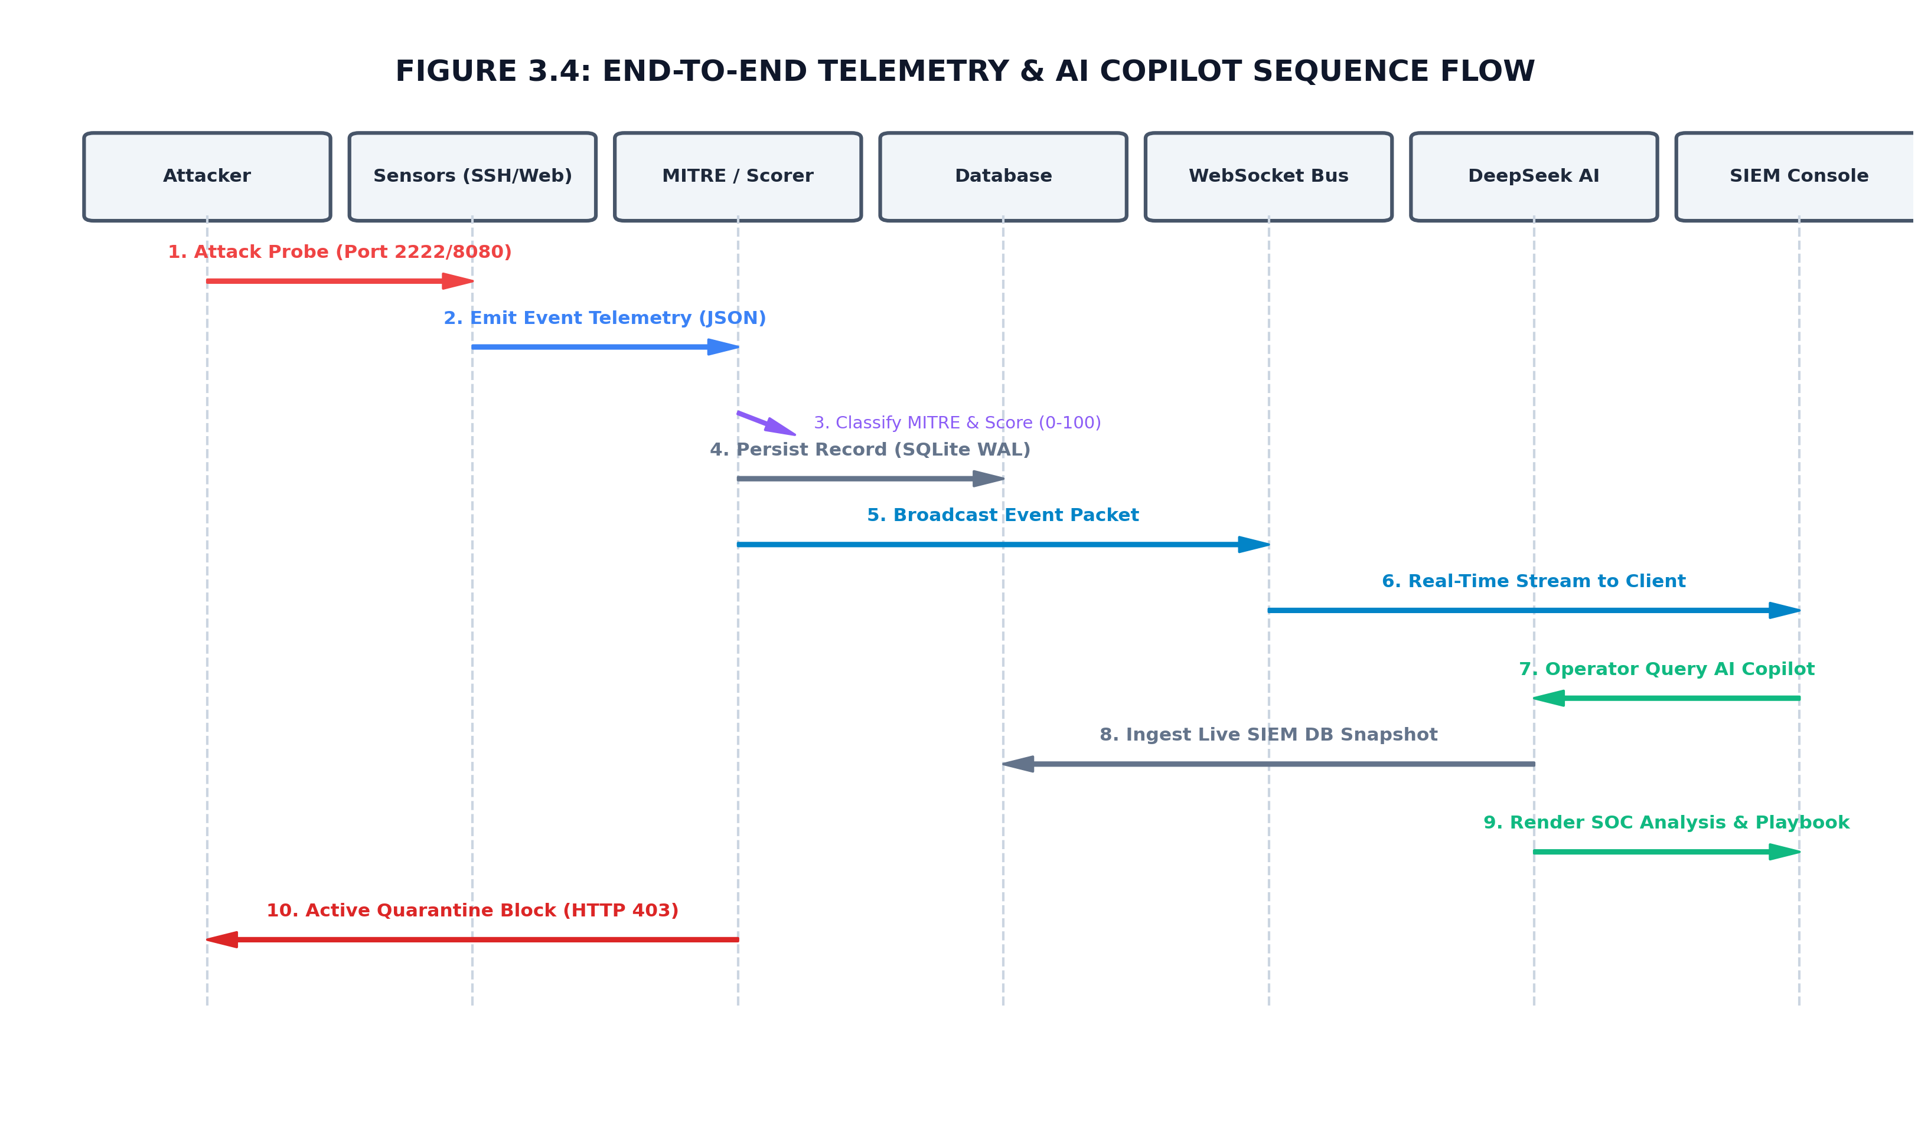
Figure 12.1: End-to-End Telemetry & AI Copilot Call Sequence Flow
Log + MITRE + risk + quarantine + dashboard

Figure 12.1: End-to-End Telemetry & AI Copilot Call Sequence Flow

12. API, Endpoint and WebSocket Concepts

12.1 API
API stands for Application Programming Interface. It is a defined interface through which software components communicate. In K.A.R.M.A, browser JavaScript calls backend HTTP endpoints instead of directly accessing the SQLite database.

12.2 Important K.A.R.M.A endpoints
Endpoint | Method | Purpose
/ | GET | Serve dashboard for localhost; external access becomes a deception event.
/api/status | GET | System status and metrics.
/api/logs | GET | Recent attack logs.
/api/attackers | GET | Attacker profiles.
/api/mitre | GET | MITRE statistics.
/api/honeytokens | GET | Honeytoken list.
/api/honeytokens/create | POST | Create a custom honeytoken.
/api/quarantine | GET | Quarantine list.
/api/quarantine/toggle | POST | Block/unblock an IP in application quarantine.
/api/ai-report/{ip} | GET | Attacker-level AI/forensic summary.
/api/ai-report/event/{log_id} | GET | Single-event forensic report.
/api/decoys | GET | Decoy registry.
/api/decoys/toggle | POST | Enable/disable a decoy.
/api/decoys/add | POST | Create custom decoy metadata.
/api/tools/phishing-eml | POST | Upload and analyse .eml/.msg file.
/ws/telemetry | WebSocket | Live telemetry stream.

12.3 WebSocket
A WebSocket is a persistent, bidirectional communication channel over a single connection. Unlike repeated HTTP polling, the server can push an event to the browser immediately after an attack event occurs.
Backend event
│
▼
manager.sync_broadcast(event)
│
├── audit_csv_logger.log_event(event)
│
└── asyncio.run_coroutine_threadsafe(
manager.broadcast_json(event)
)
│
▼
WebSocket client
│
▼
prependTelemetryRow()
│
▼
Dashboard updates

12.4 REST polling vs WebSocket
REST polling | WebSocket
Browser repeatedly asks for new data. | Server can push new data immediately.
Simple request/response. | Persistent connection.
More overhead for frequent updates. | Efficient for continuous telemetry.
Used by K.A.R.M.A for dashboard snapshots. | Used by K.A.R.M.A for live attack events.

13. SQLite Database Design

13.1 Why SQLite?
SQLite is an embedded relational database. It requires no separate database server and stores data in a local file. It is appropriate for a student/demo platform where deployment simplicity is important.

13.2 Database tables
Table | Purpose | Important fields
attack_logs | Every security event. | id, timestamp, attacker_ip, port, service, attack_type, payload, MITRE, risk, severity, geo.
attackers | One profile per IP. | ip, first_seen, last_seen, attempts, max_risk_score, status, services.
honeytokens | Decoy secrets and their hits. | token_id, name, type, token_value, hit_count, last_hit_ip.
quarantine_list | IPs currently contained in application state. | ip, quarantined_at, reason, risk_score, status.

13.3 Event persistence
log_attack_event(...)
│
├── get_db()
├── datetime.now()
├── get_geo_info(ip)
├── INSERT attack_logs
│
├── SELECT attacker profile
│
├── UPDATE existing profile
│ OR
│ INSERT new profile
│
├── COMMIT
└── return log_id

13.4 SQL injection protection in K.A.R.M.A backend
The database functions use parameterized SQLite queries such as WHERE ip = ? and pass values separately. This is safer than concatenating untrusted strings directly into SQL. The web honeypot may capture SQL injection strings, but it does not build a vulnerable production query from them.

13.5 Database migration
init_db() attempts to add geolocation columns to older database schemas using ALTER TABLE. The operation is wrapped in exception handling because the column may already exist.

14. MITRE ATT&CK, Tactics, Techniques and TTPs

14.1 What is MITRE ATT&CK?
MITRE ATT&CK is a knowledge base describing adversary tactics and techniques observed in real-world cyber operations. A tactic explains the adversary's goal; a technique explains how the goal is achieved.

14.2 TTP
TTP means Tactics, Techniques and Procedures. It is a common way of describing attacker behaviour from high-level intent to specific operational behaviour.

14.3 K.A.R.M.A mappings
ID | Technique | K.A.R.M.A trigger | Tactic
T1110 | Brute Force | Repeated/login credential probes. | Credential Access
T1190 | Exploit Public-Facing Application | SQLi/XSS/path-traversal style web payloads. | Initial Access
T1059 | Command and Scripting Interpreter | whoami, id, uname, wget, curl, chmod, cat /etc etc. | Execution
T1046 | Network Service Discovery | Port scan/connect probe. | Discovery
T1078 | Valid Accounts (Honeytoken) | Decoy credentials/API key/secret URL access. | Initial Access
T1595 | Active Scanning | Web fuzzing and common discovery paths. | Reconnaissance

14.4 How mapping actually works
Input:
decoy_service + attack_type + payload
│
▼
convert to lowercase
│
▼
iterate MITRE_MAPPING_RULES
│
├── service matches?
└── keyword matches?
│
YES▼
return MITRE ID,
name, tactic,
base risk, severity
│
NO ▼
fallback mapping

14.5 Is this machine learning?
No. The current MITRE mapper is rule-based classification. It uses predefined keywords and service names. The AI module is separate. During viva, say: “MITRE mapping is deterministic rule-based classification; AI is used for higher-level analyst-style summaries and phishing analysis.”

15. Threat Scoring and Severity

15.1 Formula
The current threat_score.py uses a simple frequency boost:
freq_boost = min(30, (attempt_count - 1) * 5)
final_score = min(100, base_risk + freq_boost)

Severity:
score >= 85 → CRITICAL
score >= 70 → HIGH
score >= 45 → MEDIUM
otherwise → LOW

15.2 Example
Base risk | Attempts | Frequency boost | Final score | Severity
70 | 1 | 0 | 70 | HIGH
70 | 2 | 5 | 75 | HIGH
70 | 4 | 15 | 85 | CRITICAL
45 | 2 | 5 | 50 | MEDIUM

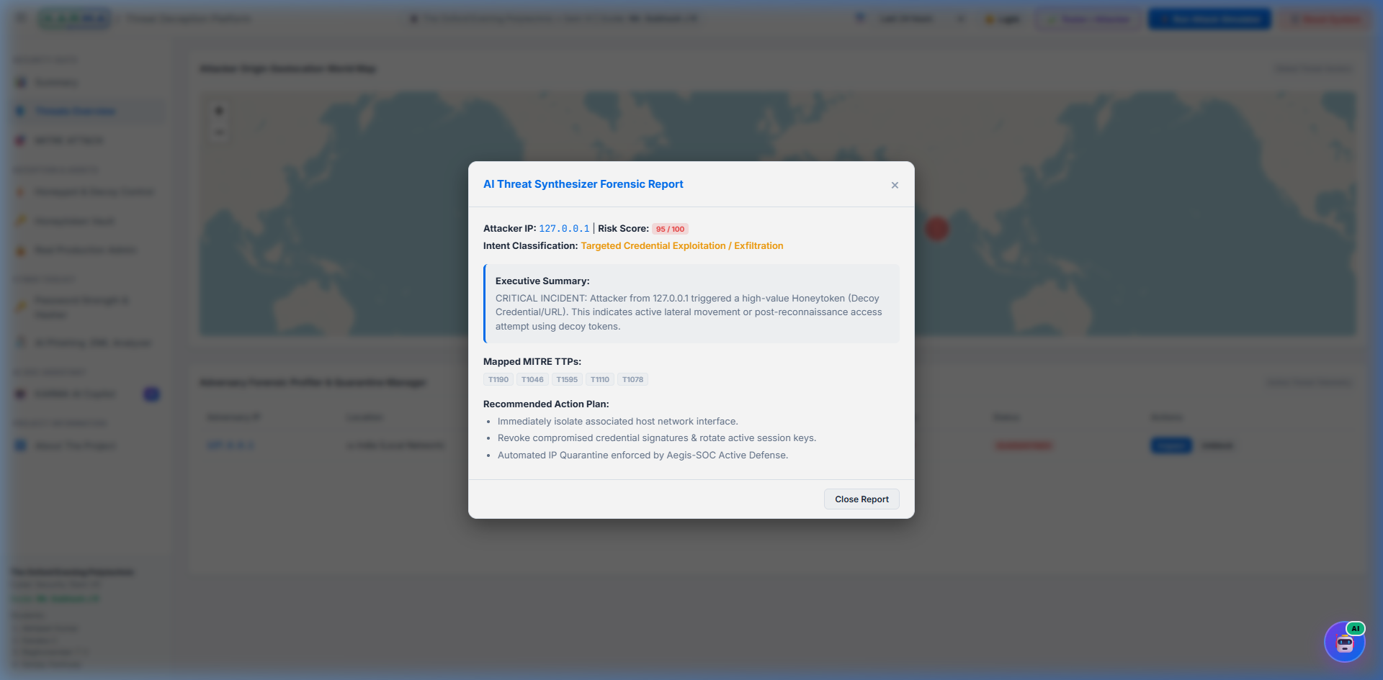
Figure 16.1: Active Defense & Automated IP Quarantine Management Panel

15.3 Important code detail
The calculate_event_risk function accepts attempt_count, but several current call sites use the default attempt_count=1. Therefore, the frequency boost is not automatically cumulative at every sensor event. The attacker profile separately stores total_attempts and max_risk_score. This distinction can impress an examiner if explained honestly.
Figure 22.1: Active Defense & Automated IP Quarantine Management Panel

15.4 Quarantine threshold
config.py defines QUARANTINE_SCORE_THRESHOLD = 75. The ActiveDefenseManager automatically adds an IP to the application quarantine list when a processed event reaches or exceeds this threshold, provided auto-quarantine is enabled.

16. Active Defense and Quarantine

16.1 What is active defense?
Active defense means taking an action after detecting malicious activity, rather than only recording it. Examples include blocking an IP, isolating a host, disabling an account or terminating a session.

16.2 K.A.R.M.A implementation
Attack event
│
▼
process_event(ip, risk, mitre)
│
├── auto_quarantine_enabled?
│
└── risk >= 75?
│
YES▼
add_to_quarantine()
│
├── INSERT/REPLACE quarantine_list
└── UPDATE attackers.status = QUARANTINED

16.3 Manual quarantine
The dashboard can POST to /api/quarantine/toggle with BLOCK or UNBLOCK. BLOCK calls manual_quarantine(); UNBLOCK calls manual_unblock().

16.4 Important limitation
The current active defense engine changes K.A.R.M.A's application/database state. It does not directly call Windows Firewall, Linux iptables/nftables, cloud security groups or a router API. Therefore, in viva call it “application-level autonomous quarantine” unless you later add actual network enforcement.
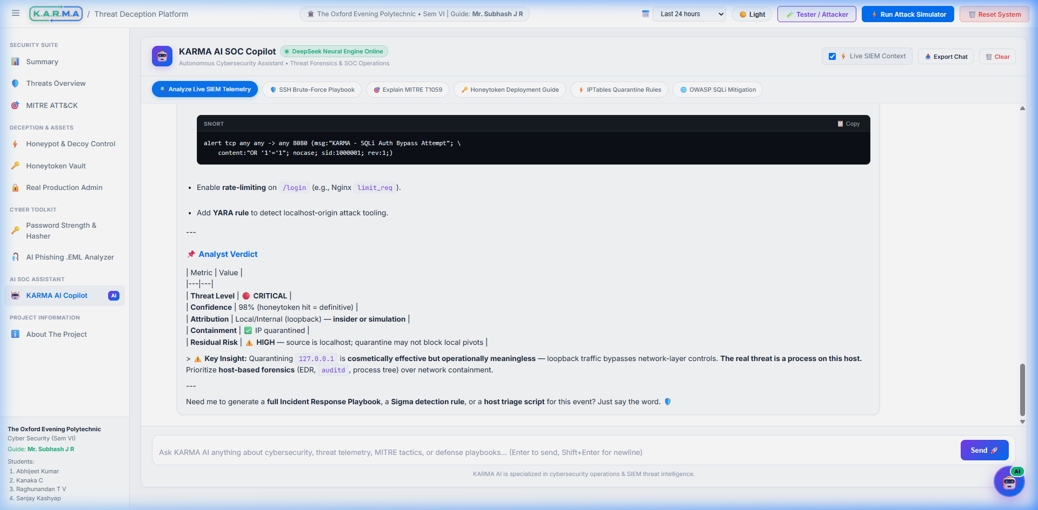
Figure 18.1: KARMA AI Cybersecurity SOC Copilot Full-Screen Workspace

17. CSV Audit Logging
The AuditCsvLogger creates a timestamped session file under logs/ and writes a standard header. Every telemetry event is flushed immediately.
CSV field | Meaning
Log_ID | Database event ID.
Timestamp | Event time.
Attacker_IP | Source IP.
Country / City | Demonstration geolocation.
Target_Service | Decoy service.
Port | Target port.
Attack_Type | Event classification.
Executed_Payload | Captured command/request.
MITRE_ID / MITRE_Name | Mapped technique.
Severity | LOW/MEDIUM/HIGH/CRITICAL.
Risk_Score | 0–100 event risk.
Action_Taken | Monitored or quarantined/isolated.

Why flush every event?
flush() pushes buffered output to the underlying file more immediately. It reduces the amount of telemetry that could remain only in memory if the program terminates unexpectedly.

Figure 18.1: KARMA AI Cybersecurity SOC Copilot Full-Screen Workspace

18. AI Threat Intelligence

18.1 Attacker-level report
generate_ai_threat_summary() receives an IP, its logs and attacker profile. It looks at total events, targeted services, MITRE IDs and maximum risk, then selects an intent category and recommended response.

18.2 Event-level report
generate_single_event_ai_report() analyses one event. It checks payload patterns such as cat /etc/passwd, whoami/id, authentication words and SQL injection strings and returns an analyst-style forensic explanation.

18.3 AI vs rule-based logic
Component | Technique
MITRE mapper | Rule-based keyword/service matching.
Threat score | Deterministic numerical formula.
Event forensic report | Rule-based intent classification.
DeepSeek phishing analysis | External AI model call with structured JSON request.
Phishing fallback | Local heuristic scanner.

18.4 What is an AI API?
An AI API is a network interface that allows an application to send input to an AI service and receive model-generated output. K.A.R.M.A uses requests.post() to send a JSON payload containing system/user messages and a model name.

18.5 Bearer token / API key
The HTTP Authorization header uses the Bearer scheme. Conceptually, the API key acts as a credential proving that the caller is authorized to use the service. It must be kept secret.

18.6 Environment variable
An environment variable is a configuration value provided outside source code, typically through the operating system or deployment environment. DEEPSEEK_API_KEY is read using os.environ.get(). This is preferable to hardcoding secrets.

18.7 Critical security issue in current code
The current phishing_analyzer.py contains a fallback key string in source code. This should be removed before public deployment. Rotate the exposed key if it is real, store secrets only in environment variables or a secret manager, and never commit API keys to Git.

19. AI Phishing .EML Analyzer

19.1 What is .EML?
An .eml file is a raw email message format. It commonly follows Internet Message Format/RFC 5322 conventions and uses MIME for multipart content such as plain text, HTML and attachments.

19.2 MIME
MIME stands for Multipurpose Internet Mail Extensions. It allows an email to contain different content types and attachments. Python's email package parses these structures.

19.3 Header fields used
Header | Purpose
From | Displayed sender address.
To | Recipient address.
Subject | Email subject.
Date | Message date/time.
Return-Path | Address used for return/bounce handling.
Reply-To | Address to which replies should be directed.
Authentication-Results | Authentication results reported by mail infrastructure.
Received | Mail transfer path/hops.

19.4 SPF
SPF stands for Sender Policy Framework. It is a DNS-based mechanism that allows a domain to publish which mail servers are authorized to send mail for that domain. SPF validation helps detect unauthorized sending, but it does not by itself prove that the displayed From address is trustworthy.

19.5 DKIM
DKIM stands for DomainKeys Identified Mail. It adds a cryptographic signature to email headers/content. The receiving system can use a DNS-published public key to verify the signature.

19.6 Return-Path mismatch
K.A.R.M.A extracts domains from From, Return-Path and Reply-To and flags mismatches. A mismatch is not automatically proof of phishing, but it is a useful forensic signal.

19.7 Phishing analysis flow
Browser
│ upload .eml
▼
POST /api/tools/phishing-eml
│
▼
parse_and_analyze_eml()
│
├── message_from_bytes()
├── extract headers
├── parse multipart/plain/html body
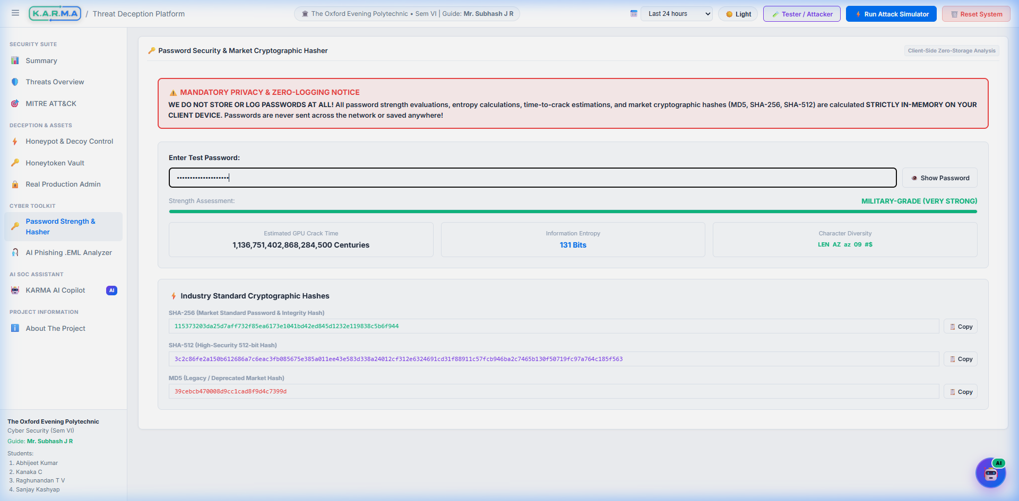
Figure 20.1: Client-Side Zero-Storage Password Hasher & Forensic Suite
├── extract domains
├── Return-Path mismatch?
├── Reply-To mismatch?
└── call_deepseek_phishing_ai()
│
├── DeepSeek JSON report
└── fallback heuristic if API fails

Figure 20.1: Client-Side Zero-Storage Password Hasher & Forensic Suite

20. Password Strength and Cryptography Tool

20.1 Password entropy
Entropy is an estimate of uncertainty in a password. K.A.R.M.A approximates entropy using H = L × log2(N), where L is password length and N is the estimated character pool size.

20.2 Character pools in current code
Character class | Pool contribution
Lowercase a–z | 26
Uppercase A–Z | 26
Digits 0–9 | 10
Symbols | 33

20.3 Crack-time estimate
The browser estimates brute-force time using N^L / 100,000,000,000 seconds, corresponding to an assumed 100 billion guesses/hashes per second. This is an illustrative estimate, not a universal real-world cracking speed.

20.4 SHA-256 and SHA-512
SHA-256 and SHA-512 are cryptographic hash functions in the SHA-2 family. They produce fixed-length digests and are designed for integrity/fingerprint purposes. A hash is not encryption because it is not intended to be reversed with a decryption key.

20.5 MD5 warning
The project UI labels one output as MD5, but the current generateClientMD5() implementation is a custom 32-character transformation, not the MD5 algorithm. MD5 should not be described as secure password hashing. If asked in viva, explicitly identify this as a limitation/area for improvement.

20.6 Client-side zero-storage concept
The password input is processed in browser JavaScript and is not intentionally sent to the backend by the password tool. This reduces exposure of the user's entered password. However, users should still avoid entering real passwords into demonstration tools.

21. HTML, CSS and JavaScript

21.1 HTML
HTML stands for HyperText Markup Language. It defines the structure of the dashboard: navigation, cards, tables, modals, forms, chart containers and tool sections.
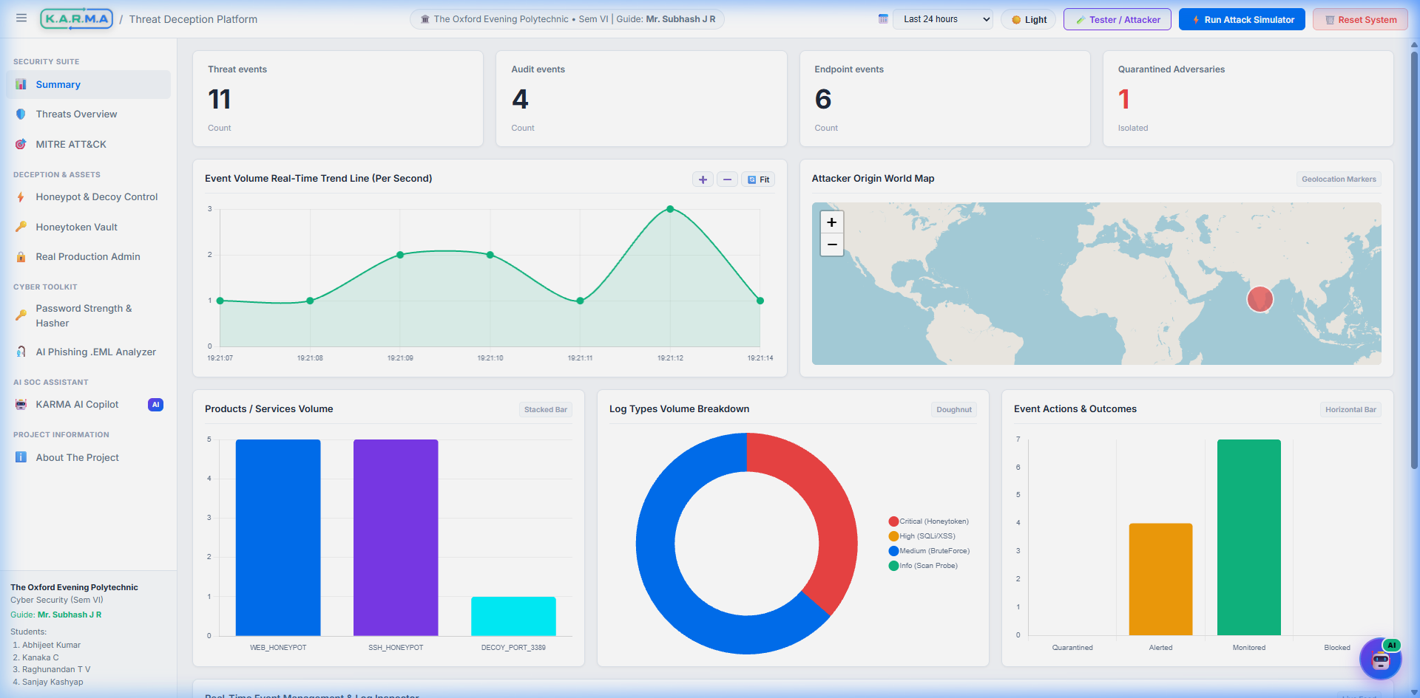
Figure 22.1: Real-Time Web SIEM Monitoring Console & KPI Analytics
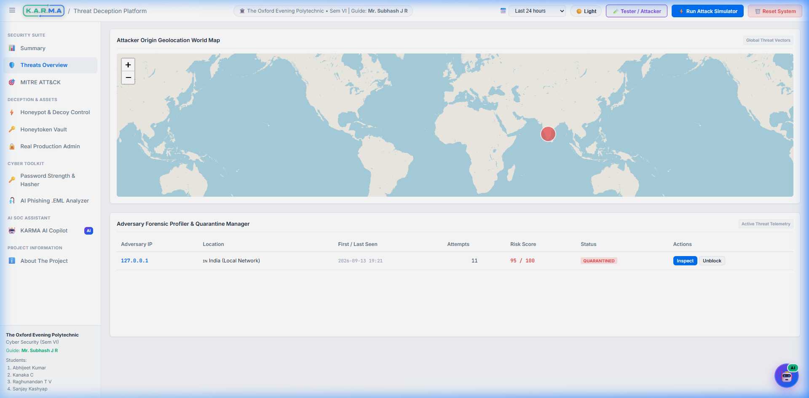
Figure 22.2: Attacker Origin Geolocation World Map with ESRI Dark Canvas

21.2 CSS
CSS stands for Cascading Style Sheets. It controls presentation: colors, spacing, typography, responsive layout, light/dark themes, buttons, tables and cards.

21.3 JavaScript
JavaScript provides browser-side behaviour. K.A.R.M.A uses it to call REST APIs, open WebSockets, update the DOM, render charts/maps, upload .eml files and trigger quarantine/AI actions.

21.4 DOM
DOM stands for Document Object Model. It represents an HTML document as objects that JavaScript can read and modify. Functions such as renderTelemetryTable() and renderAttackersTable() update DOM elements.

21.5 fetch()
fetch() is the browser API used for HTTP requests. K.A.R.M.A uses it to retrieve status/logs and send POST requests.

21.6 Promise.all()
Promise.all() waits for multiple asynchronous promises. fetchDashboardData() requests status, logs, attackers, MITRE and honeytokens concurrently.

21.7 localStorage
localStorage is browser storage. K.A.R.M.A uses it to remember the selected dashboard theme.

22. Leaflet.js and Chart.js

22.1 Leaflet
Leaflet is a JavaScript library for interactive maps. K.A.R.M.A uses it to render attacker-origin maps and place risk-based circle markers using latitude/longitude.

22.2 Chart.js
Chart.js is a JavaScript charting library. The project uses line, bar and doughnut/horizontal visualizations to show event volume and attack distribution.

22.3 Dashboard visualization flow
fetchDashboardData()
│
├── logs
│ └── updateSiemCharts(logs)
│
├── attackers
│ └── updateMapMarkers(attackers)
│
├── MITRE stats
│ └── renderMitreGrid(mitre)
│
└── honeytokens
└── renderHoneytokenList(tokens)

22.4 Geolocation limitation
The current database.py contains a demonstration IP map and deterministic fallback locations. Therefore, the map is suitable for a controlled demonstration but should not be described as accurate live geolocation without replacing the mock layer with a real IP intelligence provider.

23. Master Function Call Graph
run.py
└── uvicorn.run(...)
└── FastAPI app
└── startup_event()
├── manager.set_loop()
├── audit_csv_logger.start()
└── start_sensors()
├── init_db()
├── set_web_broadcast_callback()
├── SSHHoneypotServer.start()
│ └── _run_server()
│ └── _handle_client()
│ └── ParamikoHoneypotInterface
│ ├── check_auth_password()
│ ├── check_channel_request()
│ └── check_channel_shell_request()
│
├── WebHoneypotServer.start()
│ └── web_decoy_app routes
│ ├── get_login()
│ ├── post_login()
│ ├── get_honeytoken()
│ └── catch_all()
│ └── process_web_attack()
│
└── RawDecoyServer.start()
├── _listen_port(21)
├── _listen_port(23)
└── _listen_port(3389)
└── _handle_client_connection()
└── _log_and_broadcast()

Common event pipeline:
sensor
→ map_payload_to_mitre()
→ calculate_event_risk()
→ log_attack_event()
→ get_geo_info()
→ active_defense_engine.process_event()
→ add_to_quarantine() [if threshold reached]
→ manager.sync_broadcast()
├── audit_csv_logger.log_event()
└── manager.broadcast_json()
→ browser TelemetryWebSocket

23.1 Dashboard call graph
DOMContentLoaded
├── initTheme()
├── initSiemCharts()
├── initLeafletMap()
├── fetchDashboardData()
├── setupEventListeners()
└── initWebSocketConnection()

fetchDashboardData()
├── GET /api/status
├── GET /api/logs
├── GET /api/attackers
├── GET /api/mitre
├── GET /api/honeytokens
├── renderTelemetryTable()
├── updateSiemCharts()
├── renderMitreGrid()
├── renderAttackersTable()
├── renderHoneytokenList()
├── fetchDecoys()
└── updateMapMarkers()

TelemetryWebSocket.onmessage
└── prependTelemetryRow()
└── createTelemetryRowHTML()
+ fetchDashboardData()

24. Sensor-Level Call Graphs

24.1 SSH authentication event
SSH client
→ SSHHoneypotServer._run_server
→ _handle_client
→ Paramiko transport
→ check_auth_password(username, password)
→ map_payload_to_mitre()
→ calculate_event_risk()
→ log_attack_event()
├── get_geo_info()
└── update attackers table
→ active_defense_engine.process_event()
→ broadcast_cb(event)
→ dashboard

24.2 Web attack event
HTTP request
→ get_login()/post_login()/catch_all()
→ process_web_attack()
├── is_decoy_enabled()
├── record_honeytoken_hit() [if decoy token hit]
├── map_payload_to_mitre()
├── calculate_event_risk()
├── log_attack_event()
├── get_geo_info()
├── active_defense_engine.process_event()
└── broadcast_cb()
→ browser dashboard

24.3 Raw port scan
Scanner
→ TCP SYN/connect
→ RawDecoyServer._listen_port()
→ accept()
→ _handle_client_connection()
→ choose 21/23/3389 branch
→ _log_and_broadcast()
├── map_payload_to_mitre()
├── calculate_event_risk()
├── log_attack_event()
└── broadcast_callback()

24.4 Phishing analyzer
Upload
→ analyze_phishing_eml_api()
→ parse_and_analyze_eml()
├── message_from_bytes()
├── extract_domain()
├── header mismatch checks
└── call_deepseek_phishing_ai()
├── requests.post()
└── fallback forensic scanner
→ JSON result
→ frontend modal

25. Core Cybersecurity Terms for Viva
Term | Exam-ready meaning
Threat | A potential cause of harm to a system, organisation or data.
Vulnerability | A weakness that can be exploited.
Exploit | A method/code/action that takes advantage of a vulnerability.
Payload | The data or command delivered as part of an attack.
Attack surface | The set of exposed points through which an attacker may interact with a system.
Attack vector | The path or mechanism used to perform an attack.
IOC | Indicator of Compromise, such as an IP, hash, domain or suspicious file.
TTP | Tactics, Techniques and Procedures describing adversary behaviour.
Reconnaissance | Information gathering before or during an attack.
Brute force | Repeated attempts to guess credentials or keys.
Credential stuffing | Trying leaked username/password pairs against another service.
Password spraying | Trying one/few common passwords across many accounts.
Privilege escalation | Obtaining higher privileges than initially available.
Lateral movement | Moving from one compromised system/account to another.
Exfiltration | Unauthorised removal of data from a system/network.
Persistence | Maintaining access after initial compromise.
Command execution | Running commands or scripts on a target system.
Defence in depth | Using multiple independent security controls.
Zero trust | Security model that does not automatically trust users/devices based on network location.
SOC | Security Operations Center; monitors, investigates and responds to security events.
SIEM | Security Information and Event Management platform that collects, correlates and presents security telemetry.
SOAR | Security Orchestration, Automation and Response; automates security workflows.
IDS | Intrusion Detection System; detects suspicious activity.
IPS | Intrusion Prevention System; detects and attempts to block malicious activity.
EDR | Endpoint Detection and Response; monitors endpoint activity.
WAF | Web Application Firewall; filters and protects web applications.
MFA | Multi-Factor Authentication using two or more independent authentication factors.

26. Networking Terms You Must Know
Term | Meaning
IP address | Logical address identifying a network interface/host at the IP layer.
IPv4 | 32-bit IP addressing scheme such as 192.168.1.10.
IPv6 | 128-bit IP addressing scheme.
MAC address | Link-layer hardware/network interface identifier.
Port | 16-bit transport-layer number identifying a service endpoint.
TCP | Connection-oriented, reliable transport protocol.
UDP | Connectionless transport protocol with lower overhead and no built-in reliability.
Socket | Endpoint abstraction used by applications for network communication.
Bind | Associates a socket with a local IP/port.
Listen | Puts a TCP socket into passive server mode.
Accept | Accepts an incoming TCP connection.
Client | Initiates a connection/request.
Server | Waits for and serves incoming requests/connections.
localhost | Host name referring to the local machine, normally 127.0.0.1 for IPv4.
0.0.0.0 | Bind/listen address meaning all available IPv4 interfaces.
NAT | Network Address Translation between address spaces, commonly private and public networks.
DNS | Domain Name System; maps names to network information such as IP addresses.
HTTP | Application protocol used by the web.
HTTPS | HTTP protected by TLS.
TLS | Cryptographic protocol providing secure communication over networks.

27. Attack Techniques Mentioned by the Project
Attack | What examiner may ask | K.A.R.M.A relevance
Port scanning | What is it and why is it reconnaissance? | Ports 21/23/3389 detect connection probes.
SSH brute force | Why repeatedly try passwords? | Port 2222 captures usernames/password attempts.
SQL Injection | How does untrusted input affect a DB query? | Web honeypot captures SQLi patterns.
XSS | How can script injection affect a browser? | Web honeypot is designed to capture XSS-style probes.
Path traversal | Why is ../../ dangerous? | Mapped as web exploitation/reconnaissance.
Directory fuzzing | Why probe /.env or /phpmyadmin? | Maps to Active Scanning.
Credential harvesting | Why read /etc/passwd or shadow? | SSH fake shell records the command.
API key theft | Why is an API key a high-value secret? | Decoy API endpoint/honeytoken trap.
Database exfiltration | What is data exfiltration? | Fake db_export endpoint records access attempts.
Phishing | How do headers help detect spoofing? | .eml analyzer checks Return-Path/Reply-To and AI analysis.

28. CIA, AAA and Security Principles

28.1 CIA triad
Principle | Meaning | K.A.R.M.A perspective
Confidentiality | Only authorised parties access information. | Honeytokens demonstrate unauthorised credential/data access.
Integrity | Data remains accurate and unaltered. | Audit logs preserve a record of events.
Availability | Systems/data remain accessible to authorised users. | Decoys isolate attacker interaction from real services.

28.2 AAA
A | Meaning | Example
Authentication | Who are you? | SSH username/password attempt.
Authorization | What are you allowed to do? | Access to an admin endpoint would normally require authorization.
Accounting | What did you do? | K.A.R.M.A logs attacker actions/events.

28.3 Least privilege
Users/processes should receive only the permissions required for their task. A honeypot should also run with minimum privileges because it is intentionally exposed.

28.4 Defence in depth
Use multiple controls rather than relying on one control. In K.A.R.M.A, deception, logging, MITRE mapping, risk scoring, quarantine and analyst reporting provide multiple layers of detection/response.

29. OWASP and Web Security

29.1 OWASP
OWASP stands for Open Worldwide Application Security Project. It publishes guidance and risk information for application security.

29.2 OWASP Top 10 concepts relevant here
Concept | Why relevant
Injection | SQL injection is directly represented in the web honeypot's detection rules.
Identification/authentication failures | Fake login portal and brute-force detection demonstrate authentication threats.
Security misconfiguration | Exposed services/endpoints are common attack-surface examples.
Cryptographic failures | Password/hash discussions and insecure legacy protocols such as Telnet/FTP are relevant.
Software/data integrity | Decoy credentials demonstrate the risk of leaked secrets/configuration data.

29.3 Why is the web honeypot useful for OWASP education?
It provides a controlled target where students can send SQLi, XSS and path-traversal probes and observe how a monitoring system records and classifies them without intentionally exploiting a real production application.

30. Important Development Terms
Term | Definition | Project example
Framework | Reusable software structure providing common functionality. | FastAPI.
Library | Reusable code collection called by an application. | Paramiko, requests, Leaflet, Chart.js.
Dependency | External package required by the application. | requirements.txt entries.
Endpoint | Network-accessible route exposed by a service. | /api/logs.
Route handler | Function invoked when a request matches a route. | get_logs().
Middleware | Code that processes requests/responses around the application. | CORSMiddleware.
Callback | Function supplied to another component to be invoked later. | broadcast_callback.
Event | A notable occurrence represented as structured data. | Attack telemetry dictionary.
JSON | Text-based structured data format. | REST API request/response and WebSocket event.
CSV | Comma-separated tabular text format. | Audit session files.
CRUD | Create, Read, Update, Delete operations. | Database functions.
ORM | Object-Relational Mapping layer. | Not used; project uses raw sqlite3 SQL.
Template | Reusable document/HTML structure. | HTML_TEMPLATE in web honeypot.
Static file | File served without dynamic generation. | frontend assets.
Multipart form-data | HTTP encoding used for forms and file uploads. | .eml upload endpoint.
Serialization | Converting data into a transport/storage format. | dict → JSON response.
Deserialization | Converting received representation back to objects. | JSON request body parsed by Pydantic.

31. Function Inventory – Backend
File | Important functions/classes | What to remember
app.py | ConnectionManager.__init__, set_loop, connect, disconnect, broadcast_json, sync_broadcast | WebSocket connection lifecycle and event fan-out.
app.py | root, real_admin_login, real_admin_authenticate | Dashboard access and decoy login trap.
app.py | honeytoken_path_trap, decoy_api_auth_keys, decoy_api_db_export | Honeytoken/API deception endpoints.
app.py | get_system_status, get_logs, get_attackers, get_mitre, get_tokens, get_quarantine | Dashboard read APIs.
app.py | toggle_quarantine, get_ai_report, get_single_event_ai_report_api | Response and analyst APIs.
app.py | list_decoys, toggle_decoy_status, create_custom_decoy | Decoy management.
app.py | websocket_endpoint, start_sensors, startup_event, shutdown_event | Runtime lifecycle.
database.py | get_geo_info, get_db, init_db | DB connection/schema/geolocation.
database.py | log_attack_event | Central persistence function.
database.py | get_recent_logs, get_attackers_list, get_mitre_stats, get_honeytokens | Read-side database APIs.
database.py | record_honeytoken_hit, add_to_quarantine, remove_from_quarantine, get_quarantine_list, clear_all_data | State changes.
decoy_state.py | get_all_decoys, is_decoy_enabled, is_port_enabled, toggle_decoy, add_custom_decoy | Dynamic decoy registry.
honeytokens.py | create_honeytoken, fetch_all_honeytokens | Generate/store decoy values.
mitre_mapper.py | map_payload_to_mitre | Rule-based ATT&CK classification.
threat_score.py | calculate_event_risk | Score + severity.
active_defense.py | process_event, manual_quarantine, enforce_ip_quarantine, manual_unblock, get_status | Containment.
csv_logger.py | AuditCsvLogger.start, log_event, stop | Audit file lifecycle.
ai_analyst.py | generate_single_event_ai_report, generate_ai_threat_summary | Forensic/attacker analysis.
phishing_analyzer.py | parse_and_analyze_eml, extract_domain, call_deepseek_phishing_ai | Email forensics + AI.
ssh_honeypot.py | get_persistent_host_key | Persistent SSH server identity.
ssh_honeypot.py | ParamikoHoneypotInterface methods | Authentication/session deception.
ssh_honeypot.py | SSHHoneypotServer.start, _run_server, _handle_client | SSH listener lifecycle.
web_honeypot.py | set_web_broadcast_callback, process_web_attack | Web event processing.
web_honeypot.py | get_login, get_honeytoken, post_login, catch_all | Web decoy routes.
raw_decoy.py | RawDecoyServer.start, _listen_port, _handle_client_connection, _log_and_broadcast | FTP/Telnet/RDP-style listeners.

32. Function Inventory – Frontend
File | Functions/classes | Purpose
app.js | initTheme, setTheme, toggleTheme | Theme persistence.
app.js | initLeafletMap, updateMapTiles, updateMapMarkers | Attacker maps.
app.js | initWebSocketConnection | Starts live telemetry listener.
app.js | fetchDashboardData, fetchDecoys | Backend data retrieval.
app.js | renderTelemetryTable, prependTelemetryRow, createTelemetryRowHTML | Telemetry UI.
app.js | renderAttackersTable, renderHoneytokenList, renderDecoyList | Tables/cards.
app.js | inspectEventAIReport, inspectAIReport | AI report modals.
app.js | toggleIPBlock, toggleDecoyStatus | Admin actions.
charts.js | initSiemCharts and chart initializers | Create Chart.js visualizations.
charts.js | updateSiemCharts and helper functions | Refresh chart data.
mitre.js | renderMitreGrid | Render ATT&CK catalog/status.
tools.js | initPasswordTool, evaluatePasswordStrength | Password meter and entropy.
tools.js | computeMarketHashes, bufToHex, generateClientMD5 | Client-side hash outputs.
tools.js | initPhishingEmlTool and upload helpers | Upload .eml and display result.
websocket.js | TelemetryWebSocket.constructor, connect | WebSocket lifecycle/reconnect.

33. Complete Attack Scenario 1 – SSH Brute Force
- Attacker connects to TCP port 2222.
- SSHHoneypotServer accepts the socket.
- Paramiko handles the SSH protocol.
- check_auth_password receives username and password.
- K.A.R.M.A creates a structured attack payload.
- MITRE mapper classifies it as T1110 Brute Force.
- Threat score is calculated.
- log_attack_event() stores the event and updates the attacker profile.
- ActiveDefenseManager evaluates the score against the threshold.
- The event is broadcast to connected dashboards.
- CSV logger writes the event.
- The browser prepends the event to the telemetry table.

What examiner can ask
- Why accept a fake password? To continue attacker interaction in the decoy.
- Where is the real OS password checked? Nowhere; it is a honeypot.
- Does the attacker get real shell access? No; responses are simulated.
- Which MITRE technique? T1110 for brute-force authentication.

34. Complete Attack Scenario 2 – Web SQL Injection
- Scanner sends a request to the web honeypot on port 8080.
- A route such as /login or the catch-all handler receives it.
- process_web_attack() receives IP, path, method and payload.
- The decoy state is checked.
- The service and attack type are selected.
- map_payload_to_mitre() sees SQLi keywords such as select, union or OR 1=1.
- T1190 is returned with a high base risk.
- The event is inserted into SQLite.
- Active defense may quarantine the source IP if the score is high enough.
- The event is streamed to the SIEM dashboard.

Important safety point
The honeypot records the malicious input as data. It should not concatenate that input into a real database query. This is the correct conceptual difference between a vulnerable application and a deception sensor.

35. Complete Attack Scenario 3 – Honeytoken/Staging Credential
- A fake staging credential or secret URL is exposed inside the decoy environment.
- An attacker discovers and attempts to use/access it.
- The honeytoken endpoint or web honeypot detects the access.
- record_honeytoken_hit() updates hit_count and last_hit fields.
- The event is classified as credential/honeytoken activity.
- The event receives a high/critical risk level.
- ActiveDefenseManager adds the IP to the application quarantine list.
- The dashboard receives a critical telemetry event.
- The SOC operator can inspect the attacker and export the audit trail.

Viva definition
A honeytoken is valuable because its use is inherently suspicious: the token exists only for deception and should not be used by legitimate users.

36. Attack Simulator
The project includes an attack simulator for controlled demonstrations. It can generate multiple event types without requiring a real external attacker.
POST /api/simulator/launch
│
▼
launch_simulator()
│
▼
threading.Thread(
target=run_full_attack_scenario,
daemon=True
).start()
│
▼
attack_simulator.py
│
└── generate sequence of attack telemetry
↓
normal event pipeline

Why is a simulator useful?
- Repeatable demonstration during project viva.
- No need to depend on an internet attacker.
- Shows how different MITRE techniques appear on the dashboard.
- Useful for testing the UI, database, charts and CSV logging.

37. Security Limitations and Improvements
Current limitation | Recommended improvement
Hardcoded fallback DeepSeek API key in source | Remove it, rotate it, use environment variables/secret manager.
Mock/deterministic IP geolocation | Use a trusted IP intelligence/geolocation API or local database.
Application-only quarantine | Integrate nftables/iptables/Windows Firewall/cloud firewall or router API in a controlled deployment.
Custom pseudo-MD5 function | Use WebCrypto-supported secure algorithms or a correct library; do not advertise pseudo-MD5 as MD5.
Permissive CORS | Restrict allowed origins.
Dashboard access rule relies on client IP | Use proper authentication and network segmentation for management access.
Demo credentials are visible in source/UI | Move demo secrets to configuration and clearly isolate demo mode.
SQLite for all telemetry | For large-scale deployment consider PostgreSQL/TimescaleDB/Elastic/OpenSearch.
No TLS in default localhost setup | Use HTTPS/WSS behind a reverse proxy in a real deployment.
Simple keyword MITRE mapping | Add structured signatures, confidence scoring and richer ATT&CK data.
No real sandbox for arbitrary code | Never execute attacker commands directly; if high interaction is required, isolate in a disposable VM/container.

38. Short Notes Examiners Can Ask
Topic | Exam-ready answer
FastAPI | Python ASGI framework used for REST and WebSocket endpoints.
Uvicorn | ASGI server that runs the FastAPI application.
Paramiko | Python SSH implementation used to create the SSH honeypot.
SSH | Secure Shell protocol for remote administration and secure communication.
FTP | File Transfer Protocol; K.A.R.M.A simulates a port-21 FTP service.
Telnet | Legacy plaintext remote terminal protocol; K.A.R.M.A simulates port 23.
RDP | Remote Desktop Protocol; K.A.R.M.A detects/probes port 3389 rather than implementing full RDP.
API | Application Programming Interface for software-to-software communication.
REST API | HTTP resource-oriented API style using methods such as GET and POST.
WebSocket | Persistent two-way channel used for real-time telemetry.
JSON | Structured data format used by the API and WebSocket.
Pydantic | Validation/model library used for API request bodies.
CORS | Browser security mechanism controlling cross-origin requests.
SQLite | Embedded relational database stored in a local file.
Honeytoken | Fake secret whose use indicates suspicious activity.
Staging key | Decoy credential associated with a test/staging environment in this project.
MITRE ATT&CK | Knowledge base of adversary tactics and techniques.
TTP | Tactics, Techniques and Procedures.
Risk score | Numeric 0–100 representation of event risk.
Quarantine | Application state marking an IP as contained/blocked by K.A.R.M.A logic.
SIEM | Security Information and Event Management.
SOC | Security Operations Center.
Payload | Data/command sent by an attacker.
IOC | Indicator of Compromise.
SPF | DNS-based sender authorization mechanism for email.
DKIM | Cryptographic email signing mechanism.
Return-Path | Mail return/bounce address used during delivery.
MIME | Email format extension supporting multipart content/attachments.
RFC 822/RFC 5322 | Internet email message formatting standards; the analyzer parses raw email structure.
SHA-256 | Cryptographic hash producing a 256-bit digest.
SHA-512 | Cryptographic hash producing a 512-bit digest.
MD5 | Legacy 128-bit hash algorithm; not suitable for modern password security. Current K.A.R.M.A UI's pseudo-MD5 is a limitation.
Entropy | Measure/estimate of password uncertainty.

39. High-Probability Viva Questions and Answers
Question | Short answer
What is a honeypot? | A deliberately exposed decoy system/service designed to attract and observe malicious activity.
Why did you develop K.A.R.M.A? | To combine cyber deception with centralized monitoring, attack classification, risk scoring and automated application-level containment.
What is the main technology used? | Python is the main backend language; FastAPI and Uvicorn provide the web/API layer.
Why FastAPI? | It is lightweight, supports async programming, request validation and WebSockets, which fit a real-time security dashboard.
Why Paramiko? | It provides SSH protocol functionality in Python and lets the project implement a controlled SSH server/decoy.
Why use port 2222? | It allows the SSH honeypot to coexist with a normal SSH service on port 22.
Does the SSH honeypot execute attacker commands? | No. It returns predefined fake responses so commands are observed without executing them on the host.
What is the RSA host key? | The server identity key used during SSH protocol negotiation; it is separate from user authentication credentials.
Why use FTP/Telnet/RDP decoys? | They create recognizable network service targets that make scanning and probing observable.
What is a raw socket? | An OS networking abstraction used to send/receive data; K.A.R.M.A uses TCP sockets for decoy listeners.
What is a honeytoken? | A fake credential, API key, URL or secret designed to alert when used.
What is the staging key in your project? | A fake staging-server credential honeytoken. Its purpose is to detect unauthorized secret use, not to provide real access.
What is SIEM? | Security Information and Event Management; it collects, stores, correlates and visualizes security telemetry.
What is MITRE ATT&CK? | A knowledge base that standardizes adversary tactics and techniques.
Is your MITRE mapper AI? | No. It is rule-based keyword/service matching.
How is risk calculated? | A base risk is optionally increased by a frequency boost and capped at 100; severity is derived from thresholds.
What is the quarantine threshold? | 75 in the current configuration.
Does quarantine change the OS firewall? | Not in the current implementation. It records application-level quarantine state.
Why SQLite? | It is serverless, simple and suitable for a local academic project.
How does the dashboard get data? | REST API calls provide snapshots and a WebSocket provides live telemetry.
Why WebSocket? | It allows the server to push attack events immediately to the dashboard.
What is CORS? | A browser mechanism controlling cross-origin requests.
What is an API? | A defined interface that lets software components communicate.
What is REST? | An HTTP-based architectural style for resource-oriented APIs.
What is JSON? | A lightweight structured data format used for API/WebSocket messages.
What is phishing? | A social-engineering attack that tricks users into revealing credentials, transferring money or performing malicious actions.
Why analyse .eml files? | Raw email files contain headers and message content useful for forensic phishing analysis.
What is SPF? | A DNS-based mechanism for declaring authorized mail-sending servers.
What is DKIM? | A cryptographic email-signing mechanism used to validate message integrity/authenticity signals.
Why check Return-Path mismatch? | A domain mismatch can indicate spoofing or suspicious mail-routing behaviour, although it is not proof by itself.
What is DeepSeek API? | An external AI service interface used to request model-generated phishing/threat analysis.
Why should API keys not be hardcoded? | Anyone who obtains source code can extract them; secrets should be injected through environment variables or secret management.
What is entropy? | A measure of password uncertainty; the project estimates it from length and character pool.
Why is MD5 insecure? | It has known collision weaknesses and is not suitable for modern password storage or security-sensitive hashing.
What is XSS? | Injection of attacker-controlled script into a web context where a victim's browser executes it.
What is SQL injection? | Manipulating application database queries by injecting SQL syntax through untrusted input.
What is path traversal? | Using path manipulation such as ../ to access files outside an intended directory.
What is port scanning? | Systematically probing network ports to identify reachable services.
What is Nmap? | A widely used network scanning and service-discovery tool.
What is Masscan? | A high-speed internet-scale port scanner.
What is a false positive? | A benign event incorrectly classified as malicious.
What is a false negative? | A malicious event that the system fails to detect.
What is an IOC? | An observable indicator associated with compromise, such as an IP, domain, hash or suspicious file.
What is active defense? | Taking a response action after detection instead of only logging the event.
What is defence in depth? | Using multiple layers of security controls so one failure does not expose the system.

40. Difficult Viva Questions – How to Answer
Question | Strong answer
Why is a honeypot better than an IDS? | It is not simply better. They solve different problems. An IDS observes broader traffic and can detect attacks against real systems; a honeypot creates a controlled target where interaction is inherently suspicious and highly observable.
Why not use port 22 for the SSH honeypot? | To avoid interfering with a real SSH administration service. The project uses 2222 as a deliberate decoy port.
Why use both SQLite and CSV? | SQLite provides queryable structured application state; CSV provides a simple portable audit artifact that can be opened independently.
Why both REST and WebSocket? | REST is convenient for dashboard snapshots and administrative operations; WebSocket is better for low-latency event streaming.
What happens if DeepSeek is unavailable? | The phishing analyzer contains a local fallback heuristic scanner that evaluates header anomalies and suspicious language patterns.
Can AI output be trusted completely? | No. AI output should be treated as analyst assistance. Security decisions should be validated against deterministic telemetry, rules and human review.
Why is keyword MITRE mapping limited? | Keywords can miss obfuscated attacks and can also create false positives. A production classifier should use richer parsing, confidence scoring and contextual correlation.
How would you scale the project? | Separate sensors, message queue, central event pipeline, scalable database/search backend, authentication, TLS, proper firewall integration and distributed sensor deployment.
How would you secure the dashboard? | Use authentication/MFA, HTTPS, restricted network access, strict CORS, role-based access control and secure secret management.
How would you make active defense real? | Integrate with host firewall APIs, nftables/iptables, Windows Firewall, router ACLs or cloud security-group APIs, with careful allowlists to prevent accidental blocking.
How do you prevent the honeypot from becoming dangerous? | Never execute untrusted commands directly; isolate high-interaction components in disposable VMs/containers, restrict outbound traffic and use least privilege.
Is the geolocation real? | The current repository uses demonstration mappings/fallback locations. It should be replaced by a real intelligence source for production accuracy.

41. Final Viva Demonstration Sequence
- Start the project with python run.py.
- Open the SIEM dashboard on localhost:8000.
- Explain the dashboard sections before generating events.
- Demonstrate the attack simulator first so the dashboard receives safe, repeatable telemetry.
- Show an SSH connection to port 2222 and enter a demo password.
- Run harmless fake-shell commands such as whoami and id; explain that responses are simulated.
- Show the resulting MITRE T1110/T1059 events.
- Open the web honeypot on port 8080 and submit a fake login.
- Show how web requests are logged and mapped.
- Demonstrate a honeytoken path such as the decoy recovery URL in a controlled local environment.
- Show the critical event and quarantine status.
- Open the attacker profile and generate the AI/forensic report.
- Demonstrate the password-strength tool and explain entropy.
- Upload a harmless sample .eml and explain header checks and AI/fallback analysis.
- Open the CSV audit log and explain its fields.
- End with limitations and future improvements. This makes the presentation technically credible.

Demo safety rules
- Run demonstrations only against localhost or a network you own/are authorised to test.
- Do not expose the honeypot directly to the public internet unless it is isolated and intentionally deployed for that purpose.
- Do not use real passwords, API keys, private keys or production credentials in demonstrations.
- Rotate/remove any real API key that may have been committed to source control.

42. Two-Minute Project Explanation
K.A.R.M.A is a cyber threat deception and SIEM platform developed as a cybersecurity major project. The core idea is to deliberately expose realistic decoy services so that malicious interaction becomes detectable and observable.
The backend is written in Python. FastAPI provides the REST API and WebSocket interface, while Uvicorn runs the ASGI application. The SSH honeypot uses Paramiko on port 2222. A separate FastAPI web honeypot runs on port 8080 and captures web attack patterns such as SQL injection, XSS and path traversal. Raw TCP decoys listen on FTP, Telnet and RDP-associated ports 21, 23 and 3389 to detect service discovery.
When an attacker interacts with a decoy, K.A.R.M.A creates a telemetry event. The MITRE mapping engine classifies the behaviour, the threat-score engine assigns a 0–100 score and severity, and the active-defense module can place the IP into application-level quarantine. The event is stored in SQLite, written to a CSV audit file and streamed to the dashboard through WebSocket.
The frontend is built with HTML, CSS and JavaScript. Leaflet provides attacker-origin map visualisation and Chart.js provides charts. The platform also contains a cybersecurity toolkit including password entropy/hash analysis and an .eml phishing analyzer that checks email headers and can use DeepSeek AI for additional analysis.
The most important security principle is that attacker commands are simulated rather than executed. This keeps the deception environment controlled. The project can be improved further with real firewall enforcement, proper authentication, TLS, real IP intelligence, secure secret management and stronger ATT&CK classification.

43. Extended Glossary
Term | Definition
ASGI | Asynchronous Server Gateway Interface.
Authentication | Process of verifying identity.
Authorization | Process of determining permissions.
Audit log | Record of security-relevant actions/events.
Bearer token | HTTP authorization credential presented as a bearer token.
Brute force | Systematic repeated guessing.
Callback | Function called later by another component.
CIDR | Classless Inter-Domain Routing notation for IP ranges.
Client | Program that initiates a service request.
Cookie | Browser data sent with web requests; not central to current K.A.R.M.A logic.
Cryptography | Science of securing information using mathematical techniques.
Daemon | Background process/service concept; Python daemon threads terminate with the main process.
Digest | Fixed-length output of a cryptographic hash function.
DNS | Domain Name System.
Endpoint | Network route exposed by an application.
Entropy | Uncertainty measure.
Firewall | Network/security control that permits or blocks traffic.
Hash | One-way function mapping input to a fixed-size digest.
Header | Metadata associated with a network/email message.
HTTP | Hypertext Transfer Protocol.
HTTPS | HTTP protected with TLS.
IP | Internet Protocol.
JSON | JavaScript Object Notation.
JWT | JSON Web Token; not used as the primary authentication mechanism in current K.A.R.M.A.
Leaflet | JavaScript mapping library.
MITRE | Organisation associated with ATT&CK knowledge base.
MIME | Multipurpose Internet Mail Extensions.
Nmap | Network scanner.
Payload | Attacker-supplied content/command.
Pydantic | Python data validation library.
RDP | Remote Desktop Protocol.
REST | Representational State Transfer architectural style.
RSA | Public-key cryptographic algorithm used for the SSH host key.
SIEM | Security Information and Event Management.
SOC | Security Operations Center.
SPF | Sender Policy Framework.
SQL | Structured Query Language.
SSH | Secure Shell.
TCP | Transmission Control Protocol.
TTP | Tactics, Techniques and Procedures.
TLS | Transport Layer Security.
UDP | User Datagram Protocol.
Uvicorn | ASGI server used to run FastAPI.
WebSocket | Persistent full-duplex web communication channel.
XSS | Cross-Site Scripting.

44. Project Source and Reference Notes
Primary project source:
https://github.com/abhikr1436/KARMA-HoneyPot
The documentation in this file is derived from the current public repository structure and source files, especially backend/app.py, database.py, config.py, decoy_state.py, honeytokens.py, backend/engine/*, backend/sensors/* and frontend/js/*.
For external conceptual study, consult official documentation for FastAPI, Uvicorn, Paramiko, Python, SQLite, WebSocket, MITRE ATT&CK, OWASP, SPF/DKIM and the relevant email standards.

Repository facts used in this guide
- requirements.txt lists FastAPI, Uvicorn, websockets, Paramiko, Pydantic, Jinja2, requests and python-multipart.
- config.py defines API 8000, SSH 2222, web 8080 and raw decoy ports 21/23/3389.
- database.py defines attack_logs, attackers, honeytokens and quarantine_list.
- app.py exposes REST routes, WebSocket telemetry and startup/shutdown hooks.
- The frontend uses HTML/CSS/JavaScript with Leaflet/Chart.js-style dashboard functionality.

45. One-Page Final Revision Cheat Sheet
Question | Answer to remember
Project type | Cyber Threat Deception + SIEM platform.
Language | Python backend; JavaScript/HTML/CSS frontend.
Web framework | FastAPI.
Server | Uvicorn/ASGI.
SSH library | Paramiko.
SSH decoy | Port 2222.
Web decoy | Port 8080.
Raw decoys | 21 FTP, 23 Telnet, 3389 RDP.
Database | SQLite.
Live telemetry | WebSocket.
Audit | CSV.
Threat mapping | Rule-based MITRE ATT&CK.
Key techniques | T1110, T1190, T1059, T1046, T1078, T1595.
Risk range | 0–100.
Auto-quarantine threshold | 75.
Honeytoken | Fake secret that alerts when used.
Staging key | Fake staging credential honeytoken.
AI | DeepSeek integration + local phishing fallback.
Email analysis | .eml/MIME/header analysis + AI.
Maps | Leaflet.
Charts | Chart.js.
Password entropy | L × log2(N) approximation.
SHA | SHA-256/SHA-512 browser hashing.
MD5 warning | Current UI implementation is not a real MD5 algorithm.
Major limitation | Application quarantine is not OS firewall enforcement.
Major security issue to fix | Never keep real API keys in source code.

Final sentence for viva
“K.A.R.M.A turns attacker interaction into high-value security telemetry by using deception sensors, structured event processing, MITRE mapping, risk scoring, application-level containment, persistent logging and real-time SOC visualisation.”

End of K.A.R.M.A Complete Project Study Guide

