SOLUTIONS TO HW 4

Question 1

If the language is statically scoped, then 5 will be printed.
This is because the print statement appears inside sub1, and
sub1 is nested inside program main. Therefore, the static link of
sub1's activation record points to main. Since the value of
main's x variable is 5 , therefore 5 will be printed.

If the language was dynamically scoped, then 10 would have been
printed. This is because, x is then searched using the dynamic
link of sub1's activation record. Since the dynamic link of
sub1 points to sub2 (sub1 is called from sub2), therefore the
value of sub2's x variable (which is 10) will be printed.

Question 2

(a) Passing by name

After doing the macro-expansion (of Parameter with List[Globvar]) we get:
List[Globvar] := 3;
Globvar := Globvar + 1;
List[Globvar] := 5;
The first assignment assigns 3 to List[1] and the second assignment
assigns 5 to List[2]. Thus 3,5 will be printed.

(b) Passing by value

In this case, List[1] = 1 and List[2] = 2 when Subprogram is invoked.
These values are not changed by the execution of Subprogram. Thus
1,2 will be printed.

(c) Passing by reference

In this case, the address of List[1] is passed. The value of
Parameter when the Subprogram exits is 5. The value of List[2] is
unchanged from the time of Subprogram invocation. Thus 5,2 will be
printed.

(d) Passing by value result

Here the value of List[1] is copied to Parameter. The value of
Parameter is copied back to List[1] when Subprogram returns. Here
also 5,2 will be printed.

Question 3

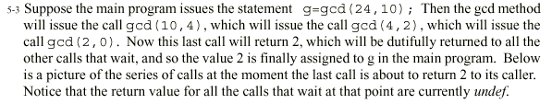

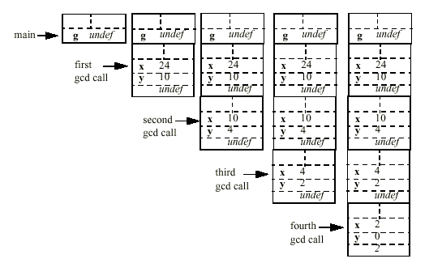

Question 3
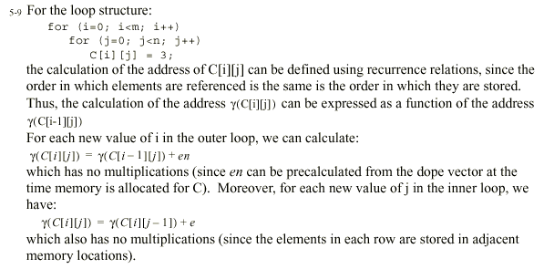

Question 4
