PIZZA SALES SQL QUERIES
- KPI’s
- Total Revenue:
SELECT ROUND(SUM(total_price),2) AS Total_Revenue FROM pizza_sales;
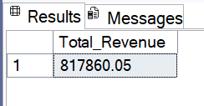

- Average Order Value:
SELECT ROUND(SUM(total_price) / COUNT(DISTINCT order_id),2) AS Average_Order_Value FROM pizza_sales;
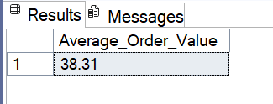

- Total Pizza Sold:
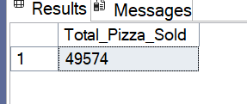
SELECT SUM(quantity) AS Total_Pizza_Sold FROM pizza_sales;

- Total Orders:
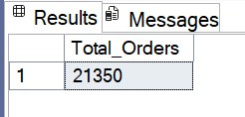
SELECT COUNT(DISTINCT order_id) AS Total_Orders FROM pizza_sales;

- Average Pizzas Per Order:
SELECT CAST(CAST(SUM(quantity) AS DECIMAL(7,2)) / COUNT(DISTINCT order_id) AS DECIMAL(7,2)) AS Average_Pizzas_Per_Order FROM pizza_sales;
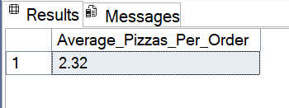

- Daily Trend For Total Orders
SELECT DATENAME(DW, order_date) AS Order_Day, COUNT(DISTINCT order_id) AS Total_Orders FROM pizza_sales GROUP BY DATENAME(DW, order_date);
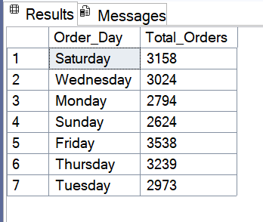

- Monthly Trend For Total Orders
SELECT DATENAME(MONTH, order_date) AS Month, COUNT(DISTINCT order_id) AS Total_Orders
FROM pizza_sales
GROUP BY DATENAME(MONTH, order_date);
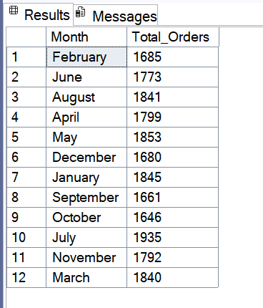

- Percentage of Sales by Pizza Category
SELECT pizza_category, CAST(SUM(total_price) AS DECIMAL(10,2)) AS Total_Sales, CONCAT(CAST(SUM(total_price) * 100 / (SELECT SUM(total_price) FROM pizza_sales) AS DECIMAL(7,2)),' %') AS Percent_of_Sales
FROM pizza_sales
GROUP BY pizza_category;
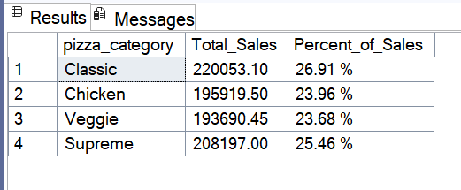

- Percentage of Sales by Pizza Size
SELECT pizza_size, CAST(SUM(total_price) AS DECIMAL(10,2)) AS Total_Sales, CONCAT(CAST(SUM(total_price) * 100 / (SELECT SUM(total_price) FROM pizza_sales) AS DECIMAL(7,2)),' %') AS Percent_of_Sales
FROM pizza_sales
GROUP BY pizza_size
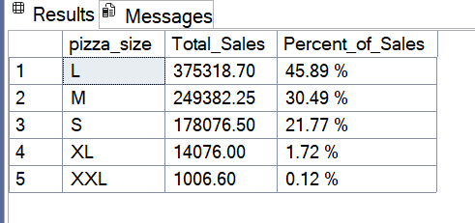
ORDER BY Percent_of_Sales DESC;

- Top 5 Best Sellers by Revenue
SELECT TOP 5 pizza_name, CAST(SUM(total_price) AS DECIMAL(10,2)) AS Total_Revenue
FROM pizza_sales
GROUP BY pizza_name
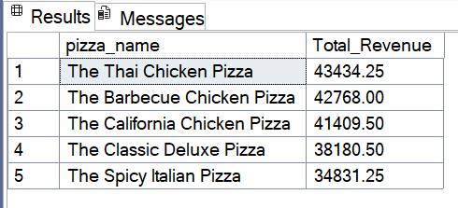
ORDER BY Total_Revenue DESC;

- Bottom 5 Best Sellers by Revenue
SELECT TOP 5 pizza_name, CAST(SUM(total_price) AS DECIMAL(10,2)) AS Total_Revenue
FROM pizza_sales
GROUP BY pizza_name
ORDER BY Total_Revenue ASC;
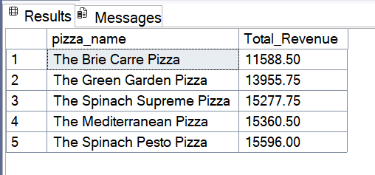
- Top 5 Best Sellers by Total Quantity
SELECT TOP 5 pizza_name, SUM(quantity) AS Total_Quantity
FROM pizza_sales
GROUP BY pizza_name
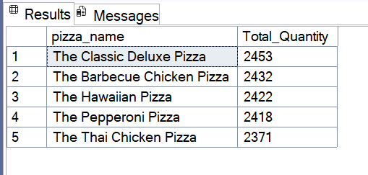
ORDER BY Total_Quantity DESC;

- Bottom 5 Best Sellers by Total Quantity
SELECT TOP 5 pizza_name, SUM(quantity) AS Total_Quantity
FROM pizza_sales
GROUP BY pizza_name
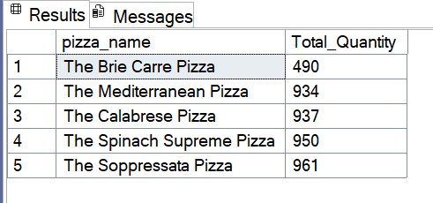
ORDER BY Total_Quantity ASC;

- Top 5 Best Sellers by Total Orders
SELECT TOP 5 pizza_name, COUNT(DISTINCT order_id) AS Total_Orders
FROM pizza_sales
GROUP BY pizza_name
ORDER BY Total_Orders DESC;

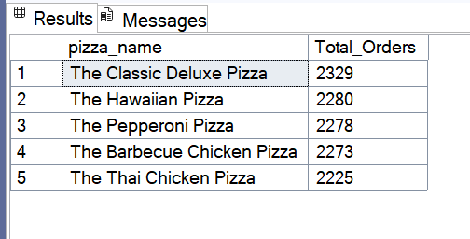
- Bottom 5 Best Sellers by Total Orders
SELECT TOP 5 pizza_name, COUNT(DISTINCT order_id) AS Total_Orders
FROM pizza_sales
GROUP BY pizza_name
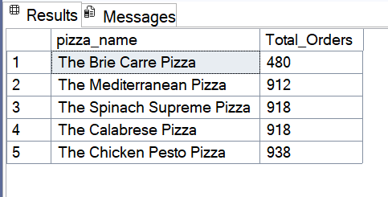
ORDER BY Total_Orders ASC;

