INDEX

Sl No | Name of the program | Date | Page No | Remarks
1 | Create your class time table using table tag. |  | 2
2 | Design a web Page for your college containing description of courses, department, faculties, library etc. Using list tags, href tags and anchor tags.

Program 1
Create class time table using table tag

Aim
Create a html page to display class time table

Program

<!DOCTYPE html>
<html>
<head><title>BCA Timetable</title>
</head>
<body>
<u><h1>2nd SEM BCA Timetable</h1></u>
<div class="table">
<table border="2">
<tr>
<th>DAYS</th>
<th>Hour1</th>
<th>Hour2</th>
<th>Hour3</th>
<th>Hour4</th>
<th>Hour5</th>
</tr>
<tr>
<th>Day1</th>
<td>DS</td>
<td>OS</td>
<td>English</td>
<td>Weblab</td>
<td>Weblab</td>
</tr>
<tr>
<th>Day2</th>
<td>Hin/Mal</td>
<td>DS</td>
<td>IC</td>
<td>Mathematics</td>
<td>OS</td>
</tr>
<tr>
<th>Day3</th>
<td>DS</td>
<td>English</td>
<td>Hin/Mal</td>
<td>OS</td>
<td>Mathematics</td>
</tr>
<tr>
<th>Day4</th>
<td>OS</td>
<td>DS</td>
<td>English</td>
<td>Mathematics</td>
<td>Hin/Mal</td>
</tr>
<tr>
<th>Day5</th>
<td>Mathematics</td>
<td>IC</td>
<td>Web technologies</td>
<td>DSlab</td>
<td>DSlab</td>
</tr>
</table>
</div>
</body>
</html>

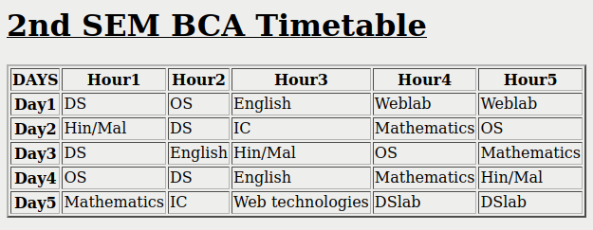
Output

Program 2
Design a web Page for your college containing description of courses, department, faculties, library ect. Using list tags, href tags and anchor tags.

Aim
Design a web Page for your college containing description of courses, department, faculties, library etc. Using list tags, href tags and anchor tags.

Program

<!DOCTYPE html
<html>
<head><title>st.george's college,aruvithura</title>
<h1 align="centre"><strong>ST.GEORGE'S COLLEGE ,ARUVITHURA</strong></h1></head>
<body>
<img src="sgccampus.jpg" height="200" width="300" >
<img src="sgc-college.png" height="200" width="300" >
<img src="sgc.jpg" height="200" width="270" >

<h3 align="left">About</h3>
<P>St. George’s College Aruvithura, is a minority educational institution founded by St. George Forane Church,
Aruvithura in 1965. Pioneered under the patronage of His Excellency Mar Sebastian Vayalil, the first Bishop o
f Pala, and cherished by a host of visionaries and philanthropists like Very Rev. Fr. Thomas Araythinal and
Mr T. A. Thomman (Former Minister), the college, right from its inception, embarked on an odyssey towards
academic pre-eminence. Very Rev. Fr. Thomas Manakkat, the founding manager and a great visionary, was truly
instrumental in laying the foundations for a great beginning and Very Rev. Fr. Jacob Thazhathel, who followed
him, was equally adept and insightful in his ideals, guiding the college during the early stages of its growth.
For more than two decades, His Excellency Mar Joseph Pallickaparampil, the Bishop of Pala, had been the patron
of the college. His Excellency Mar Joseph Kallarangattu is the present patron of this seat of
learning.</p>
<h3 align="left">Departments</h3>
<ul>
<li><a href="dca.html">Department of computer application</a></li>
<li><a href="dbz.html">department of botany&zoology</a></li>
<li><a href="dchem.html">Department of Chemistry</a></li>
<li><a href="dcom.html">department of commerce</a></li>
<li><a href="dmath.html">department of mathematics</a></li>
<li><a href="dphy.html">department of physics</a></li>
<li><a href="deng.html">department of english</a></li>
</ul>
To visit our library
<a href="lib.html" >click here</a>
</body>
</html>

department of computer application hyperlink

<!DOCTYPE html>
<html>
<head><title>st.george's college,aruvithura</title>
<h1 align="centre"><strong>ST.GEORGE'S COLLEGE ,ARUVITHURA</h1>
<body>
<h3 align="left">1.department of computer application</h3>
<h4 align="left">courses</h4>
<ul>
<li>BCA (Honours) with Specialization in Data Science & Full Stack Development</li>
<li>Informatics and Cyber Ethics</li>
<li>Modern Website Development</li>
<li>Javascript Fundamentals</li>
</ul>
<h4 align="left">faculties</h4>
<table border="2" align="left">
<tr><th>Name</th><th>Subject</th><th>designation</th></tr>
<tr><td>Jestin Joy</td><td>web development</td><td>HOD</td></tr>
<tr><td>Dr.Gemini George</td><td>Data Structures</td><td>professor</td></tr>
<tr><td>Dr.Anu Thomas</td><td>Indian Constitution</td><td>professor</td></tr>
<tr><td>Dr.Soumya George</td><td>Operating Systems</td><td>professor</td></tr>
</table>
</body>
</html>

department of botany and zoology hyperlink

<!DOCTYPE html
<html>
<head><title>st.george's college,aruvithura</title>
<h1 align="centre"><strong>ST.GEORGE'S COLLEGE ,ARUVITHURA</strong></h1></head>
<body>
<h3 align="left">1.department of computer application</h3>
<h4 align="left">courses</h4>
<ul>
<li>B.Sc (Honours) Botany</l>
<li>Horticulture and Nursery Management</li>
<li>Mushroom Farming Technology</li>
</ul>

<h4 align="left">faculties</h4>
<table border="2" align="left">
<tr><th>Name</th><th>Subject</th><th>designation</th></tr>
<tr><td>Jestin Joy</td><td>web development</td><td>HOD</td></tr>
<tr><td>Dr.Gemini George</td><td>Data Structures</td><td>faculty</td></tr>
<tr><td>Dr.Anu Thomas</td><td>Indian Constitution</td><td>faculty</td></tr>
<tr><td>Dr.Soumya George</td><td>Operating Systems</td><td>faculty</td></tr>
</table>

</body>
</html>

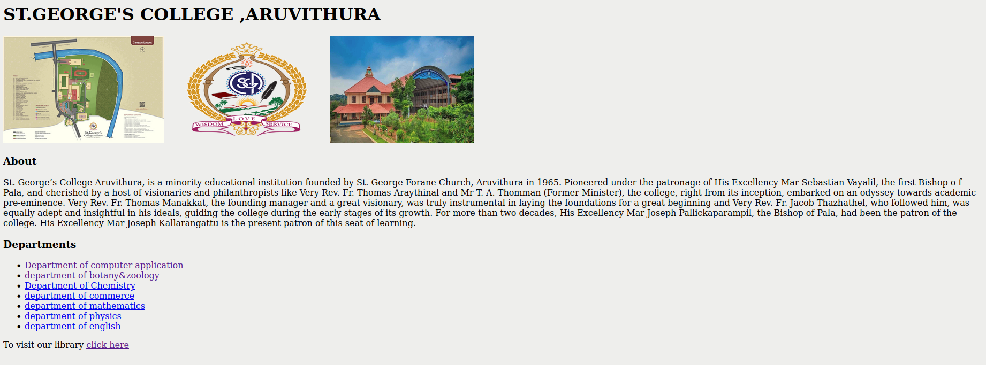
Output

department of computer application hyperlink
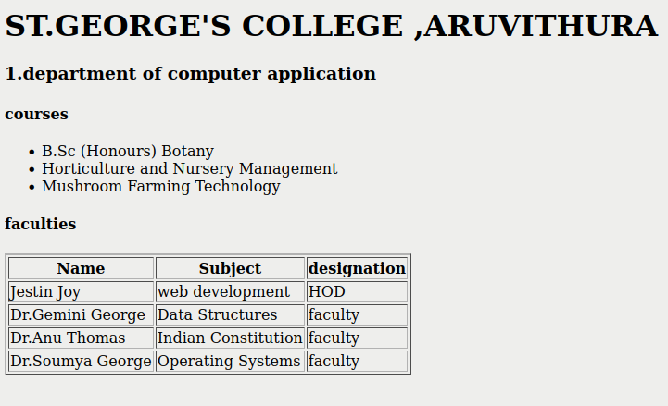
department of botany amd zoology hyperlink

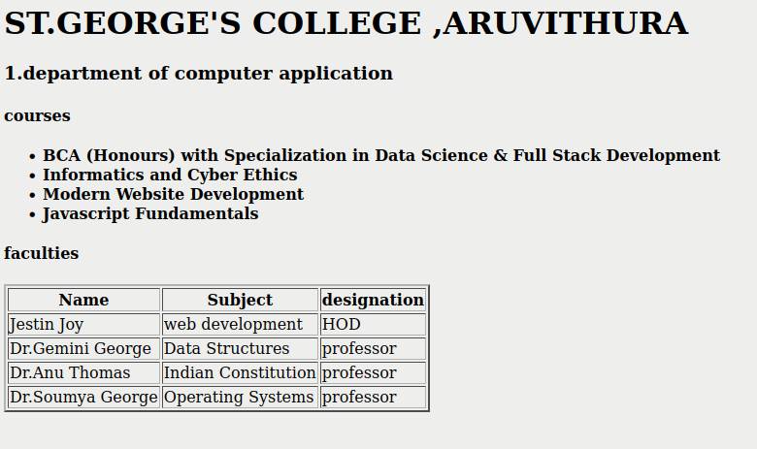

Program 3
Create your Resume using HTML.Use text,link,and lists
Aim
Create your Resume using HTML.Use text,link,and lists
Program
<html>
<head><title>resume</title>
<h1 align="left">>RESUME</h1>
<head>
<body>
<div>
<h2>Personal details</h2>
<b>Name:</b>Abhilash C.H<br>
<b>Email:</b>abhilashch123@gmail.com<br>
<b>Mobile:</b>9576453627<br>
<b>Address:</b>cherukatu(h),<br>
paduva p.o,<br>
kottayam,<br>
kerala<br>
pin:686564<br>
</div>
<div>
<h2>Profile</h2>
Iam a dedicated and responsible student with a strong interest in learning new technologies.Iam eager to improve my knowledge and skills,and apply them effectively in real-life situations.
</div>
<div>
<h2>Education</h2>
<ul>
<li>Degree</li>
college:St.Georges college,Aruvithura.<br>
first year 2025-29 batch.
<li>12th</li>
school:MGM NSS HSS,Lakkattoor.<br>
passed out with 94% marks.
<li>10th</li>
school:NSS HSS,Kezhuvamkulam.<br>
passed out with full A+.
</ul>
</div>
<div>
<h2>skills</h2>
<ul>
<li>programming languages:C,C++,Python</li>
<li>web technologies:HTML,CSS,JS</li>
<li>communication skill</li>
</ul>
</div>
<div>
<h3>languages</h3>
<ul>
<li>English:read,write,speak</li>
<li>Malayalam:read,write,speak</li>
<li>Hindi:read,write,speak</li>
<li>french:read,write</li>
</ul>
<h3>contact</h3>
Mobile:956432215<br>
Email:abhilashch123@gmail.com
</div>
<div>
<h2>Declaration</h2>
I here by declare that all the details submitted are correct to the best of my knowledge.
</div>
</body>
</html>

