Bridge Platform — Air-Gap Deployment

Contents
Bridge Platform — Air-Gap Deployment 1
Overview 1
Components 1
orchestrator 1
k8s-manager 2
kvm-controller 3
postprovisioning-controller 4
slurm-controller 6
k8s-bootstrap (ArgoCD — vcs/helm/argo) 7
kamaji 8
kubekey 9
vcs/src/job-orchestrator 9
ui 10
vcs-ui 11
5.x-installer — Charts Requiring Mirroring 11
Air-Gap Solution 12
Container Images → Internal Registry (Harbor) 13
Helm Charts → Internal Helm Registry (Harbor) 14
Binary/Artifact Downloads → Internal Artifact Server (Nexus) 14
OS Packages → Internal APT/YUM Mirror (Nexus) 15
Python Packages → Internal PyPI Mirror (Nexus) 15
Git Repositories → In-Cluster Git Server (Gitea) 15
External SaaS/APIs → Disable or Replace 16
Full Architecture 17
One-Time Seed Process 18
Infrastructure Stack 18
Summary — Mitigation by Infrastructure 19

Overview
An air-gapped deployment means the platform runs in an isolated datacenter with no public internet access. All software, images, binaries, and configuration must be pre-staged on internal infrastructure before deployment.
This document audits every Bridge platform component, lists all public internet communications discovered, and defines what must be done to make the platform fully air-gap compatible.

Components

orchestrator
Communication | URL / Domain | Purpose
Let’s Encrypt ACME | https://acme-v02.api.letsencrypt.org/directory | Creates a cert-manager Issuer for automatic TLS certificate provisioning via HTTP-01 challenge. Requires both outbound call to Let’s Encrypt and inbound call from Let’s Encrypt to the domain.
AI App Catalog (Git) | https://gitlab.com/aarnanetworks/catalog (default) | Periodically clones/pulls the AI application and model catalog repository using go-git. The catalog defines available AI workload templates.
Ray LLM image | amcop/ray-llm:2.50.0-py311-cu128 (Docker Hub) | Container image for Ray head and worker pods spawned when deploying AI model serving workloads (RayService CR).
HF Dataset Downloader image | amcop/hf-dataset-downloader:2026.01.19 (Docker Hub) | Container image used in Kubernetes Jobs to download HuggingFace datasets to persistent storage.
busybox image | busybox:latest (Docker Hub, unpinned) | Container image used in dataset deletion Kubernetes Jobs.
HuggingFace Hub | https://huggingface.co | Ray worker pods reach HuggingFace at model load time to download model weights, using the HUGGING_FACE_HUB_TOKEN env var injected into each pod.

k8s-manager
Communication | URL / Domain | Purpose
CMS Helm repo | https://gitlab.com/api/v4/projects/54152051/packages/helm/stable/ | Helm chart repository for the internal CMS/k8s-bootstrap chart installed on worker clusters.
Kubernetes Dashboard Helm repo | https://kubernetes-retired.github.io/dashboard/ | Deploys the Kubernetes dashboard UI on managed clusters.
Flannel Helm repo | https://flannel-io.github.io/flannel/ | Installs Flannel CNI networking on managed clusters.
Cilium Helm repo | https://helm.cilium.io/ | Installs Cilium CNI networking on managed clusters.
Local Path Provisioner Helm repo | https://charts.containeroo.ch | Installs local path storage provisioner on managed clusters.
NFS CSI Driver Helm repo | https://raw.githubusercontent.com/kubernetes-csi/csi-driver-nfs/master/charts/ | Installs NFS CSI driver on managed clusters for NFS storage support.
ArgoCD Helm repo | https://argoproj.github.io/argo-helm | Installs ArgoCD on worker clusters to manage workload deployments.
DDN CSI Driver (ArgoCD app) | https://github.com/DDNStorage/exa-csi-driver.git | ArgoCD Application pointing to DDN CSI driver Git repo for DDN Lustre storage support.
NFS CSI Driver (ArgoCD app) | https://raw.githubusercontent.com/kubernetes-csi/csi-driver-nfs/master/charts | ArgoCD Application for NFS CSI driver Helm chart.
VAST CSI Driver (ArgoCD app) | https://vast-data.github.io/vast-csi | ArgoCD Application for VAST Data CSI driver Helm chart.
Weka CSI Driver (ArgoCD app) | https://weka.github.io/csi-wekafs | ArgoCD Application for Weka CSI driver Helm chart.
k8s-bootstrap chart repo | https://gitlab.com/api/v4/projects/61409034/packages/helm/devel | Helm repo for the k8s-bootstrap chart deployed on worker clusters via ArgoCD.
NFS CSI provisioner image | registry.k8s.io/sig-storage/csi-provisioner:v3.6.0 | Container image for the NFS CSI sidecar provisioner deployed on managed clusters.
NFS CSI plugin image | registry.k8s.io/sig-storage/nfsplugin:v4.5.0 | Container image for the NFS CSI plugin deployed on managed clusters.
Karpenter image | amcopnightly/karpenter-clusterapi-controller:v1.0.1 (Docker Hub) | Container image for the Karpenter cluster autoscaler deployed on managed clusters.

kvm-controller
Communication | URL / Domain | Purpose
Mellanox OFED | https://content.mellanox.com/ofed/MLNX_OFED-24.10-1.1.4.0/...tgz | Downloads Mellanox OFED network driver tarball and installs it on KVM hypervisor hosts to enable high-performance InfiniBand/RDMA networking.
NVIDIA driver | https://us.download.nvidia.com/XFree86/Linux-x86_64/565.57.01/NVIDIA-Linux-x86_64-565.57.01.run | Downloads and installs the NVIDIA GPU driver on KVM hypervisor hosts. Required for GPU passthrough and vGPU functionality.
Base OS image (NVIDIA GPU) | https://storage.googleapis.com/subash-test/ubuntu-jammy-nvidia575-gpu.qcow2 | Downloads the base QCOW2 VM disk image for GPU-enabled VMs. Personal GCS dev bucket — must be replaced.
vGPU OS image | https://storage.googleapis.com/subash-test/ubuntu-jammy-nvidia580-vgpu.qcow2 | Downloads the base QCOW2 VM disk image for vGPU VMs. Personal GCS dev bucket — must be replaced.
vGPU driver package | https://storage.googleapis.com/subash-test/nvidia-linux-grid-580_580.82.07_amd64.deb | Downloads the NVIDIA vGPU (GRID) driver .deb package for SR-IOV vGPU setup. Personal GCS dev bucket — must be replaced.
AMD base OS image | https://storage.googleapis.com/subash-test/ubuntu-jammy-amd.img | Downloads the base disk image for AMD GPU VMs. Personal GCS dev bucket — must be replaced.
APT packages (on hypervisor host) | Ubuntu APT repos | Installs libguestfs-tools, qemu-kvm, libvirt-*, python3-pip and other KVM/libvirt dependencies on hypervisor hosts.
pip packages (on hypervisor host) | PyPI | Installs libvirt-python, lxml on hypervisor hosts for Ansible’s libvirt module.

postprovisioning-controller
Communication | URL / Domain | Purpose
NVIDIA driver (x86_64) | https://download.nvidia.com/XFree86/Linux-x86_64/580.95.05/NVIDIA-Linux-x86_64-580.95.05.run | Downloads and installs the NVIDIA GPU driver on bare-metal servers after MaaS provisioning. Required for CUDA workloads.
NVIDIA driver (ARM64) | https://download.nvidia.com/XFree86/Linux-aarch64/580.95.05/NVIDIA-Linux-aarch64-580.95.05.run | Same as above for ARM64 architecture.
Mellanox OFED (v24.10) | https://content.mellanox.com/ofed/MLNX_OFED-24.10-1.1.4.0/...tgz | Downloads Mellanox OFED network driver tarball for InfiniBand/RDMA support on bare-metal servers.
Mellanox OFED (v5.9) | https://www.mellanox.com/downloads/ofed/MLNX_OFED-5.9-0.5.6.0/...tgz | Alternate OFED version used in the metal virtualization preparation role.
AMD GPU driver | https://repo.radeon.com/amdgpu-install/7.1/ubuntu/<os>/amdgpu-install_7.1.70100-1_all.deb | Downloads and installs the AMD ROCm GPU driver on bare-metal servers for AMD GPU workloads.
AMD MxGPU driver | https://github.com/amd/MxGPU-Virtualization/releases/download/8.5.0.K/gim-dkms_8.5.0.K_all.deb | Downloads the AMD GIM SR-IOV virtualization driver for AMD vGPU support.
Node Exporter | https://github.com/prometheus/node_exporter/releases/download/v1.8.2/node_exporter-1.8.2.linux-<arch>.tar.gz | Downloads Prometheus Node Exporter binary for hardware/OS metrics collection on bare-metal servers.
NVIDIA GPU Exporter | https://github.com/utkuozdemir/nvidia_gpu_exporter/releases/download/v1.4.1/nvidia-gpu-exporter_1.4.1_linux_amd64.deb | Downloads NVIDIA GPU metrics exporter for Prometheus monitoring of GPU utilization, temperature, and memory.
AMD GPU Exporter GPG key | https://repo.radeon.com/rocm/rocm.gpg.key | Fetches the GPG signing key for the AMD ROCm APT package repository.
AMD GPU Exporter APT repo | https://repo.radeon.com/device-metrics-exporter/apt | Adds the AMD device metrics exporter APT repository to install amdgpu-exporter.
APT packages (on bare-metal) | Ubuntu APT repos | Installs build-essential, gcc, linux-headers-*, libglvnd-dev, qemu-kvm, libvirt-*, nfs-common, infiniband-diags, mstflint and other dependencies on provisioned servers.
pip packages (on bare-metal) | PyPI | Installs libvirt-python, lxml on bare-metal hosts.

network-controller
Communication | URL / Domain | Purpose
pip bootstrap | https://bootstrap.pypa.io/get-pip.py | Downloaded by an Ansible playbook during gateway device provisioning if pip is not already installed on the node.  Required before installing the requests Python package used by the playbooks.
PyPI | https://pypi.org | Installs the requests Python package via pip on the gateway node. Used by Ansible library scripts to call the inventory manager's API.

storage-controller
Communication | URL / Domain | Purpose
APT packages | Ubuntu APT repos | Installs nfs-common (NFS client) on compute nodes when mounting NFS shares, nfs-kernel-server (NFS server) on storage nodes when creating NFS volumes, and Lustre client build prerequisites (build-essential, libtool, pkg-config, flex, bison, libpython3-dev, libmount-dev, libaio-dev, libssl-dev, libnl-genl-3-dev, libkeyutils-dev, libyaml-dev, libreadline-dev, module-assistant, debhelper, dpatch, libsnmp-dev, mpi-default-dev, quilt, swig) on compute nodes when setting up Lustre.
APT — full upgrade | Ubuntu APT repos | Runs apt upgrade (all packages to latest) on compute nodes as part of the Lustre client setup role.
Ubuntu cloud images | https://bootstrap.pypa.io/get-pip.py | Downloads Ubuntu base VM disk image via wget in utils/vm_creation.sh for setting up storage test VMs.
CentOS cloud image | https://pypi.org | Downloads CentOS 8 Stream base VM image in utils/vm_creation.sh
Rocky Linux cloud image | https://cloud.centos.org | Downloads CentOS 8 Stream base VM image in utils/vm_creation.sh

slurm-controller
Communication | URL / Domain | Purpose
Slurm source tarball | https://download.schedmd.com/slurm/slurm-<version>.tar.bz2 | Downloads Slurm HPC scheduler source code, compiles, and installs it on cluster master and worker nodes.
Slurm pre-built packages (fallback) | https://armadabridgeml5637376883.blob.core.windows.net/slurm-deps | Azure Blob Storage used as a cache for pre-built Slurm .deb packages to skip source compilation. Internal dev Azure storage — must be replaced with internal file server.
Node Exporter | https://github.com/prometheus/node_exporter/releases/download/v1.7.0/node_exporter-1.7.0.linux-amd64.tar.gz | Downloads Prometheus Node Exporter for hardware metrics collection on Slurm nodes.
Rackslab APT repo GPG key | https://pkgs.rackslab.io/keyring.asc | Fetches GPG signing key for the Rackslab package repository.
Rackslab APT repo | https://pkgs.rackslab.io/deb | Adds Rackslab APT repository to install slurm-web-agent for the Slurm web interface.
NodeSource GPG key | https://deb.nodesource.com/gpgkey/nodesource-repo.gpg.key | Fetches GPG key for the NodeSource Node.js APT repository.
NodeSource Node.js APT repo | https://deb.nodesource.com/node_20.x | Adds NodeSource APT repository to install Node.js 20 for building the Slurm web frontend.
APT packages (on Slurm nodes) | Ubuntu APT repos | Installs gnupg, nodejs, slurm-web and standard Slurm build dependencies on cluster nodes.

k8s-bootstrap (ArgoCD — vcs/helm/argo)
These are ArgoCD Applications deployed on worker clusters. Each pulls its Helm chart from an external repository at deployment and upgrade time.
App | Helm Repo / Source | Purpose
cert-manager v1.12.0 | https://charts.jetstack.io | TLS certificate management via Let’s Encrypt or internal CA
external-secrets-operator 0.18.0 | https://charts.external-secrets.io | Syncs secrets from Vault/AWS Secrets Manager into Kubernetes
jupyterhub 4.2.0 | https://hub.jupyter.org/helm-chart/ | Multi-user JupyterHub for interactive AI/ML notebooks
kai-scheduler v0.7.12 | ghcr.io/nvidia/kai-scheduler (OCI) | NVIDIA KAI scheduler for GPU-aware workload scheduling
kube-state-metrics 6.1.2 | https://prometheus-community.github.io/helm-charts | Exposes Kubernetes object state as Prometheus metrics
kubeflow-prod HEAD | https://github.com/armadasystems/bridge-kubeflow (Git) | Kubeflow ML platform deployment
kuberay-operator 1.4.1 | https://ray-project.github.io/kuberay-helm/ | Manages Ray clusters for distributed AI/ML workloads
nginx-ingress 4.12.3 | https://kubernetes.github.io/ingress-nginx | Ingress controller for routing HTTP traffic on worker clusters
nim-operator v2.0.2 | https://helm.ngc.nvidia.com/nvidia | NVIDIA NIM operator for deploying inference microservices
node-feature-discovery 0.18.3 | https://kubernetes-sigs.github.io/node-feature-discovery/charts | Detects hardware features (GPUs, CPU flags) and labels nodes
nvidia-gpu-operator v25.10.1 | https://helm.ngc.nvidia.com/nvidia | Automates NVIDIA GPU driver and toolkit setup on K8s nodes
opentelemetry-collector 0.126.0 | https://open-telemetry.github.io/opentelemetry-helm-charts | Collects and forwards traces, metrics, and logs
otel-target-allocator 0.126.10 | https://open-telemetry.github.io/opentelemetry-helm-charts | Distributes Prometheus scrape targets across collector instances
rocm-gpu-operator v1.4.0 | https://rocm.github.io/gpu-operator | Automates AMD ROCm GPU driver setup on K8s nodes
local-path-provisioner v0.0.32 | https://github.com/rancher/local-path-provisioner (Git) | Provides local-path dynamic storage provisioning on nodes

kamaji
Communication | URL / Domain | Purpose
Telemetry | https://telemetry.clastix.io | Sends anonymous usage analytics every 5 minutes: Kamaji version, Kubernetes version, TenantControlPlane count, DataStore statistics.
Kubernetes control plane images | registry.k8s.io/kube-apiserver, kube-controller-manager, kube-scheduler | Container images pulled for each tenant Kubernetes control plane spawned by Kamaji.
Konnectivity proxy images | registry.k8s.io/kas-network-proxy/proxy-server:v0.28.6, proxy-agent:v0.28.6 | Network proxy containers enabling connectivity between the tenant API server and worker nodes.
CoreDNS / kube-proxy images | registry.k8s.io/coredns, kube-proxy | Standard Kubernetes DNS and network proxy components deployed on tenant clusters.

kubekey
KubeKey downloads the entire Kubernetes node stack at cluster provisioning time. All URLs are configurable.
Communication | URL / Domain | Purpose
Kubernetes binaries | https://dl.k8s.io/release/{version}/bin/linux/{arch}/ | Downloads kubeadm, kubelet, kubectl binaries for installation on cluster nodes.
etcd | https://github.com/coreos/etcd/releases/download/ | Downloads etcd binary for the Kubernetes control plane.
CNI plugins | https://github.com/containernetworking/plugins/releases/download/ | Downloads CNI network plugins required for pod networking.
containerd | https://github.com/containerd/containerd/releases/download/ | Downloads containerd container runtime for cluster nodes.
runc | https://github.com/opencontainers/runc/releases/download/ | Downloads runc low-level container runtime.
crictl | https://github.com/kubernetes-sigs/cri-tools/releases/download/ | Downloads CRI CLI tool for interacting with the container runtime.
Helm | https://get.helm.sh/helm-{version}-linux-{arch}.tar.gz | Downloads Helm package manager for deploying charts on clusters.
APT/YUM packages (on nodes) | Ubuntu/CentOS repos | Installs socat, conntrack, ipset, ebtables, chrony, ipvsadm — Kubernetes networking prerequisites on cluster nodes.

job-orchestrator
Communication | URL / Domain | Purpose
HuggingFace API | https://huggingface.co/ | Used as the base URL for resolving HuggingFace model repository paths when users specify HuggingFace models for deployment.
NVIDIA NIM catalog | https://build.nvidia.com/ | Used as the base URL for NVIDIA NIM model repository when users deploy NIM-based inference endpoints.
vLLM image | vllm/vllm-openai:latest (Docker Hub, unpinned) | Container image for vLLM inference server pods spawned for LLM model serving (DeepSeek R1, Qwen, etc.).
JupyterHub image | quay.io/jupyter/pytorch-notebook:cuda12-python-3.11.8 | Container image for PyTorch Jupyter notebook instances.
ComfyUI image | valyriantech/comfyui-with-flux:latest (Docker Hub, unpinned) | Container image for ComfyUI image generation workloads.
HunyuanVideo ComfyUI image | thelocallab/hunyuan-comfyui:latest (Docker Hub, unpinned) | Container image for HunyuanVideo generation workloads.
HuggingFace model weights | https://huggingface.co | Spawned pods mount ~/.cache/huggingface and download model weights at startup using HUGGING_FACE_HUB_TOKEN.

Platform Manager
Communication | URL / Domain | Purpose
HuggingFace API | https://huggingface.co/ | Called at dataset creation time to validate the dataset ID and retrieve metadata (size, info) before scheduling the download job.
HF Dataset Downloader image | amcop/hf-dataset-downloader:2026.01.19 | Container image spawned as a Kubernetes Job to download HuggingFace datasets into cluster PVCs. Configurable via APP_DATASETDOWNLOADERJOBIMAGE env var

ui
Communication | URL / Domain | Purpose
Google Fonts | https://fonts.googleapis.com, https://fonts.gstatic.com | Loads the Poppins font family for the Keycloak login page styling.
GitLab raw — cluster icons | https://gitlab.com/aarnanetworks/catalog/-/raw/main/icons/ray_serve_logo.svg, jupyterhub_logo.svg, nvidia_nim_logo.png | Fetches AI workload type icons displayed in the cluster/workload UI from the public catalog GitLab repo.
GitHub raw — Kubeflow logo | https://raw.githubusercontent.com/kubeflow/kubeflow/master/logo/stacked.svg | Fetches the Kubeflow logo image for display in the clusters UI.
GitLab raw — app icons | https://gitlab.com/aarnanetworks/catalog/-/raw/main/icons/application_icons/{name} (6 icons) | Fetches application icons (MLflow, Nginx, NIM, OpenWebUI, Postgres, etc.) for the applications UI.

vcs-ui
Communication | URL / Domain | Purpose
Stripe SDK | Stripe CDN | Dynamically loads the Stripe.js payment SDK for billing and payment processing. Only active when billing is enabled.
Google Fonts | https://fonts.googleapis.com, https://fonts.gstatic.com | Loads Manrope (Dapple theme) or Plus Jakarta Sans (Yotta theme) fonts. Default Armada theme uses system fonts — no CDN call.

5.x-installer — Charts Requiring Mirroring
The installer deploys the following third-party Helm charts. All must be mirrored to an internal Helm registry.
- cert-manager
- external-secrets-operator
- jupyterhub
- kai-scheduler
- kube-state-metrics
- kubeflow-prod
- kuberay-operator
- nginx-ingress
- nim-operator
- node-feature-discovery
- nvidia-gpu-operator
- opentelemetry-collector
- otel-target-allocator
- rocm-gpu-operator
- local-path-provisioner
- cilium
- metallb
- longhorn
- postgresql-ha
- redis
- alloy
- cortex
- kube-prometheus-stack
- loki
- capi-operator
- gatekeeper
- vault
- velero
- velero-ui
- kamaji
- keycloak
- ingress-nginx

Air-Gap Solution
All public internet communications fall into 7 categories. Each category has a distinct solution. Addressing all 7 fully closes the airgap.
Category | Examples
Container Images | Docker Hub, quay.io, registry.k8s.io, ghcr.io, nvcr.io
Helm Charts | helm.cilium.io, charts.jetstack.io, nvidia NGC, prometheus-community, etc.
Binary/Artifact Downloads | NVIDIA drivers, OFED, node_exporter, Kubernetes binaries, Slurm, etc.
Python Packages | pip install libvirt-python, lxml, etc.
OS Packages | apt install on bare-metal (Ubuntu repos), yum/dnf on RHEL/Rocky
Git Repositories | Catalog repo (orchestrator), ArgoCD app sources, kubeflow, local-path-provisioner
External SaaS / APIs | Let's Encrypt, HuggingFace API, NVIDIA NIM catalog, Stripe, Kamaji telemetry

Container Images → Internal Registry (Harbor)
Components pull container images from Docker Hub, quay.io, registry.k8s.io, ghcr.io, and nvcr.io at runtime when spawning pods and controllers.
Harbor is the internal container registry. Harbor supports hosting images from a one-time seed import, proxy cache projects for transparent pull-through caching, and replication from an internet-connected staging environment.
# Use skopeo to copy images (run from internet-connected seed machine)
skopeo copy docker://vllm/vllm-openai:latest \
docker://harbor.internal/dockerhub-proxy/vllm/vllm-openai:latest
skopeo copy docker://registry.k8s.io/kube-apiserver:v1.31.0 \
docker://harbor.internal/k8s-proxy/kube-apiserver:v1.31.0
# Bulk-copy with crane
crane copy nvcr.io/nvidia/gpu-operator:v25.10.1 \
harbor.internal/nvidia/gpu-operator:v25.10.1
Configuration overrides: - Set registrySettings.registry in Kamaji TenantControlPlane CRD - Set image overrides in all Helm chart values.yaml (Harbor URL as registry prefix) - Configure KubeKey registry.privateRegistry in cluster config - Configure postprovisioning/kvm-controller Ansible vars to pull from Harbor

Helm Charts → Internal Helm Registry (Harbor)
k8s-manager, k8s-bootstrap ArgoCD apps, and the 5.x-installer all reference ~30 external Helm repositories.
Harbor natively supports Helm/OCI chart hosting (Harbor 2.0+). All charts are pushed to Harbor and referenced as oci://harbor.internal/helm/<chart>.
# Pull from upstream and push to Harbor
helm pull cert-manager --repo https://charts.jetstack.io --version v1.19.2
helm push cert-manager-v1.19.2.tgz oci://harbor.internal/helm
helm pull gpu-operator --repo https://helm.ngc.nvidia.com/nvidia --version v25.10.1
helm push gpu-operator-v25.10.1.tgz oci://harbor.internal/helm
Configuration overrides: - Update all repoURL fields in ArgoCD Application templates in k8s-manager/pkg/template/ - Update all hardcoded Helm repo URL constants in k8s-manager/pkg/kubernetes/cluster_client.go - Update 5.x-installer charts_config.yaml repo URLs

Binary/Artifact Downloads → Internal Artifact Server (Nexus)
Ansible roles in postprovisioning-controller, kvm-controller, and slurm-controller download large binary artifacts using get_url tasks pointing to public URLs.
Nexus Repository Manager serves as the internal artifact store. It supports raw hosted repositories, proxied repositories (auto-caches on first request), and APT/YUM repos in one tool.
# Download all artifacts on an internet-connected seed machine, then upload to Nexus
wget https://download.nvidia.com/XFree86/Linux-x86_64/580.95.05/NVIDIA-Linux-x86_64-580.95.05.run
wget https://content.mellanox.com/ofed/MLNX_OFED-24.10-1.1.4.0/MLNX_OFED_LINUX-24.10-1.1.4.0-ubuntu22.04-x86_64.tgz
wget https://github.com/prometheus/node_exporter/releases/download/v1.8.2/node_exporter-1.8.2.linux-amd64.tar.gz
# ... all other binaries
rsync -avz ./artifacts/ nexus.internal:/repository/raw-hosted/
Configuration overrides: - Update get_url target defaults in all role defaults/main.yml files (or override via Helm values/ConfigMaps) - Replace storage.googleapis.com/subash-test/ (GCS dev bucket) with nexus.internal/... - Replace armadabridgeml5637376883.blob.core.windows.net (Azure dev blob) with nexus.internal/... - Point KubeKey DefaultDownloadHost to nexus.internal

OS Packages → Internal APT/YUM Mirror (Nexus)
Ansible roles run apt install and yum install on bare-metal hosts at provisioning time, requiring access to Ubuntu and RHEL package repositories.
Nexus Repository Manager handles APT and YUM proxy repositories in the same instance already deployed for binary artifacts. Create an APT proxy repository for each upstream source:
# Nexus APT proxy repositories to configure:
http://archive.ubuntu.com/ubuntu → nexus.internal/repository/ubuntu
https://repo.radeon.com → nexus.internal/repository/amd-radeon
https://pkgs.k8s.io/core:/stable:/v1.x → nexus.internal/repository/kubernetes
https://deb.nodesource.com/node_20.x → nexus.internal/repository/nodesource
https://pkgs.rackslab.io/deb → nexus.internal/repository/rackslab
Configuration overrides: - Deploy internal apt sources list to bare-metal hosts via Ansible before provisioning roles run - Override apt repo URLs in Ansible role vars for AMD, Kubernetes, NodeSource, Rackslab repos

Python Packages → Internal PyPI Mirror (Nexus)
Ansible roles run pip install libvirt-python lxml on bare-metal hosts.
Nexus provides a PyPI proxy repository at zero additional infrastructure cost when already deployed for APT/artifacts.
# Configure pip to use internal mirror on bare-metal hosts
pip install \
--index-url https://nexus.internal/repository/pypi-proxy/simple/ \
libvirt-python lxml
Configuration overrides: - Add pip_extra_args: "--index-url https://nexus.internal/repository/pypi-proxy/simple/" to Ansible pip tasks

Git Repositories → In-Cluster Git Server (Gitea)
The orchestrator clones the AI app catalog from gitlab.com/aarnanetworks/catalog. ArgoCD applications in k8s-manager point to GitHub repos for DDN CSI, kubeflow, local-path-provisioner, etc. The UI loads icons directly from raw GitLab URLs.
Deploy Gitea as a lightweight in-cluster Git server. All external repositories are mirrored to Gitea before going air-gapped.
Note: This overlaps with the GitOps feature currently in development. Coordinate with that effort to avoid duplicating the Git server infrastructure.
# Mirror external repos to Gitea
git clone --mirror https://github.com/DDNStorage/exa-csi-driver.git
git remote add internal https://gitea.internal/mirrors/exa-csi-driver.git
git push --mirror internal
# Catalog repo — update orchestrator config:
# HostedCatalogDirUrl: "https://gitea.internal/amcop/catalog"
Configuration overrides: - Update HostedCatalogDirUrl in orchestrator Helm values to internal Gitea - Update repoURL in ArgoCD Application templates in k8s-manager/pkg/template/argocd-*.yaml - Update icon URLs in ui/src/features/clusters/clusters.const.ts and applications.utils.ts to internal Gitea raw URLs

External SaaS/APIs → Disable or Replace
Service | Used For | Action
Let’s Encrypt (acme-v02.api.letsencrypt.org) | Automatic TLS cert issuance | Deploy step-ca as a private ACME-compatible CA. cert-manager continues to work with minimal reconfiguration.
HuggingFace Hub (huggingface.co) | Model weight downloads in Ray/vLLM pods | Pre-download models and serve from an internal S3-compatible object store. Set the HF_ENDPOINT env var in Ray/vLLM pods to the internal endpoint.
NVIDIA NIM catalog (build.nvidia.com) | Resolving NIM model image paths | Host an internal NIM model catalog and make the base URL configurable via config/env.
Kamaji telemetry (telemetry.clastix.io) | Anonymous usage analytics | Disable via telemetry.disabled: true in Kamaji Helm values.
Google Fonts (fonts.googleapis.com) | Fonts in Keycloak login page | Bundle the Poppins font locally and update the Keycloak login page to load it from the internal server.
Stripe | Payment/billing processing (vcs-ui) | Is Stripe still actively used? If not, the integration should be removed entirely.

Full Architecture
The diagram below shows the internal infrastructure and how each Bridge component uses it instead of the public internet.

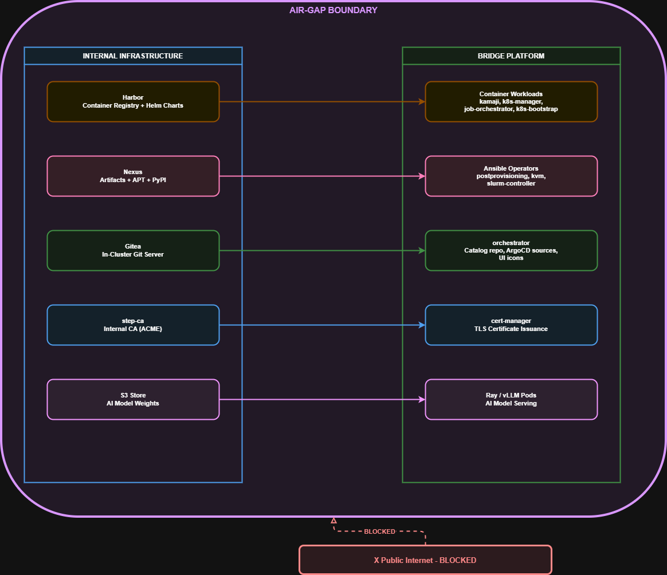

One-Time Seed Process
Before going air-gapped, a seed machine with internet access populates all internal infrastructure. This is a one-time operation, repeated only for platform upgrades.

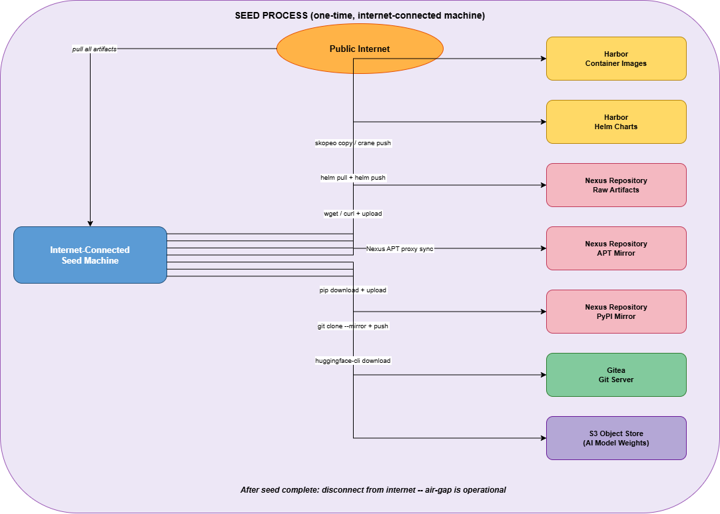

Infrastructure Stack
Tool | Replaces | License | Notes
Harbor | Docker Hub, quay.io, registry.k8s.io, ghcr.io, nvcr.io, all external Helm repos | Apache 2.0 (free) | Single tool for container images and Helm charts. Supports OCI artifacts natively.
Nexus Repository Manager | GitHub releases, nvidia.com, mellanox.com, Ubuntu APT, PyPI, all binary downloads | Apache 2.0 (free OSS edition) | All-in-one: raw hosted repos for binaries, APT proxy for OS packages, PyPI proxy for Python.
Gitea | gitlab.com catalog repo, GitHub repos for ArgoCD, UI icon assets | MIT (free) | Lightweight in-cluster Git server. Overlaps with GitOps feature in development — coordinate with that team.
step-ca | Let’s Encrypt | Apache 2.0 (free) | ACME-compatible private CA. cert-manager integration requires minimal config changes.
S3-compatible object store | HuggingFace Hub | Depends on chosen solution | Set HF_ENDPOINT env var in Ray/vLLM pods to point to the internal endpoint.
Harbor + Nexus together cover the vast majority of air-gap requirements. Combined with Gitea (which also serves the GitOps feature), these three tools resolve all dependencies except the SaaS/API category which is handled via configuration changes.

Summary — Mitigation by Infrastructure
Infrastructure | What It Resolves
Harbor (container registry + Helm registry) | All Docker Hub, quay.io, registry.k8s.io, ghcr.io, nvcr.io image references; all external Helm repo URLs
Nexus (artifacts + APT + PyPI) | NVIDIA drivers, AMD ROCm, OFED, node_exporter, Kubernetes binaries, Slurm; all apt install and pip install on bare-metal hosts
Gitea (in-cluster Git server) | AI app catalog repo, UI icon assets, ArgoCD Git-sourced apps
step-ca (internal CA) | TLS certificate issuance replacing Let’s Encrypt
S3-compatible object store | HuggingFace model weight downloads in Ray/vLLM pods (via HF_ENDPOINT)
Kamaji Helm values (telemetry.disabled: true) | Kamaji analytics calls to telemetry.clastix.io
Bundle Google Fonts locally | Keycloak login page font loading from fonts.googleapis.com
Replace GCS dev bucket URLs | kvm-controller VM images (storage.googleapis.com/subash-test/)
Replace Azure dev blob URL | slurm-controller Slurm packages cache (armadabridgeml5637376883.blob.core.windows.net)

