10/18/2020

Submitted by: Abhilash Anil Kale

Find the code and more details at:  
<https://github.com/akale1994/Melbourne-Datathon-2020>

*Causal Forecasting Model predicting Electricity Prices to aid Energy Providing Companies*

Melbourne Datathon 2020

Can Electricity Consumption Patterns Tell Us Anything About the Pandemic?

Table of Contents

1. Introduction 1

2. Data Wrangling 1

2.1 Datasets Used 1

2.2 Features Added 1

3. Data Exploration 2

3.1 Covid-19 affecting the Electricity Demand and Prices 2

3.2 Seasons as a perspective 3

3.3 Weekdays and Weekends as a perspective 4

3.4 Public Holidays as a perspective 5

3.5 Time of the day as a perspective 6

4. Multi-layer Perceptron – ANN 7

4.1 Feature Engineering 7

4.2 Model Results 7

6. Reflection 8

7. References 9

Table of Figures

Figure 1. Demand and Prices w.r.t. Covid-19 2

Figure 2. Demand and Prices w.r.t. Seasons in Victoria 3

Figure 3. Demand and Prices w.r.t. Weekdays and Weekends 4

Figure 4. Demand and Prices w.r.t. Public Holidays in Victoria 5

Figure 5. Demand and Prices w.r.t. Time Period of the day 6

Figure 6. Label and Prediction Comparison to check Model Performance 7

# Introduction

Covid-19 has affected our lives in different ways. Electricity consumption is one of the major factors that has also been heavily affected. Considering the very long lockdown in Victoria, Australia, it is interesting to see the various aspects influencing the fluctuations in the demand and pricing of electricity. Due to these unexpected fluctuations, energy-providing companies might have faced unprecedented scenarios where their traditional time-series forecasting models might not have performed up to the mark.

This report is a summary of:

* The data used to accomplish this forecasting.
* The insights gained while exploring the data.
* The test results of the Causal Forecasting Model built to predict Victoria’s electricity prices using the **Multi-layer Perceptron Artificial Neural Network**.

These accurately predicted prices can then be helpful to the various energy providers to tackle such unexpected issues, where human behaviour is changed drastically that creates such sudden fluctuations in electricity consumption.

# Data Wrangling

## Datasets Used

1. The instability in electricity demand and prices throughout the day can be evidently seen through the 30-minute electricity demand and price data provided by **AEMO** ("Aggregated price and demand data," 2020). This data has been acquired from the year 2016 to 2020.
2. To support the above dataset, daily temperature, rainfall and solar radiation observation data has been acquired from **BoM**, as these factors contribute to the electricity consumption directly ("Climate Data Online," 2020).
3. Further, Victoria’s statistical data which includes estimated population, household count and income, individual income and Victoria’s GSP ("Macroeconomic Indicators," 2020), have been included considering them as the factors that affect electricity consumption ("Demographic Resources," 2020).
4. Lastly, public holiday data for these 5 years is used as a feature which is also used to add further supporting features ("Victorian public holidays," 2020).

*(Datasets 3 and 4 have been directly compiled into CSV files manually as some data was dispersed while some were available through webpages)*

## Features Added

These datasets were joined based on the respective dates and certain additional features i.e. weekdays and weekends, seasons, daytime (morning, night, etc.), lighting condition and school and industry holiday, were added based on the date and time attribute, which would act as important causes in identifying a pattern in the electricity consumption.  
**As we are treating the case as a causal model, these features play a very important role in forecasting the prices.**

# Data Exploration

As the plan is to train the model on the data before Covid-19 pandemic and forecast it for the Covid-19 period, the data has been split accordingly as the first lockdown began on 16th March 2020, in Victoria (Wahlquist, 2020).

Let’s have a look at the electricity demand and prices over time for both periods considering various perspectives which might act as important causes.

## Covid-19 affecting the Electricity Demand and Prices

*Before Covid-19 After Covid-19*

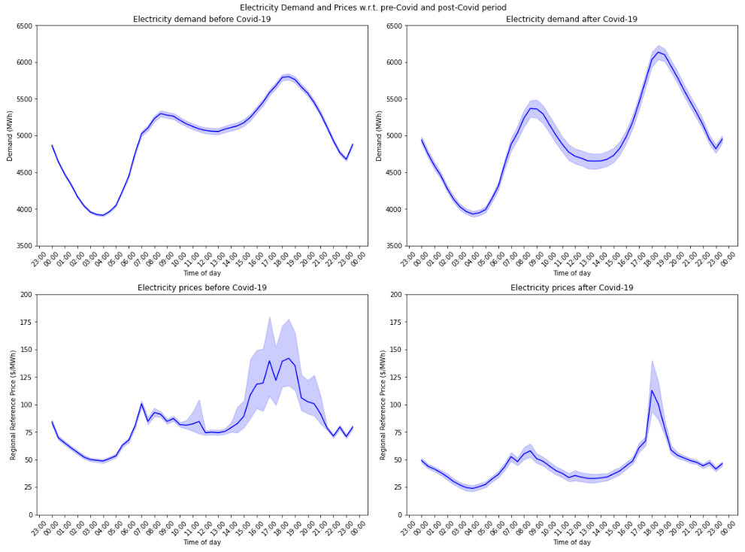

Figure . Demand and Prices w.r.t. Covid-19

From the above figure, we can say that Covid-19 has definitely created a shift in electricity consumption. The prices have been significantly reduced during the Covid-19 period, which might have caused

## Seasons as a perspective

*Before Covid-19 After Covid-19*

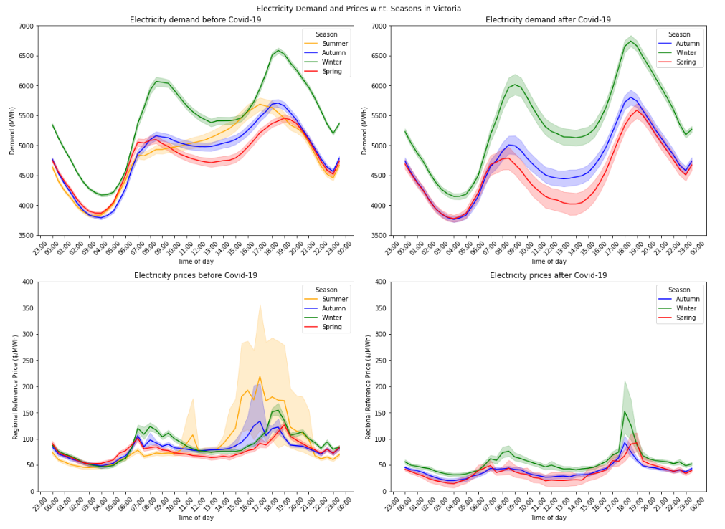

Figure . Demand and Prices w.r.t. Seasons in Victoria

Important Observations:

* Different seasons have significant different electricity demand. Winter has the highest demand due to the probable high usage of electric heaters, whereas, Spring has the lowest demand respectively.
* The trend based on time is similar to what we observed before.
* Electricity prices have been comparatively low during the Covid-19 period.
* High variation in the prices is observed during the summer season before the Covid-19 period.

## Weekdays and Weekends as a perspective

*Before Covid-19 After Covid-19*

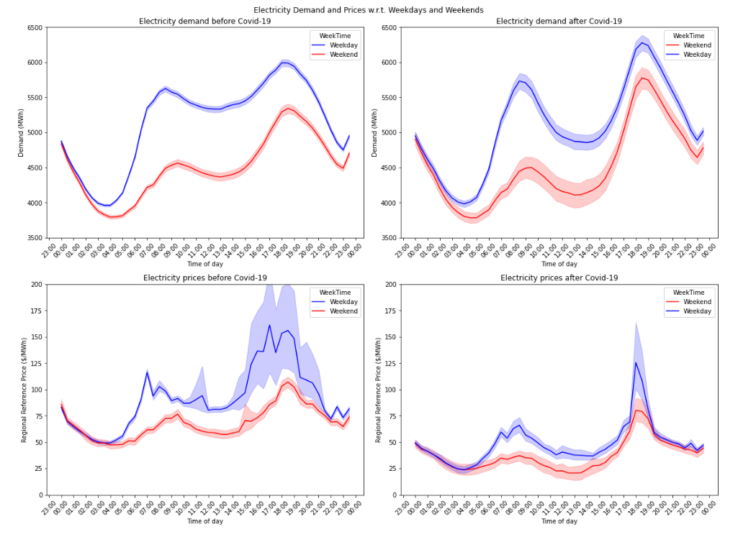

Figure . Demand and Prices w.r.t. Weekdays and Weekends

Important observations:

* A significant difference in electricity demand between weekdays and weekends is observed. There is a high electricity demand during the weekdays.
* The demand looked pretty stable before Covid-19 while we see more variations during Covid-19.
* Based on the demand, prices have fluctuated while observing certain peaks during the mornings and evenings.
* The evening demand has been increased in Victoria since the lockdown, although, the prices have been comparatively reduced.

## Public Holidays as a perspective

*Before Covid-19 After Covid-19*

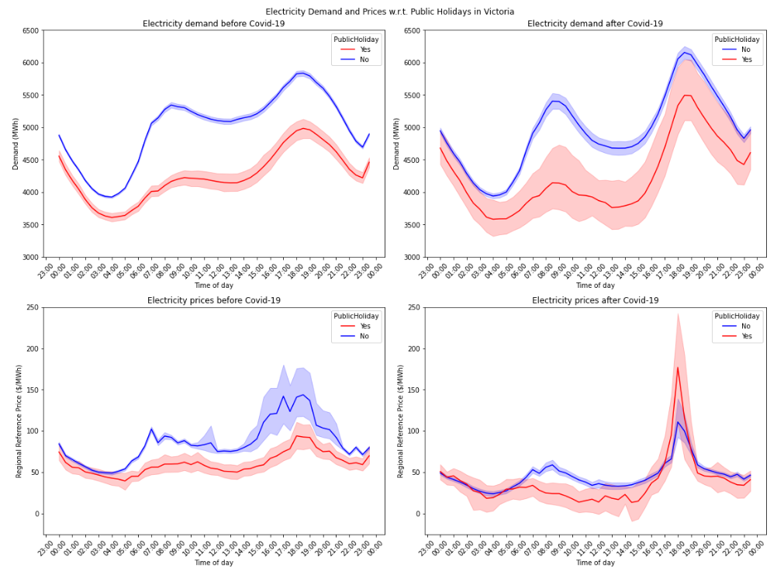

Figure . Demand and Prices w.r.t. Public Holidays in Victoria

A similar to weekdays and weekends trend is observed with respect to the public holidays in Victoria. Except, an irregular spike during the evenings when people are enjoying their holiday occasion. **Overall, we can say that holidays including weekends and people staying at home has a huge impact on electricity demand and its prices.**

## Time of the day as a perspective

*Before Covid-19 After Covid-19*

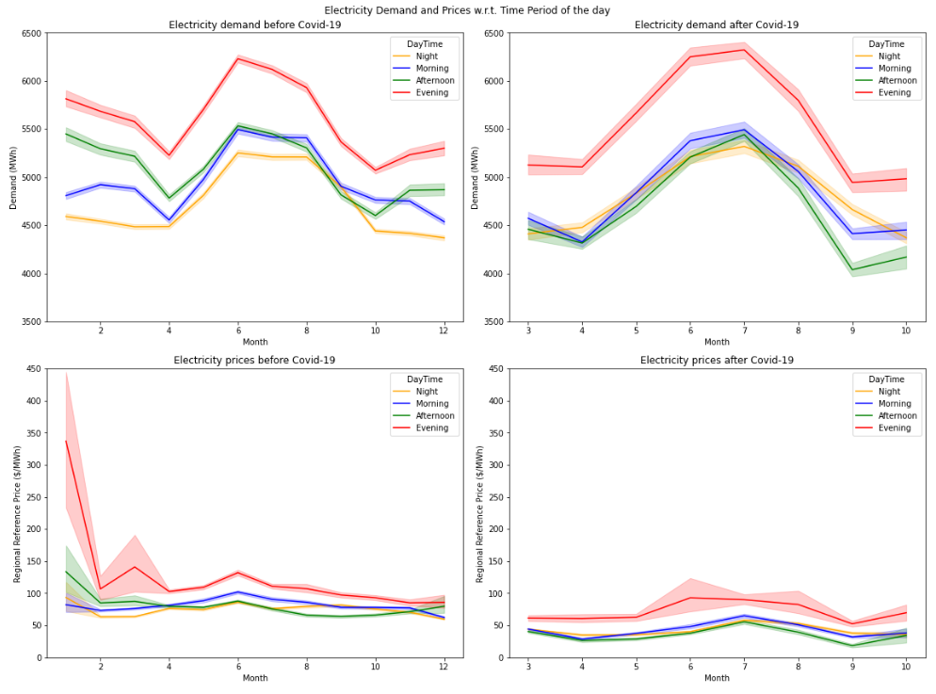

Figure . Demand and Prices w.r.t. Time Period of the day

A similar to season pattern is observed with the electricity demand with respect to the time of the day. Evenings have the highest electricity demand, and hence the highest prices too. An unexpected spike in the evening electricity price is observed during the start of the year. This might be due to the grand New Year’s Eve celebration throughout Victoria.

Overall, we can see that the previously added features show great meaning in the data and reveal important trends with regards to the consumption of electricity. We will be using these important features while training the MLP-ANN model.

# Multi-layer Perceptron – ANN

## Feature Engineering

1. To attain the desired accuracy, features like ‘Time’, ‘Year’, ‘Month’, ‘Day’, ‘WeekNumber’, ‘DayOfWeek’, etc. are all treated as categorical rather than continuous.
2. All the categorical features are one-hot encoded into the data.
3. The data is then scaled down to a consistent range.
4. Training and testing data are split based on the pre-Covid and post-Covid periods respectively.
5. The data is then passed through the MLP-ANN model for training after tuning the hyperparameters.

## Model Results

The best result was observed using scikit-learn’s MLPRegressor with the following configuration:

* 6 hidden layers
* 20 neurons in each layer
* Rectified Linear Unit as the activation function
* 5000 epochs to train the model

An **R2 score** of approx. **95.59%** and a **mean squared error** of approx. **0.21** are observed for the predictions from the regression**.** The **mean squared error** changes to approx. **9.32** when the predictions are scaled back to the original values.

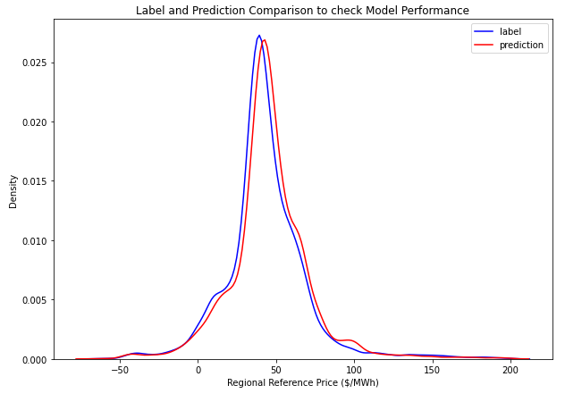

Figure . Label and Prediction Comparison to check Model Performance

Above is the KDE plot to compare the label and prediction values which shows how well the model has been trained.

# Reflection

Treating this case of predicting electricity prices in the event of Covid-19 as a causal forecasting model instead of a time-series model has led to good results (Brierley, 1998). Identifying the various causes for the shift in human behaviour in terms of electricity consumption correctly was one of the most important steps. Choosing the right model was also a key phase in the process. XGBoost and CatBoost models were also trained and tested with the same data before finalising the MLP-ANN. No other model produced such good results. The current model was tested on various configurations, and it was observed that 6 hidden layers with 20 neurons in each, produces the best result. We have successfully forecasted the electricity prices for the Covid-19 period based on historical data, which can aid the electricity providing companies in avoiding losses due to unprecedented events.

The MRIM data for electricity, available only till March 2020, by AEMO, was referred to gain insights. 5 different energy providers supplying electricity to 5 regions in Victoria were seen in the data ("Victorian MRIM meter data," 2020). Geographical differences were observed in the electricity data. Location is another very important aspect to identify further drilled-down electricity consumption trends. An increase in electricity demand of about 20% was observed in residential consumption of Victoria, whereas, a decrease in demand of about 10% to 15%, also ranging up to 30% in certain locations, was observed in business consumption, during the Covid-19 period (Cainey, 2020).

Also, Western Australia’s WEM data was referred which shows the amount of electricity generated every 30 minutes by the different energy providers ("WEM Data Dashboard," 2020). If such similar data would have been easily available for Victoria, we would have been able to predict the energy to be generated or prices as required for each energy providing company. And as each company is responsible for a specific region, we would have gained even more control over the data and its trends and insights. Also, we would have been able to predict the electricity to be generated on a more granular level aiding every company individually.

Find the code and more details at:  
<https://github.com/akale1994/Melbourne-Datathon-2020>

# References

Aggregated price and demand data. (2020). Retrieved from <https://aemo.com.au/energy-systems/electricity/national-electricity-market-nem/data-nem/aggregated-data>

Brierley, P. (1998). *Some Practical Applications of Neural Networks in the Electricity Industry.* (Engineering Doctorate). Cranfield University, Retrieved from <http://philbrierley.com/phil/thesis.zip>

Cainey, J. (2020). Mapping the impact of COVID-19 on electricity demand. *2020 Energy Insider.* Retrieved from <https://www.energynetworks.com.au/news/energy-insider/2020-energy-insider/mapping-the-impact-of-covid-19-on-electricity-demand/>

Climate Data Online. (2020). Retrieved from <http://www.bom.gov.au/climate/data/>

Demographic Resources. (2020). Retrieved from <https://profile.id.com.au/australia?WebID=110>

Macroeconomic Indicators. (2020). Retrieved from <https://www.dtf.vic.gov.au/sites/default/files/document/Macroeconomic%20data_2019-20%20Budget%20Update_1.xlsx>

Victorian MRIM meter data. (2020). Retrieved from <https://aemo.com.au/energy-systems/electricity/national-electricity-market-nem/data-nem/metering-data/victorian-mrim-meter-data>

Victorian public holidays. (2020). Retrieved from <https://www.business.vic.gov.au/victorian-public-holidays-and-daylight-saving/victorian-public-holidays>

Wahlquist, C. (2020). Australia's coronavirus lockdown – the first 50 days. *The Guardian*. Retrieved from <https://www.theguardian.com/world/2020/may/02/australias-coronavirus-lockdown-the-first-50-days>

WEM Data Dashboard. (2020). Retrieved from <https://aemo.com.au/energy-systems/electricity/wholesale-electricity-market-wem/data-wem/data-dashboard>