Game Design Document

Fill up the following document

1. Write the title of your project.

Expect The Unexpected

1. What is the goal of the game?

To know each and every cell organelle in a human cell

1. Write a brief story of your game.

The character after playing a puzzle will be able to know the cell

organelle and its functions

1. Which are the playing characters of this game?

* Playing characters are the ones who respond to the user based on the input from the user.
* Cars, monkeys, dinos, wizards, etc., are the playing characters in the game.

|  |  |  |
| --- | --- | --- |
| Number | Character Name | What can this character do? |
| 1 | wizard | Who tells the goal for each and every stage |
| 2 |  |  |
| 3 |  |  |
| 4 |  |  |
| 5 |  |  |
| 6 |  |  |
| 7 |  |  |
| 8 |  |  |

1. Which are the Non-Playing Characters of this game?

* Non-Playing characters are the ones that don't have an action or behavior when the user interacts with the game.
* Hurdles, stones, bananas, coins, etc., are non-playing characters in the game.

|  |  |  |
| --- | --- | --- |
| Number | Character Name | What can this character do? |
| 1 | The cables | Fit the correct cable |
| 2 | bananas | Count the banans |
| 3 | triangles | How many triangles are there ?? |
| 4 | ribosomes | Find the hidden ones |
| 5 | ATP molecles | Reading and answering the questions |
| 6 |  |  |
| 7 |  |  |
| 8 |  |  |

Draw your imagination of this game. What does this game look like?

* Draw the game either on your computer or on paper.
* Add images of the game scenes to show each of the playing and non-playing characters at least once. 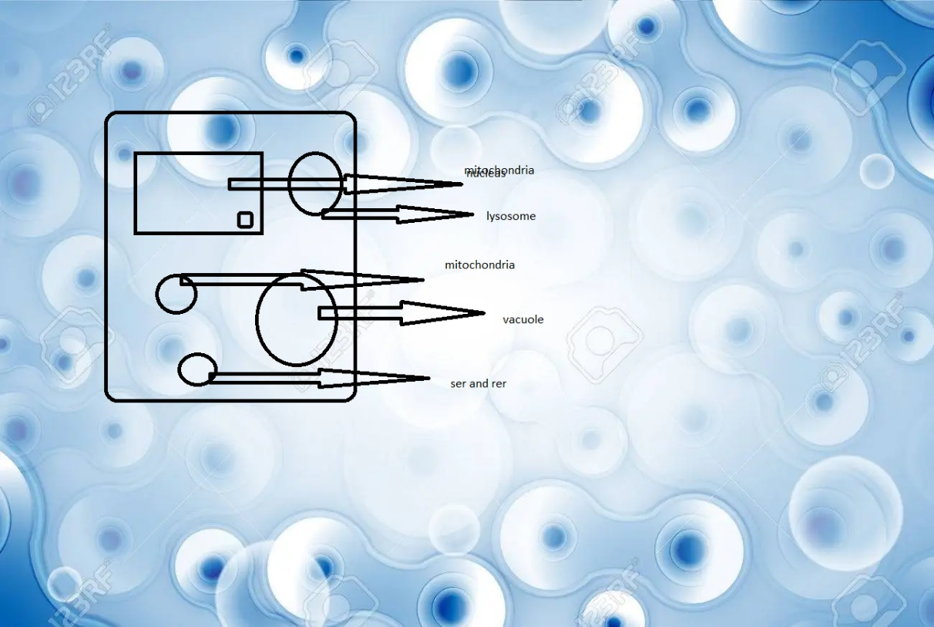

How do you plan to make your game engaging?

Adding puzzles and increasing difficulty in them