**ENPM673 – Perception for Autonomous Robots – Spring 2021**

**Project 3**

1. Calibration
   1. First step to do feature matching this is done by SIFT.

SIFT-Scale-invariant feature transform

SIFT is a method that helps in detecting and describing local features from given images It is one of the best feature detector (excluding deep learning) as has following advantages over other detector scale, stability, accuracy, & rotational invariance. It is also affine invariance. Which makes it one of the best feature detector to use. Disadvantage is its speed as it takes lot amount of time.

SIFT is divided into 4 parts

* 1. Using this feature points to calculate fundamental matrix

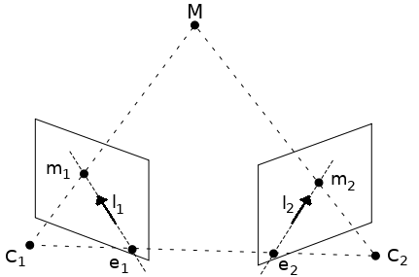

X’TFX=0

Where X are points of 1st image and X’ are points of 2nd image

* 1. Extracting essential matrix from fundamental matrix
  2. Then extracting rotation and translation from essential matrix
  3. Using linear triangulation to get best sets of rotation from the sets of rotation(which is basically taking the rotation and translation set which have high number of positive depth )

1. Rectification
   1. Rectifying the image so that the epipolar lines are horizontal to the image and the epipoles are to the infinity.
   2. Calcutaing homography for the same.
   3. (H1)

We first center the co-ordinate system on the principal point

, 

Then we find a rotation matrix that will rotate the epipole to infinity



And lastly transforming the epipole to infinity using



H2=T3xT2xT1xpts

H1= HaxMxH2

M=e[x]+F+eV.T

V.T=[1,1,1]

e=epipole

Ha is calculated by taking least square of

X1= hom[xi1;H2M]

X2= hom[xi2;H2]:

Done for easy pixel matching in image

1. SSD – Sum of square difference

This is done to find the matching pixel point easily from the both image. This is calculated by subtracting one rectified image from other. This substraction is minimized to get matching pixel points location in image and to get disparity from it.

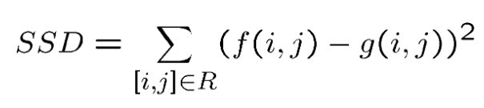

* 1. Getting depth from disparity we can get easy depth if we get difference between the 2 pixel

