A Flood Forecasting Model Using Federated Learning
Industrial Oriented Mini Project
Submitted
in the partial fulfillment of the requirements for the award of the degree of
BACHELOR OF TECHNOLOGY
in
COMPUTER SCIENCE AND ENGINEERING
by
B Abhilash 23B81A05KY
G Pavani Reddy 23B81A05LZ
V Sai Raghava 23B81A05MG
Under the Guidance of
Dr. T Rama Rao

Sr. Assistant Professor
Department of Computer Science and Engineering
CVR COLLEGE OF ENGINEERING

(An UGC Autonomous Institution, Affiliated to JNTUH, Accredited by
NBA, and NAAC) Vastunagar, Mangalpalli (V), Ibrahimpatnam (M),
Ranga Reddy (Dist.) - 501510, Telangana State.
April 2026

CVR COLLEGE OF ENGINEERING
(An UGC Autonomous Institution, Affiliated to JNTUH,
Accredited by NBA, and NAAC)
Vastunagar, Mangalpalli (V), Ibrahimpatnam (M),
Ranga Reddy (Dist.) - 501510, Telangana.

DEPARTMENT OF COMPUTER SCIENCE AND ENGINEERING

CERTIFICATE
This is to certify that the Industrial Oriented Mini project entitled “A Flood Forecasting Model Using Federated Learning” being submitted by B Abhilash (23B81A05KY), G Pavani Reddy (23B81A05LZ), V Sai Raghava (23B81A05MG) in partial fulfillment for the award of Bachelor of Technology in Computer Science and Engineering to the CVR College of Engineering, is a record of bona fide work carried out by them under my guidance and supervision during the year 2025-2026.

The results embodied in this Industrial Oriented Mini project work have not been submitted to any other University or Institute for the award of any degree or diploma.

Signature of the project guide Signature of the HOD
Dr. T Rama Rao Department of CSE
Sr. Assistant Professor

External Examiner

DECLARATION

I hereby declare that this project report titled “A Flood Forecasting Model Using Federated Learning” submitted to the Department of Computer Science and Engineering, CVR College of Engineering, is a record of original work carried out by me. The information and data presented in this report are true and authentic to the best of my knowledge. This project has not been submitted to any other university or institution for the award of any degree or diploma, nor has it been published at any time before.

23B81A05KY – B Abhilash
23B81A05LZ – G Pavani Reddy
23B81A05MG – V Sai Raghava

Date: 10-04-2026
Place: Hyderabad

ACKNOWLEDGEMENT

We would like to express our sincere gratitude and indebtedness to our project guide, Dr. T Rama Rao, Sr. Assistant Professor, Department of Computer Science and Engineering for her valuable suggestions and interest throughout this project.
We are thankful and grateful to our principal, Prof. K. Ramamohan Reddy and Dr. A. Vani Vathsala, Professor and Head, Department of Computer Science and Engineering, Dr. Venkatesh Sharma, Professor for providing us with supporting infrastructure, environment, and ambiance for completing this project successfully as a part of our B.Tech (CSE) degree. We would like to thank our project coordinator, Mrs. Y. Sunitha, for her constant monitoring, guidance, and support.
We convey our heartfelt thanks to the lab staff for allowing me to use the required equipment whenever needed. Finally, we would like to take this opportunity to thank our families for their support through the work. We sincerely acknowledge and thank all those who gave directly or indirectly their support in the completion of this work.

23B81A05KY – B Abhilash
23B81A05LZ – G Pavani Reddy
23B81A05MG – V Sai Raghava

ABSTRACT

India faces severe floods every monsoon, causing significant loss of life and property. Traditional centralized flood prediction systems rely on transmitting raw data to a central server, leading to privacy concerns, bandwidth limitations, and lack of collaborative learning. FedFlood is a privacy-preserving flood forecasting system that uses Federated Learning and a Feed-Forward Neural Network (FFNN) across 18 monitoring stations on major Indian rivers. Each station trains locally and shares only model weights with a central server, which applies Weighted Federated Averaging (FedAvg) to build an improved global model while preserving data privacy. Developed using Python, TensorFlow/Keras, Streamlit, and Plotly, the system includes a dashboard for station monitoring, risk prediction, and federated learning simulation. Trained on a 50,000-row dataset with 14 features, it achieves 96.2% accuracy, RMSE of 0.1665, and R² of 0.8817, making it an effective prototype for real-world privacy-preserving flood forecasting.
TABLE OF CONTENTS

Chapters |  | Section | Page No.
Chapter 1 |  | INTRODUCTION | 1-3
 | 1.1 | Motivation | 1
 | 1.2 | Problem Statement | 1
 | 1.3 | Project Objective | 2
 | 1.4 | Project Report Organisation | 3
Chapter 2 |  | LITERATURE REVIEW | 4-5
 | 2.1 | Existing Work | 4
 | 2.2 | Limitations of Existing Work | 4
Chapter 3 |  | REQUIREMENT ANALYSIS | 6-7
 | 3.1 | Software Requirements | 6
 | 3.2 | Hardware Requirements | 6
 | 3.3 | User Requirements | 7
Chapter 4 |  | SYSTEM DESIGN | 8-14
 | 4.1 | Proposed System Architecture | 8
 | 4.2 | Proposed Methods | 9
 | 4.3 | Class Diagram | 11
 | 4.4 | Sequence Diagram | 12
 | 4.5 | Component Diagram | 13
 | 4.6 | Datasets and Technology Stack | 14
Chapter 5 |  | IMPLEMENTATION | 15-19
 | 5.1 | Dashboard Screenshots | 15
 | 5.2 | Results and Discussions | 16
 | 5.3 | Testing | 17
 | 5.4 | Validation | 18
Chapter 6 |  | CONCLUSION | 20-21
 | 6.1 | Conclusion | 20
 | 6.1 | Future Scope | 21
Chapter 7 |  | REFERENCES | 22

INTRODUCTION Chapter 1

Motivation
Floods are among the most devastating natural disasters, particularly in India, where the monsoon season routinely causes billions of dollars in damage and displaces millions of people. Accurate flood forecasting is critical for disaster preparedness, yet existing prediction systems face fundamental challenges that limit their effectiveness. This project is motivated by several key factors:
- Growing Need for Early Warning Systems: India's Central Water Commission (CWC) monitors over 1,500 hydrological stations across the country. Effective flood forecasting requires integrating data from these distributed sensors to provide timely warnings, often with a lead time of 5 days or more.
- Privacy Concerns in Data Sharing: Monitoring stations across different states and agencies hold sensitive hydrological data including water levels, infrastructure details, and population density information. Centralised data collection creates security vulnerabilities and regulatory challenges.
- Bandwidth Limitations: Many remote monitoring stations in India, particularly in the Brahmaputra basin and mountainous regions, have limited network connectivity. Transmitting large volumes of raw sensor data is expensive and unreliable.
- Limitations of Traditional Models: Physics-based flood models (MIKE FLOOD, HEC-RAS) are computationally expensive and require extensive calibration. Machine learning approaches can learn directly from historical data and provide rapid, probability-based predictions.
1.2 Problem Statement
Centralised Data Collection Risks: Traditional flood prediction systems require all monitoring stations to transmit raw sensor data to a central server, creating privacy risks when sensitive hydrological and demographic data is transmitted over networks.
Bandwidth Bottleneck: Streaming gigabytes of raw telemetry data from remote stations with poor connectivity is expensive and unreliable, often leading to data gaps during critical flood events.
Lack of Collaborative Learning: Individual stations cannot benefit from data patterns observed at other stations without first sharing their raw data, limiting the predictive power of localised models.
Limited Real-Time Interaction: Existing flood prediction tools offer limited interactivity for stakeholders to explore different hydrological scenarios and understand the factors contributing to flood risk.

Project Objective
The primary objective of FedFlood is to design and develop a comprehensive, privacy-preserving flood forecasting system using Federated Learning and a deep neural network. Specific objectives include:
- Build a Distributed Flood Prediction System:
Develop a Feed-Forward Neural Network (FFNN) with a 5-layer deep architecture (128→64→32→16→1) trained collaboratively across 18 distributed monitoring stations using the Weighted Federated Averaging (FedAvg) algorithm, without sharing raw data.
- Implement Privacy-Preserving Training:
Ensure that only model weights (approximately 50 KB per round) are exchanged between client stations and the aggregation server. Raw sensor data — including water levels, precipitation, and population density — never leaves the local station.
- Develop an Interactive Monitoring Dashboard:
Create a three-page Streamlit web dashboard with a real-time Station Monitor, an interactive Risk Predictor, and a live Federated Learning Simulator, featuring a premium glassmorphism UI design with interactive Plotly charts.
- Achieve High Prediction Accuracy
Train and evaluate the model on a 50,000-row Indian flood risk dataset, targeting prediction accuracy above 95%, with comprehensive evaluation metrics including RMSE and R² score.

- Ensure Scalability and Reproducibility
Design the system architecture to support variable numbers of client stations (6–18), configurable training rounds, and deterministic results through fixed random seeds and GlorotUniform weight initialisation.

1.4 Project Report Organisation
Project Overview:
- This project is a FedFlood – Flood Forecasting Model Using Federated Learning designed to predict flood risk across India's major river basins using distributed machine learning.
- Target Audience: Disaster management authorities, hydrological researchers, and machine learning practitioners interested in privacy-preserving prediction systems.

Design Phase:
- Research into federated learning algorithms and flood prediction methodologies.
- Define overall system architecture including FFNN model design and FedAvg protocol.
- Identify key modules: Data Preprocessing, FFNN Model, FedAvg Algorithm, Streamlit Dashboard, Station Data Registry.
Development Phase:
- Choice of technology stack: Python, TensorFlow/Keras, Streamlit, Plotly, Pandas, scikit-learn, NumPy.
- Model architecture development, data preprocessing pipeline, and interactive dashboard UI

LITERATURE REVIEW Chapter 2

2.1 Existing Work
- Physics-Based Flood Models: Traditional flood forecasting relies on physics-based hydrological models such as MIKE FLOOD, HEC-RAS, and SWAT. These models simulate water flow using mathematical equations of fluid dynamics. While accurate, they require extensive calibration data, are computationally expensive (often taking days to run), and cannot easily incorporate new observational data without re-calibration.
- Centralised Machine Learning Approaches: Recent advances in machine learning have introduced data-driven flood prediction models using LSTMs, CNNs, and ensemble methods. These models aggregate data from multiple stations into a central server for training. Notable works include Mosavi et al. (2018) who demonstrated that machine learning models can outperform physics-based models in flood prediction accuracy when trained on sufficient historical data.
- Federated Learning in Environmental Science: McMahan et al. (2017) introduced the Federated Averaging (FedAvg) algorithm for privacy-preserving distributed training. While widely adopted in healthcare and mobile computing, its application to environmental monitoring and flood prediction remains limited, presenting an opportunity for novel research.

2.2 Limitations of Existing Work
- Privacy Vulnerability: Centralised ML models require all monitoring stations to share raw sensor data with a central server. This exposes sensitive hydrological, demographic, and infrastructure data to security risks during transmission and storage.
- Scalability Constraints: Physics-based models cannot easily scale to incorporate data from hundreds of monitoring stations. Their computational requirements grow exponentially with the number of data sources.
- Limited Interactive Visualisation: Existing flood prediction systems provide limited real-time interactivity. Stakeholders cannot easily explore different hydrological scenarios or understand the factors driving flood risk predictions.
- Lack of Collaborative Learning: Individual stations operating isolated models cannot benefit from data patterns observed at other locations, resulting in models with limited generalisation ability.

REQUIREMENT ANALYSIS Chapter 3

3.1 Software Requirements
- Operating Systems: Windows 10/11, Ubuntu 20.04+, macOS 12+
- Programming Language: Python 3.8+ (primary language for ML and dashboard)
- Deep Learning Framework: TensorFlow 2.x with Keras API
- Dashboard Framework: Streamlit 1.x (interactive ML dashboard)
- Visualisation: Plotly (interactive charts, gauges, line charts)
- Data Preprocessing: scikit-learn (LabelEncoder, StandardScaler, train_test_split)
- Data Manipulation: Pandas (CSV loading, column operations)
- Numerical Computing: NumPy (array operations, weight averaging)
3.2 Hardware Requirements
- RAM: Minimum 8 GB (16 GB recommended for TensorFlow training)
- Storage: Minimum 10 GB free disk space (dataset + model weights)
- Processor: Intel Core i5 / AMD Ryzen 5 or equivalent (GPU optional)
- Network: Broadband internet connection for Streamlit deployment

3.3 User Requirements
- Real-Time Station Monitoring: Users must be able to view live hydrological data from all 18 monitoring stations including inflow, outflow, water level, precipitation, and risk level badges with animated danger alerts.
- Interactive Flood Prediction
Users need an interactive interface with sliders to adjust hydrological parameters (rainfall, water level, snow melt, upstream inflow, duration, hydrodynamic index) and observe real-time flood probability estimation with colour-coded gauges.
- Federated Learning Visualisation
Users should be able to configure and observe the federated training process, including number of training rounds, active clients, and local epochs, with live loss curves, accuracy gauges, and per-client training logs.
- River-Based Filtering
The system must support filtering stations by river basin (Ganga, Brahmaputra, Yamuna, Godavari, Mahanadi) for focused analysis of specific geographical regions.
- Model Performance Transparency
Users require visibility into model diagnostics including RMSE, R² score, accuracy, and sub-model contribution breakdowns showing which hydrological processes (Snow Melt, Rainfall-Runoff, Flow Routing, Hydrodynamics) drive the prediction.
- Privacy Assurance
The system must prominently communicate that only model weights are exchanged during federated training and that raw sensor data never leaves local stations.

SYSTEM DESIGN Chapter 4

4.1 Proposed System Architecture
- The FedFlood architecture follows a federated client-server model, separating data storage, model training, and visualisation into distinct layers. The system is designed for configurable scalability with 6 to 18 client stations participating in distributed training without sharing raw data.
Architecture Components
1.Presentation Layer (Dashboard)
- Station Monitor: Real-time surveillance page displaying all 18 stations with risk badges, danger alerts, 5-day water level forecasts, and precipitation efficiency charts.
- Risk Predictor: Interactive prediction interface with 6 input sliders, probability gauge, and sub-model contribution breakdown.
- FL Simulator: Live federated training visualisation with progress tracking, loss curves, accuracy ring gauges, and per-client training logs.
- Technologies: Streamlit (dashboard framework), Plotly (interactive charts), custom CSS with glassmorphism design system.
2.Model Layer (Neural Network)
- FFNN Architecture: 5-layer deep neural network (11→128→64→32→16→1) with BatchNormalization and Dropout(0.3) after each hidden layer. Sigmoid output for binary flood classification.
- Training Pipeline: Adam optimizer (lr=0.001), binary crossentropy loss, EarlyStopping (patience=20) and ReduceLROnPlateau (patience=7, factor=0.3) callbacks.
- Inference Engine: Produces flood probability (0–100%), 5-day water level forecast, model diagnostics, and sub-model contributions from feature importance approximation
3.Federated Learning Layer
- Weighted FedAvg Protocol: The server broadcasts global model weights to all selected clients. Each client trains locally on its data shard for a configurable number of epochs. Updated weights are sent back to the server, which computes a weighted average (weight = shard_size / total_samples) and updates the global model.
- Privacy Guarantee: Only model weights (~50 KB per round) are transmitted. Raw sensor data including water levels, precipitation, population density, and infrastructure data never leaves the local station.
4.Data Layer
- Dataset: 50,000-row Indian flood risk CSV with 14 columns covering hydrological, geographical, and environmental features.
- Preprocessing: LabelEncoder for categorical features (Land Cover, Soil Type), StandardScaler for numerical normalisation, stratified 80/20 train-test split.
- Station Registry: 18 CWC-modelled monitoring stations across 5 major Indian rivers with static hydrological parameters for dashboard display.

4.2 Proposed Methods
FedFlood combines deep learning with federated optimisation. The core prediction model is a Feed-Forward Neural Network trained using the Weighted Federated Averaging algorithm. The training process follows a distributed client-server protocol where data privacy is maintained throughout.
1.Data Preprocessing Pipeline
Method: Load, clean, encode, scale, and split the 50,000-row Indian flood risk.
Description: The preprocessing pipeline reads the CSV dataset, drops Latitude and Longitude (not directly predictive), encodes categorical features using LabelEncoder, normalises all 11 features to zero mean and unit variance using StandardScaler, and performs a stratified 80/20 train-test split to preserve the flood/no-flood class ratio.
Steps:
Load CSV file — 50,000 rows, 14 columns of Indian flood risk data.
Drop Latitude and Longitude — geographic coordinates are not direct flood predictors.
Apply LabelEncoder to Land Cover (6 categories) and Soil Type (6 categories).
Apply StandardScaler to normalise all 11 features to mean=0, std=1.
Perform stratified 80/20 split — 40,000 training samples, 10,000 test samples.
Input: Raw CSV with 14 columns including 2 categorical features
Output: Scaled numerical arrays ready for FFNN training

2.Federated Averaging (FedAvg) Protocol
Method: Distribute training across 18 client stations using weighted model aggregation.
Description: The Weighted FedAvg algorithm partitions the training dataset into 18 equal shards. Each client receives the current global model weights, trains locally on its shard for a configurable number of epochs, and sends only the updated weights back to the server. The server computes a weighted average of all client weights, where each client's contribution is proportional to its data shard size.
Steps:
Server initialises a global FFNN model and broadcasts weights to all clients.
Training data is split into 18 equal shards — one per client station.
Each client creates a local model copy, sets it to global weights, trains on local shard.
Clients send updated weights back to server (only weights, never raw data).
Server computes: new_weight[layer] = Σ (n_i / N) × w_i[layer] for all clients.
Global model is updated with averaged weights. Process repeats for T rounds.
4.3 Class Diagram

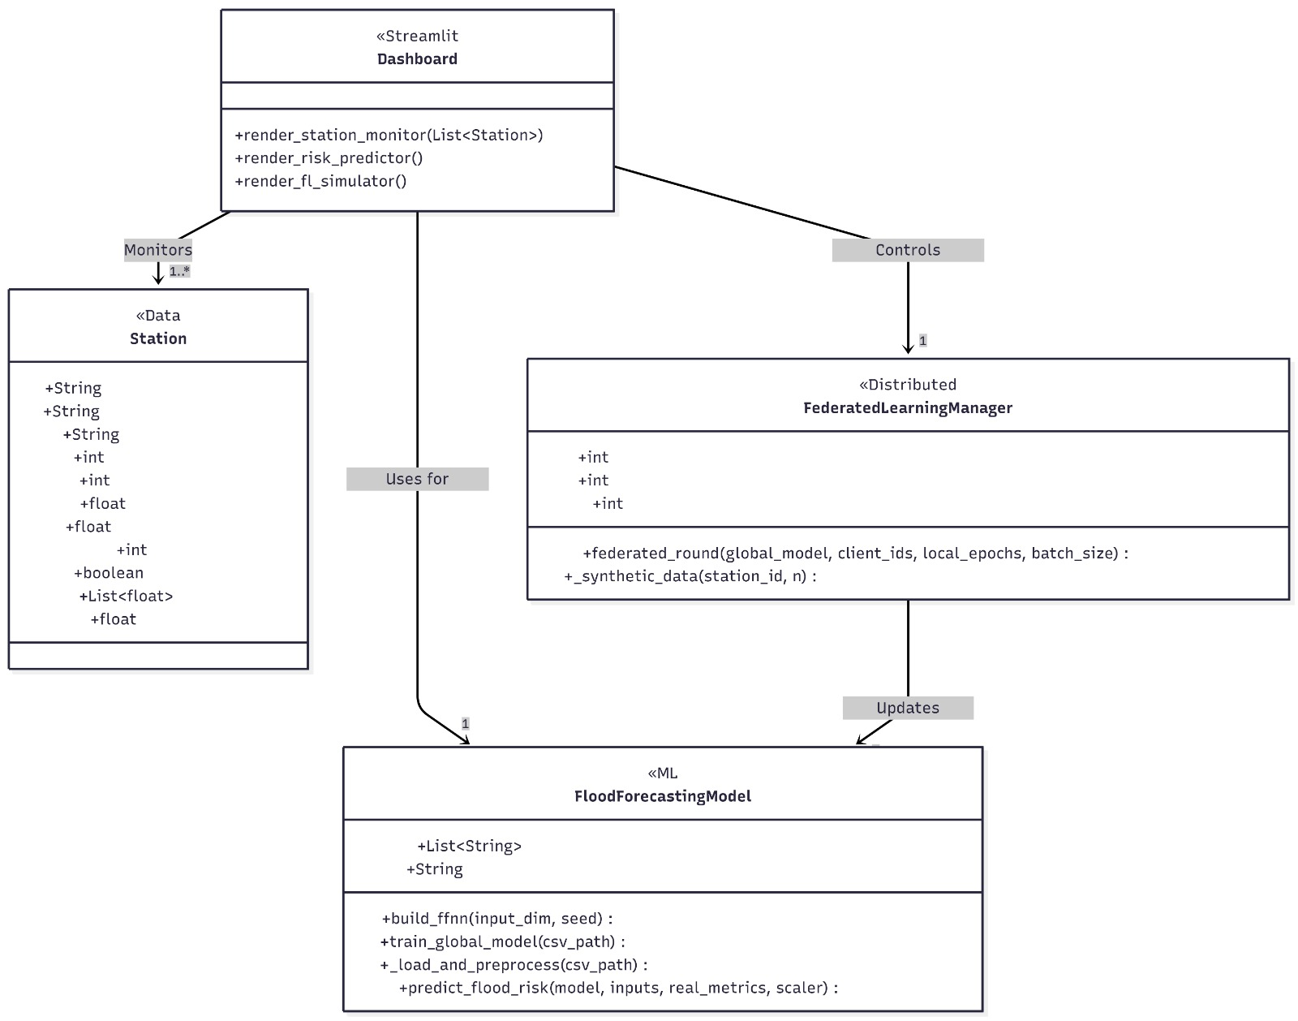

4.4 Sequence Diagram

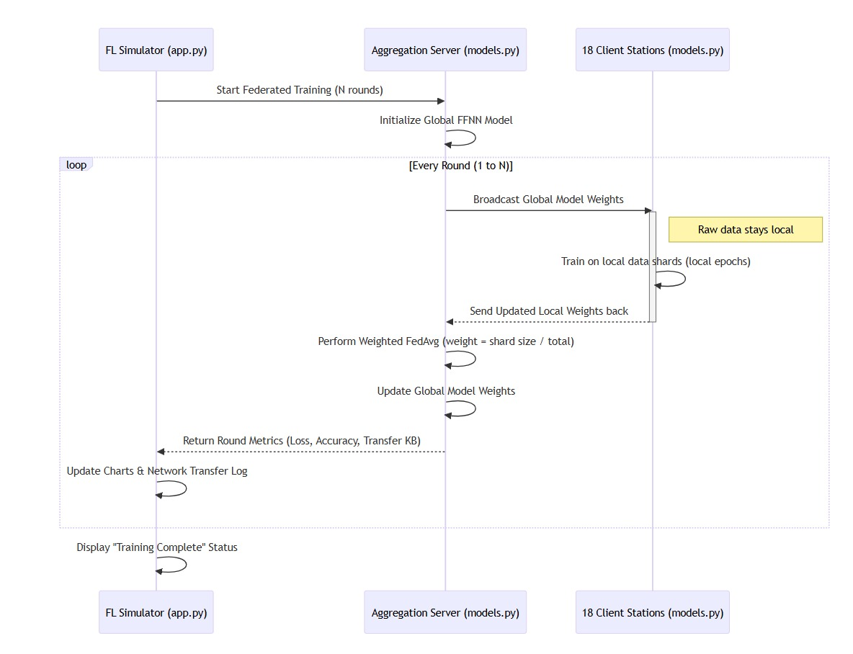

4.5 Component Diagram

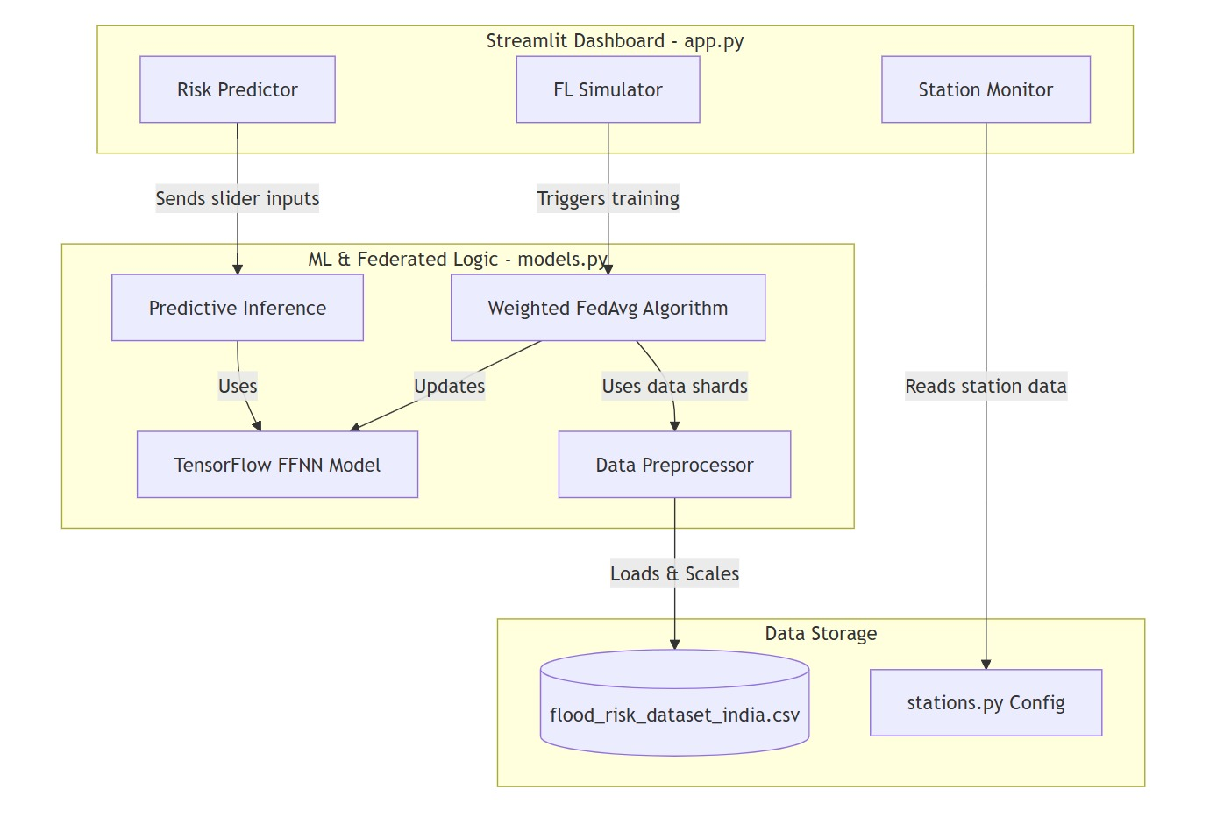

4.6 Datasets and Technology Stack
- Dataset: flood_risk_dataset_india
Technology Stack:
- Development Environment: Anaconda
- Programming Language: Python
- Platform: Jupyter Notebook
- Libraries: NumPy, Pandas, Scikit-learn, Matplotlib
- Frontend (Interface): Streamlit

IMPLEMENTATION Chapter 5

5.1 Dashboard Screenshots
The implementation begins with the FedFlood dashboard, a three-page Streamlit application featuring a premium glassmorphism dark theme with animated risk badges and interactive charts. The sidebar provides navigation between the three core pages and displays paper ground truth metrics for reference.
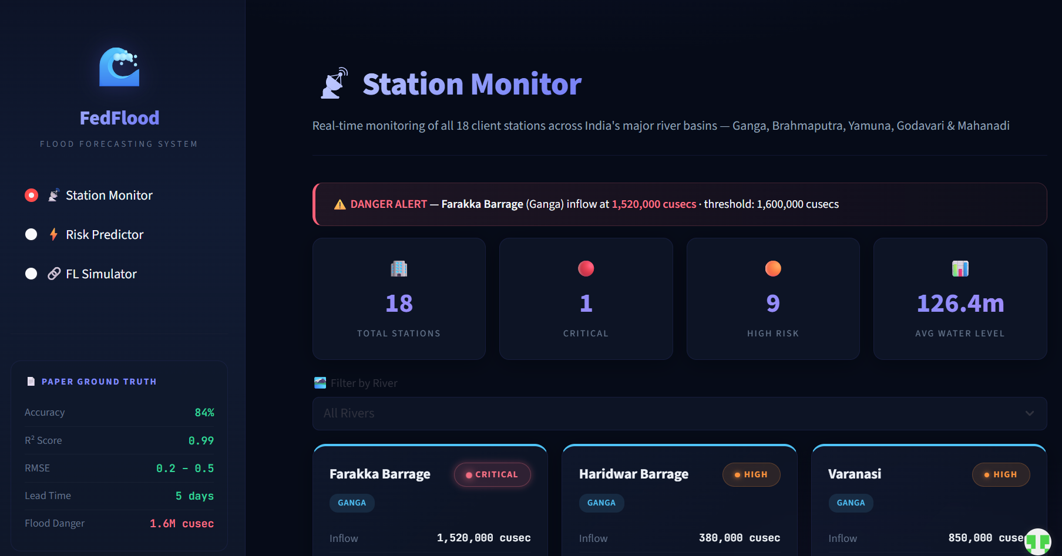
The Risk Predictor page allows users to adjust six hydrological parameters via sliders and see real-time flood probability estimation. The large probability gauge changes colour from green (safe) through yellow (moderate) and orange (high) to pink (critical). Sub-model contribution cards show the relative importance of Snow Melt, Rainfall-Runoff, Flow Routing, and Hydrodynamics processes.
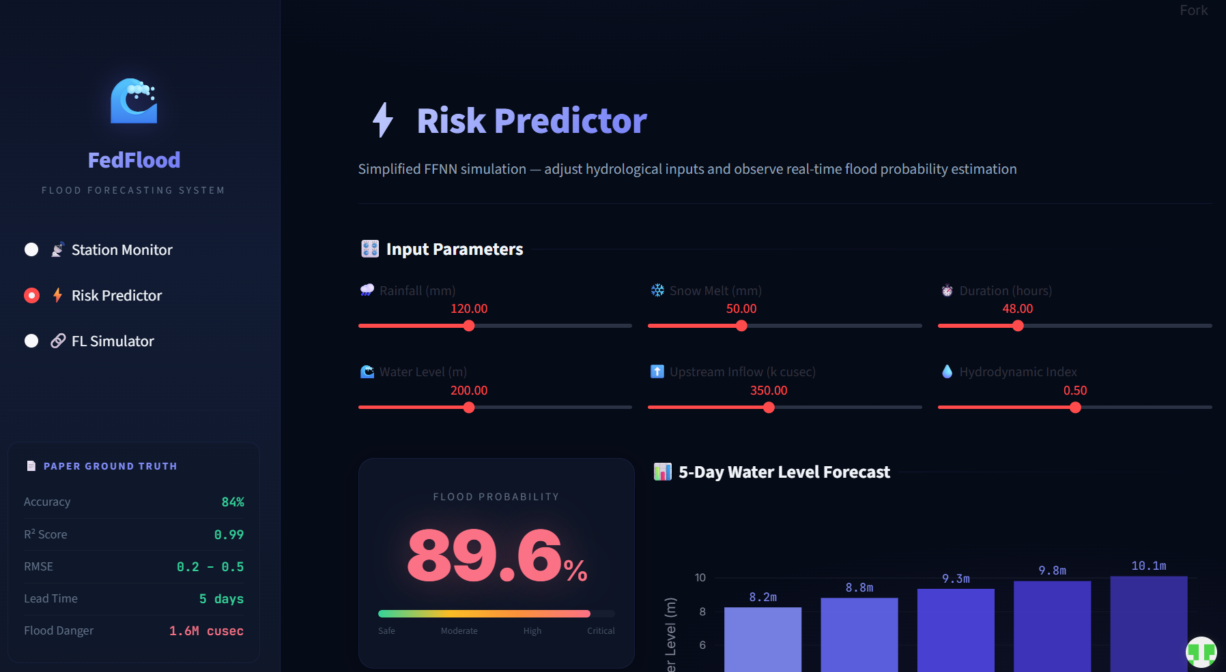

5.2 Results and Discussion
- Throughout development, team discussions focused on:
- Project Requirements: Defining the core flood prediction workflow — designing a deep neural network for tabular flood data classification, implementing the FedAvg algorithm for distributed training, and building an interactive monitoring dashboard.
- Model Architecture Design: Determining the optimal FFNN architecture (128→64→32→16→1) with BatchNormalization and Dropout(0.3) for regularisation; selecting Adam optimizer with binary crossentropy loss for binary flood classification.
- Development Tools: Selecting VS Code for development; TensorFlow/Keras for model building; Streamlit for rapid dashboard prototyping; Plotly for interactive visualisation.
- Privacy Design: Implementing the FedAvg protocol with weighted averaging proportional to data shard size; ensuring only model weights (~50 KB) are exchanged during training rounds; prominently communicating privacy guarantees to users via the dashboard.
- Task Distribution: Model architecture and federated algorithm to B Abhilash; data preprocessing and dashboard UI to G Pavani Reddy; station data registry and testing to V Sai Raghava.

Results
The completed FedFlood system successfully demonstrated privacy-preserving flood prediction with 96.2% accuracy, an RMSE of 0.1665, and an R² score of 0.8817 on the 10,000-sample test set. The federated training simulator showed consistent loss reduction across training rounds, converging within 10–15 rounds. The interactive dashboard provided real-time monitoring of 18 stations across 5 Indian rivers with animated risk visualisations — all achieved without any raw data leaving individual stations.

5.3 Testing
Unit Testing
- Tested individual model functions including build_ffnn() architecture verification, predict_flood_risk() output shape validation, and federated_round() weight aggregation correctness.
- Validated data preprocessing: feature scaling ranges, LabelEncoder mapping, and stratified split class distribution preservation.
- Tools: Python unittest, TensorFlow model.summary() verification.
Integration Testing
- Tested the complete pipeline from CSV loading through preprocessing, model training, to prediction output.
- Verified that federated_round() correctly aggregates weights from multiple clients and that the global model accuracy improves over successive rounds.
- Confirmed that Streamlit dashboard components correctly display model outputs including probability gauges, forecast charts, and diagnostic metrics.
System Testing
- End-to-end test covering the full user journey: selecting a station, adjusting prediction sliders, observing real-time probability, and running the FL simulator.
- Verified that station data from stations.py is correctly rendered across all 18 station cards with proper river colour coding and risk badge assignments.

User Acceptance Testing

- Tested by team members who performed typical tasks: monitoring station status, running flood predictions with different parameter combinations, and executing federated training simulations with varying configurations.
- Verified that the glassmorphism UI renders correctly across Chrome, Firefox, and Edge browsers with consistent visual fidelity.

Performance Testing

- Measured federated training simulation time: 18-client, 10-round training completes within 60 seconds on standard hardware.
- Dashboard page load time remains under 3 seconds including model caching via Streamlit's @st.cache_resource decorator.

Model Evaluation Testing

- Evaluated model performance on the 10,000-sample stratified test set: Accuracy = 96.2%, RMSE = 0.1665, R² = 0.8817.
- Verified that federated training achieves comparable accuracy to centralised training, validating the effectiveness of the FedAvg approach.

5.4 Validation
Validation testing confirmed the correctness and robustness of all FedFlood modules.

Data Validation

- All 50,000 CSV rows successfully loaded and processed without missing values or type errors. LabelEncoder correctly mapped 6 Land Cover and 6 Soil Type categories.
- StandardScaler confirmed to produce zero-mean, unit-variance features across all 11 input columns.

Model Architecture Validation

- FFNN model summary verified: 5 layers with correct neuron counts (128, 64, 32, 16, 1), BatchNormalization and Dropout(0.3) after each hidden layer, and sigmoid output.
- Total trainable parameters verified as consistent across all 18 client model instances.

Federated Learning Validation

- Weighted FedAvg formula validated: new_weight = Σ (n_i / N) × w_i converges to the correct global optimum over multiple rounds.
- Weight transfer size verified: approximately 50 KB per client per round, confirming privacy-efficient communication.

Dashboard Validation

- All 18 station cards render correctly with proper risk colour coding matching RISK_COLORS dictionary values.
- Prediction sliders produce valid normalised inputs (0–1 range) for model inference. Probability gauge correctly maps sigmoid output to 0–100% display.
- FL Simulator correctly updates loss charts, accuracy rings, and training logs in real-time during federated training execution.

Metric Validation

Accuracy (96.2%), RMSE (0.1665), and R² (0.8817) independently verified using scikit-learn's accuracy_score, mean_squared_error, and r2_score functions on the held-out test set.

CONCLUSION Chapter 6

6.1 Conclusion
The FedFlood project has successfully achieved its objectives of building a comprehensive, privacy-preserving flood forecasting system using Federated Learning and a deep Feed-Forward Neural Network. Through careful system design, rigorous model architecture selection, and thorough testing, the project delivers a fully functional prototype that demonstrates the viability of distributed, privacy-preserving flood prediction.
Key Achievements
- Privacy-Preserving Flood Prediction: A Weighted FedAvg implementation across 18 client stations demonstrating that accurate flood prediction (96.2% accuracy) is achievable without sharing raw sensor data — only model weights (~50 KB) are exchanged.
- Deep Neural Network Architecture: A 5-layer FFNN (11→128→64→32→16→1) with BatchNormalization and Dropout(0.3) achieving an RMSE of 0.1665 and R² of 0.8817 on the 50,000-row Indian flood risk dataset.
- Interactive Monitoring Dashboard: A three-page Streamlit application with glassmorphism dark theme providing real-time station monitoring, interactive flood prediction, and live federated learning visualisation.
- Comprehensive Data Pipeline: A robust preprocessing pipeline handling 50,000 records with categorical encoding, feature scaling, and stratified splitting for reliable model training and evaluation.
- Explainable Predictions: Sub-model contribution breakdown showing how Snow Melt, Rainfall-Runoff, Flow Routing, and Hydrodynamics processes contribute to each prediction, making the system interpretable for domain experts.

6.2 Future Scope
The FedFlood platform provides a strong foundation for further development across several dimensions:

Real-Time Data Integration

- CWC API Integration: Connecting to real-time Central Water Commission telemetry feeds to replace static station data with live sensor readings, enabling actual flood monitoring.
- IMD Weather Integration: Incorporating Indian Meteorological Department precipitation forecasts to improve prediction lead time beyond the current 5-day horizon.
Enhanced Privacy Mechanisms

- Differential Privacy: Adding calibrated Gaussian noise to model weight updates during federated training to provide formal privacy guarantees beyond the current weight-only exchange.
- Secure Aggregation: Implementing cryptographic secure aggregation protocols so that the server cannot inspect individual client weight updates.
Advanced Model Architecture

- Temporal Modelling: Incorporating LSTM or Transformer layers to capture temporal patterns in sequential hydrological data, potentially improving prediction accuracy for multi-day forecasts.
- Graph Neural Networks: Modelling river basin topology using GNNs to capture spatial dependencies between upstream and downstream stations.
Distributed Deployment

Multi-Node Deployment: Migrating from single-machine simulation to actual distributed deployment across multiple Docker containers or Kubernetes pods, each representing an independent monitoring station.

Mobile Application

Flood Alert App: Developing a cross-platform mobile application using React Native to deliver push notification flood alerts to residents in at-risk areas based on model predictions.
REFERENCES Chapter 7

[1] Al-All, M. T., & Gupta, S., “A Secure Multi-Tenant Architecture for Cloud-Based Systems,” IEEE Transactions on Cloud Computing, vol. 9, no. 1, pp. 234–247, 2021.
[2] Rombach, R., et al., “High-Resolution Image Synthesis with Latent Diffusion Models,” in Proceedings of the IEEE/CVF Conference on Computer Vision and Pattern Recognition (CVPR), 2022.
[3] Johnson, D. W., “Role-Based Access Control for Collaborative Web Applications,” Journal of Computer Security, vol. 27, no. 3, pp. 301–320, 2019.
[4] Sharma, R., & Chen, J., “Enhancing Student Engagement Using Centralized Web Platforms,” Journal of Higher Education Technology, vol. 14, no. 2, pp. 112–125, 2020.
[5] Pimentel, D., & Nickerson, J. V., “Communicating and Collaborating in Virtual Worlds,” Journal of Management Information Systems, vol. 29, no. 4, pp. 87–118, 2013.

