State full components:

1. Components that manages states be it class based components using the state or functional components using hooks.
2. The hooks based functional components are available only with React ver > 16.8 prior to this only class based components are present and are the standard way of creating stateful components.
3. Class based components are used for state management while functional ones are used for the presentation of content.
4. Only changes in props and/or state trigger React to re-render your components and potentially update the DOM in the browser.
5. Props allow you to pass data from a parent (wrapping) component to a child (embedded) component.
6. 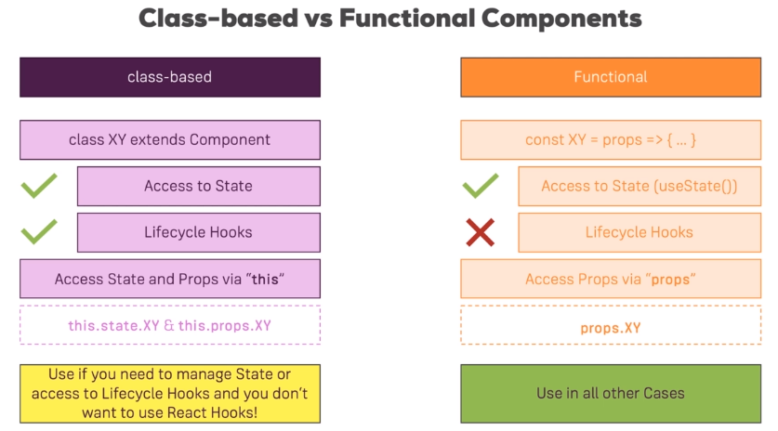Whilst props allow you to pass data down the component tree (and hence trigger an UI update), state is used to change the component, well, state from within. Changes to state also trigger an UI update.
7. Component Life cycle:

