DESIRABILITY LEVEL ANALYSIS FOR LIVING IN SINGAPORE
FOR STUDENTS

Assignment 2

Spatio-Temporal Analytics


Submitted By: TEAM “Chillax” |  | STORY LINK:
1. | Abhilasha Kumari, | STORY LINK:
2. | Ashok Eapen | https://rohitpattnaik.maps.arcgis.com/a
3. | Pranav Agarwal | https://rohitpattnaik.maps.arcgis.com/a
3. | Pranav Agarwal | pps/MapSeries/index.html?appid=a8db6
4. | Snehal Singupalli | pps/MapSeries/index.html?appid=a8db6
4. | Snehal Singupalli | 49ad83d4e17a7e13de5334a7c6a&edit
5. | Rohit Pattnaik | 49ad83d4e17a7e13de5334a7c6a&edit

 |  | TABLE OF CONTENTS
 | Desirability Level Analysis for Living in Singapore for Students |  |  |  | ................................................ 1
1 |  | The thought process .......................................................................................................................... |  |  | 3
 | 1.1 |  | Motivation: “Why This” .............................................................................................................. |  | 3
 | 1.2 |  | The Objective .............................................................................................................................. |  | 3
 | 1.3 |  | Data Collection and Cleansing .................................................................................................. |  | 3
2 |  | The Implementation ........................................................................................................................... |  |  | 4
 | 2.1 |  | The Process ................................................................................................................................. |  | 4
 | 2.2 |  | The Story ..................................................................................................................................... |  | 4
 | 2.2.1 |  |  | House Rents ........................................................................................................................ | 4
 | 2.2.2 |  |  | Separation into Zones ........................................................................................................ | 5
 | 2.2.3 |  |  | MRT concentration.............................................................................................................. | 6
 | 2.2.4 |  |  | MRT Vs Home ...................................................................................................................... | 6
 | 2.2.5 |  |  | Healthy Eating Places ......................................................................................................... | 7
 | 2.2.6 |  |  | Community Clubs ................................................................................................................ | 8
 | 2.2.7 |  |  | Park Connectors .................................................................................................................. | 8
 | 2.2.8 |  |  | Low Price Desirability Map ................................................................................................. | 9
 | 2.2.9 |  |  | Medium Price Desirability Map ........................................................................................ | 10
 | 2.2.10 |  |  | High Price Desirability Map .............................................................................................. | 10
 | 2.2.11 |  |  | Overall Desirability Map ................................................................................................... | 11
 | 2.2.12 |  |  | Accommodation Proximity to NUS.................................................................................. | 12
3 |  | The Insights ....................................................................................................................................... |  |  | 13

1 THE THOUGHT PROCESS

1.1 MOTIVATION: “WHY THIS”

Singapore is a highly-developed city in the South East-Asian region and houses many excellent Universities. Hence, it attracts thousands of students from around the world annually. These students are from a diverse set of socio-economic backgrounds and hence have a varied taste in choosing an accommodation.

We were very interested in trying to understand the influential role played by the amenities or services in the selection of accommodation by Students. With this study, we would like to model the most desirable areas that our target group (ISS EBAC 04 associates) should find most suitable for their needs.

1.2 THE OBJECTIVE

Our objective is to derive the most desirable places to live in Singapore for NUS students based on certain set of amenities

The selection of the variables was done keeping the general psyche of the students in mind. We arrived at the following Key service variables that can influence the decision made by the students:
  - House Rental Prices

  - Distance to:

    - MRT and LRT Stations

    - Community Clubs

    - Park Connectors

    - Healthy Dining Places

- DATA COLLECTION AND CLEANSING

The Starting point was the cumulative data collected by our class mates. A total of “7747” data points were collected by all the students taken together. We segregated the data points to derive the following

- Home Location: Using Time between 12 AM and morning 8 AM. We found a total of “233” Data Points as a good approximate representation of the entire class

- Lunch Location: Using Time between 1 PM and 3 PM. “731” points were found for this category

The external data of Amenities/Facilities that we used to overlay on this base data were:

Community Clubs
Park Connectors
Health Dining Options
MRT and LRT
House Rental Prices
Singapore District
Data Sources
- https://data.gov.sg

- ArcGIS online

2 THE IMPLEMENTATION

2.1 THE PROCESS


 |  |  | •Import |  | •Importmaps
 | •Design |  | Layers |  | •Importmaps
 | •Design |  | Layers |  | from ArcGIS
ArcGIS | Layers | ArcGIS | •Distinct | Story | from ArcGIS
 |  |  |  |  | Online
(Desktop) | •Design | Online | Maps with | Map | Online
 |  |  |  |  | •Final
 | Algorthm |  | unique |  | •Final
 | Algorthm |  | unique |  | Insights
 |  |  | Layering |  | Insights
 | 28 Layers |  | 13 Maps |  | Model
 | Created |  | Created |  | Displayed

2.2 THE STORY

2.2.1 House Rents

House Rent data was collected and we joined the attribute table of House rent layer with that of the district layer to give the district wise rental. We guessed approximate values for rent for locations for which the data was not available. However, note that this was for the completeness of map only and does not represent true rental of those locations.

The Most Expensive areas are among the least desirable of places for renting out a home.
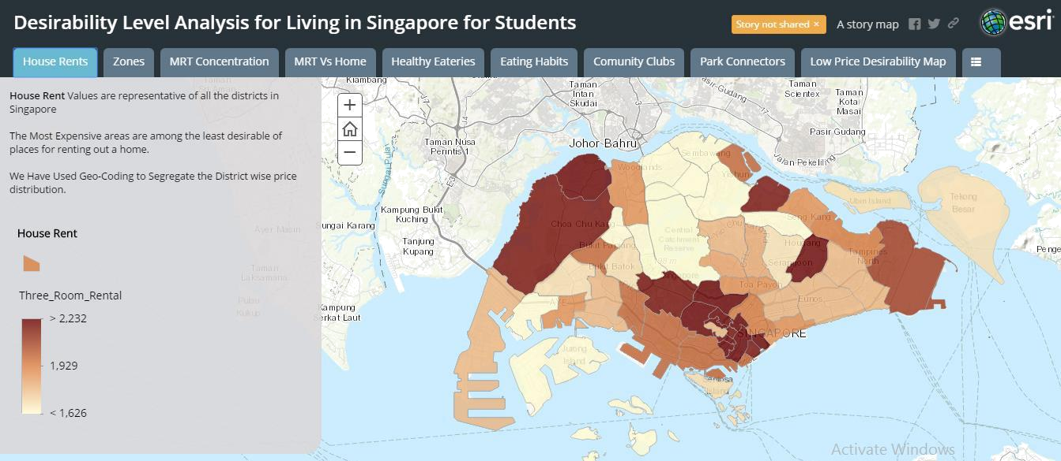

2.2.2 Separation into Zones

We partitioned Singapore map based on the rental prices into 3 “zones” so that we can easily manage 3 mutually exclusive zones according to affordability. 3 Sub Zones were:

- $1500 - $1850 - Low Priced Zone
- $1900 - $2200 - Medium Priced Zone
- $2200 - $2700 - High Priced Zone

Partitioning was done using the Lasso Tool and we Rasterized the 3 zones to be able to demarcate them individually. We could then intersect any of these zones with the buffered polygons of shortlisted Amenities/Facilities. The zones are as displayed in the map below.
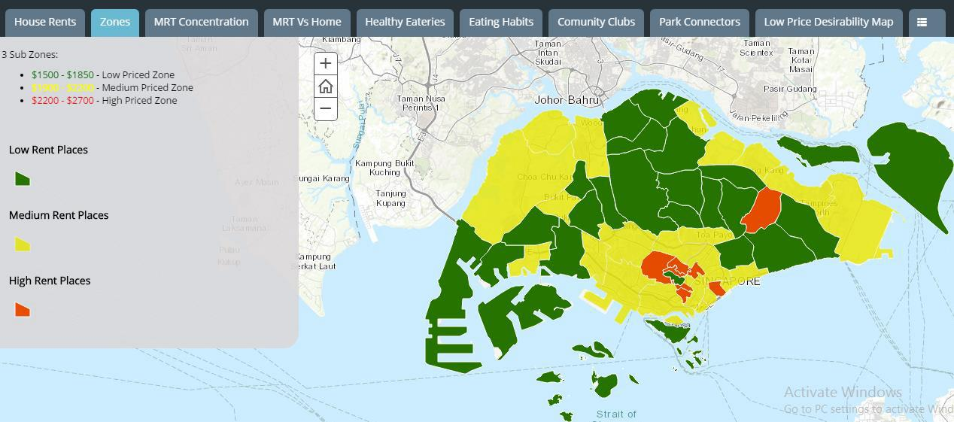
2.2.3 MRT concentration

The MRT concentration Heat Map gives us an insight into the Governments’ prioritization for residential and business areas. We can clearly see that the services are concentrated in the

“Raffles Place”, “Punggol” and “Choa Chu Kang” areas. “Raffles Place” is the financial hub of the island and hence this is a highly unlikely area for residential properties.
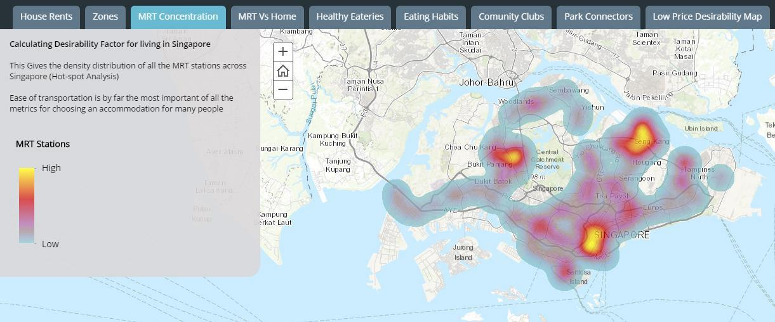

2.2.4 MRT Vs Home

We made a polygon buffer taking 1.5 km distance for the radius from the exact coordinates of the MRT stops. This, when over-laid with the “Home Locations of Students” gave us a good insight that MRT locations are definitely one of the major deciding factors as most students were found to be residing with in the 1.5 km raster of MRT. However, on closer Inspection some densely packed home locations near “Pasir Panjang road” were found to be far from the MRT Locations.
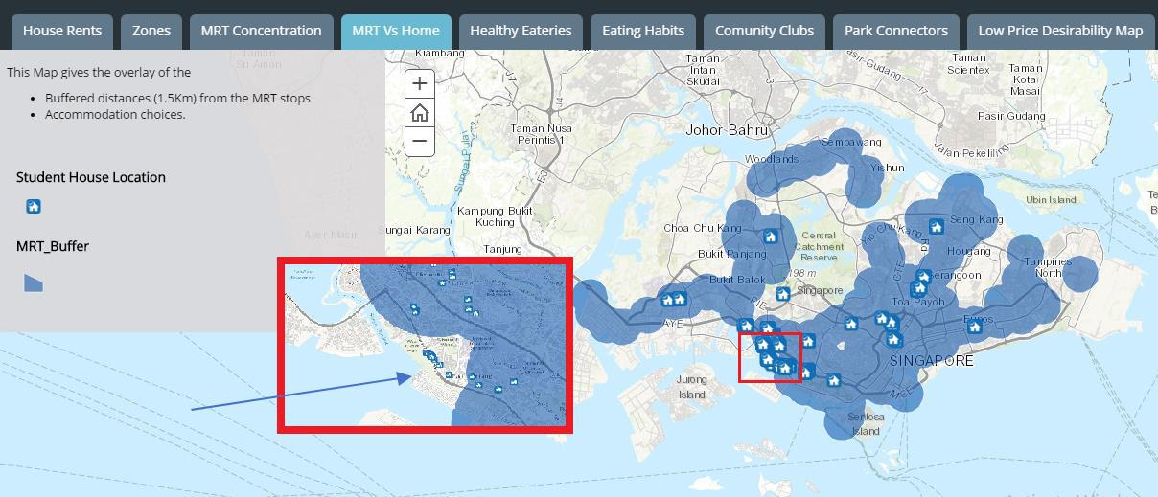

Houses at Pasir

Panjang
The map below is a definite indication that we would have to find some other decisive services or amenities in addition to the MRT services to give us a better understanding about students residing in Pasir Panjang.
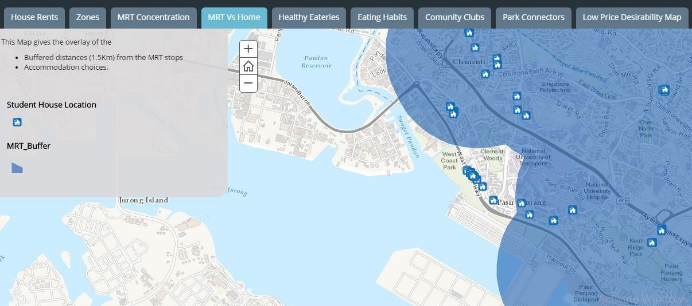

2.2.5 Healthy Eating Places

To stay healthy, it is essential to eat healthy! So we wanted to get an Insight into the eating habits of the NUS Students and their decisions to take the accommodation.

The following Map gives the “Lunch locations” layer over-laid on polygon buffer of Healthy Eateries taking 1 Km distance from the exact coordinates of the eateries. This gives us the locations for lunch of the students on a college day as well as a non-college day. So, we can infer that most of the students are within 1 km radius of healthy dining options
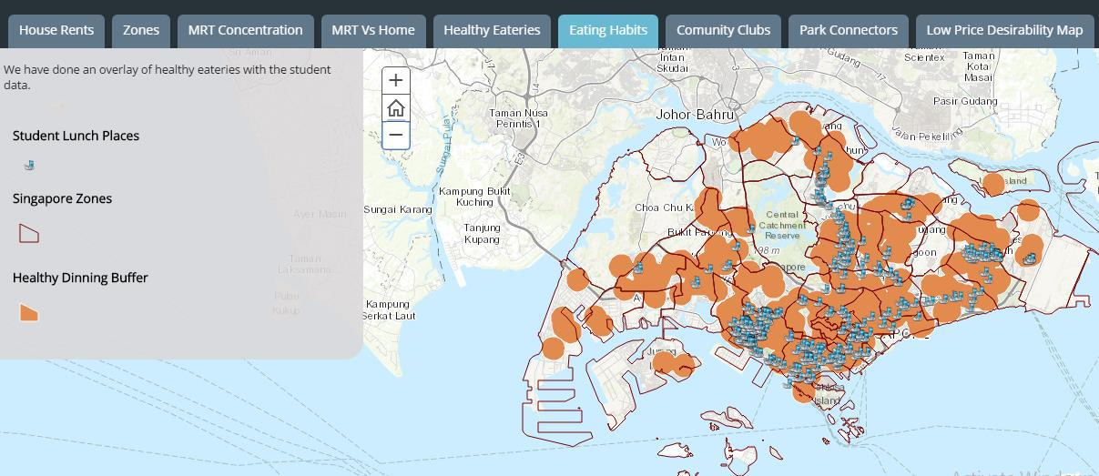
2.2.6 Community Clubs

Community Clubs (CCs) are recreational centers, having various activities related to hobby, fitness, sports and short courses on different topics. Even for CCs, we created a polygon buffer of 1 km radius which gives the ideal reach to a person in the neighborhood.

The following map gives an overlay of home locations of students over the Community Center buffer. It was found that most students resided within 1 Km distance from the nearest community clubs.
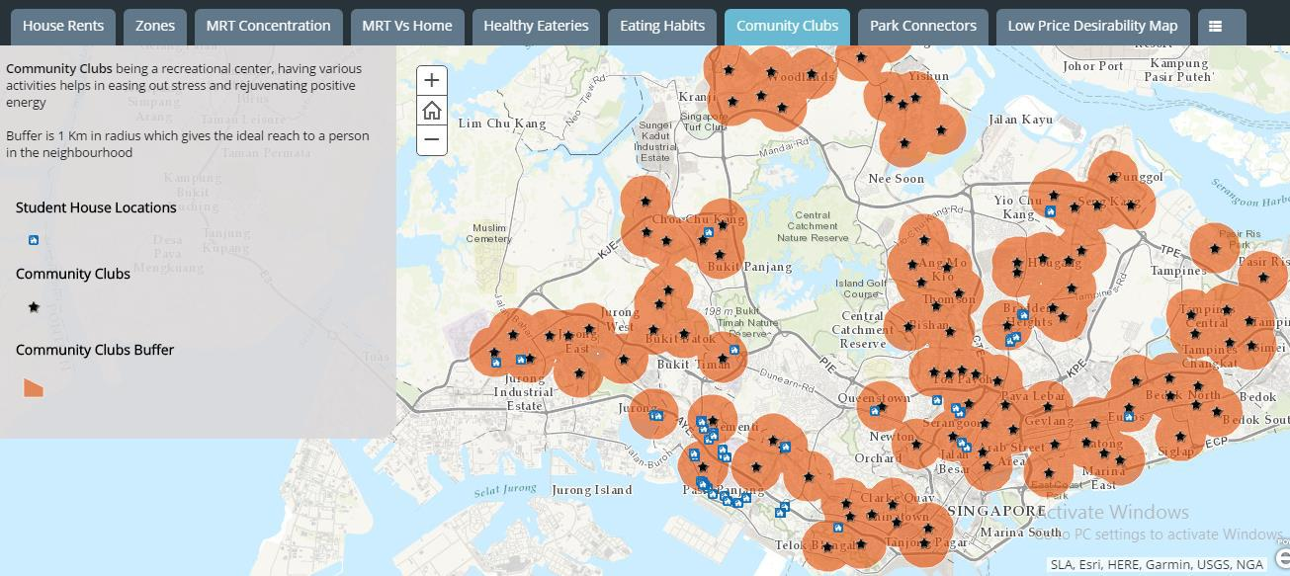

2.2.7 Park Connectors

People prefer park connectors near their homes and therefore we have rated the students’ residences about 1Km within park connectors as more desirable for the people. The Following Map Does Cover most of the home locations of students with in the 1 km distance to park connectors
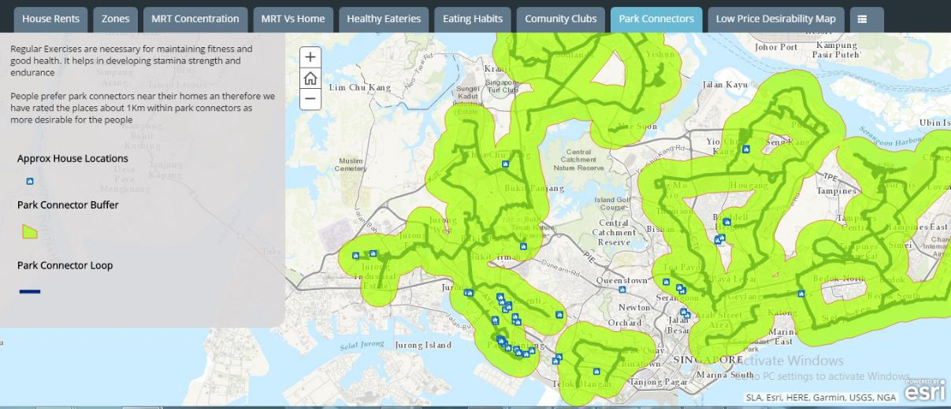
2.2.8 Low Price Desirability Map

For deriving the following map, we took all the layers above and considered intersections of rental zones with any two or all the facilities/amenities in the vicinity.

Hence, we took multiple intersects of all the polygon buffers derived for amenities/facilities (2.2.4 – 2.2.7) in various combinations.

This helped us geographically isolate areas in the map which had all or some of the facilities contained within them.

Most Desirable Area (in Dark Green) is the intersection of:

- MRT+

- Healthy Dining Places +

- Community Clubs +

- Park Connectors +

- Polygon for Low Price Zone (from derivation 2.2.2)

The other colors representations are as follows:

Light Green: intersection of Low Rent Zone + MRT + Healthy Dining Places

Yellow: Intersection of Low Rent Zone + Community Clubs + Healthy Dining Places

Surprisingly, the most desirable areas with all amenities with lowest rent zones had just few students residing in them
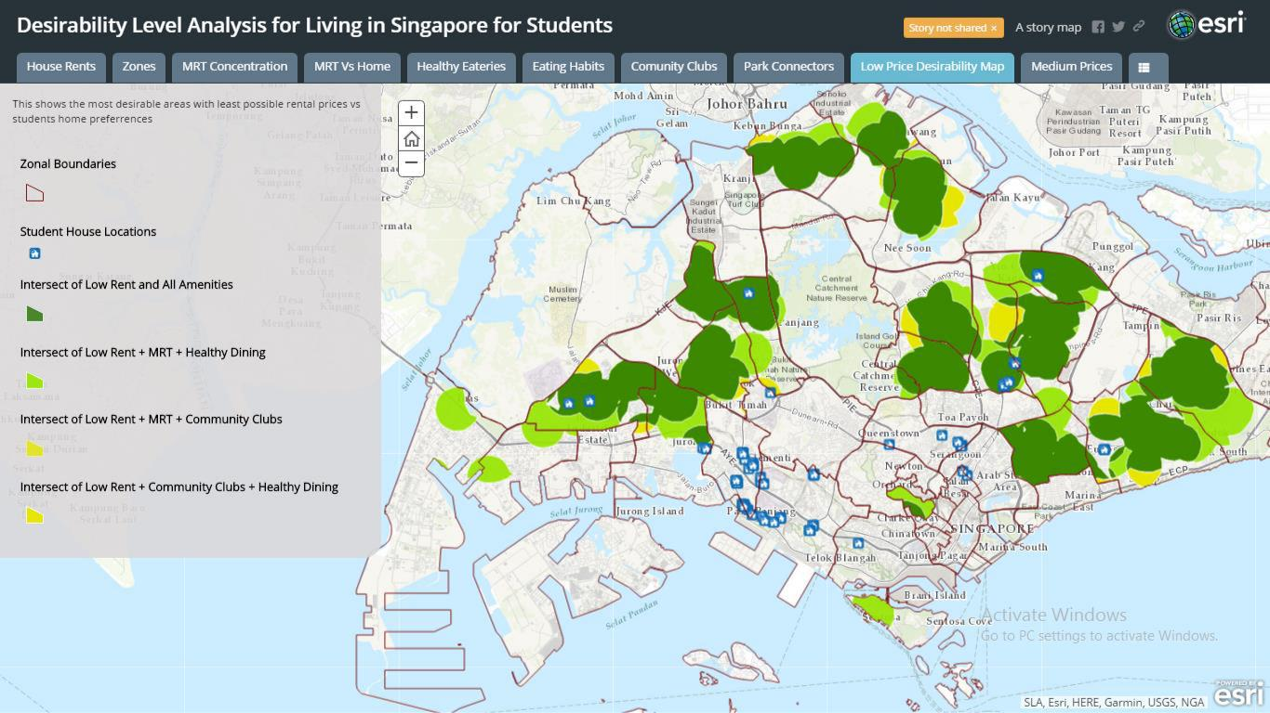
2.2.9 Medium Price Desirability Map

We repeated the above intersections for medium rental zones. This time we found several students residing on medium rent locations with all amenities or at least 2 amenities. The colours representing different intersections are same as above (where low rent zones are now replaced with medium rent zones)
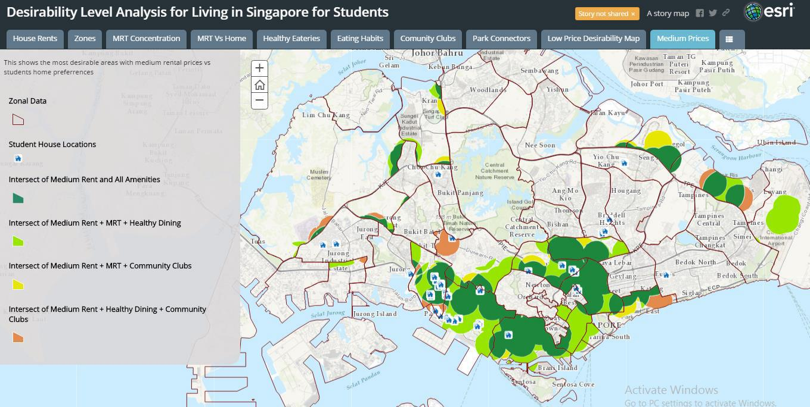

2.2.10 High Price Desirability Map

We now applied intersections with “High Rent Zone”. Now, we see only a few students’ homes in the most desirable but highly expensive areas.
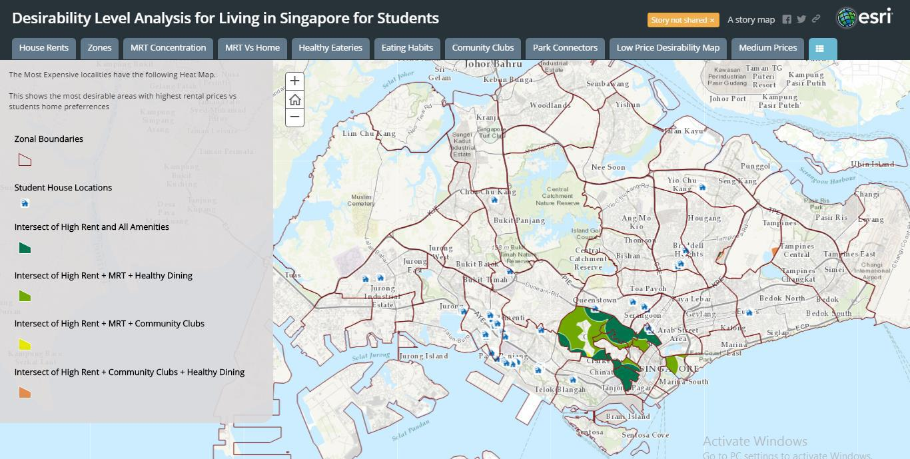
2.2.11 Overall Desirability Map

We Overlay the Maps in 2.2.9 to 2.2.11 on each other. This gives a union of three maps as the zones are disjoint.

From this map, we can clearly see that we have captured most number of students within most desirable areas will all amenities in around 1 km radius of the amenities (ignoring rent) in dark green. This was the advantage of color coding locations as per the intersection of the number of amenities and not price.

This map shows that:

- Majority of students reside in dark green areas, i.e. locations which have all amenities.

- Some students reside in light green regions indicating they have facilities like MRTs and Healthy Dining places closer to their houses and

- Only a few students live in brown colored locations where in Community Clubs and Healthy Dining options are in about 1 km distance of their houses. However, these houses were spread across all (high, medium and low) rental prices
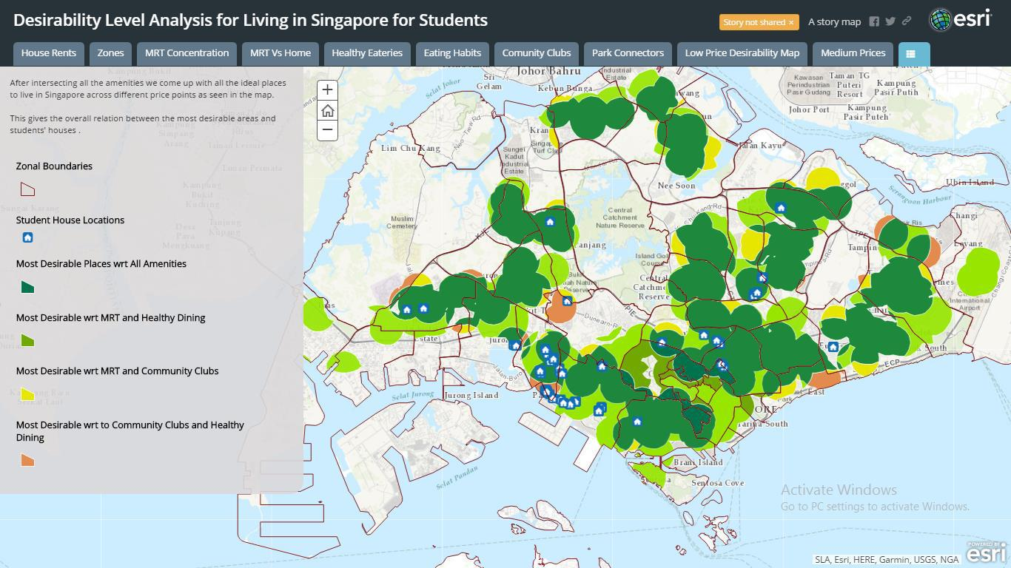

However, it was interesting to see that the area near Pasir Panjang was highly populated despite not being the most desirable, owing to the fact that all amenities are away from this location according to our model. This brings us to the final addition to our analysis.
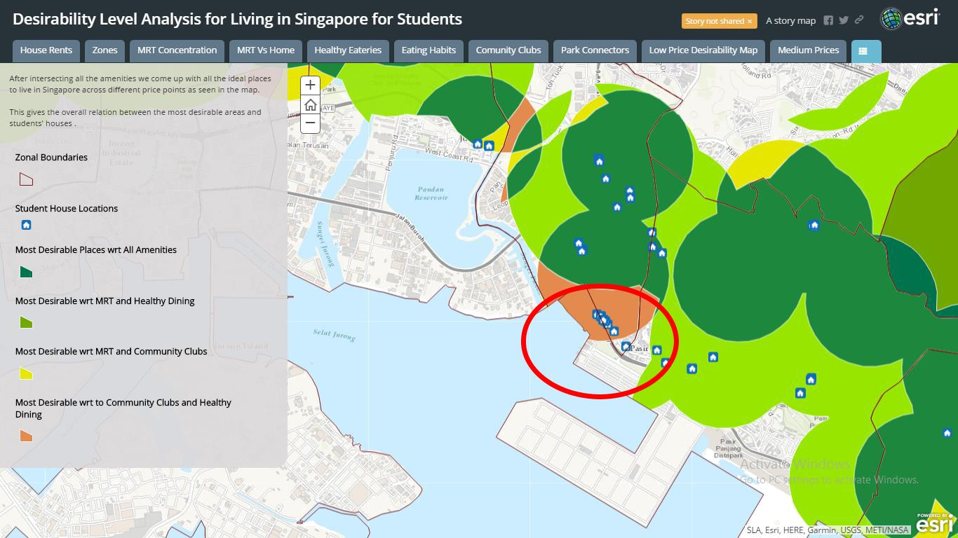

Pasir Panjang

2.2.12 Accommodation Proximity to NUS

We added a polygon to represent NUS which acts as a Geo-Fence (in brown) for the spread of NUS. We made another buffered polygon with a range of 1 Km (in Blue) extending out from this geo fenced area. This area accounts for an extremely desirable area for our target group.

The group of students residing in this area have given up most other amenities in favor of proximity to the university. This explains the query raised above of why some students stay at Pasir Panjang even when the amenities are far-off
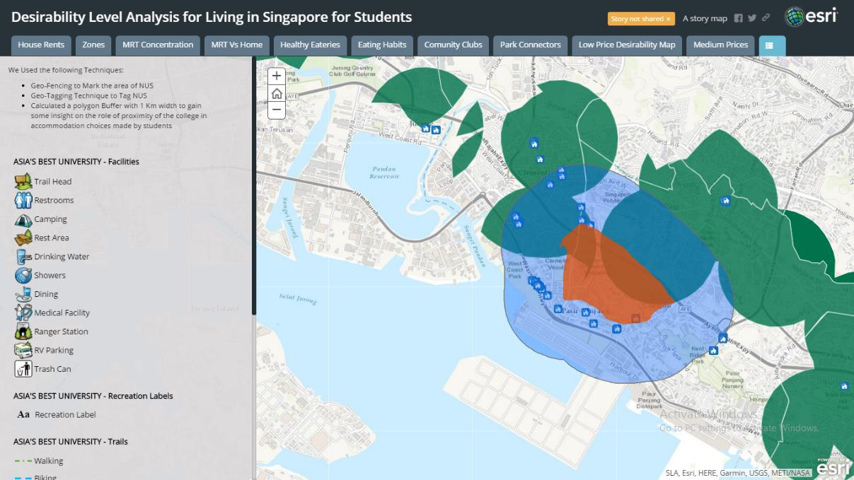

3 THE INSIGHTS

The entire analysis of the geospatial data gives us the following insights into the student choice of accommodation:

- Most Students prefer being close to the University at the cost of lesser amenities

- Most students reside in locations of medium rent. Again, this is a Proximity based decision for the students. The locations closer to the university have higher desirability irrespective of rent

- Very few students live in locations of low rent, however these places are at longer distance from

NUS

- The few student houses are found in high rent locations and these mainly because they are within a kilometer radius from NUS

- Majority of the students’ residences have proximity to amenities to at least some of the amenities from MRT station, Community center, Healthy dining facilities and Park connectors.

- However, those staying closest to NUS campus must travel more than a kilometer to avail all the amenities and are in general paying high rent. They are still able to utilize amenities like community centers and healthy dining facilities.

- The Priority that we found in decreasing order of preference are:

  - Proximity to NUS

  - Proximity to MRT

  - Proximity to Healthy Eateries

  - Others

