--------------Module 4,Problem 1 Solution---------------------------------------------

Select DISTINCT city, state, zip from customer;

-------------Snapshot for the above statement-----------------------------------------------

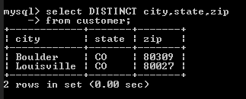

------------------Module 4,Problem 2 Solution-----------------------------------------------

Select EmpName AS EmployeeName, Department, Phone AS PhoneNo, Email AS EmailAddress

From Employee

Where Phone LIKE '3-%';

-------------Solution Snapshot for the above statement-----------------------------------

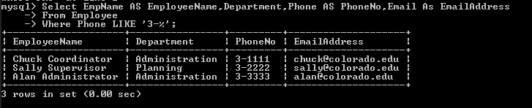

-----------------Module 4,Problem 3 solution---------------------------------------------------------------------------

SELECT RESNO, RESNAME, RATE

FROM RESOURCETBL

WHERE RATE BETWEEN 10 AND 20

ORDER BY RATE;

-----------------Solution Snapshot for the above statement--------------------------------------

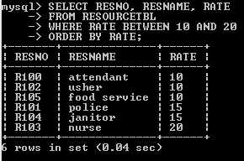

-----------------Module 4,Problem 4 Solution-----------------------------------------------------------

Select EventNo,DateAuth,Status

FROM EventRequest

Where Status IN ('Approved','Denied')

AND DateAuth BETWEEN '2013-07-01' AND '2013-07-31';

---------------Solution Snapshot for the above statement------------------------------------------

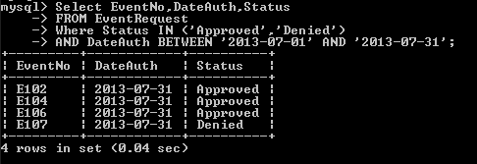

-----------------Module 4,Problem 5 Solution------------------------------------------------------------

SELECT LocNo AS LocationNo, LocName AS LocationName

From Location Inner Join

Facility ON Facility.FacNo= Location.FacNo

Where FacName='Basketball arena';

--------------------Solution Snapshot for the above statement-----------------------------------------

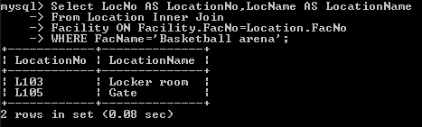

--------------------Module 4,Problem 6 Solution----------------------------------------------------------

Select PlanNo,Count(LineNo) AS LineCount,SUM(NumberFld) AS TotalResources

FROM EventPlanLine

Group By PlanNo

Having LineCount>=1;

-------------------Solution Snapshot for the above statement---------------------------------------------

