Online Grocery Shopping

Revision History
Version No. | Date | Prepared by / Modified by | Significant Changes
1 |  | Abhilasha Choudhary  Alka Badhan  Aman Chauhan  Anjana Jose  A S Sreenivasan | Draft Version
2 |  | Abhilasha Choudhary  Alka Badhan  Aman Chauhan  Anjana Jose  A S Sreenivasan | Draft Version

Glossary
Abbreviation | Description
OGS | Online Grocery Shopping

Table of Contents
1 Introduction 3
2 Scope of Change 3
3 List of impacted modules 3
4 Design and Detailed technical updates 4
4.1 Process model 4
4.1.1 Use case Model 4
4.1.2 Sequence diagram 5
4.1.3 Architecture Diagram 6
4.2 Proposed user Interface design 7
4.2.1 User Registration 7
4.2.2 Login 9
4.2.3 View Products 10
4.2.4 View All Products 11
4.2.5 Add Products 12
4.2.6 Update Products 13
4.2.7 View Cart 14
4.2.8 Add Item To Cart 15
4.3 Database design changes 16
4.3.1 ER Diagram 16
5 References 16

Introduction

Online grocery shopping is a form of electronic commerce, which allows consumers to directly buy goods or services from a seller over the Internet using a web browser.
A shopping cart is an essential part of a retailer’s online store that streamlines the online shopping experience. Software allows website visitors to select, reserve, and purchase a product or service from an e-commerce interface. You can add and remove items as you wish, just as if you would in the real world.
Shopping cart software is a fundamental part of the online shopping experience. It is what facilitates everything in between the customer finding a product they like and completing their purchase. For that reason, implementing excellent shopping cart software is crucial for your e-commerce business.

Scope of Change
Change will not be entertained and whatever specifications mentioned in this document is final.

List of impacted modules
All the functional modules will be created from scratch.

Design and Detailed technical updates

Process model

Use case Model

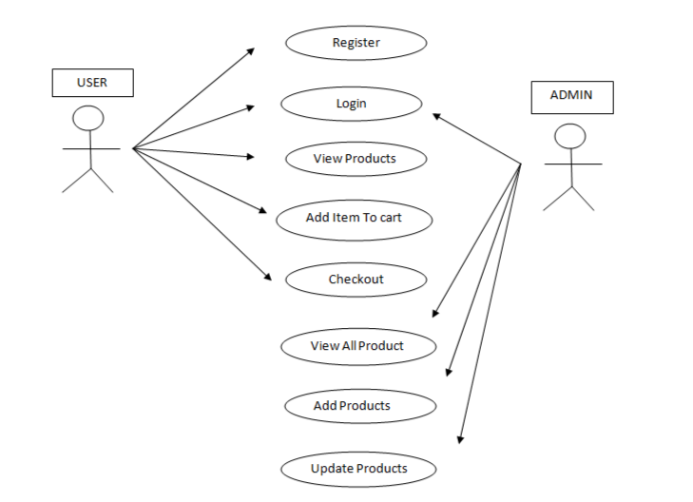

Sequence diagram

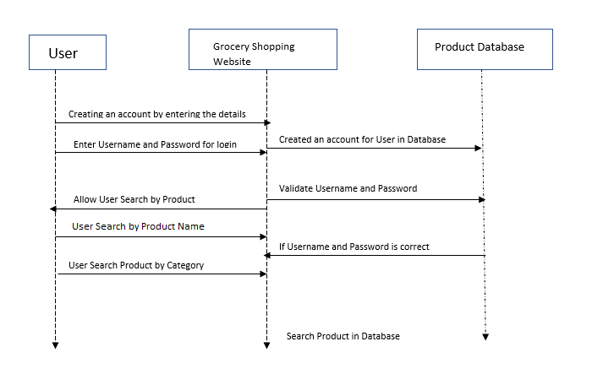

Architecture Diagram

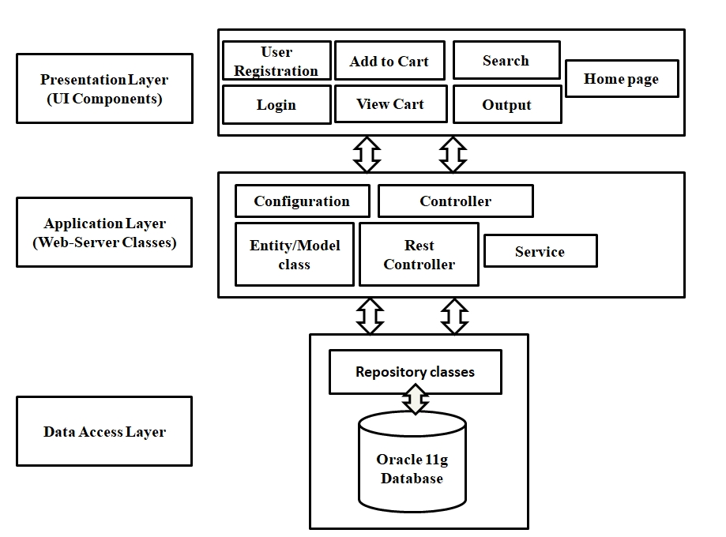

Presentation Layer
This layer consists of all UI components.
- Register Component: Users can use a register component to create an account.
- Login Component: Users can use a login component to login to the website.
- Home Component: Users can use a home component to view grocery.
- Cart Component: Users can use a cart component to add grocery to the cart.

Application Layer
This layer comprises of all server and business classes.
- Configuration settings (XML or class based) will define the application and server configuration.
- Spring Controllers define the server classes, which are required to process the incoming http requests.
- Service classes are required to perform the required business services.
- REST Controllers process HTTP AJAX requests.
- Model classes are used to define the functions of the entities present in the system.

Data Layer
The data layer is implemented through Spring Data JPA. It will contain the repository classes, which provides interface to the table.

Proposed user Interface design

User Registration
Brief Description | User Registration
Basic Flow | This use case describes how a customer register in to the system  - The user/admin has to register himself/herself into the system.  - After the successful registration, user will get a success message.  - The following information is required during registration.  - First Name  - Last Name  - Email  - Mobile Number  - Username  - Password  - Confirm Password
Alternate Flow | - The system will validate the information provided. If any invalid data is found, the input form will be redirected with error message.
Validation | - Name is required and minimum 3 characters and max 30 characters.  - The Email should be valid.  - Mobile Number should be 10 digits.  - Password should contain one upper case, one lower case alphabet and length between 6 to 30 characters.  - Password and Confirm password should be same.
Pre-Conditions | User should have network access and Browser with latest updates.
Post-Conditions | Success message should be shown.

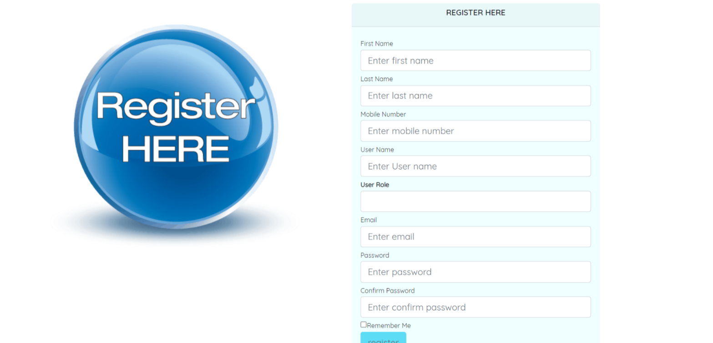

Login
Brief Description | Login
Basic Flow | This use case describes how a user log-in in to the system  - The user has to login himself into the system.  - After the successful login, user will be taken to the landing page.  - The following information is required to login.  - Email  - Password
Alternate Flow | - The system will validate the credentials provided. If credentials are invalid, login form will be redirected again with error message.
Validation | - Valid email  - Valid password
Pre-Conditions | User should have network access and Browser with latest updates.
Post-Conditions | Landing page has to be displayed.

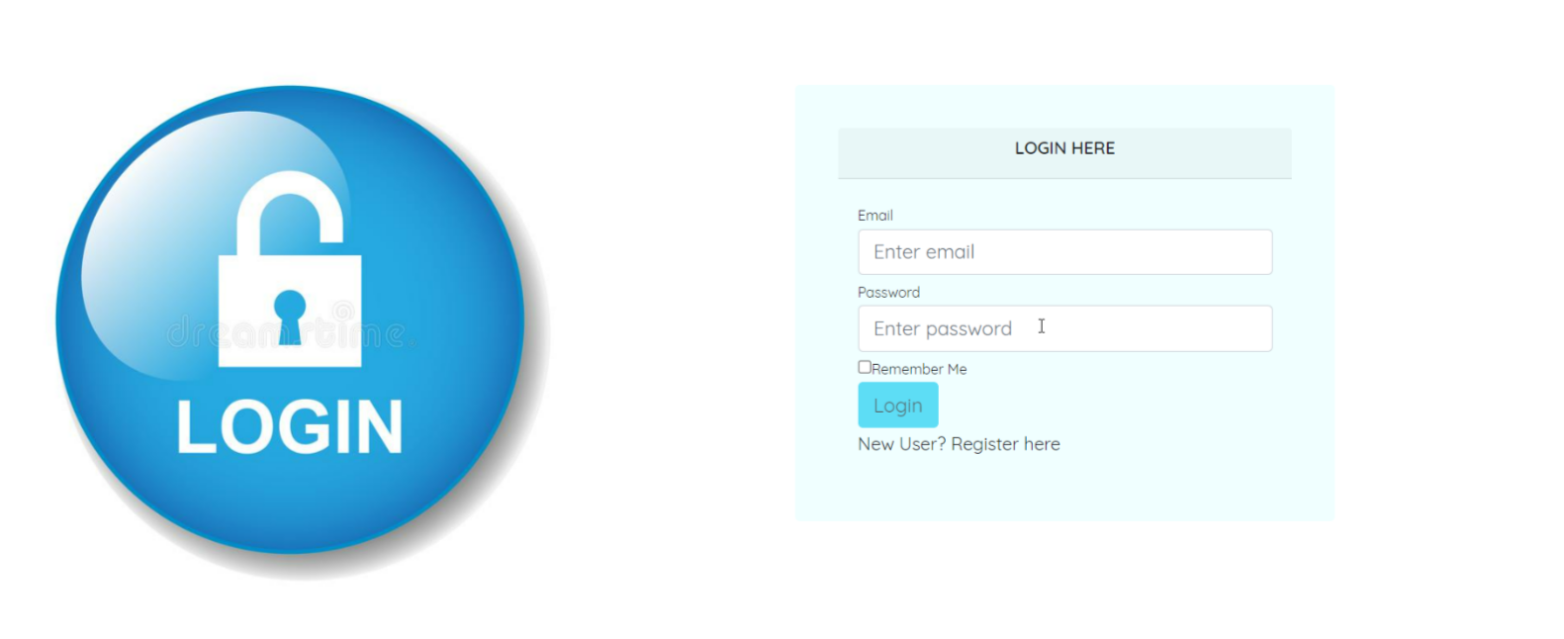

View Products
Brief Description | View Products
Basic Flow | This use case describes how the user view products.  - The user has to login into the system.  - The following information are seen during view products.  - Product Id  - Product Name  - Brand  - Price  - Image
Alternate Flow | Not applicable
Validation | Not applicable
Pre-Conditions | User should have already logged into the system.

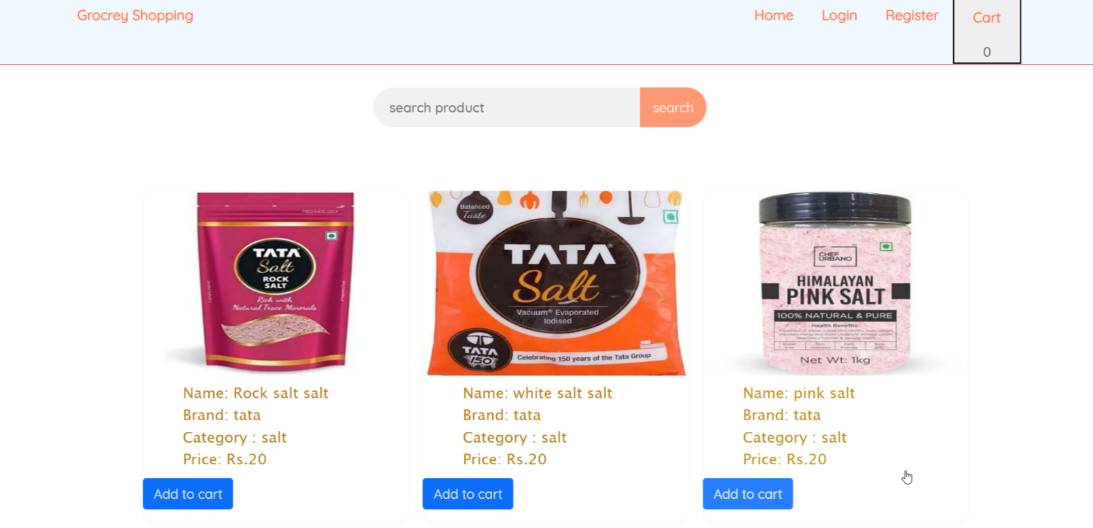

View All Products
Brief Description | View Products
Basic Flow | This use case describes how the admin view all products.  1. The user has to login into the system.  2. The following information are seen during view products.  - Product Id  - Product Name  - Brand  - Price  - Image
Alternate Flow | Not applicable
Validation | Not applicable
Pre-Conditions | Admin should have already logged into the system.
Post-Conditions | Success message should be shown.

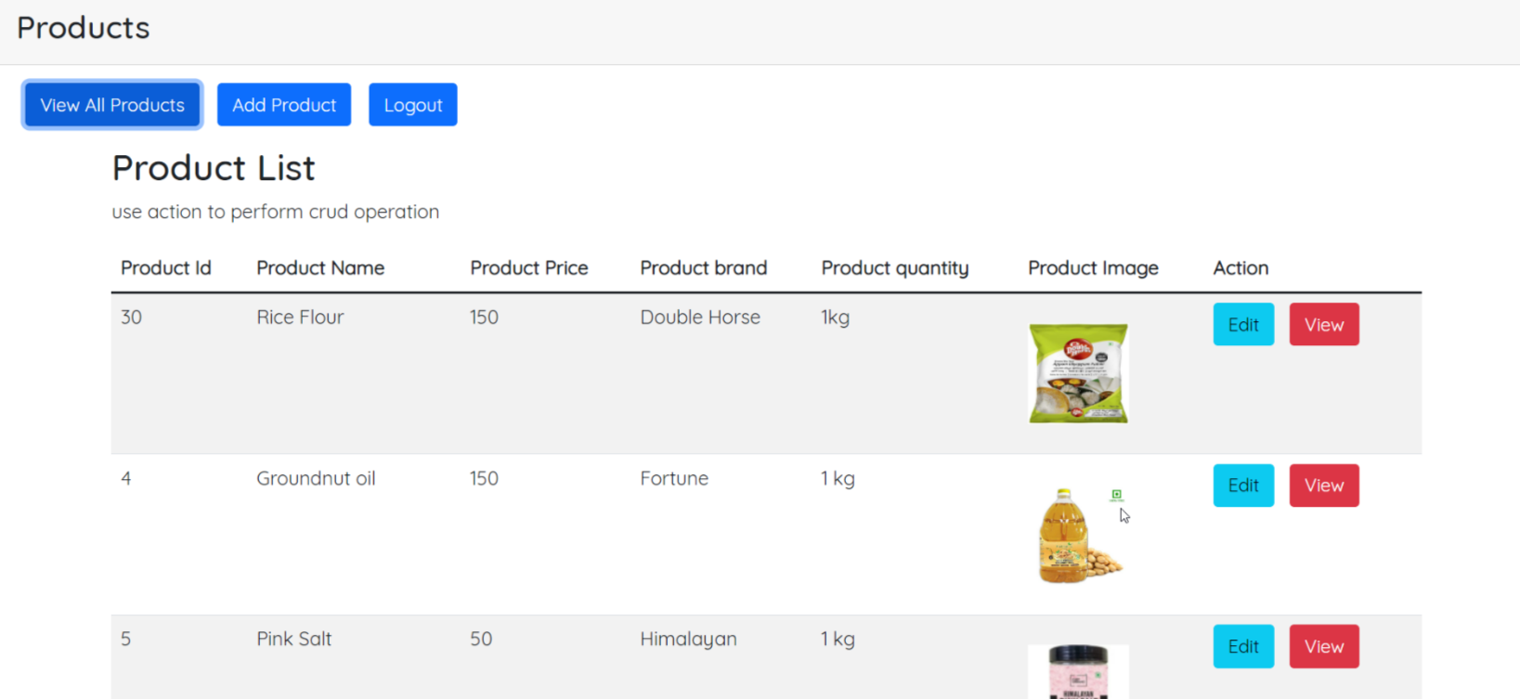

Add Products
Brief Description | Add Products
Basic Flow | This use case describes how the admin add products.  1. The admin has to login into the system.  2.The following information are seen during add products.  - Product Id  - Product Name  - Brand  - Price  - Image
Alternate Flow | Not applicable
Validation | Product Id, Product Name, Brand, Price and image is required.
Pre-Conditions | Admin should have already logged into the system.
Post-Conditions | Successfully product added message has to be displayed.

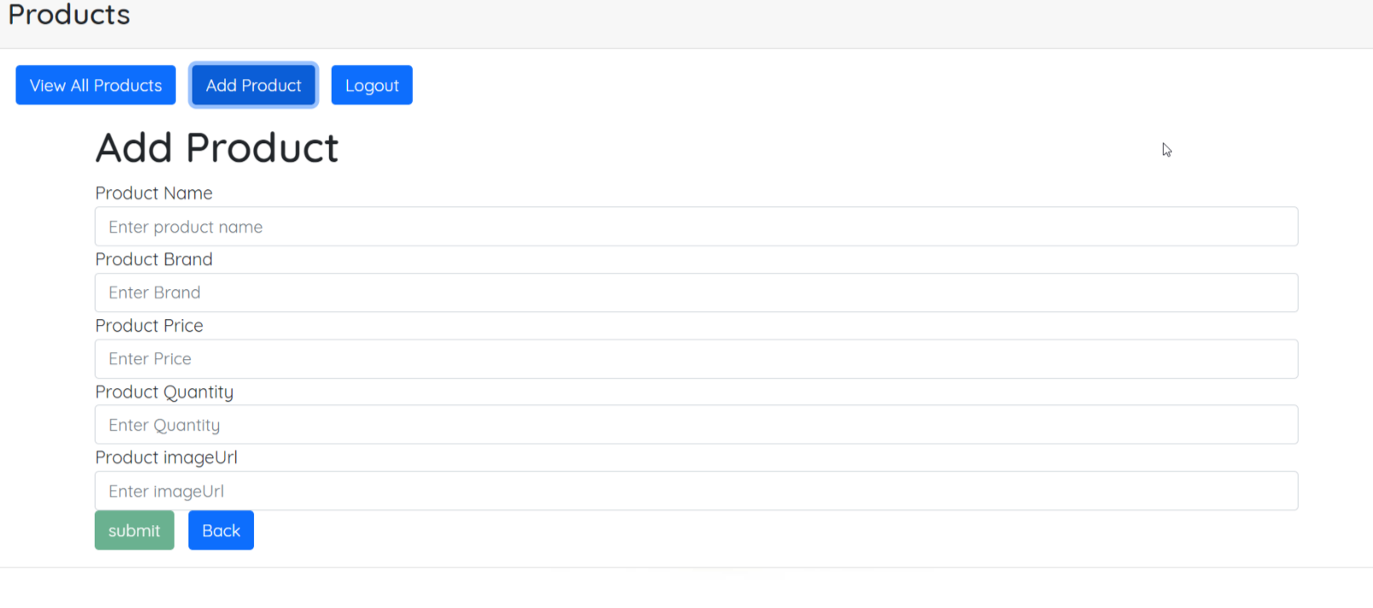

Update Products
Brief Description | Update Products
Basic Flow | This use case describes how the admin update products..  1. The admin has to login into the system.  2.The following information are seen during update products.  - Product Id  - Product Name  - Brand  - Price  - Image
Alternate Flow | Not applicable
Validation | Product Id, Product Name, Brand, Price and image is required.
Pre-Conditions | User should have already logged into the system.

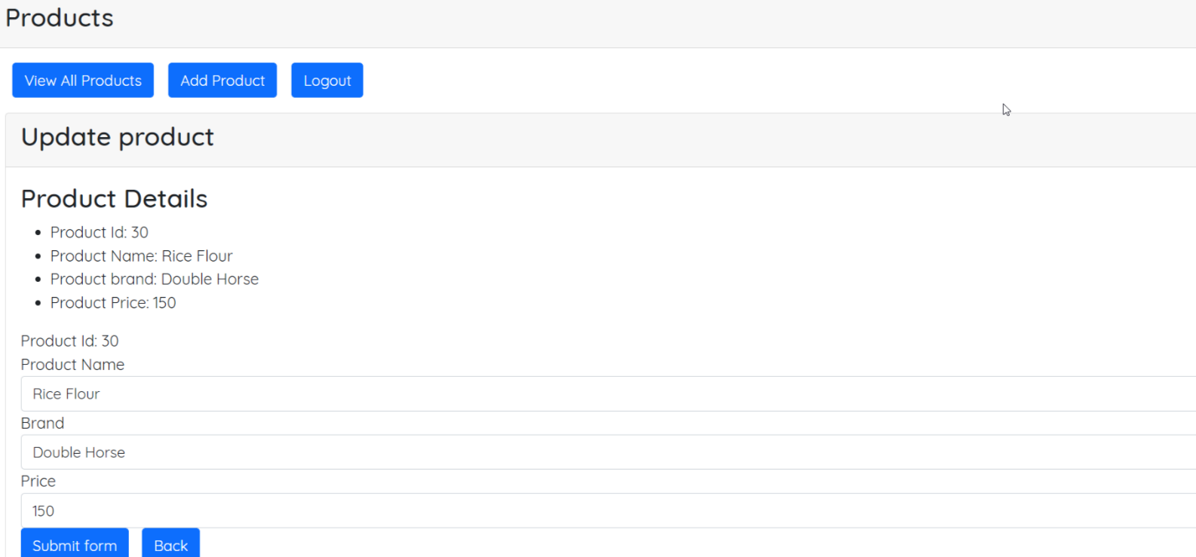

View Cart
Brief Description | View Cart
Basic Flow | This use case describes how user can view the status of the uploaded invoices.  - The client/supplier has to login into the system.  - The following information has to be displayed.  - Supplier code  - Invoice number  - Invoice Date  - Invoice amount  - Currency  - Invoice Status
Alternate Flow | Not Applicable
Validation | Not Applicable
Pre-Conditions | User should have already logged into the system.
Post-Conditions | Not Applicable

Add Item To Cart
Brief Description | Add item To cart
Basic Flow | This use case describes how to add item into the cart  - The user has to login into the system as user.  - The user should select the necessary grocery products to add item to cart.
Alternate Flow | Not applicable
Validation | Not applicable
Pre-Conditions | User should have already logged into the system.
Post-Conditions | Success message should be shown.

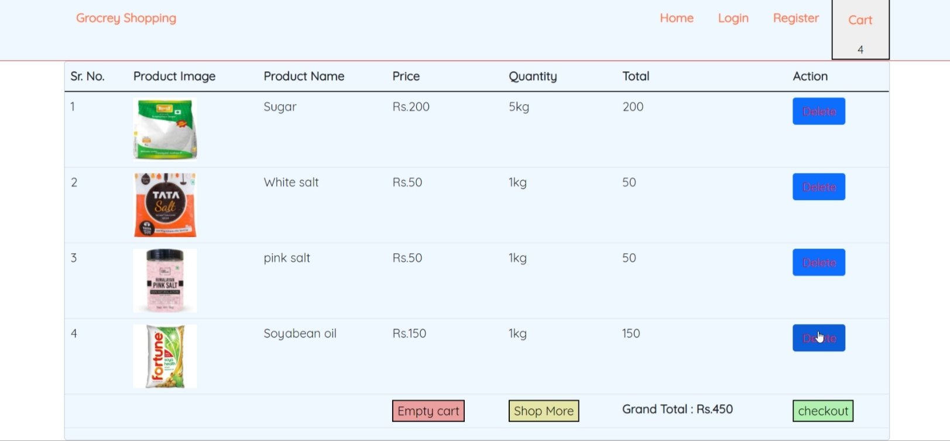

Database design changes

ER Diagram

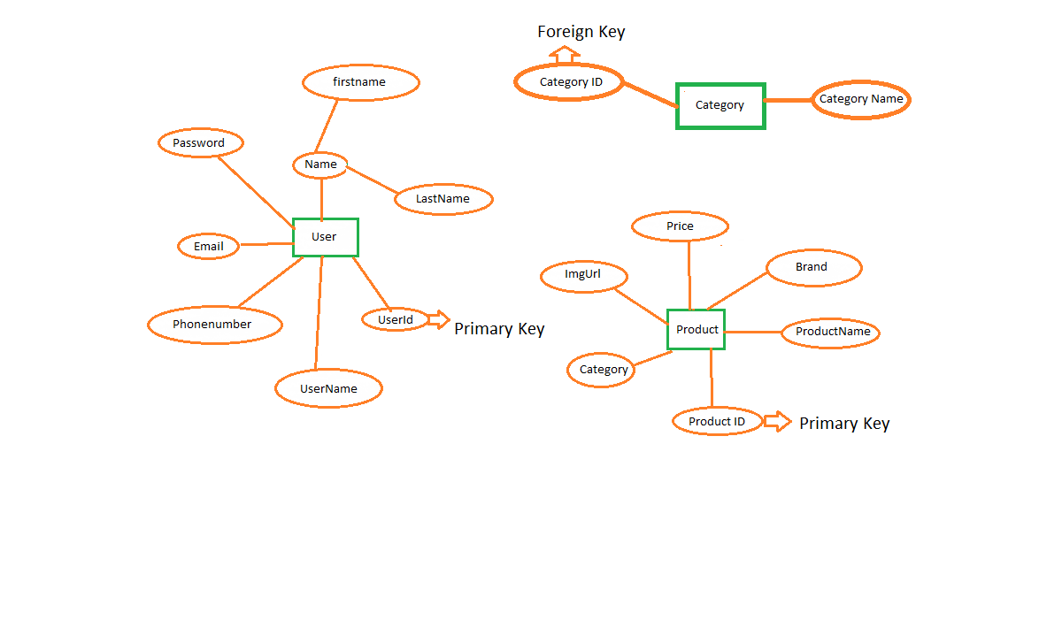

References
- As a team, we have referred LMS content to complete our project named as “SHOPPING GROCERY CART”. HCL provided three months training for us on that particular training we learnt so many technologies like Core Java, HTML5, CSS3, Spring boot2.3.3, Spring Data JPA, Angular8. Whatever we learnt in the training we implement in our project.

