Jenkins CI/CD Pipeline
Automated deployment of a Flask backend and an Express frontend on AWS EC2
Student | Abhilasha
Course | DevOps
Express repository | pawarsnehal4972/Jenkins_cicd_Snehal
Platform | AWS EC2 (Amazon Linux 2023), Jenkins LTS, pm2

How to use this document: each yellow box marks a screenshot to capture while you follow the steps. Replace the box with your screenshot before submitting. All code, Jenkinsfiles and scripts referred to here are in the same folder.

1. Architecture
Both applications run on one EC2 instance and are kept alive by the pm2 process manager. Jenkins runs on the same instance. A GitHub webhook notifies Jenkins about every push; the matching pipeline then pulls the code, installs dependencies, runs the tests, deploys the new version and restarts it with pm2.
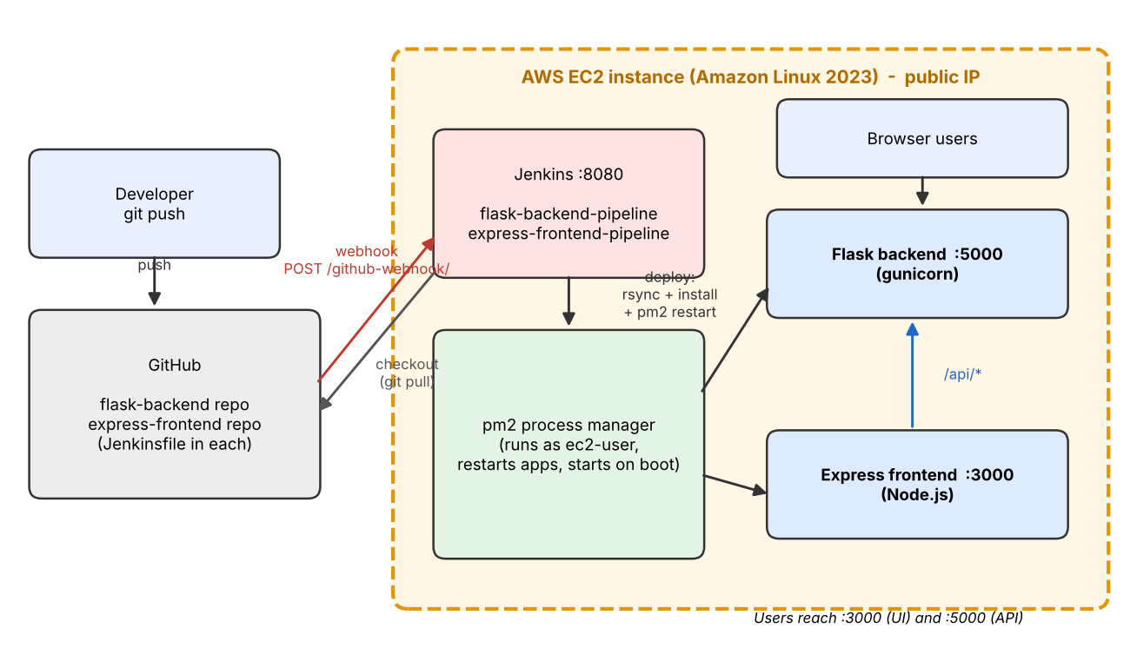
Component | Port | Role
Flask backend (gunicorn) | 5000 | REST API: /api/health, /api/message, /api/info, /api/config-status
Express frontend (Node.js) | 3000 | Web page; proxies /api/* to Flask
Jenkins | 8080 | Two pipelines: flask-backend-pipeline and express-frontend-pipeline
pm2 | - | Runs and restarts both apps, starts them again after a reboot
GitHub | - | Two repositories (Flask, Express); webhook calls Jenkins on every push

2. Part 1 - Deploy on a Single EC2 Instance

2.1 Launch the EC2 instance
An Amazon Linux 2023 instance (t3.micro, free tier) was launched with a key pair. The security group allows SSH (22, my IP only), Flask (5000), Express (3000) and Jenkins (8080).

2.2 Connect and install dependencies (Python, Node.js, Git, pm2)
ssh -i your-key.pem ec2-user@<EC2_PUBLIC_IP>
bash ~/infra/01_setup_ec2.sh
01_setup_ec2.sh adds swap space, installs Git, Python 3, pip, rsync, Node.js with npm, and the pm2 process manager. The versions are printed at the end.

2.3 Clone the repositories and start the apps
FLASK_REPO=https://github.com/<you>/flask-backend.git \
EXPRESS_REPO=https://github.com/<you>/express-frontend.git \
bash ~/infra/02_deploy_apps_manually.sh
The script clones both repositories into /home/ec2-user/apps, creates a Python virtualenv and runs pip install -r requirements.txt for Flask, runs npm install for Express, and starts both with pm2 using each repo's ecosystem.config.js (Flask on port 5000, Express on port 3000). pm2 save and pm2 startup make the processes survive reboots.

2.4 Verify
curl http://localhost:5000/api/health
curl http://localhost:3000/health
Both applications are also reachable from the internet through the instance's public IP.

3. Part 2 - CI/CD with Jenkins

3.1 Install Jenkins
bash ~/infra/03_install_jenkins.sh
The script installs Java 21 and the Jenkins LTS package, configures Jenkins to run as ec2-user (so pipelines can deploy into /home/ec2-user/apps and control the same pm2 processes) and prints the initial admin password.

3.2 Install and verify plugins
Required plugins: Git, GitHub, Pipeline, NodeJS, Credentials Binding, JUnit, Timestamper, Workspace Cleanup and Pipeline Stage View. Most are installed by 'Install suggested plugins'; NodeJS is added manually. Python needs no plugin because the pipelines use the system Python 3 with a virtualenv.

3.3 Credentials for sensitive data (optional enhancement)
A 'Secret text' credential with the ID flask-api-key stores an API key in Jenkins. The Flask pipeline injects it with withCredentials as the environment variable API_KEY, which pm2 passes to the app. Jenkins masks the value in the build log, and the application only reports whether the key is configured (/api/config-status).

3.4 Create the two pipeline jobs
Two separate Pipeline jobs were created, each with 'Pipeline script from SCM' (Git, branch */main, script path Jenkinsfile) and the build trigger 'GitHub hook trigger for GITScm polling'.

3.5 The Jenkinsfiles
Stage | Flask pipeline | Express pipeline
Checkout | checkout scm (latest code from GitHub) | checkout scm (latest code from GitHub)
Install Dependencies | python3 -m venv venv; pip install -r requirements.txt | npm install
Test | pytest with JUnit report | npm test (node --test)
Deploy | rsync to ~/apps/flask-backend, pip install, pm2 startOrRestart, pm2 save | rsync to ~/apps/express-frontend, npm install --omit=dev, pm2 startOrRestart, pm2 save
Health Check | curl /api/health, pm2 list | curl /health, pm2 list

Both files use a declarative pipeline with the githubPush() trigger. If the Test stage fails, the pipeline stops and the running version is left untouched. pm2 startOrRestart restarts the process when it exists and starts it otherwise.

3.6 First successful builds

4. GitHub Webhook
In both repositories: Settings > Webhooks > Add webhook, payload URL http://<EC2_PUBLIC_IP>:8080/github-webhook/, content type application/json, event 'Just the push event'.

5. Automatic Deployment on Push - Evidence
A small change was committed and pushed to each repository. Jenkins started the matching pipeline automatically (the build shows 'Started by GitHub push'), deployed the change and restarted the application with pm2.

5.1 Flask
# edit app.py (change the text returned by /api/message), then:
git commit -am "Change message"
git push

5.2 Express
# edit server.js (change the page heading), then:
git commit -am "Update heading"
git push

6. Deliverables Checklist
Requirement | Where it is covered
Running EC2 instance, Flask and Express reachable on the public IP | Section 2 and screenshots 2.1 / 2.4
Architecture description / diagram | Section 1, docs/architecture.png
Jenkins installed, plugins configured | Section 3.1 - 3.2, infra/03_install_jenkins.sh
Two separate Jenkins pipelines | Section 3.4
Pull code, install dependencies, restart with pm2 | Jenkinsfile in each repo, Section 3.5
GitHub webhook trigger on every push | Section 4 and 5
Testing stages (optional) | pytest (Flask), node --test (Express)
Environment variables / secrets in Jenkins (optional) | Section 3.3, credential flask-api-key
Jenkinsfile for each application | flask-backend/Jenkinsfile, express-frontend/Jenkinsfile
Screenshots of EC2 and pipeline logs | Sections 2, 3.6, 5
README.md | README.md in the project root
GitHub links for Flask and Express | Title page, README.md, GITHUB_LINK.txt

7. Conclusion
The Flask backend and Express frontend are deployed on a single EC2 instance under pm2. Two Jenkins pipelines, triggered by GitHub webhooks, test and redeploy each application automatically on every push, so a code change reaches the running servers without manual steps.

