Linux Basics – DevOps Assignment
Name: Abhilasha
GitHub Repository: PASTE YOUR GITHUB REPOSITORY LINK HERE
Objective: Practise essential Linux command-line operations: file and directory management, viewing files, searching, archiving, downloading, permissions and environment variables. All 12 tasks were run in a Linux (Ubuntu/bash) terminal. The full set of commands is also saved in linux_basics_tasks.sh in this folder.

Task 1 – Create a directory (mkdir)
Command:
mkdir test_dir
Explanation: mkdir creates a new directory. Here it creates test_dir in the current working directory. ls -ld confirms it exists (the leading 'd' in the permissions means it is a directory).
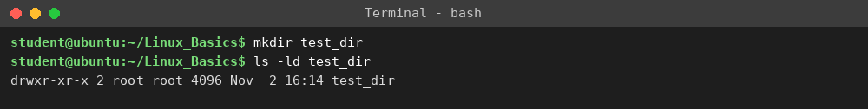

Task 2 – Create an empty file (touch)
Command:
touch test_dir/example.txt
Explanation: touch creates an empty file if it does not already exist. The path test_dir/example.txt places the file inside test_dir. ls -l shows the file with size 0 bytes.
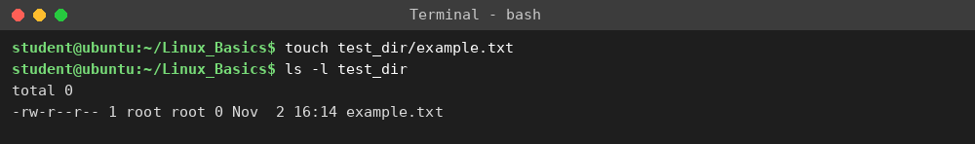

Task 3 – Rename a file (mv)
Command:
mv test_dir/example.txt test_dir/renamed_example.txt
Explanation: mv moves or renames. Since the source and destination are in the same directory, the file is simply renamed. ls -l confirms example.txt is gone and renamed_example.txt exists.
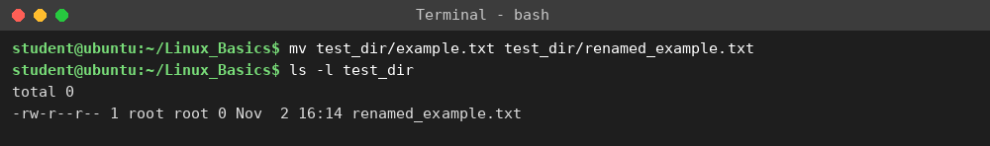

Task 4 – Display file contents (cat)
Command:
cat /etc/passwd
Explanation: cat prints the whole file to the terminal. /etc/passwd lists the user accounts on the system, one per line in the format name:password:UID:GID:comment:home:shell.
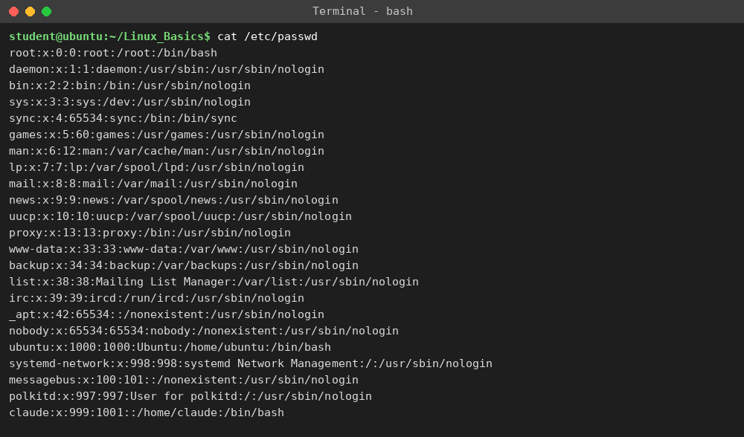

Task 5 – First 5 lines (head)
Command:
head -n 5 /etc/passwd
Explanation: head prints the beginning of a file. -n 5 limits the output to the first 5 lines.
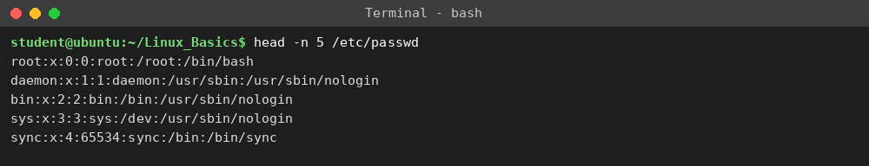

Task 6 – Last 5 lines (tail)
Command:
tail -n 5 /etc/passwd
Explanation: tail prints the end of a file. -n 5 limits the output to the last 5 lines.
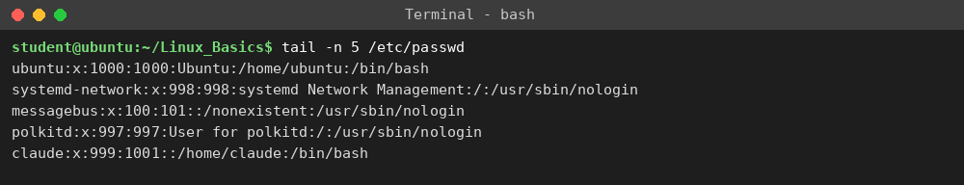

Task 7 – Search for a pattern (grep)
Command:
grep root /etc/passwd
Explanation: grep prints every line that contains the given pattern. Here it finds the lines containing the word 'root' in /etc/passwd.
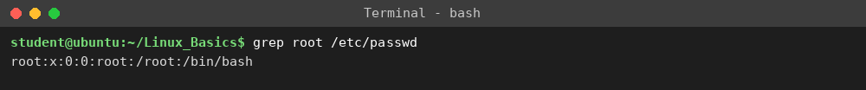

Task 8 – Compress a directory (zip)
Command:
zip -r test_dir.zip test_dir
Explanation: zip creates a compressed archive. -r means recursive, so the directory and everything inside it are added to test_dir.zip.
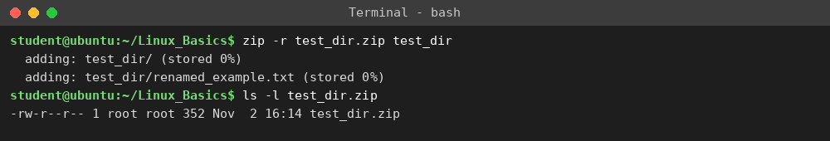

Task 9 – Extract an archive (unzip)
Command:
unzip test_dir.zip -d unzipped_dir
Explanation: unzip extracts an archive. -d chooses the destination directory, which is created automatically (unzipped_dir). ls -R lists the extracted contents recursively.
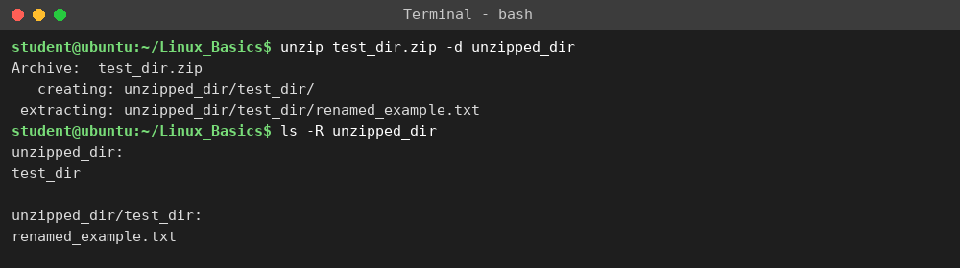

Task 10 – Download a file (wget)
Command:
wget http://localhost:8000/sample.txt
Explanation: wget downloads a file from a URL and saves it in the current directory. In this run the file was downloaded from a local test web server (python3 -m http.server 8000) because the machine had no internet access. On a normal machine you can use any URL, e.g. wget https://example.com/sample.txt (note that example.com does not actually host a sample.txt, so use any real file URL). The output shows HTTP 200 OK and 'saved', and cat shows the downloaded content.
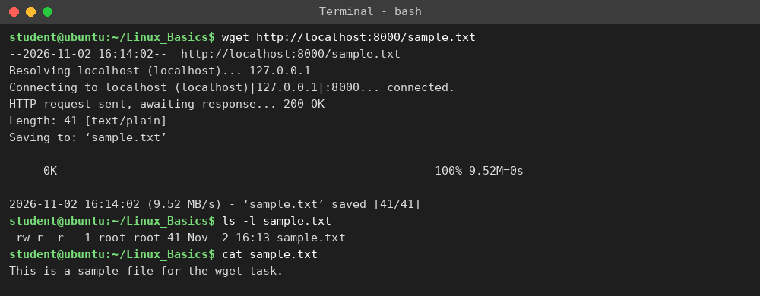

Task 11 – Make a file read-only (chmod)
Command:
touch secure.txt
chmod 444 secure.txt
Explanation: First the file secure.txt is created. chmod 444 sets permissions to r--r--r-- (4 = read). The owner, group and others can read the file, and nobody has write or execute permission. ls -l shows -r--r--r--. (Equivalent: chmod a-w secure.txt.)
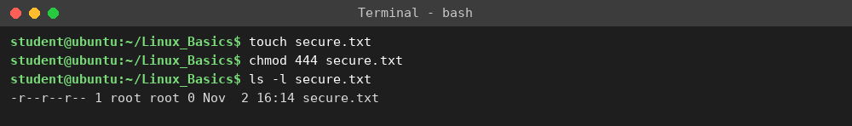

Task 12 – Environment variable (export)
Command:
export MY_VAR="Hello, Linux!"
Explanation: export sets a variable and makes it available to child processes started from the shell. echo $MY_VAR and printenv MY_VAR both print its value. The variable lasts only for the current shell session.


