**14232 instances**

**Simple pruned tree (x = default, framing, whof, whatf, purposef, cstore, c action; y= decision)**

Confidence factor = 0.25(default)

Accuracy: 63.77

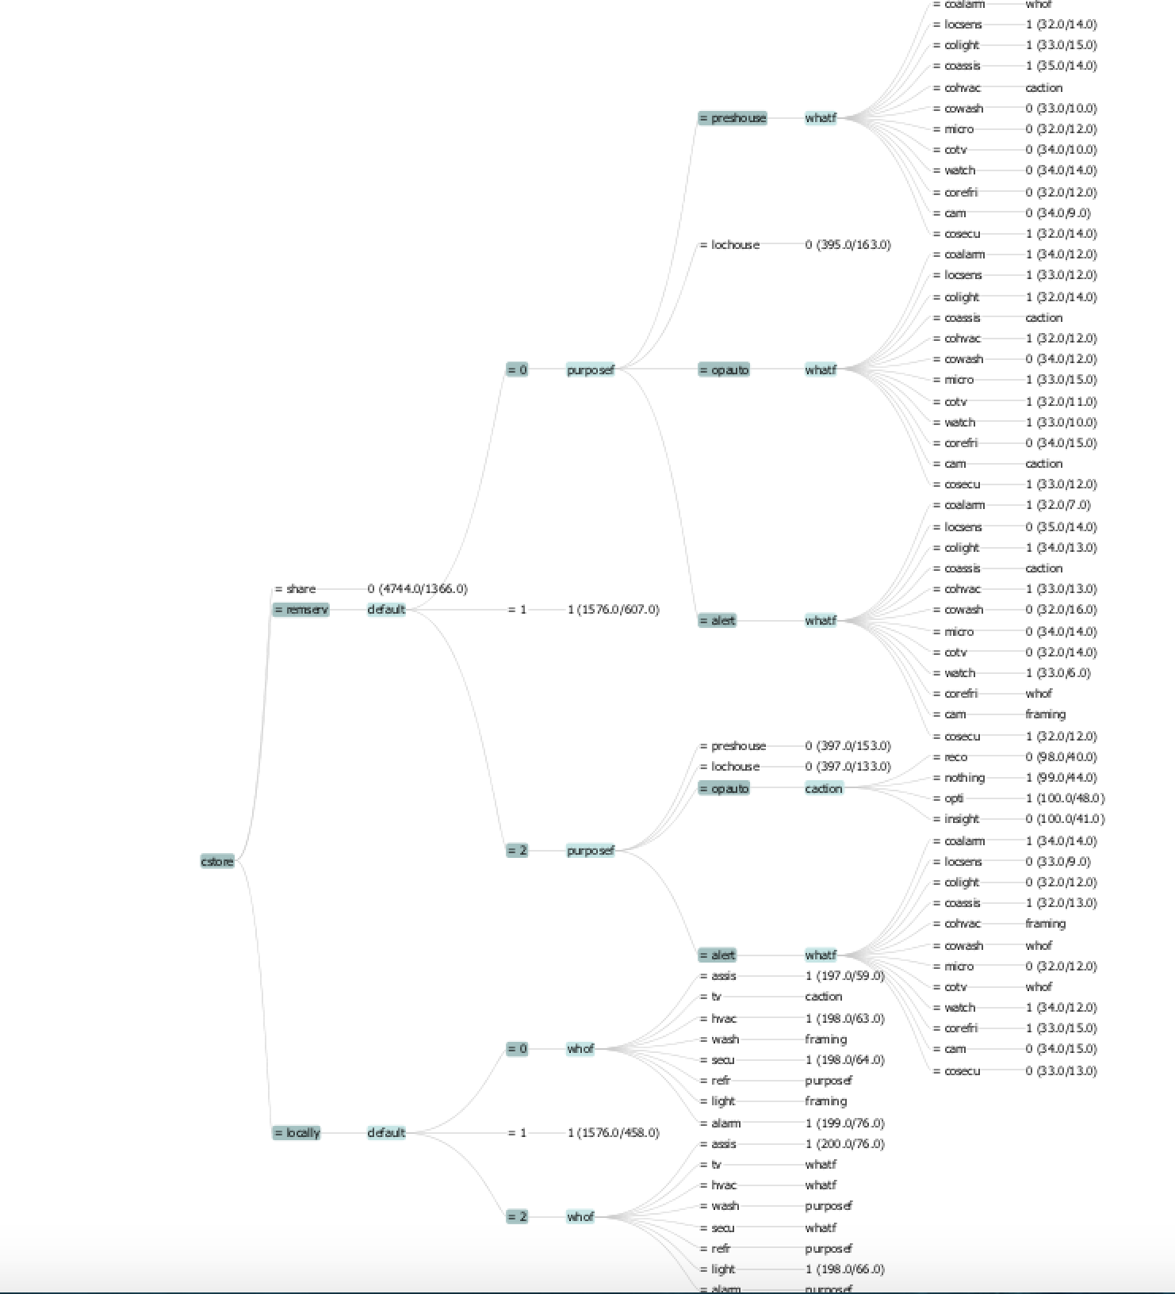

**14232 instances**

**Simple pruned tree (x = default, framing, whof, whatf, purposef, cstore, c action; y= decision)**

Confidence factor = 0.15

Accuracy: 63.50

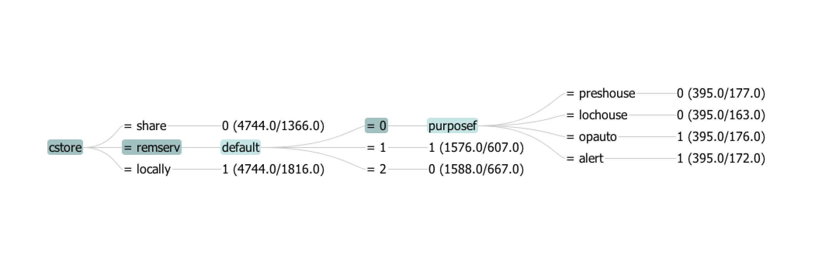

**default=0, framing=0 (dataset with 1584 instances)**

**pruned tree (x = whof, whatf, purposef, cstore, c action; y= decision)**

Confidence factor = 0.25(default)

Accuracy: 61.74

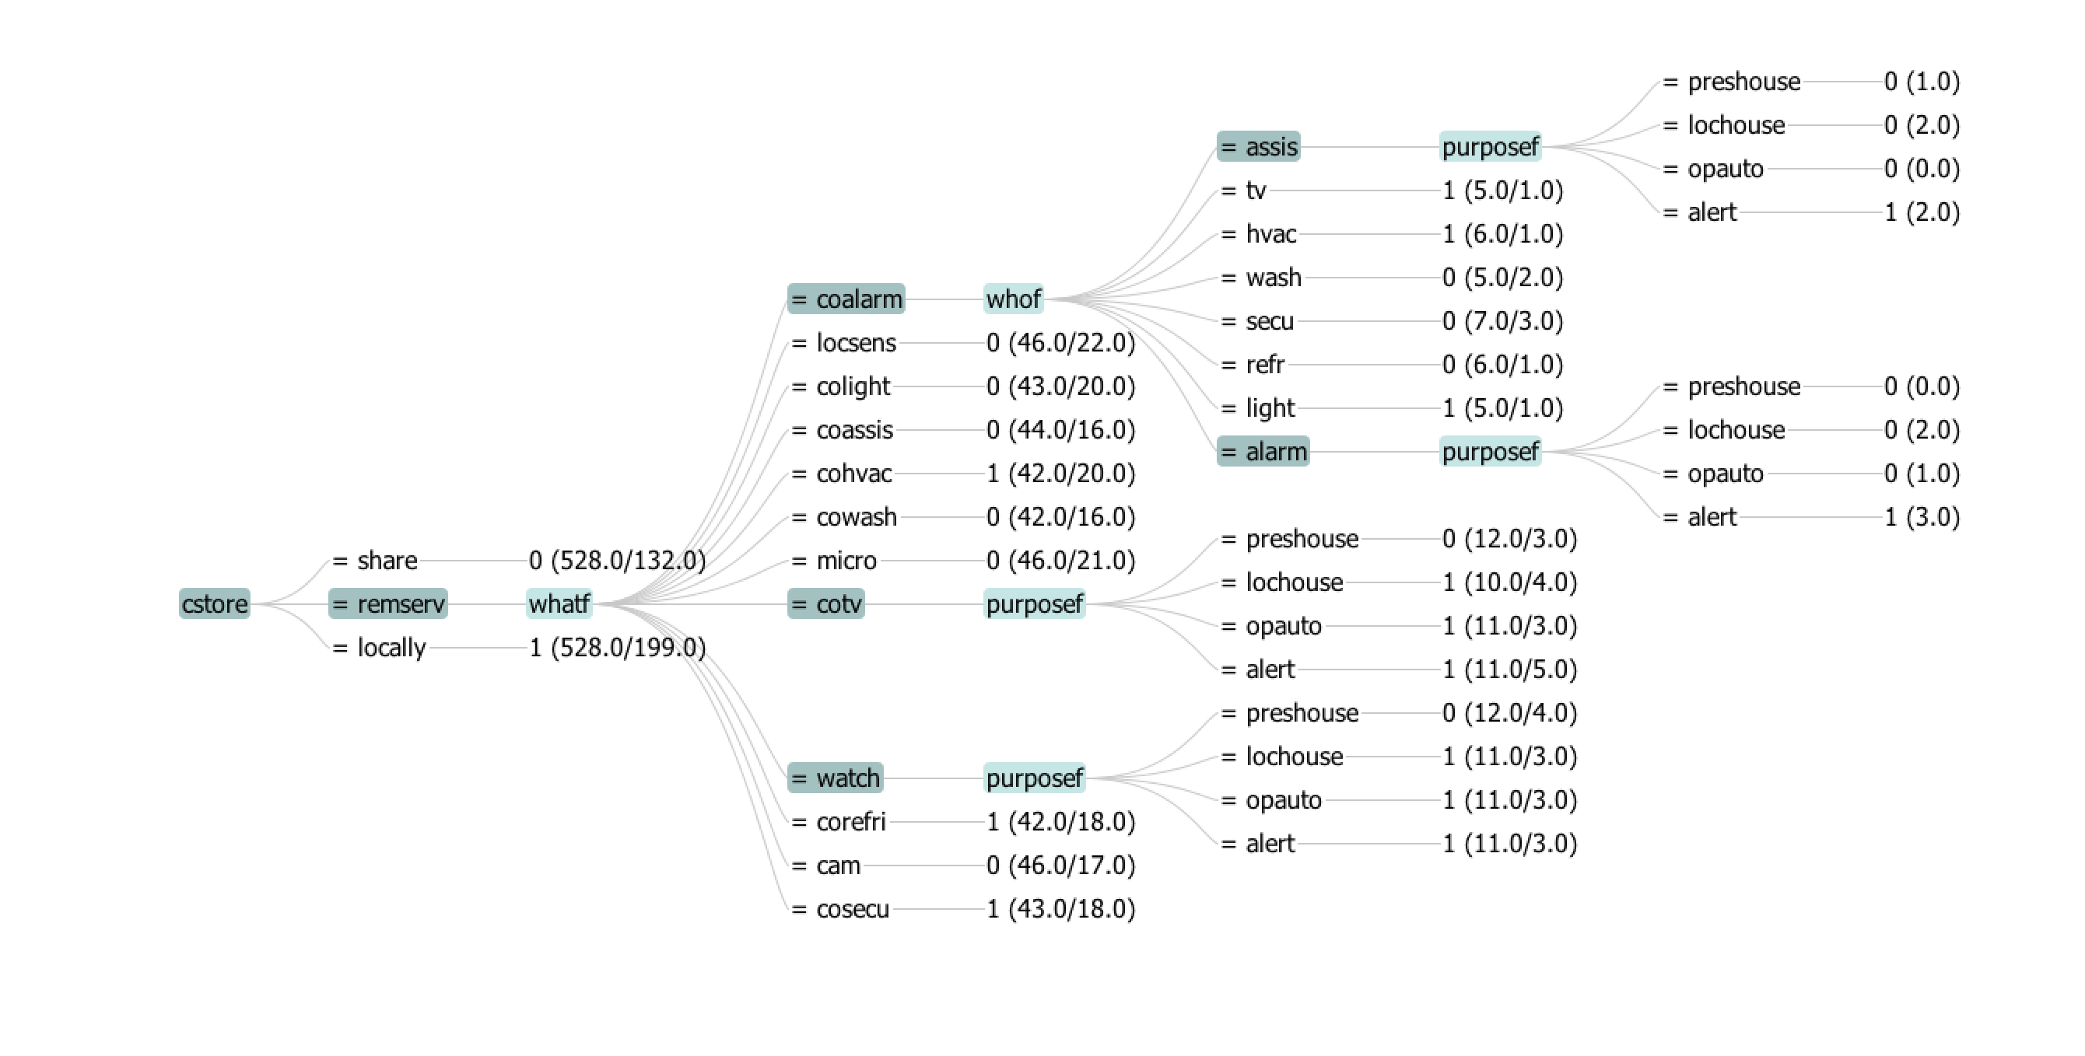

**default=0, framing=0 (dataset with 1584 instances)**

**pruned tree (x = whof, whatf, purposef, cstore, c action; y= decision)**

Confidence factor = 0.15

Accuracy: 61.93

I was expecting the accuracy to go down after decreasing the confidence factor and forcefully pruning the tree but it went up.

