**DOCKER MINI PROJECT**

**ON**

**JOOMLA DEVELOPMENT ENVIRONMENT WITH MSQL DATABASE**

**https://medium.com/@abhilashkpy/menu-driven-python-program-in-red-hat-linux-49fd11e0b740**

**INTRODUCTION**

**Docker Compose** is a complementary system which helps you link together individual Docker containers so they can work together. This Project is on the deployment of a Joomla container and another MySQL container that Joomla will use to store its data. Docker Compose will facilitate the networking between them.

**PROJECT OBJECTIVE**

**To configure and set up Joomla Development Environment using Docker containers**

**STEP 1: Prior to running the docker services, you are required to disable the firewall**

**and SELinux using the following command:**

**systemctl stop firewalld**

**STEP 2: Disabling the SELinux:**

**setenforce 0**

**STEP 3: Start docker services:**

**systemctl start docker**

**STEP 4: Pull the latest version of Joomla docker image from hub.docker.com**

**docker pull Joomla:latest**

**STEP 5 Pull the latest version 5.6 of MySQL docker image from hub.docker.com**

**docker pull mysql:5.6**

**STEP 6: To see all docker images:**

**docker images**

**STEP 7: Create a directory named “joomla” in the root folder:**

**mkdir joomla**

**STEP 8: Create a file named “docker-compose.yml” inside the “joomla” directory.**

**cd jooomla**

**vim docker-compose.yml**

**STEP 9: Enter the following source code inside the “docker-compose.yml” file:**

**version: '2'**

**services:**

**joomla102:**

**image: joomla**

**restart: always**

**volumes:**

**- joomla_storage:/var/www/html**

**ports:**

**- 8092:80**

**depends_on:**

**- mysql101**

**environment:**

**JOOMLA_DB_HOST: mysql101**

**JOOMLA_DB_PASSWORD: abhilash**

**mysql101:**

**image: mysql:5.6**

**volumes:**

**-mysql_storage:/var/lib/mysql**

**restart: always**

**environment:**

**MYSQL_ROOT_PASSWORD: rootpass**

**MYSQL_USER: abhilash**

**MYSQL_PASSWORD: abhilash**

**MYSQL_DATABASE: mydb1**

**phpmyadmin:**

**image: phpmyadmin/phpmyadmin**

**depends_on:**

**- mysql101**

**environment:**

**- PMA_ARBITRARY=1**

**restart: always**

**volumes:**

**- /sessions**

**volumes:**

**mysql_storage:**

**joomla_storage:**

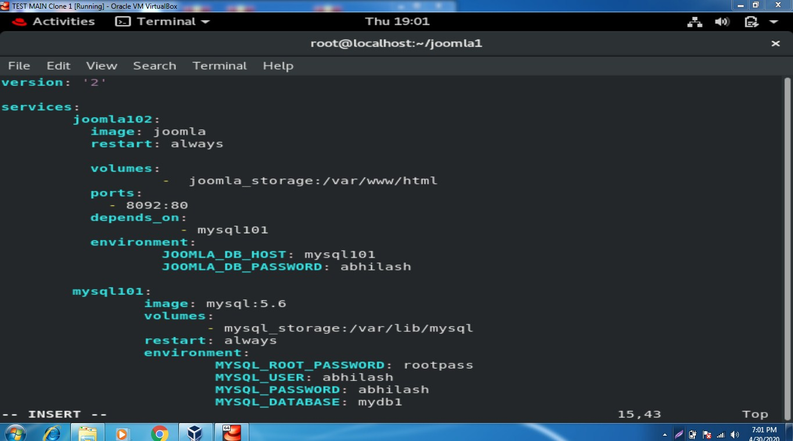

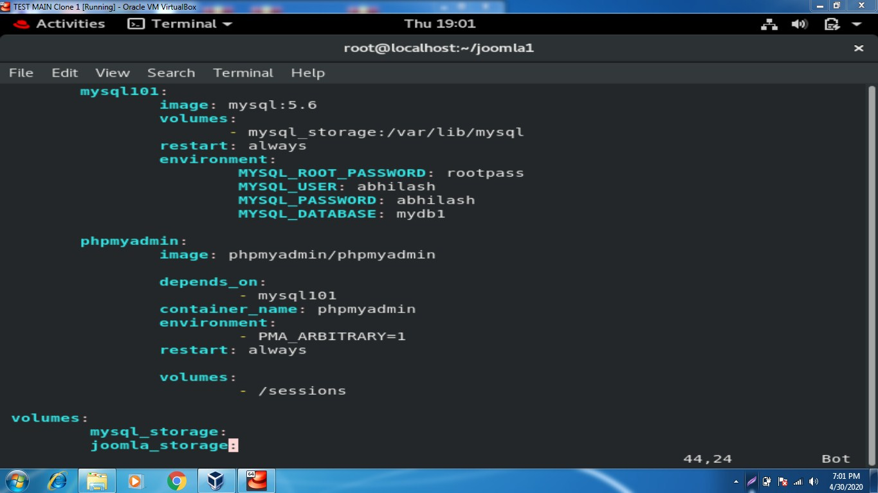

**STEP 10: Run the docker-compose file: docker-compose up**

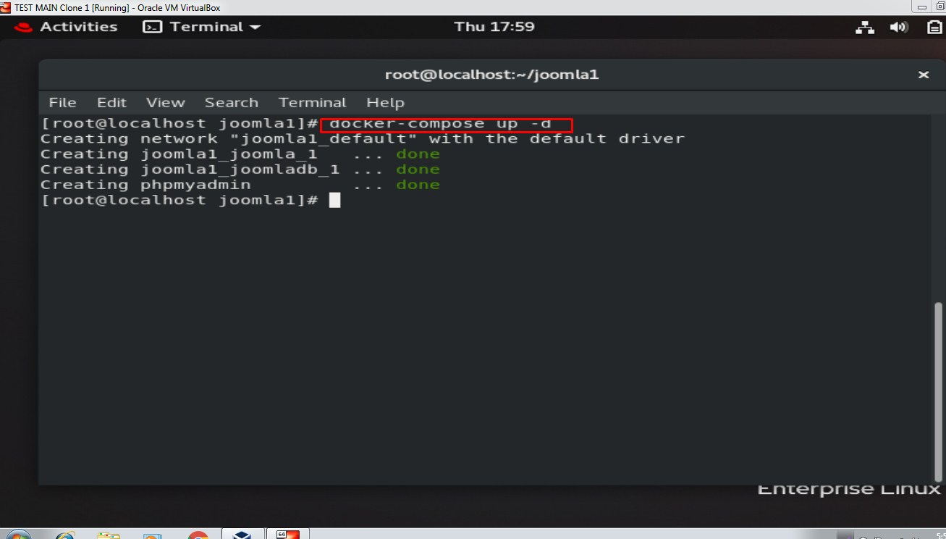

**STEP 11: Open a new terminal window and check all running containers using docker ps –a command**

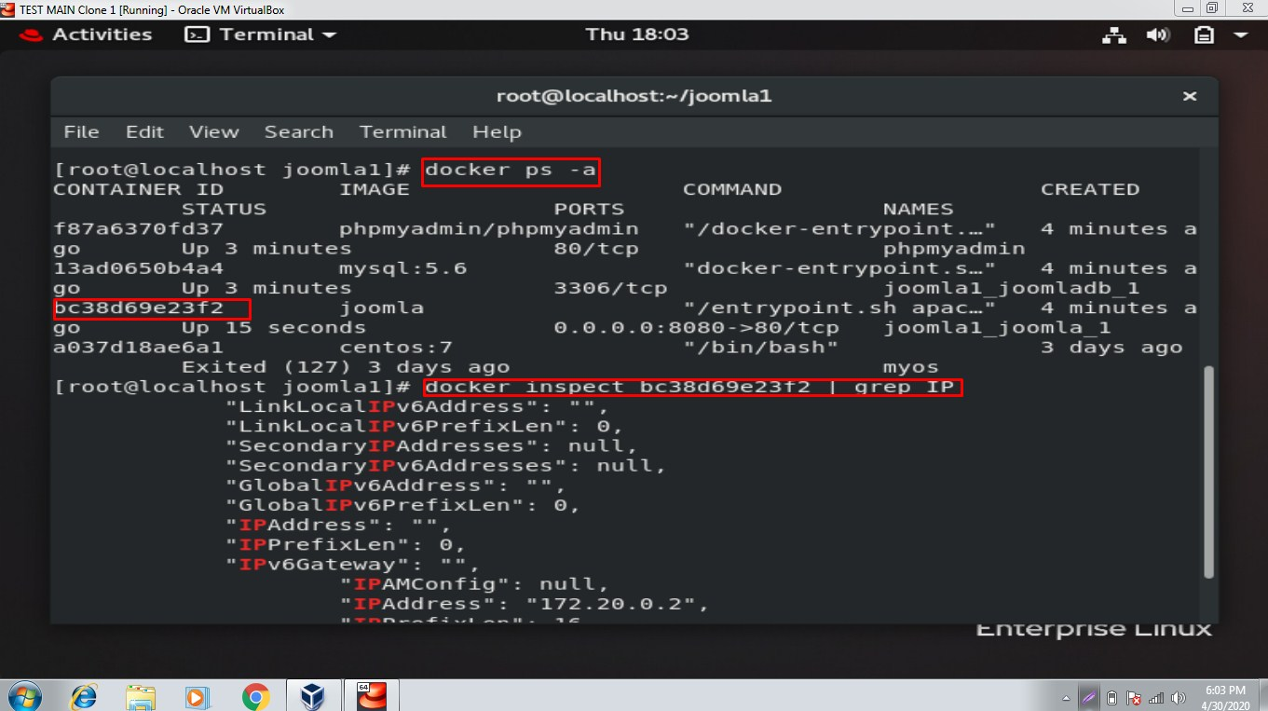

**STEP 12: Inpect the joomla container using its container ID:**

**docker inspect [CONTAINER ID]**

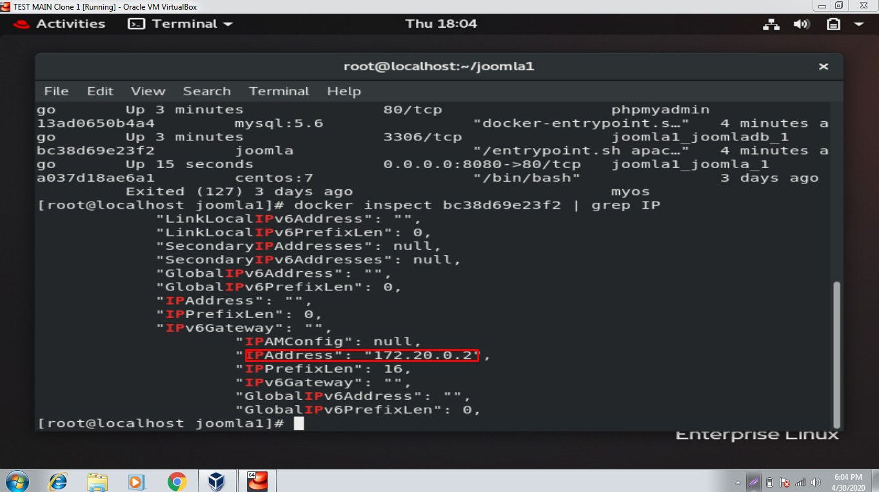

**STEP 13: Open the browser and browse with URL:**

**10.10.100.20:8092**

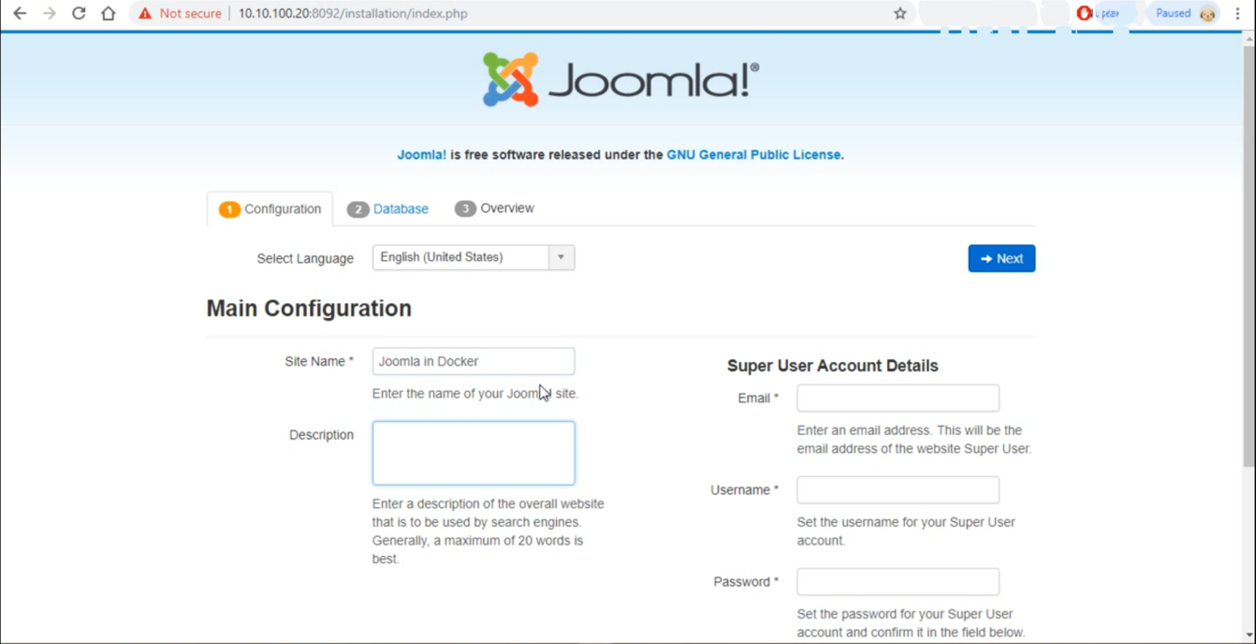

**STEP 14: Proceed with the installation process by selecting the data database con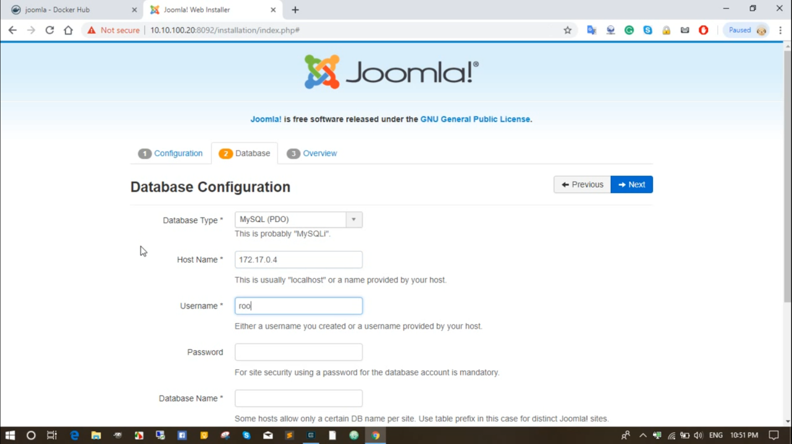figuration:**

**NOTE: Complete the other screens in the setup guide. When creating your Joomla user, be sure to enter a password that is different from your MySQLSQL password.**

**To stop your Joomla application:**

**cd joomla**

**docker-compose stop**

**To restart your Joomla application:**

**cd joomla**

**docker-compose start**

To stop and remove containers, networks and images created by the **docker-compose.yml**file:

**cd joomla**

**docker-compose down**

Update Joomla

The **docker-compose.yml** specifies the latest version of the Joomla image, so it’s easy to update your Joomla version:

**docker-compose down**

**docker-compose pull && docker-compose up -d**