Chatlog

**Project Documentation**

**Contents**

1. **Introduction**
2. **Technology Used**
3. **Installation Instructions**
4. **Home Page**
5. **Register Page**
6. **Login Page**
7. **Chat Board Page**
8. **Profile Page**

**Introduction**

The chatlog application is named as **Simplichat**. This chat application is designed to allow registered users to communicate with each other in real time. The application features a user-friendly interface that enables users to easily login or register and start chatting with other users.

With the increasing need for remote communication and collaboration, chat applications have become an essential tool for business and individuals alike. This chat application provides a secure platform for users to interact with each other without any interruptions or distractions. Users can send messages to other users in real time.

In this project documentation, you will find a detailed description of the application’s architecture, features, and functionalities. You will also find instructions on how to install and run the application on your local machine. Additionally, the documentation includes the project’s future plans and possible improvements.

Overall, this chat application is a result of hard work, dedication, and attention to detail. I hope that this application will help users to communicate more effectively and efficiently, and we welcome any feedback or suggestions that can help me improve the application further.

**Technologies Used**

* Visual Studio Code
* Bootstrap 5
* HTML5 / CSS3
* Jade Template
* JavaScript
* NodeJS
* Express
* MongoDB
* Socket.io
* GitHub

**Installation Instructions**

Users can download the application from Github repository at <https://github.com/abhilashlegend/simplichat.git>. After downloading the source code from the repository users need to install node packages use npm install command on the project root folder. The project can be run on local machine using nodemon app command or npm start. The server can be found running on <http://localhost:8000/>

**Home Page**

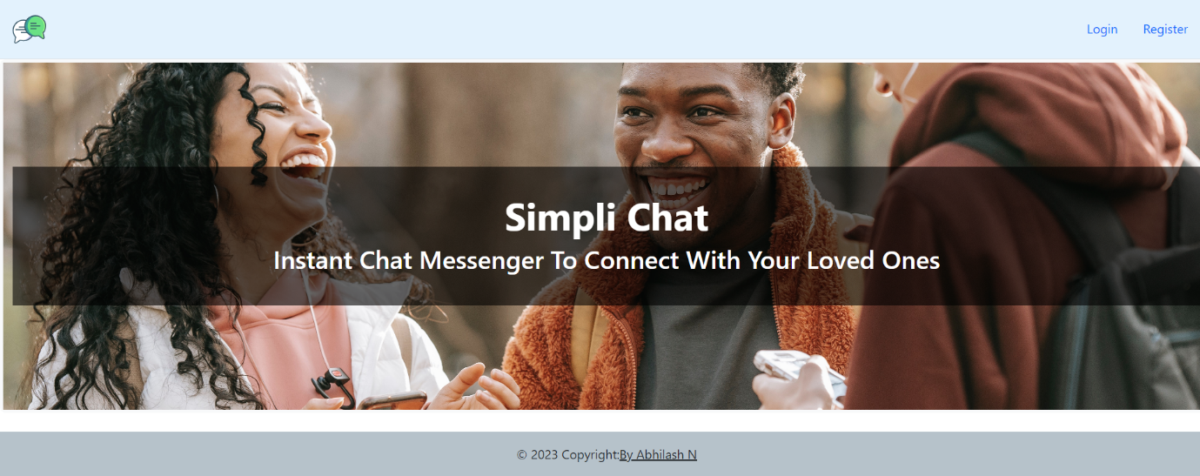

The home page of the chat application is a simple landing page and describes about the application. The Top header consists of Logo, Login and Register navigation with footer at the bottom.

**Register Page**

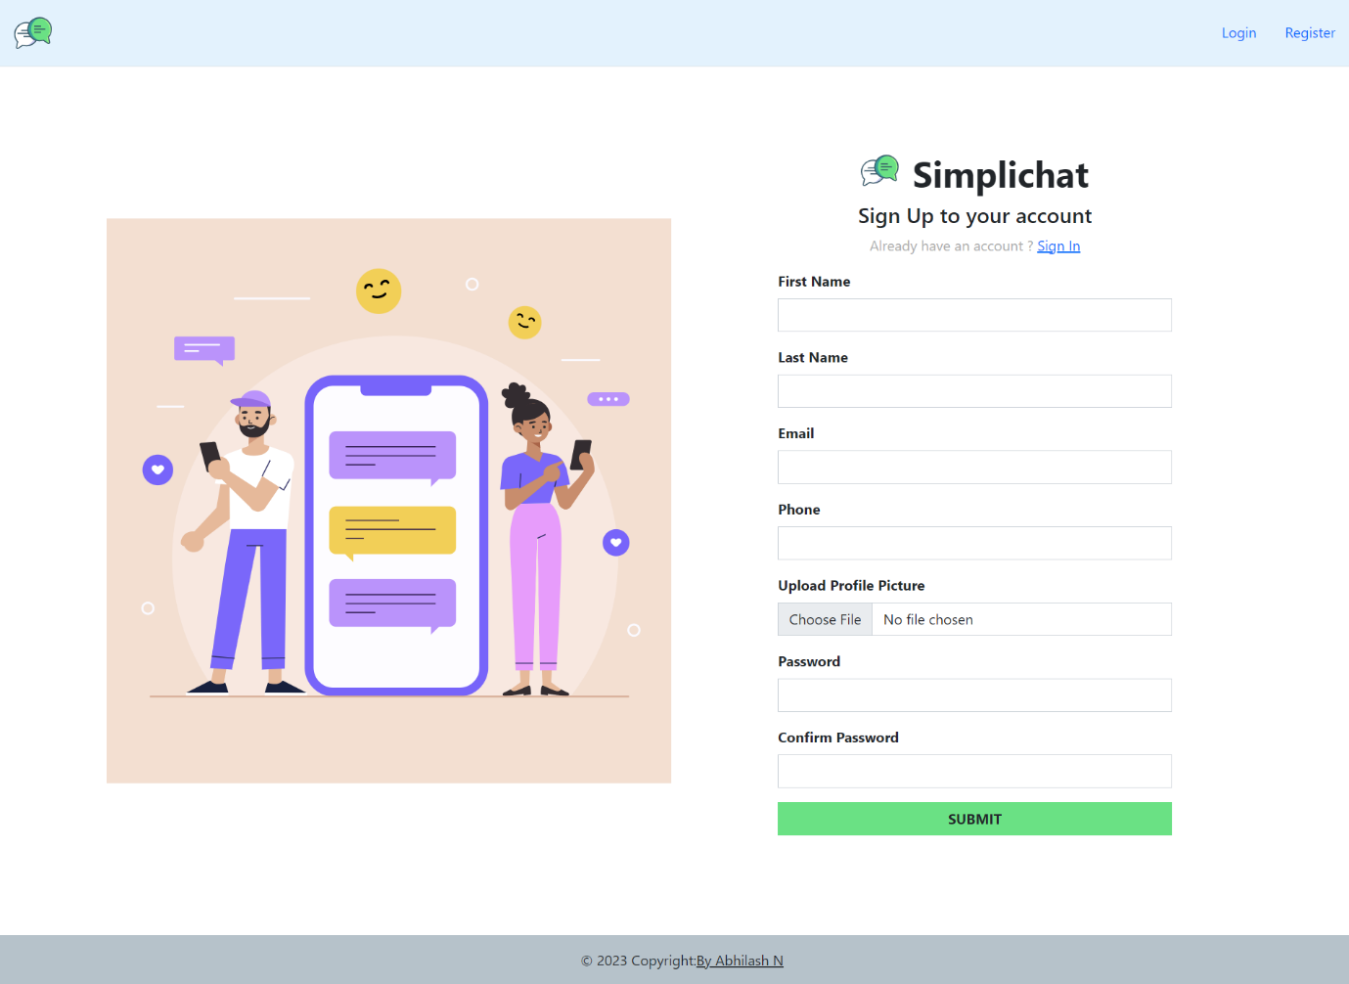

The register page consists of register form that takes in user first name, last name, email, phone, profile picture and password. The user information is stored in mongodb database after successful submission of the form.

Login Page

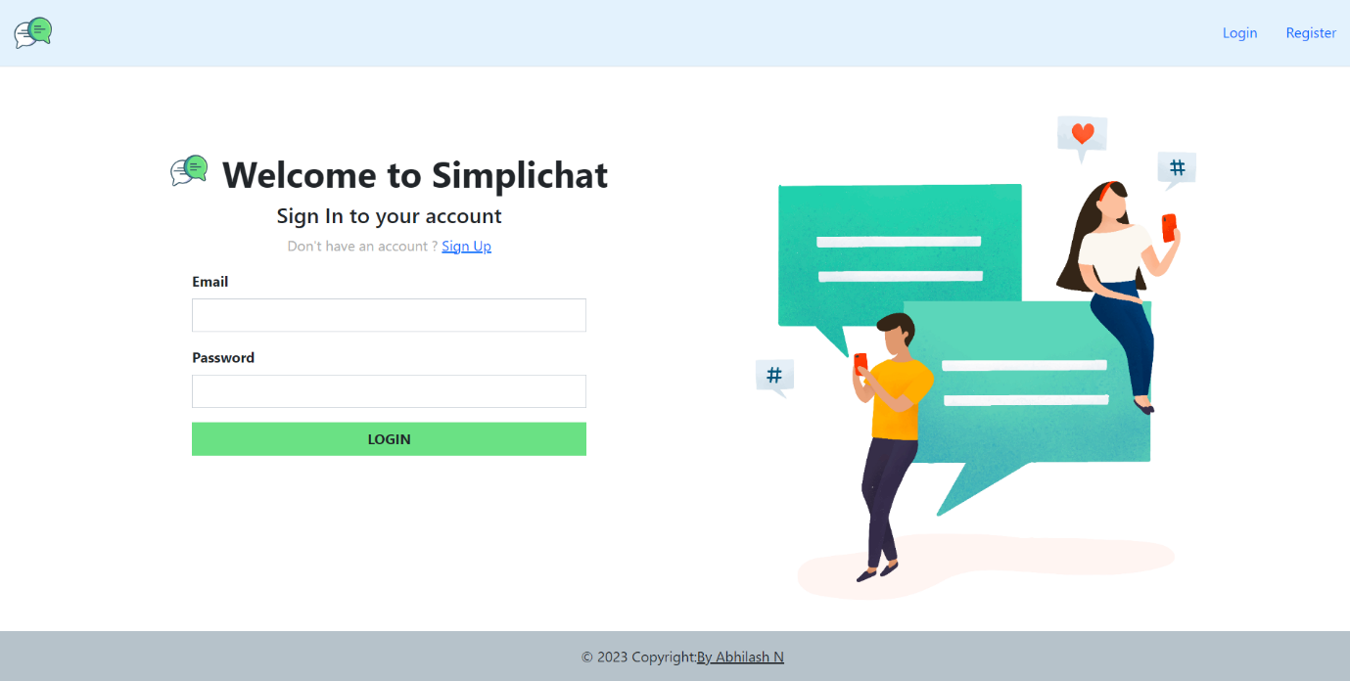

Users can login using their email id and password. The users can also go to sign up page if they haven’t registered already.

Chat Board Page

The chat board page where users can see other registered users and select the users from the list to chat / send messages. The user list has red circle to denote that the user is offline and green to denote online. Users can also save the users to contacts where users can chat only with the saved users.

**Profile Page**

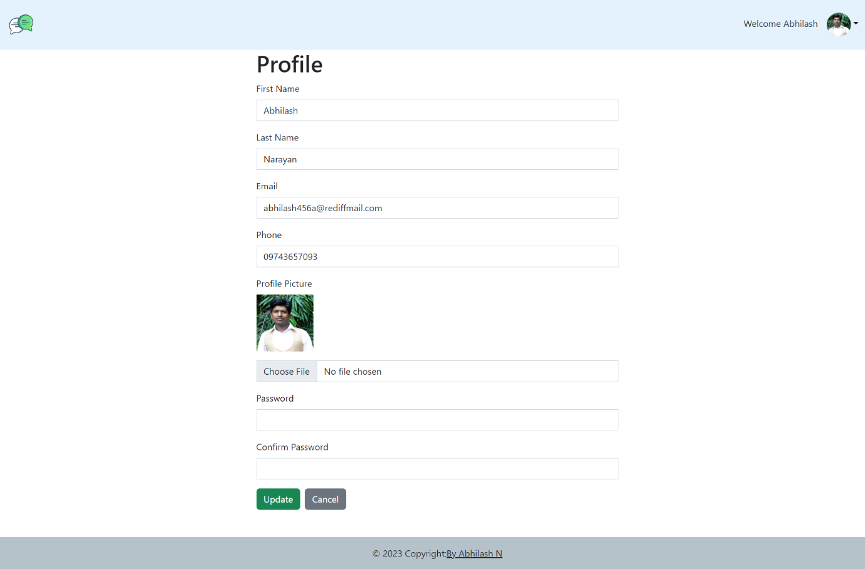

The Profile page can be accessed by going to top right menu. This is where the user can update his details, password and profile picture.