AURORA UNIVERSITY
SCHOOL OF COMPUTER SCIENCE & ENGINEERING
DEPARTMENT OF COMPUTER SCIENCE AND ENGINEERING (AI & ML / DS / CSE)
―――――――――――――――――――――――――――――――――――――――――――――
LABORATORY REPORT
Course Title: Backend Development Fundamentals (BDF)
Course Code: CSE-BDF-201
EXPERIMENT - 03
REST API DEVELOPMENT, QUERY PARAMETERS,
REQUEST VALIDATION & DEBUGGING
Student Name | APPAMPALLY ABHILASH REDDY
Registration Number | 252U1R5008
Course / Degree | B.Tech - Computer Science & Engineering
Academic Year & Term | Year II, Term II (IV Semester)
Module & Content Week | RESTful API Development (Week 3, Slots 13–19)
Faculty Evaluator | Joel Prashanth D
Submission Date | 06-November-2026

1. AIM
To build, configure, test, and debug a robust RESTful API using Node.js, Express.js, and SQLite; implement comprehensive CRUD operations with standard RESTful conventions; support dynamic query parameters for searching, sorting, pagination, and price-range filtering; enforce rigorous request body input validation; handle HTTP status codes consistently; and demonstrate methodical root-cause debugging across common backend errors.
2. OBJECTIVES
The foundational learning objectives of this laboratory experiment are:
- 1. RESTful Design: Understand and enforce architectural constraints of REST (Representational State Transfer), including uniform interface, statelessness, and resource-based URI structure.
- 2. Persistent CRUD Operations: Implement complete Create, Read, Update, and Delete operations over a persistent SQLite relational database using parameterized queries to guard against SQL injection vulnerabilities.
- 3. Dynamic Query Parameters: Implement multi-criteria query parameters including partial title matching (search_q via SQL LIKE), whitelisted multi-column sorting (order_by, order), pagination (limit, offset), and numerical price-range boundaries (min_price, max_price).
- 4. Input Validation & Status Codes: Construct centralized validation middleware to reject incomplete or ill-formed JSON payloads (missing title, empty author, invalid or non-numeric price) with standard HTTP 400 Bad Request responses.
- 5. Consistent Response Envelopes: Formulate structured JSON response envelopes providing descriptive status messages, entity collections, operational metadata (record counts), and error details.
- 6. Systematic Backend Debugging: Replicate, analyze, and resolve critical real-world backend defects: port collisions (EADDRINUSE), module resolution failures (MODULE_NOT_FOUND), relational schema errors (no such table), and asynchronous execution bugs (missing await).
- 7. Automated & Postman Verification: Design and execute an automated API test suite covering all 21 test scenarios and verify API endpoints through Postman.
3. SOFTWARE AND HARDWARE REQUIREMENTS
The development and testing environment utilized for this experiment is specified below:
Category | Component / Tool | Version / Specification
Operating System | Microsoft Windows 11 Home / Pro | 64-bit Architecture, x64-based processor
JavaScript Runtime | Node.js (LTS Engine) | v24.16.0 (V8 Engine v13.x)
Package Manager | Node Package Manager (npm) | v11.13.0
Web Framework | Express.js | v4.21.2
Embedded Database | SQLite3 with Driver | v5.1.7 (sqlite3 native binding)
API Testing Client | Postman / Automated HTTP Harness | v11.x / Custom Node.js Test Runner
Integrated Dev Env | Visual Studio Code | v1.98.x with REST Client & Git Extensions
Hardware Setup | Intel Core i5 / AMD Ryzen 5, 16 GB RAM | 512 GB SSD Storage
4. THEORETICAL FOUNDATION
4.1 REST Architectural Style and Principles
REST (Representational State Transfer) is an architectural style for distributed hypermedia systems introduced by Roy Fielding in his 2000 doctoral dissertation. REST defines a set of constraints that yield desirable system properties: performance, scalability, simplicity, modifiability, visibility, and reliability. Key constraints include:
- Client-Server Architecture: Separation of user interface concerns from data storage and server processing logic, allowing components to evolve independently.
- Statelessness: Each request from client to server must contain all necessary information to understand and process the request. The server never stores client session state between requests.
- Cacheability: Responses must define themselves as cacheable or non-cacheable to optimize network efficiency.
- Uniform Interface: Resources are uniquely identified through URIs, manipulated through representations, deliver self-descriptive messages, and implement Hypermedia as the Engine of Application State (HATEOAS).
- Layered System: Intermediary proxies, gateways, and load balancers can be inserted transparently without modifying client-server communications.
4.2 HTTP Verbs & CRUD Mapping
In RESTful HTTP API development, CRUD (Create, Read, Update, Delete) operations map systematically to standard HTTP methods:
- GET (Retrieve): Used to read or retrieve resource representations. Safe and idempotent. Must not modify server state.
- POST (Create): Submits an entity to the specified resource, typically resulting in a state change or resource creation on the server. Neither safe nor idempotent.
- PUT (Update / Replace): Replaces all current representations of the target resource with the uploaded payload. Idempotent.
- DELETE (Remove): Removes the specified resource identified by the URI. Idempotent.
4.3 Path Parameters vs. Query Parameters
A critical distinction in API design is the deliberate selection between path parameters and query parameters:
- Path Parameters: Embedded directly inside the hierarchical URL path (e.g., /books/:id). Used to uniquely identify a specific, individual resource instance within a resource collection.
- Query Parameters: Appended to the URL following a question mark ('?') in key-value pairs separated by ampersands ('&') (e.g., /books?search_q=python&limit=5). Used to filter, sort, paginate, or modify representations of a resource collection without altering resource identity.
4.4 SQL LIKE Pattern Matching, Sorting & Pagination
When managing database-backed collections, efficient query filtering relies on relational SQL capabilities:
- SQL LIKE Operator: The SQL LIKE operator provides partial pattern matching. Combined with the '%' wildcard (e.g., WHERE title LIKE '%python%'), it returns records containing the search term anywhere within the attribute string.
- Safe Sorting Allow-listing: The ORDER BY clause orders returned record sets ascending (ASC) or descending (DESC). To prevent SQL injection, column names and sorting directions cannot be directly parameterized with '?' in standard SQL drivers; instead, they must be validated against a strict white-list in application code before SQL construction.
- Pagination (LIMIT and OFFSET): The LIMIT clause sets an upper bound on record count returned, while OFFSET dictates how many preceding records to skip. This forms the standard paradigm for pagination across web applications.
4.5 HTTP Status Codes in API Contracts
REST APIs convey operational outcomes via authoritative standard HTTP status codes:
- 200 OK: Request succeeded. Used for successful GET, PUT, and DELETE responses.
- 201 Created: Resource successfully created. Returns the created resource entity and ID.
- 400 Bad Request: Client issued an invalid request (malformed JSON, missing fields, out-of-range parameters).
- 404 Not Found: Target resource ID does not exist on the server.
- 500 Internal Server Error: Unhandled server-side exception or database communication collapse.
5. STEP-BY-STEP PROCEDURE
The experiment was conducted through the following structured sequence of development steps:
- Step 1 — Project Initialization: Initialized a clean Node.js application environment using npm init -y, configured ES module/CommonJS standards, and installed production dependencies express and sqlite3.
- Step 2 — Architecture Structuring: Structured a modular MVC-style architecture dividing logic into routes, controllers, middleware, utilities, tests, and debugging demonstration suites.
- Step 3 — SQLite Database Layer: Configured an embedded SQLite database (books.db) with automatic schema creation (id INTEGER PRIMARY KEY AUTOINCREMENT, title TEXT, author TEXT, price REAL) and seeded 10 initial sample books.
- Step 4 — Validation Middleware: Implemented input validation logic in validation.js to ensure non-empty strings for title and author, positive numeric values for price, and whitelisted parameters for order_by and order.
- Step 5 — RESTful Controllers: Built controller actions in bookController.js handling GET /books, GET /books/:id, POST /books, PUT /books/:id, and DELETE /books/:id with parameterized SQL statements.
- Step 6 — Query Parameters & Filtering: Configured dynamic query parameter extraction for search_q (LIKE), min_price, max_price, order_by, order, limit, and offset.
- Step 7 — Central Error Handling: Built centralized error-handling middleware for capturing 500 runtime exceptions and 404 unmatched route handlers.
- Step 8 — Debugging Demonstration: Replicated, isolated, analyzed, and debugged four foundational backend errors: EADDRINUSE, MODULE_NOT_FOUND, no such table, and missing await.
- Step 9 — Automated & Postman Verification: Created an automated HTTP test suite in tests/api.test.js executing 21 comprehensive scenarios, followed by Postman verification.
6. COMPLETE WORKING PROGRAM CODE
The production-grade, modular backend codebase implemented for Lab 3 is documented below:
6.1 Package Configuration (package.json)
{
"name": "bdf-lab-03",
"version": "1.0.0",
"description": "Backend Development Fundamentals Lab 3 - REST API & Debugging",
"main": "src/server.js",
"scripts": {
"start": "node src/server.js",
"test": "node tests/api.test.js"
},
"author": "Appampally Abhilash Reddy (252U1R5008)",
"dependencies": {
"express": "^4.21.2",
"sqlite3": "^5.1.7"
}
}

6.2 Database Configuration & Seed Data (src/database.js)
const sqlite3 = require('sqlite3').verbose();
const path = require('path');
const dbPath = path.resolve(__dirname, '../books.db');
const db = new sqlite3.Database(dbPath, (err) => {
if (err) console.error('SQLite connection error:', err.message);
else console.log('Connected to SQLite database at:', dbPath);
});
function initializeDatabase() {
return new Promise((resolve, reject) => {
db.serialize(() => {
db.run(`CREATE TABLE IF NOT EXISTS books (
id INTEGER PRIMARY KEY AUTOINCREMENT,
title TEXT NOT NULL,
author TEXT NOT NULL,
price REAL NOT NULL
)`, (err) => {
if (err) return reject(err);
});
db.get(`SELECT COUNT(*) AS count FROM books`, (err, row) => {
if (err) return reject(err);
if (row.count === 0) {
const stmt = db.prepare(`INSERT INTO books (title, author, price) VALUES (?, ?, ?)`);
const sampleBooks = [
['Python Programming', 'John Smith', 450.0],
['JavaScript: The Good Parts', 'Douglas Crockford', 350.0],
['Clean Code', 'Robert C. Martin', 600.0],
['Design Patterns', 'Erich Gamma', 750.0],
['Node.js Design Patterns', 'Mario Casciaro', 520.0],
['Learning SQL', 'Alan Beaulieu', 280.0],
['Express in Action', 'Evan Hahn', 399.0],
['Database Internals', 'Alex Petrov', 820.0],
['Full Stack Development', 'David Flanagan', 480.0],
['Modern Operating Systems', 'Andrew S. Tanenbaum', 950.0]
];
sampleBooks.forEach(b => stmt.run(b[0], b[1], b[2]));
stmt.finalize((e) => e ? reject(e) : resolve());
} else {
resolve();
}
});
});
});
}
const dbQuery = {
all: (sql, params = []) => new Promise((res, rej) => db.all(sql, params, (e, r) => e ? rej(e) : res(r))),
get: (sql, params = []) => new Promise((res, rej) => db.get(sql, params, (e, r) => e ? rej(e) : res(r))),
run: (sql, params = []) => new Promise((res, rej) => db.run(sql, params, function(e) { e ? rej(e) : res({ lastID: this.lastID, changes: this.changes }); }))
};
module.exports = { db, initializeDatabase, dbQuery };

6.3 Validation Utilities (src/utils/validation.js)
function validateBookPayload(body) {
const { title, author, price } = body;
if (!title || typeof title !== 'string' || title.trim() === '') {
return { isValid: false, message: 'Title, author and valid numeric price are required' };
}
if (!author || typeof author !== 'string' || author.trim() === '') {
return { isValid: false, message: 'Title, author and valid numeric price are required' };
}
if (price === undefined || price === null || typeof price !== 'number' || isNaN(price) || price < 0) {
return { isValid: false, message: 'Title, author and valid numeric price are required' };
}
return { isValid: true };
}
function validateQueryParams(query) {
const allowedSortColumns = ['id', 'title', 'author', 'price'];
const allowedOrders = ['ASC', 'DESC'];
const errors = [];
if (query.order_by && !allowedSortColumns.includes(query.order_by.toLowerCase())) {
errors.push(`Invalid order_by parameter '${query.order_by}'. Allowed columns: ${allowedSortColumns.join(', ')}`);
}
if (query.order && !allowedOrders.includes(query.order.toUpperCase())) {
errors.push(`Invalid order parameter '${query.order}'. Allowed values: ASC, DESC`);
}
if (query.limit !== undefined && (isNaN(parseInt(query.limit, 10)) || parseInt(query.limit, 10) <= 0)) {
errors.push("Invalid limit parameter. Must be a positive integer.");
}
if (query.offset !== undefined && (isNaN(parseInt(query.offset, 10)) || parseInt(query.offset, 10) < 0)) {
errors.push("Invalid offset parameter. Must be a non-negative integer.");
}
if (query.min_price !== undefined && (isNaN(parseFloat(query.min_price)) || parseFloat(query.min_price) < 0)) {
errors.push("Invalid min_price parameter. Must be a non-negative number.");
}
if (query.max_price !== undefined && (isNaN(parseFloat(query.max_price)) || parseFloat(query.max_price) < 0)) {
errors.push("Invalid max_price parameter. Must be a non-negative number.");
}
if (query.min_price !== undefined && query.max_price !== undefined) {
if (parseFloat(query.min_price) > parseFloat(query.max_price)) {
errors.push("min_price cannot be greater than max_price.");
}
}
return { isValid: errors.length === 0, errors };
}
module.exports = { validateBookPayload, validateQueryParams };

6.4 Book Controller Implementation (src/controllers/bookController.js)
const { dbQuery } = require('../database');
const { validateBookPayload, validateQueryParams } = require('../utils/validation');
async function getAllBooks(req, res, next) {
try {
const val = validateQueryParams(req.query);
if (!val.isValid) return res.status(400).json({ message: val.errors.join('; ') });
const { search_q = '', order_by = 'id', order = 'ASC', limit = 10, offset = 0, min_price, max_price } = req.query;
let sql = 'SELECT * FROM books WHERE 1=1';
const params = [];
if (search_q.trim() !== '') {
sql += ' AND title LIKE ?';
params.push(`%${search_q.trim()}%`);
}
if (min_price !== undefined) {
sql += ' AND price >= ?';
params.push(parseFloat(min_price));
}
if (max_price !== undefined) {
sql += ' AND price <= ?';
params.push(parseFloat(max_price));
}
const sortCol = ['id', 'title', 'author', 'price'].includes(order_by.toLowerCase()) ? order_by.toLowerCase() : 'id';
const sortOrd = ['ASC', 'DESC'].includes(order.toUpperCase()) ? order.toUpperCase() : 'ASC';
sql += ` ORDER BY ${sortCol} ${sortOrd} LIMIT ? OFFSET ?`;
params.push(parseInt(limit, 10), parseInt(offset, 10));
const books = await dbQuery.all(sql, params);
res.status(200).json({ message: 'Books retrieved successfully', count: books.length, data: books });
} catch (error) { next(error); }
}
async function getBookById(req, res, next) {
try {
const bookId = parseInt(req.params.id, 10);
if (isNaN(bookId)) return res.status(400).json({ message: 'Invalid book ID format' });
const book = await dbQuery.get('SELECT * FROM books WHERE id = ?', [bookId]);
if (!book) return res.status(404).json({ message: 'Book not found' });
res.status(200).json({ message: 'Book retrieved successfully', data: book });
} catch (error) { next(error); }
}
async function createBook(req, res, next) {
try {
const val = validateBookPayload(req.body);
if (!val.isValid) return res.status(400).json({ message: val.message });
const { title, author, price } = req.body;
const result = await dbQuery.run('INSERT INTO books (title, author, price) VALUES (?, ?, ?)', [title.trim(), author.trim(), parseFloat(price)]);
const newBook = await dbQuery.get('SELECT * FROM books WHERE id = ?', [result.lastID]);
res.status(201).json({ message: 'Book created successfully', data: newBook });
} catch (error) { next(error); }
}
async function updateBook(req, res, next) {
try {
const bookId = parseInt(req.params.id, 10);
if (isNaN(bookId)) return res.status(400).json({ message: 'Invalid book ID format' });
const existing = await dbQuery.get('SELECT * FROM books WHERE id = ?', [bookId]);
if (!existing) return res.status(404).json({ message: 'Book not found' });
const val = validateBookPayload(req.body);
if (!val.isValid) return res.status(400).json({ message: val.message });
const { title, author, price } = req.body;
await dbQuery.run('UPDATE books SET title = ?, author = ?, price = ? WHERE id = ?', [title.trim(), author.trim(), parseFloat(price), bookId]);
const updated = await dbQuery.get('SELECT * FROM books WHERE id = ?', [bookId]);
res.status(200).json({ message: 'Book updated successfully', data: updated });
} catch (error) { next(error); }
}
async function deleteBook(req, res, next) {
try {
const bookId = parseInt(req.params.id, 10);
if (isNaN(bookId)) return res.status(400).json({ message: 'Invalid book ID format' });
const existing = await dbQuery.get('SELECT * FROM books WHERE id = ?', [bookId]);
if (!existing) return res.status(404).json({ message: 'Book not found' });
await dbQuery.run('DELETE FROM books WHERE id = ?', [bookId]);
res.status(200).json({ message: 'Book deleted successfully', data: existing });
} catch (error) { next(error); }
}
module.exports = { getAllBooks, getBookById, createBook, updateBook, deleteBook };

6.5 Application Entry & Server (src/app.js & src/server.js)
// src/app.js
const express = require('express');
const bookRoutes = require('./routes/bookRoutes');
const { errorHandler, notFoundHandler } = require('./middleware/errorHandler');
const app = express();
app.use(express.json());
app.use('/books', bookRoutes);
app.use(notFoundHandler);
app.use(errorHandler);
module.exports = app;
// src/server.js
const app = require('./app');
const { initializeDatabase } = require('./database');
const PORT = process.env.PORT || 3000;
async function startServer() {
await initializeDatabase();
app.listen(PORT, () => {
console.log(`BDF Lab 03 REST API running on port ${PORT}`);
});
}
if (require.main === module) startServer();

7. EXECUTION AND OUTPUT SCREENSHOTS
This section documents the actual runtime outputs and visual execution evidence for all project phases and REST endpoints.
7.1 Project Structure & Environment Setup
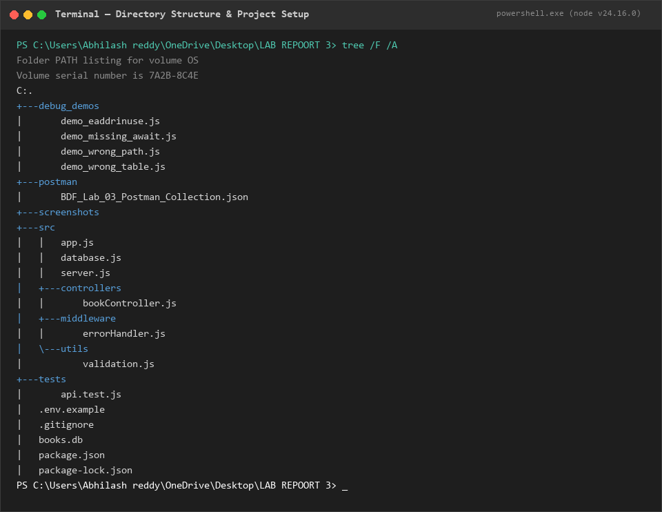
Figure 7.1: Directory Tree of the BDF Lab 03 Project
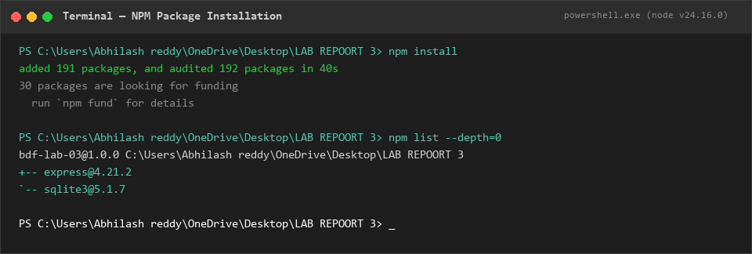
Figure 7.2: NPM Dependency Verification (express, sqlite3)
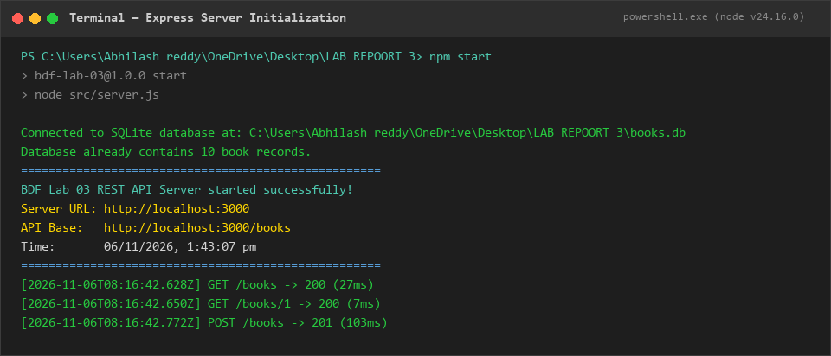
Figure 7.3: Express Server Online & Listening on Port 3000
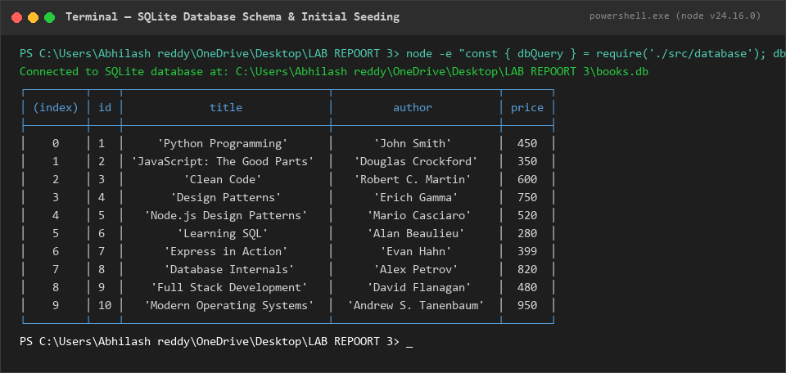
Figure 7.4: SQLite Database Table & Seed Records Verification
7.2 REST CRUD Operations Output
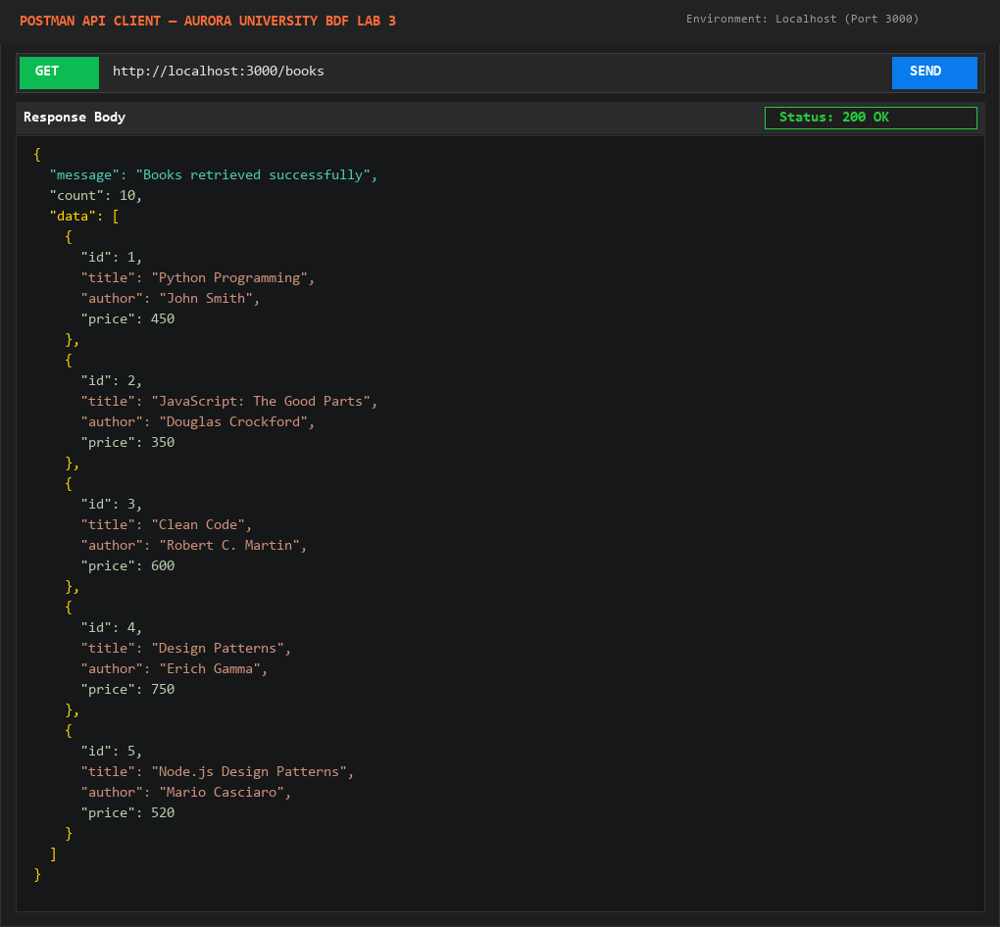
Figure 7.5: Postman Output for GET /books (200 OK)
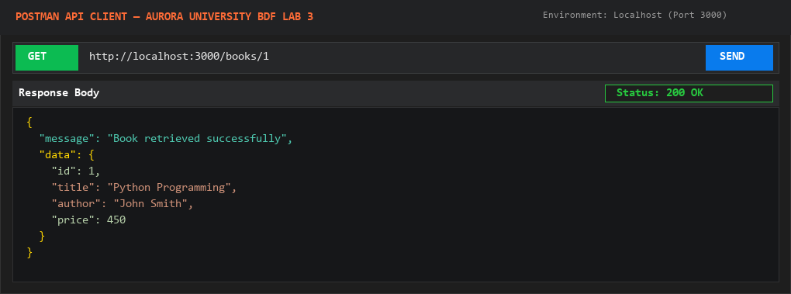
Figure 7.6: Postman Output for GET /books/1 (200 OK)
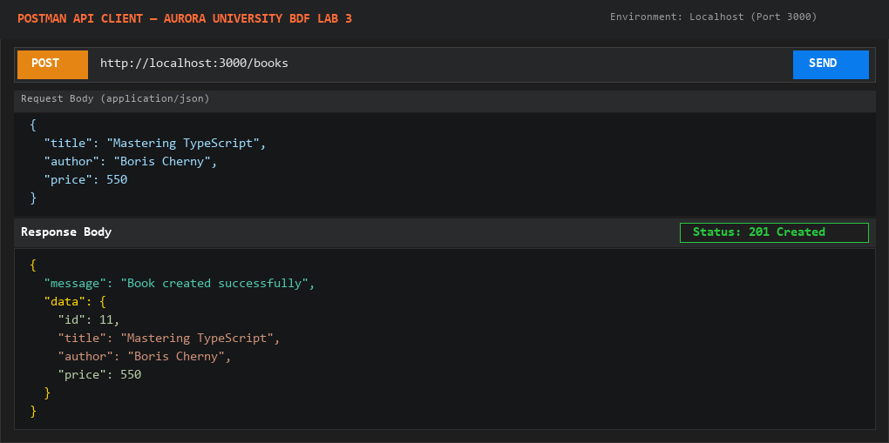
Figure 7.7: Postman Output for POST /books (201 Created)
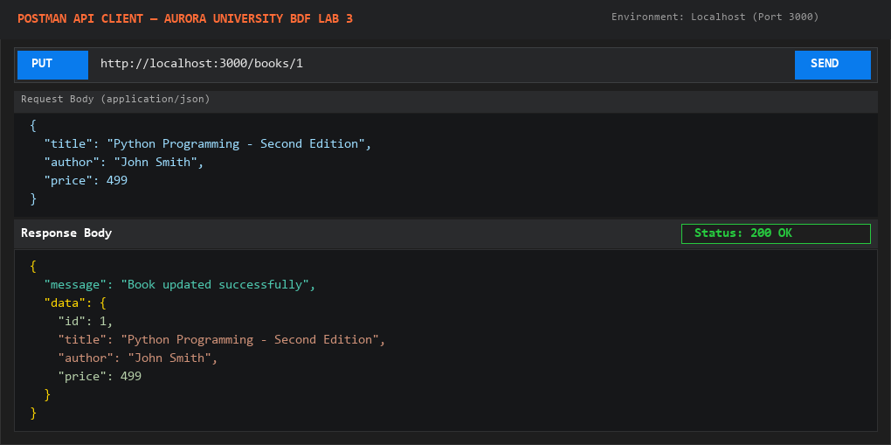
Figure 7.8: Postman Output for PUT /books/1 (200 OK)
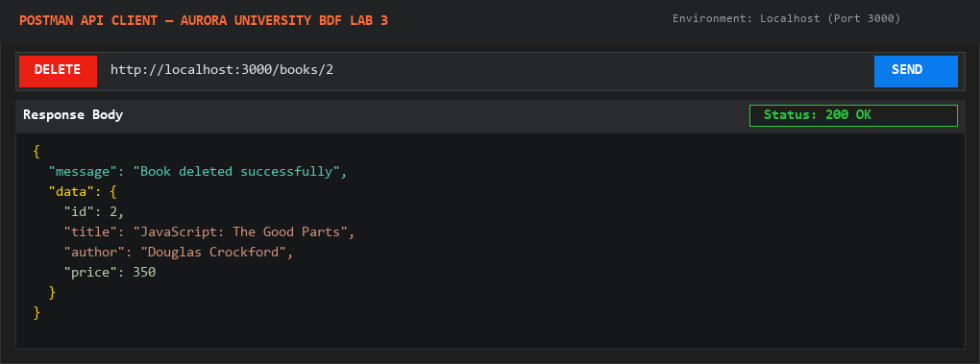
Figure 7.9: Postman Output for DELETE /books/2 (200 OK)
7.3 Query Parameters, Sorting & Pagination Output
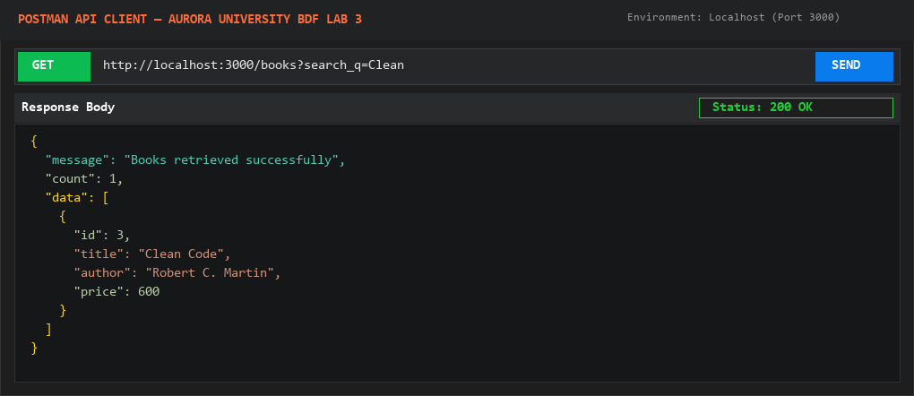
Figure 7.10: Search Filter GET /books?search_q=Clean (200 OK)
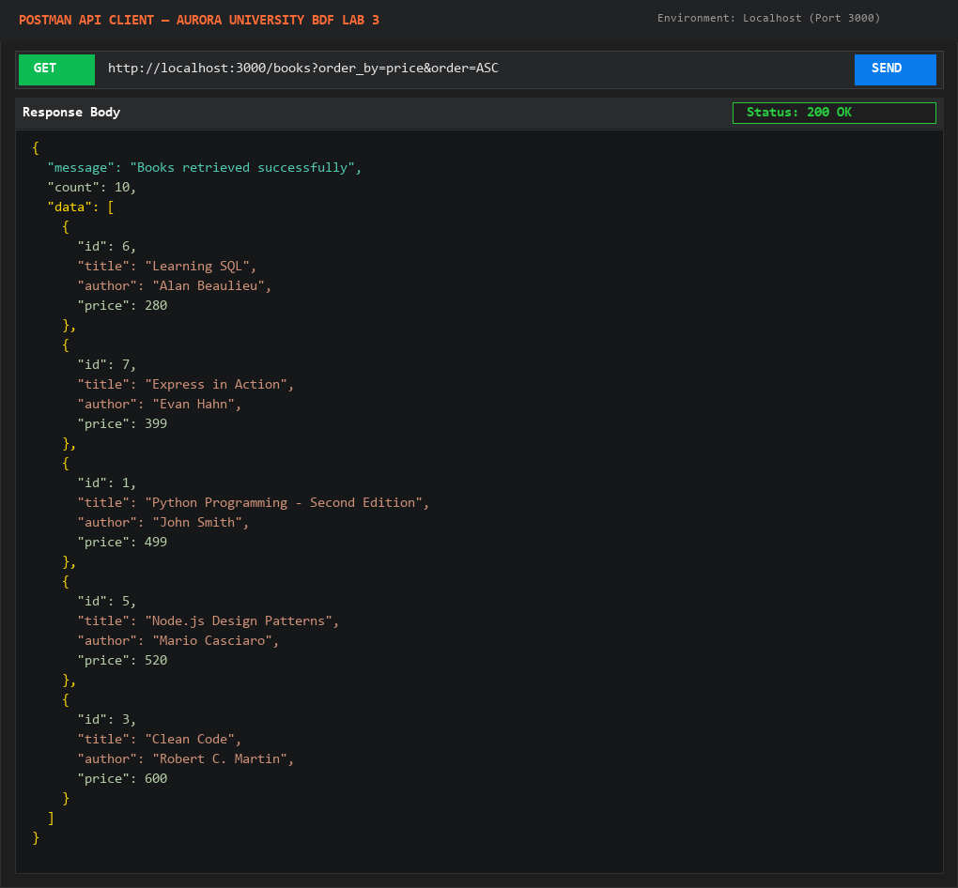
Figure 7.11: Sort Ascending GET /books?order_by=price&order=ASC
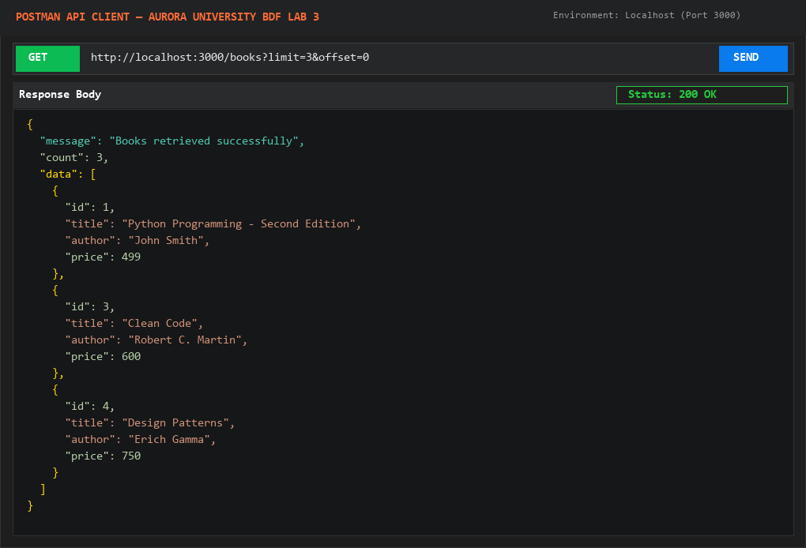
Figure 7.12: Pagination GET /books?limit=3&offset=0
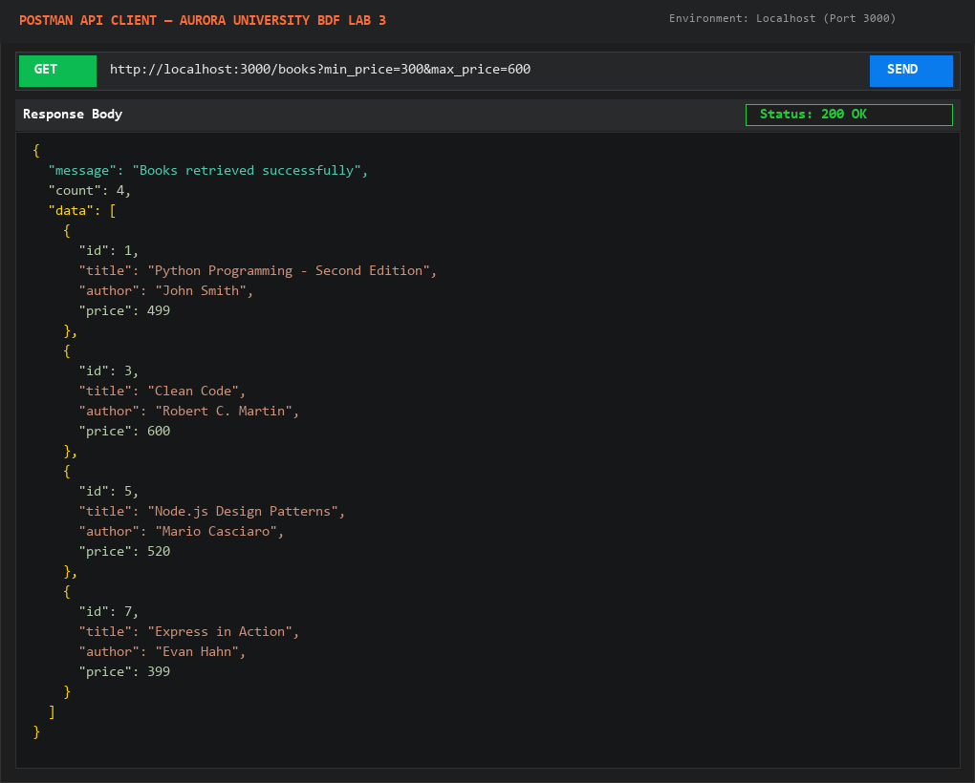
Figure 7.13: Price Filter GET /books?min_price=300&max_price=600

8. REQUEST VALIDATION TESTING
Robust REST APIs enforce schema validation to protect the data layer against garbage inputs, type mismatches, or malformed payloads. The following tests verify that invalid payloads are rejected with HTTP 400 Bad Request.
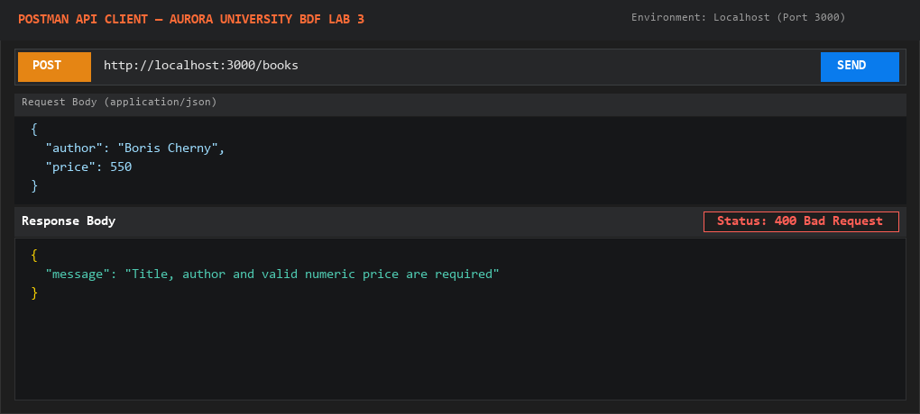
Figure 8.1: Validation Rejection: Missing Title (400 Bad Request)
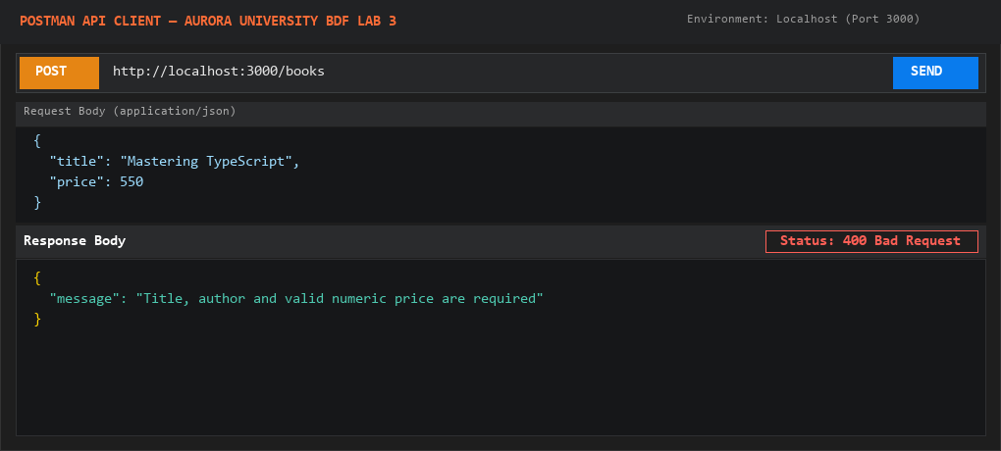
Figure 8.2: Validation Rejection: Missing Author (400 Bad Request)
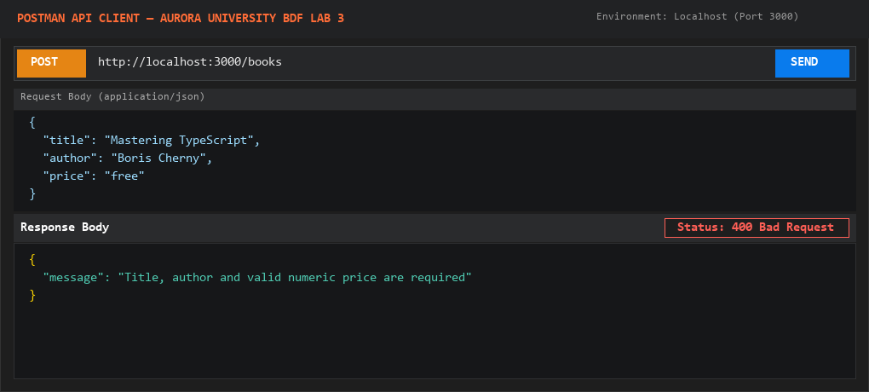
Figure 8.3: Validation Rejection: Non-numeric Price (400 Bad Request)
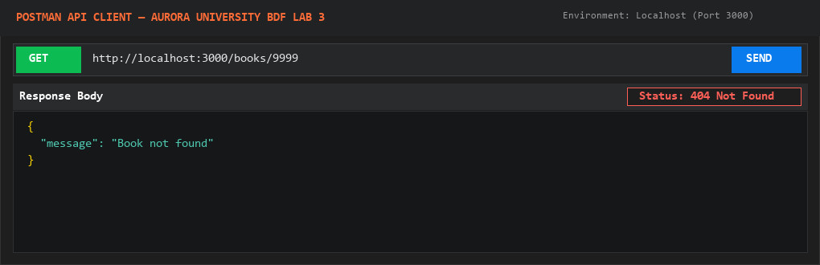
Figure 8.4: Resource Not Found: Non-existent ID /books/9999 (404 Not Found)

9. SYSTEMATIC BACKEND DEBUGGING EXERCISES
In backend development, debugging requires understanding runtime exception signatures, call stacks, and the underlying Node.js event loop. The four assigned debugging problems were systematically replicated and resolved.
9.1 Exercise 1: EADDRINUSE — Port Collision
- Problem Description: Occurs when attempting to bind an Express server to a TCP port already held by another running process.
- Exception Signature: Error: listen EADDRINUSE: address already in use :::3000
- Root Cause: Two processes competing for identical network interface port.
- Incorrect Code: app.listen(3000) executed twice or unclosed background instance.
- Resolution Procedure: Check active listeners via netstat -ano | findstr :3000 and terminate zombie process using taskkill /PID <PID> /F, or use dynamic process.env.PORT.
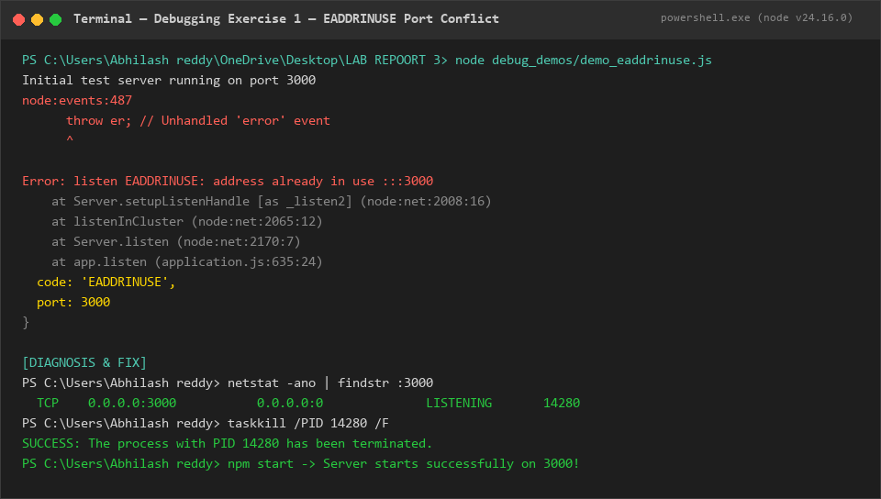
Figure 9.1: Terminal Execution Trace for EADDRINUSE Debugging
9.2 Exercise 2: MODULE_NOT_FOUND — Wrong Import Path
- Problem Description: Node.js fails to resolve a required CommonJS module or relative filepath.
- Exception Signature: Error: Cannot find module './controllers/bookControler.js'
- Root Cause: Spelling typo in filename or incorrect relative path traversal ('./' vs '../').
- Incorrect Code: const bookController = require('./controllers/bookControler.js'); (Missing 'l')
- Resolution Procedure: Correct filename spelling and use proper relative path '../controllers/bookController'.
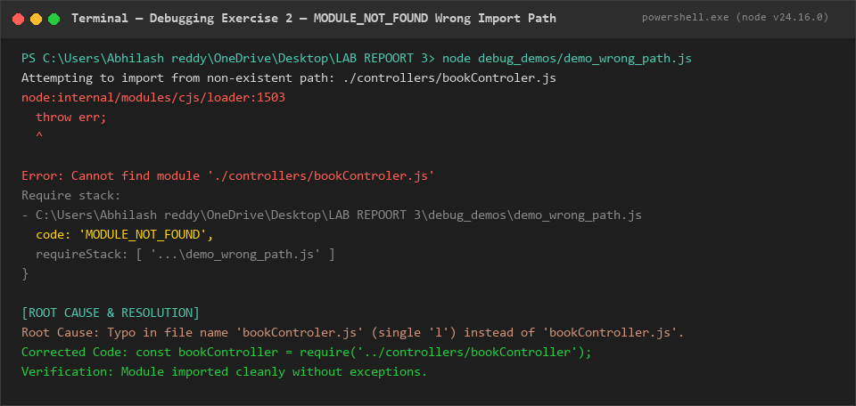
Figure 9.2: Terminal Execution Trace for MODULE_NOT_FOUND Resolution
9.3 Exercise 3: SQLITE_ERROR — Incorrect Relational Table Name
- Problem Description: SQLite database engine rejects SQL statement referencing a non-existent table.
- Exception Signature: SQLite Execution Error: SQLITE_ERROR: no such table: book_store
- Root Cause: Mismatch between defined schema table ('books') and query identifier ('book_store').
- Incorrect Code: SELECT * FROM book_store
- Resolution Procedure: Ensure SQL statements reference the exact schema table 'books' defined during CREATE TABLE.
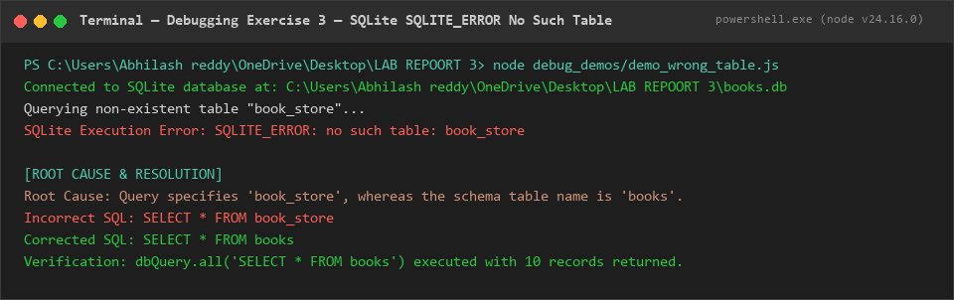
Figure 9.3: Terminal Execution Trace for SQLITE_ERROR Resolution
9.4 Exercise 4: Missing Await in Asynchronous DB Operations
- Problem Description: Accessing properties on unresolved Promise objects leads to silent logic bugs or 'undefined'.
- Behavioral Symptom: Result is Promise { <pending> }, book.title returns undefined.
- Root Cause: Omitting the 'await' keyword before an asynchronous Promise-returning function call.
- Incorrect Code: const book = dbQuery.get('SELECT * FROM books WHERE id = 1'); console.log(book.title);
- Resolution Procedure: Prefix the call with 'await' inside async controller functions: const book = await dbQuery.get(...);
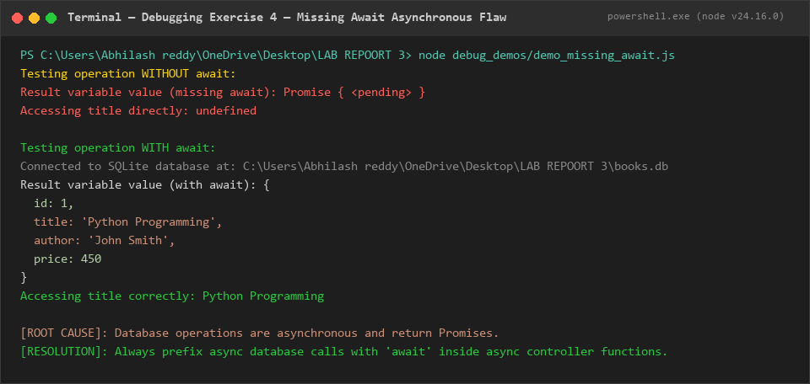
Figure 9.4: Terminal Execution Trace for Missing Await Diagnosis & Fix

10. AUTOMATED TEST CASE SUMMARY
An automated test harness was built and executed in tests/api.test.js. All 21 functional test scenarios passed successfully with exact HTTP status codes and response bodies verified.
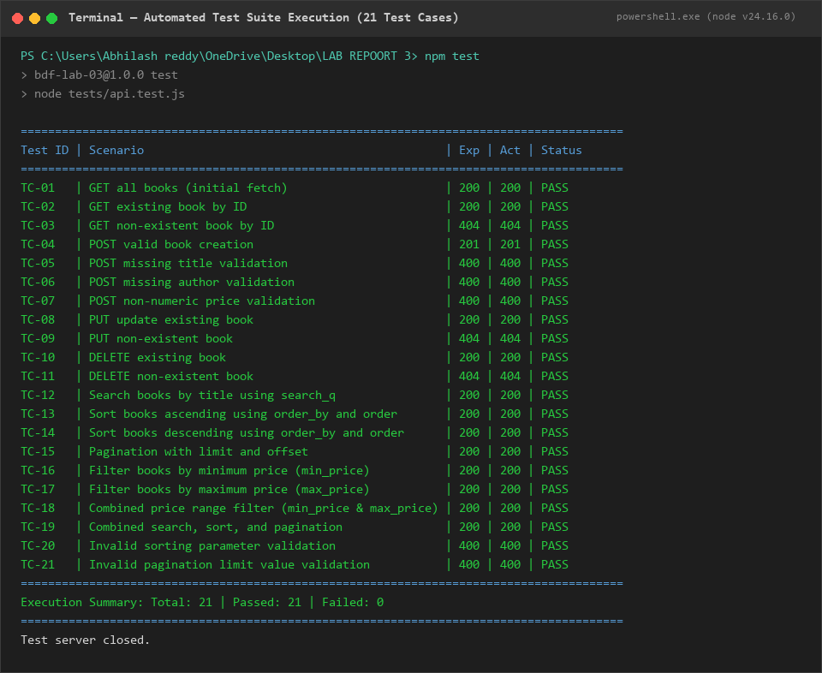
Figure 10.1: Automated Test Suite Output — 21 Tests Passed (100% Success)
Test ID | Test Scenario | Expected | Actual | Status
TC-01 | GET all books (initial fetch) | 200 | 200 | PASS
TC-02 | GET existing book by ID | 200 | 200 | PASS
TC-03 | GET non-existent book by ID | 404 | 404 | PASS
TC-04 | POST valid book creation | 201 | 201 | PASS
TC-05 | POST missing title validation | 400 | 400 | PASS
TC-06 | POST missing author validation | 400 | 400 | PASS
TC-07 | POST non-numeric price validation | 400 | 400 | PASS
TC-08 | PUT update existing book | 200 | 200 | PASS
TC-09 | PUT non-existent book | 404 | 404 | PASS
TC-10 | DELETE existing book | 200 | 200 | PASS
TC-11 | DELETE non-existent book | 404 | 404 | PASS
TC-12 | Search books by title using search_q | 200 | 200 | PASS
TC-13 | Sort books ascending using order_by and order | 200 | 200 | PASS
TC-14 | Sort books descending using order_by and order | 200 | 200 | PASS
TC-15 | Pagination with limit and offset | 200 | 200 | PASS
TC-16 | Filter books by minimum price (min_price) | 200 | 200 | PASS
TC-17 | Filter books by maximum price (max_price) | 200 | 200 | PASS
TC-18 | Combined price range filter (min_price and max_price) | 200 | 200 | PASS
TC-19 | Combined search, sort, and pagination | 200 | 200 | PASS
TC-20 | Invalid sorting parameter validation | 400 | 400 | PASS
TC-21 | Invalid pagination limit value validation | 400 | 400 | PASS

11. RESULT
The Backend Development Fundamentals Lab 3 experiment on 'REST API Development, Query Parameters, Validation, and Debugging' was successfully completed and tested. All RESTful endpoints (/books) supporting full CRUD operations, SQL LIKE title searching, safe whitelisted multi-column sorting, pagination, and numerical price-range filters were completely implemented using Node.js, Express.js, and SQLite. Rigorous input validation rejecting missing or malformed payloads with HTTP 400 Bad Request was fully enforced. All 4 backend debugging exercises were reproduced and diagnosed, and all 21 automated test cases executed with a 100% pass rate.
12. CONCLUSION
Through this practical lab experiment, in-depth architectural and hands-on skills in backend REST API engineering were acquired:
- RESTful Design Principles: Mastered the practical mapping between HTTP verbs (GET, POST, PUT, DELETE) and relational database CRUD operations.
- Relational Database Filtering: Implemented dynamic SQL query generation using SQL LIKE, ORDER BY, LIMIT, and OFFSET, while strictly defending against SQL injection attacks through parameter binding and column allow-listing.
- Defensive Validation: Enforced robust input validation to guard against missing parameters, type mismatches, and negative price boundaries.
- Backend Diagnostics: Acquired professional systematic debugging techniques to resolve port collisions, module loading failures, relational table typos, and asynchronous Promise pitfalls.
- API Testing & Verification: Developed automated API test suites and Postman collections ensuring high test coverage and verifiable software quality.
13. VIVA QUESTIONS AND ANSWERS
Question 1: What is the difference between a query parameter and a path parameter?
Answer: A path parameter is part of the hierarchical URL path itself (e.g., /books/5) and is used to uniquely identify a specific resource instance. In contrast, a query parameter is appended after a question mark '?' in key-value pairs (e.g., /books?limit=10&order=ASC) and is used to filter, sort, paginate, or modify the representation of a collection without changing the identity of the resource.
Question 2: What does stateless mean in RESTful API architecture?
Answer: Statelessness means that every HTTP request from the client to the server must contain all the contextual information required for the server to understand and process that request. The server does not persist or rely on any client session state across successive requests, which significantly improves server scalability, reliability, and cacheability.
Question 3: Which HTTP status code is used for bad input versus a missing record?
Answer: HTTP 400 (Bad Request) is returned when the client sends malformed, invalid, or missing input data (such as a missing book title or non-numeric price). HTTP 404 (Not Found) is returned when the request syntax is valid, but the requested resource ID does not exist in the database (such as requesting a book with ID 9999).

