Multithreaded

Reads from arduino - writes to sd card

Takes images - writes to sd card

Writes to firebase - active only when JIP connection is available

# Latency Analysis

Configured delays : **try configuring sleep according to cpu used**

a)Rpi threads -

|  |  |
| --- | --- |
| writearduino | 35ms |
| writeimage | 2s |

b)in Arduino -

|  |
| --- |
| **void** **loop**() {  **for**(**int** i = 0; i<16 ; i++)  {  innerloop(); //reads MPU data  }  Serial.println(millis()-tlast);  Serial.print("BME-");  printBME280Data(&Serial);  Serial.print('\n');  **int** readv = pms7003ReadData();  tlast = millis(); } |

Time for one iteration of loop ~ 720 ms

Expected latency for arduino = $720÷16 ≃45$

Expected latency for BME $≃$ 720ms

**Include as hz**

BME latencies : (0.541 Hz)

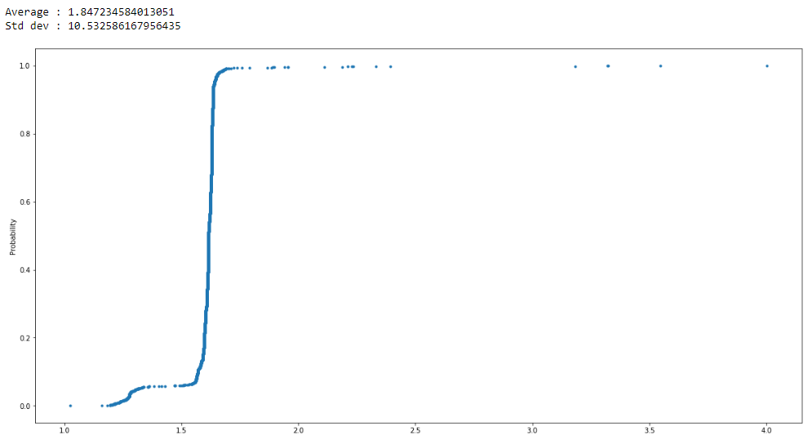

PMS latencies: (0.524 Hz)

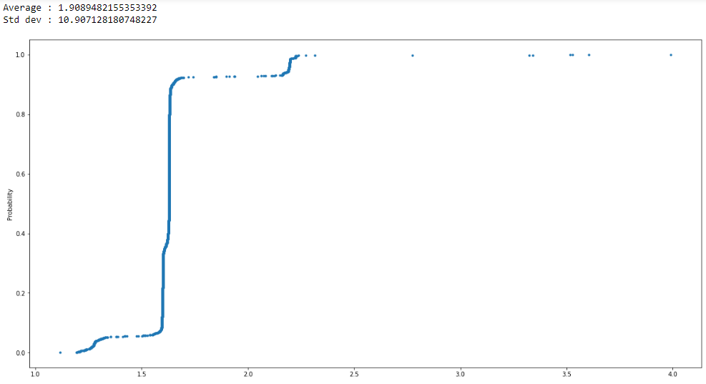

Image latencies : (0.245 Hz)

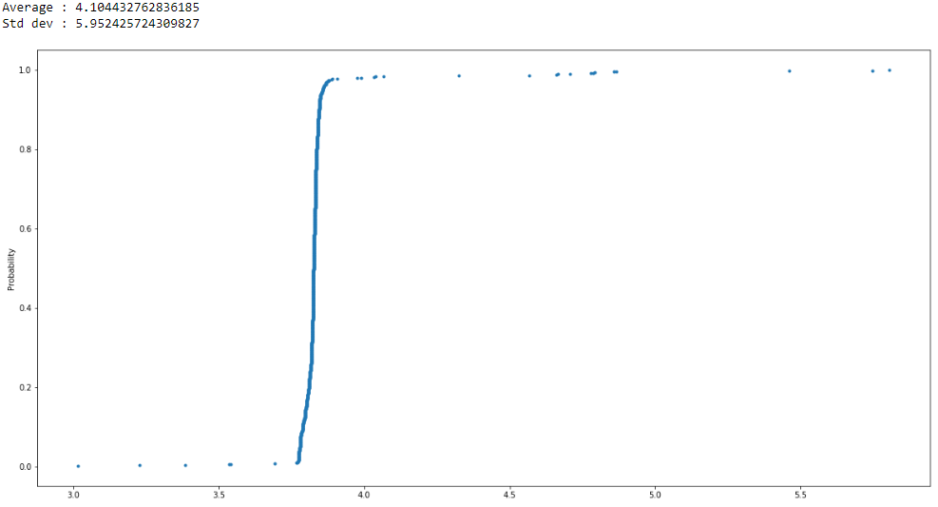

Arduino latencies : (8.62 Hz)

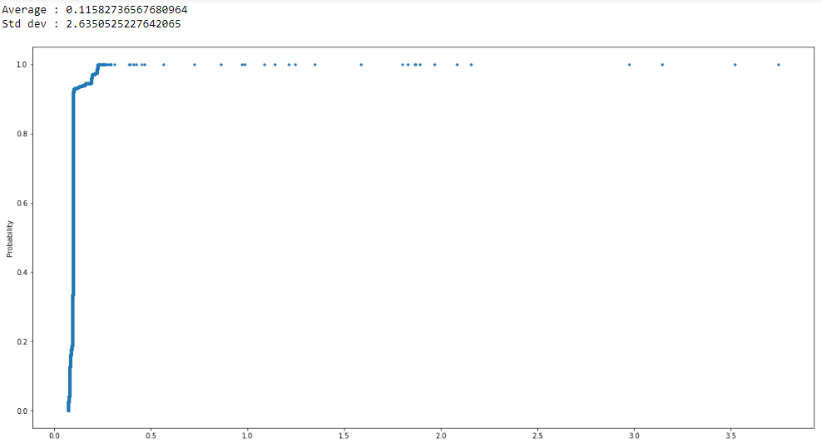

# Bandwidth Estimation

Rate of data generation = $187÷39≃4.79MB per sec ≃$ Data consumed in uploading to firebase

# Load Analysis

Reference : [uptime](https://unix.stackexchange.com/questions/118124/why-how-does-uptime-show-cpu-load-1)

**Not sure what this graph means - should be periodic** (Is average load over the last minute)

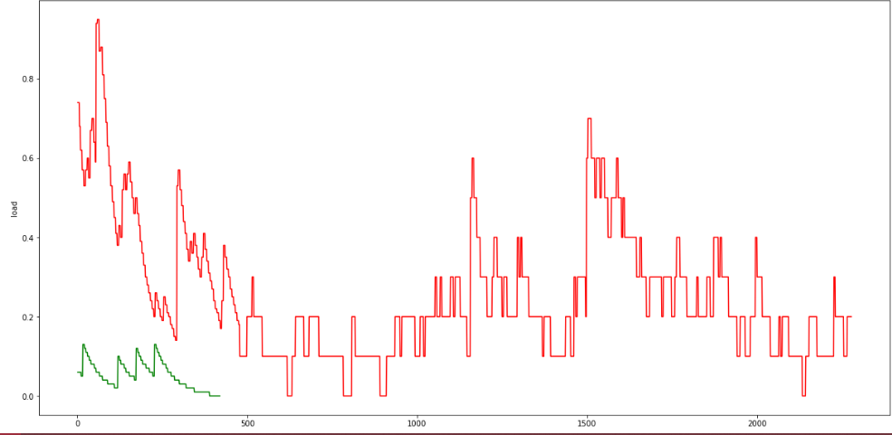

# Power Consumption

(All measurements with JioFI connected through USB)

Base Consumption(with cpu load script running) : 3.3-3.4W

With Scripts running : 3.8

**Try without jio -** Without Jio baseline consumption is 1.8W

Multiprocessed

# Latency Analysis

Configured delays :

a)Rpi threads -

|  |  |
| --- | --- |
| writearduino | 35ms |
| writeimage | 2s |

b)in Arduino -

|  |
| --- |
| **void** **loop**() {  **for**(**int** i = 0; i<16 ; i++)  {  innerloop(); //reads MPU data  }  Serial.println(millis()-tlast);  Serial.print("BME-");  printBME280Data(&Serial);  Serial.print('\n');  **int** readv = pms7003ReadData();  tlast = millis(); } |

Time for one iteration of loop ~ 720 ms

Expected latency for arduino = $720÷16 ≃45$

Expected latency for BME $≃$ 720ms

BME latencies : (0.640 Hz) [improved to 0.657 Hz]

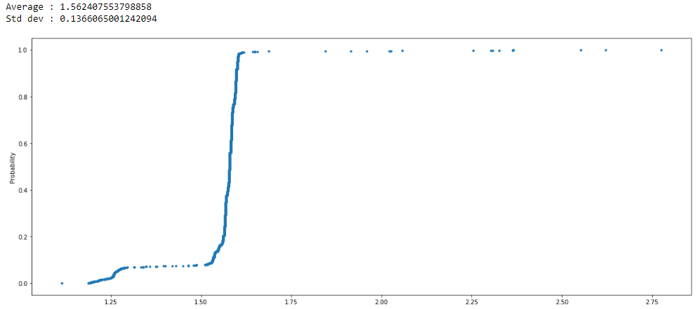

PMS latencies: (0.616 Hz) [improved to 0.628 Hz]

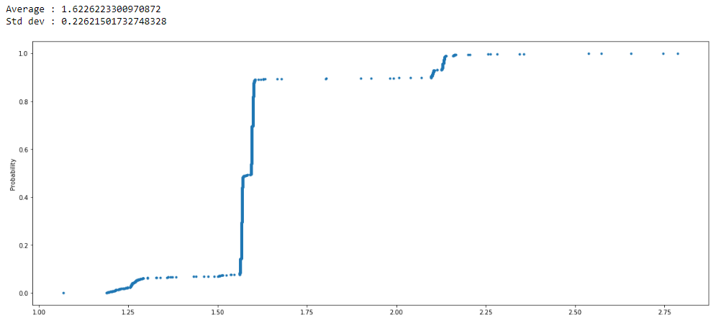

Image latencies : (0.258 Hz) [improved to 0.843 Hz]

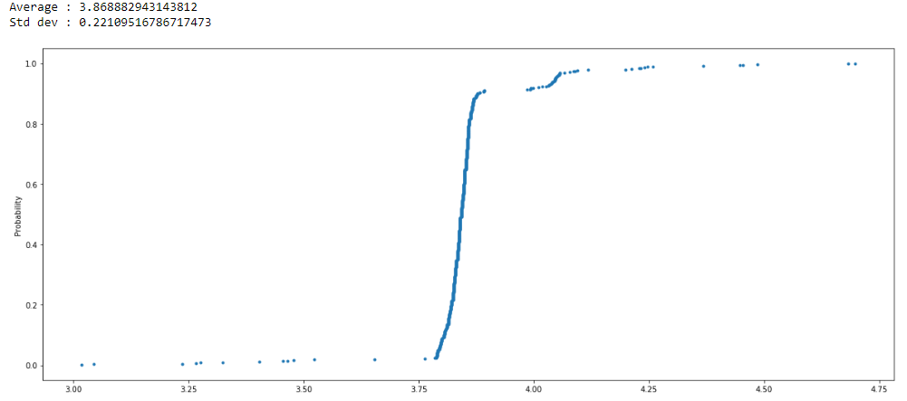

Arduino latencies : (10.20 Hz) [improved to 10.482]

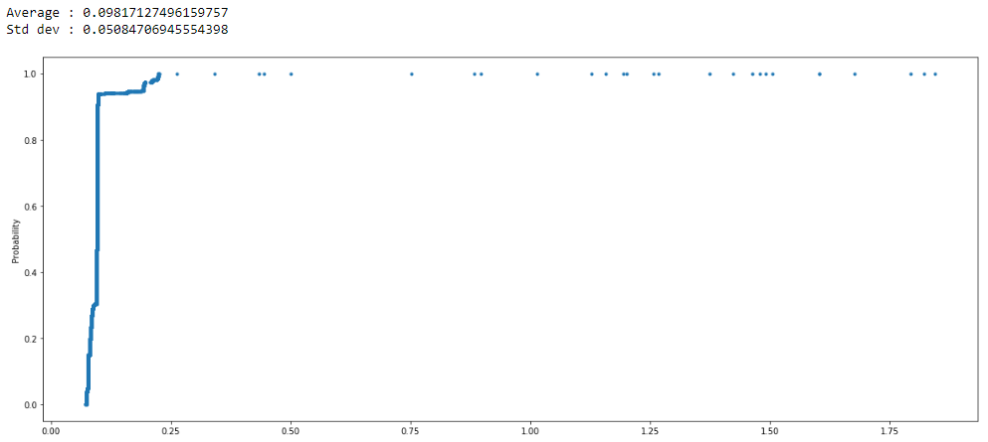

# Bandwidth Estimation

Rate of data generation = $168÷30≃5.6MB per min ≃$ Data consumed in uploading to firebase

[Increased to 15.02 MB per min, due to increase image frequency]

# Load Analysis

Reference : [uptime](https://unix.stackexchange.com/questions/118124/why-how-does-uptime-show-cpu-load-1)

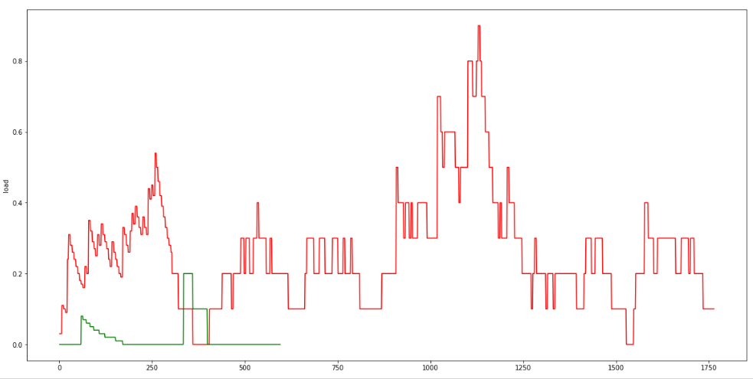

# Power Consumption

(All measurements with JioFI connected through USB)

Base Consumption(with cpu load script running) : 3.3-3.4W

With Scripts running : 3.5

**Try without jio -** Without Jio baseline consumption is 1.8W