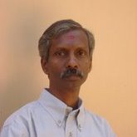

Dr.C.V.Jayamani

Dr.C.V.Jayamani is presently the Vice Chairman of Institute of Management Development and Research (IMDR), Trivandrum and the Chief Editor of its house journal Management Researcher. He retired as a Professor, School of Management Studies (SMS), CUSAT Cochin. Formerly he was the Finance Officer of the University of Kerala.
He was the Dean, Faculty of Commerce M.G. University, Governing Board member, IIM Kozhikode. He has published many article in History, Economics and Commerce and authored many books.

