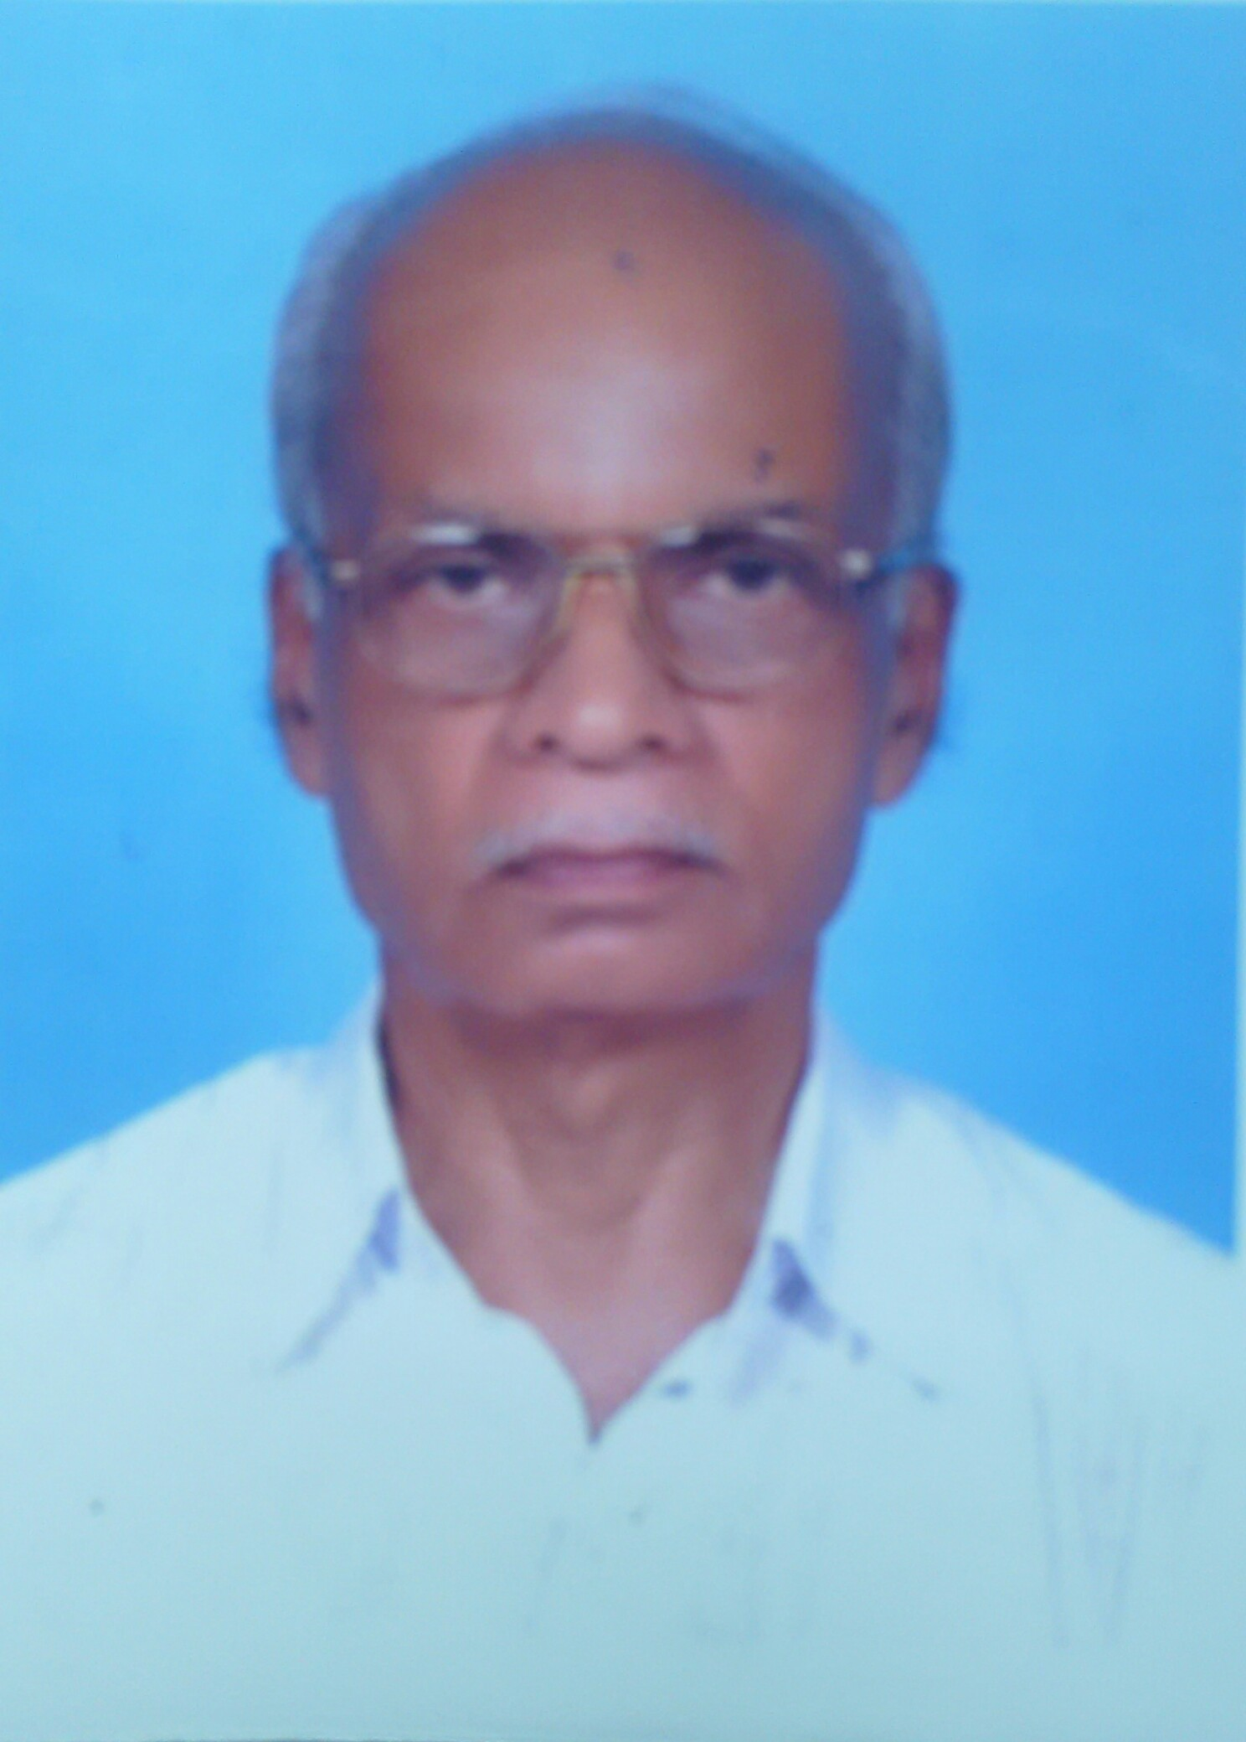

Prof (Dr).R.Gopimony

Worked as Agricultural Officer in the Department of Agriculture and as Research Officer, State Institute of Languages, Thiruvananthapuram and published 30 University level Text Books on various subjects related to Biological Science.

In 1976 joined at the newly formed Agricultural University in the State of Kerala as Professor of Plant Breeding and Genetics in various Institutions of Kerala Agricultural University, Mannuthy, Thrichur and finally retired as Head of the Department of Plant Breeding and Genetics from College of Agriculture, Vellayani. During the above tenure he has formulated and successfully executed fifteen major Research Projects on various aspects of breeding new varieties of Crops like Coconut, Banana, Pineapple, Vegetables and fodder Crops. Guided 22 students for Post Graduation including two Ph.D.’s. Published 72 books through KAU, SIL, D.C.Books, N.B.S., and Poorna, more than fifty Research Papers in National and International publications and more than Three thousand popular articles in various Malayalam and English Journals and News Papers.

