



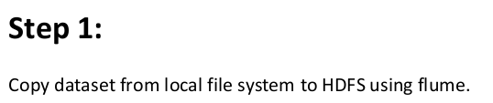

## SOLUTION:

Flume Conf file

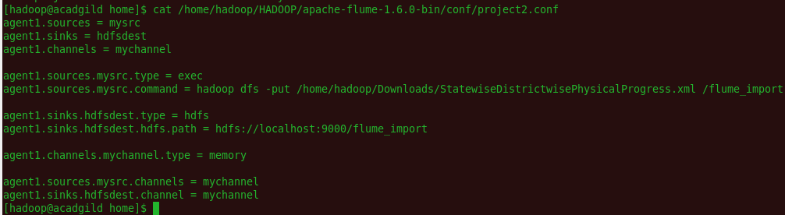

Running flume job

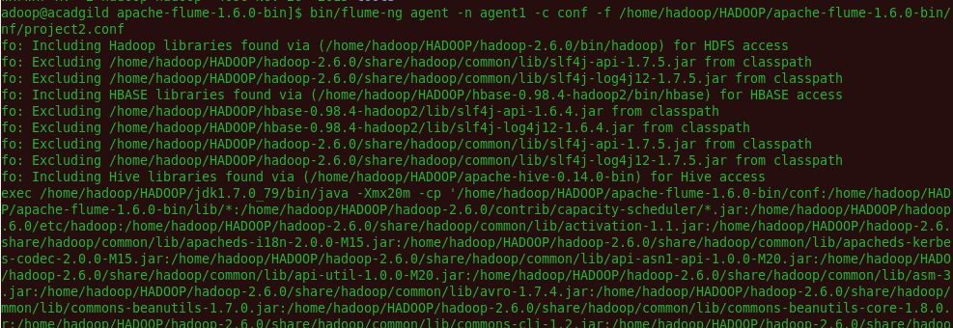

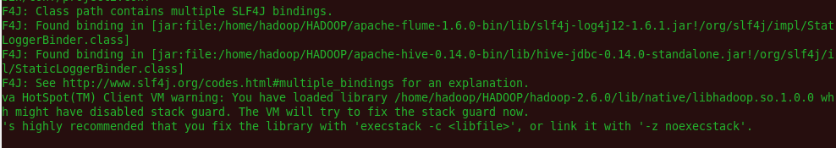

Data is imported into HDFS through flume

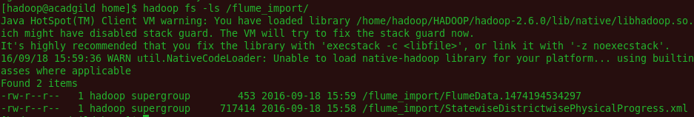

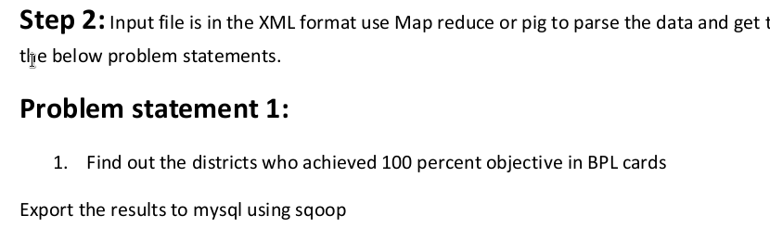

### SOLUTION 1 : Pig scripts:

### There are two pig scripts – 1) Project2PigScript.pig 2) Project2PigScript2.pig

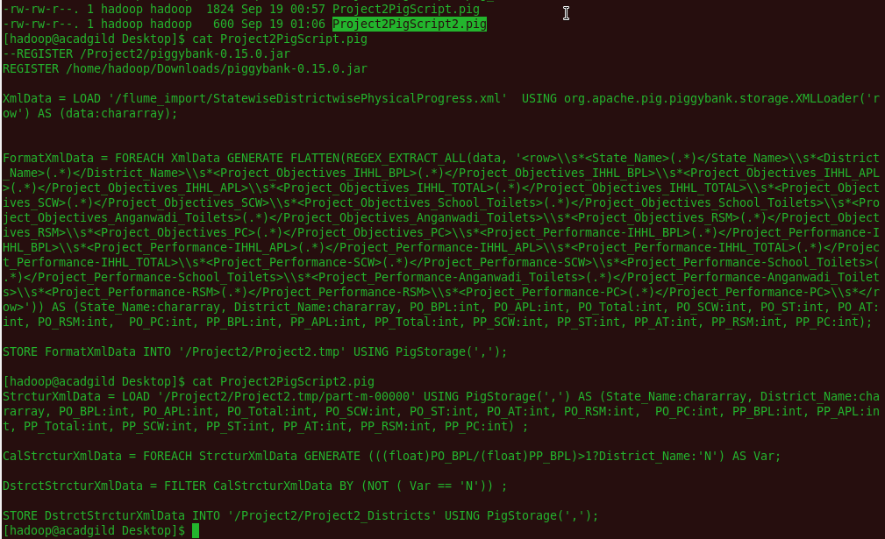

### Output of Pig Script 1 (Intermediate data) :



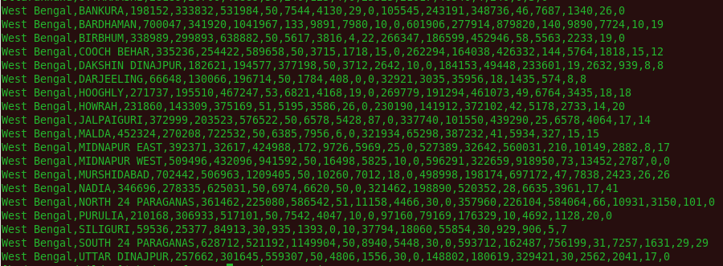

### Output of Pig Script 2 (Final data) :

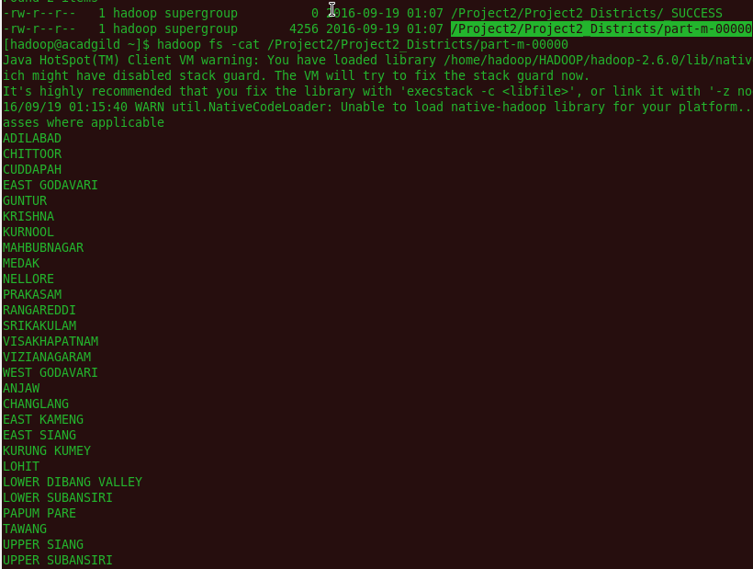



### b) Sqoop Command to export data from HDFS to MySql:

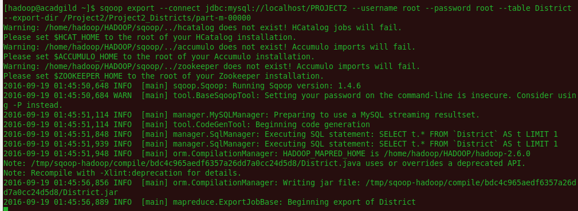

### District Table is created in MySql:

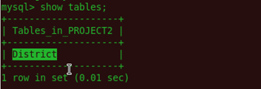

### Data is exported into MySql table - District:

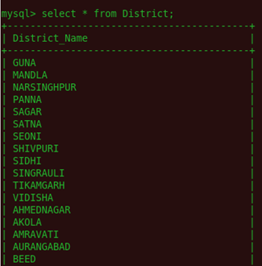

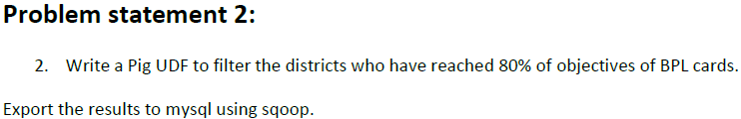

## SOLUTION 2 :

Pig Commands







# PIG UDF

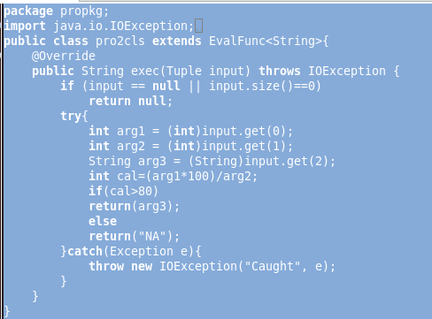





Data is stored into HDFS



### *b) Sqoop Command to export data from HDFS to MySql*



