

## SOLUTION - FLUME:

Flume Conf file



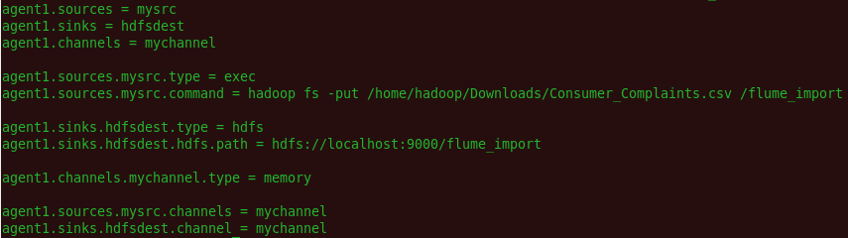

Running flume job

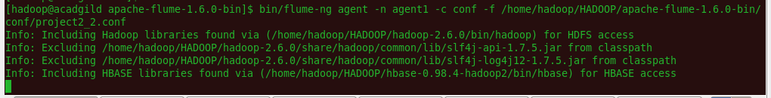

Data is imported into HDFS through flume

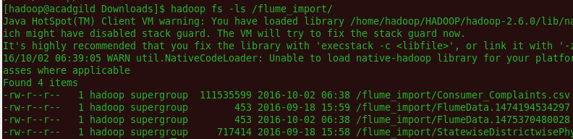

## Problem Statements Solutions in Pig



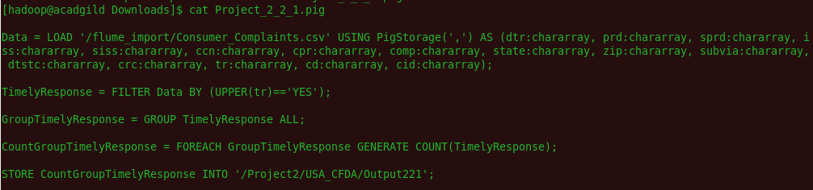



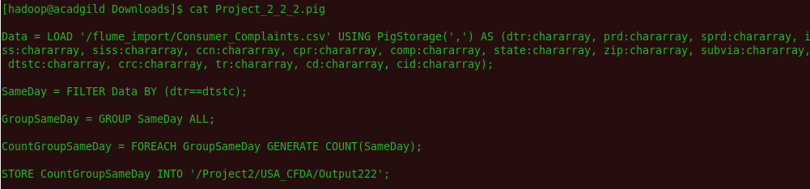



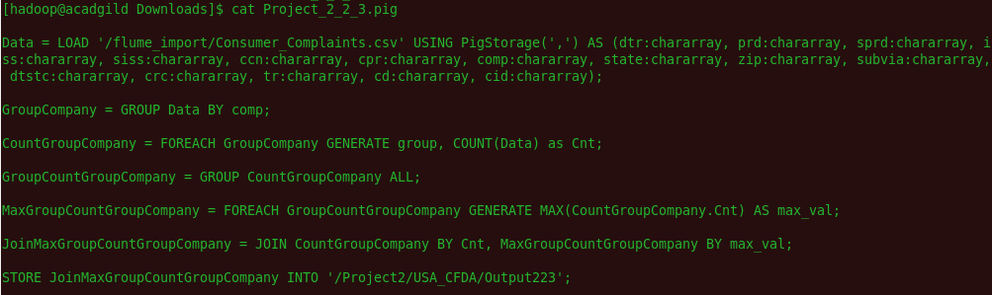



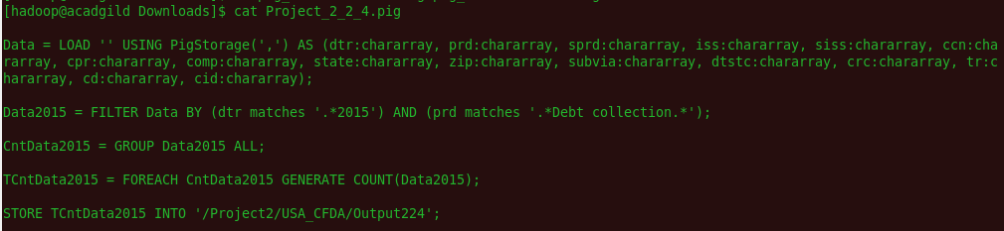

Sqoop tool:

Created Table into MySql



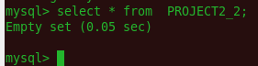

Problem Statement 1 export into MySql

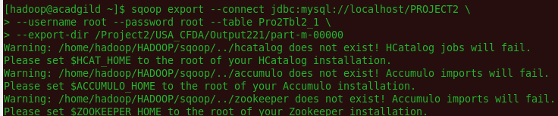

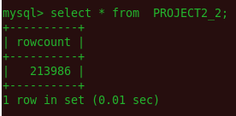

Problem Statement 2 export into MySql

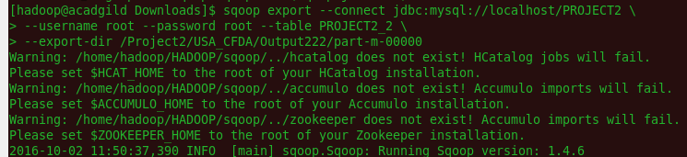

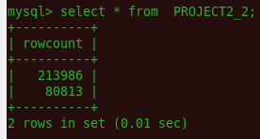

Problem Statement 4 export into MySql

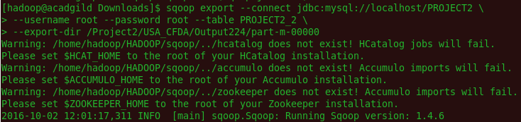

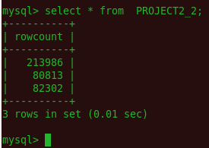

*Problem Statement 3 export into MySql*

