# CREATE TABLE AND LOAD DATA INTO TABLE

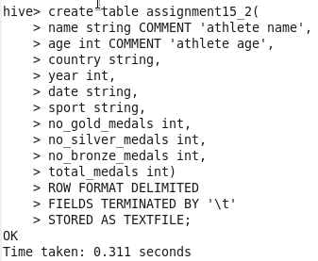

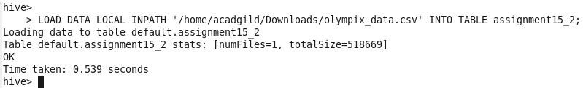

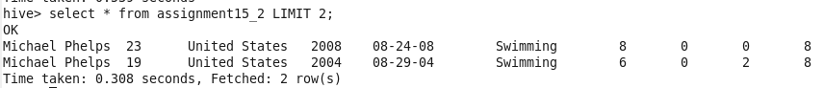

## Write a Hive program to find the number of medals won by each country in swimming.

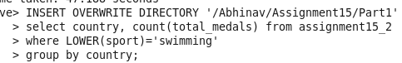

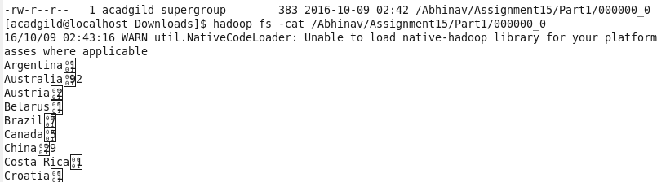

## Write a Hive program to find the number of medals that India won year wise.

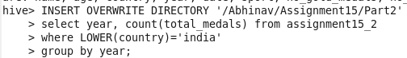

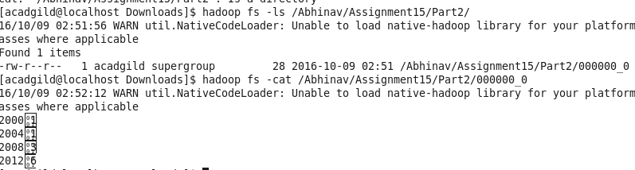

## Write a Hive Program to find the total number of medals each country won.



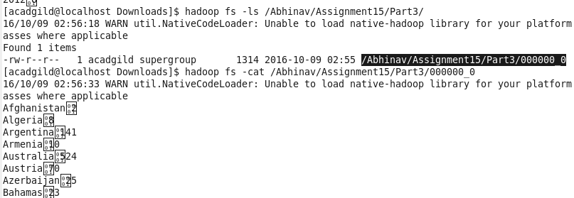

## Write a Hive program to find the number of gold medals each country won.



