### SET PROPERTIES FOR ROW LEVEL TRANSACTIONS:

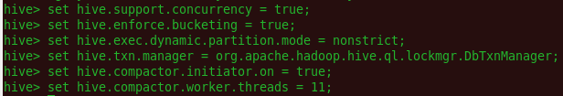



### CREATE TABLE:

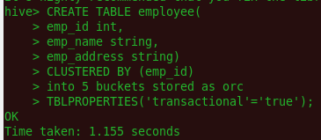

### SHOW TABLES

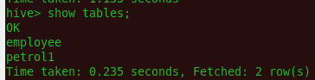

### INSERT RECORDS



### SELECT RECORDS

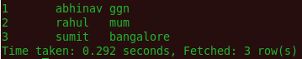

### UPDATE RECORDS

