## Table Creation

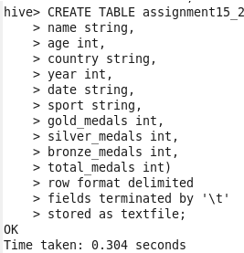

## load data into the created table as follows:

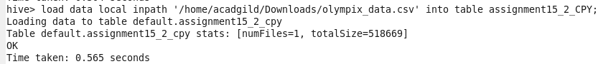

## SELECT AVG(age)

## 

## create the index for this table:

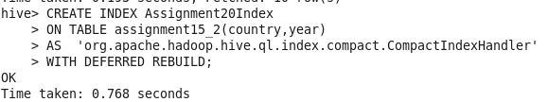



show formatted index on olympic;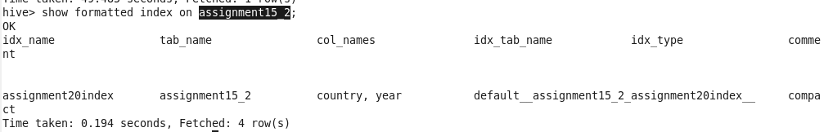

## Perform the same Average operation on the same table.

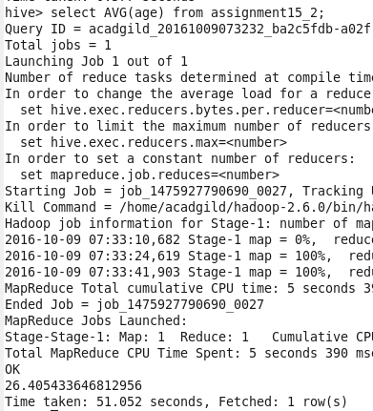

## ****create a Bitmap index for the same table:****

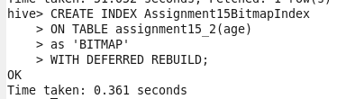



## ****show formatted index****

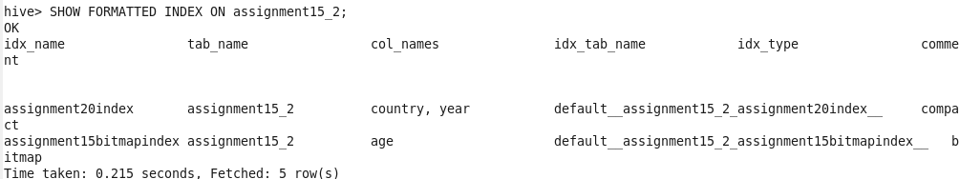

## ****Average Operation with Two Indexes****

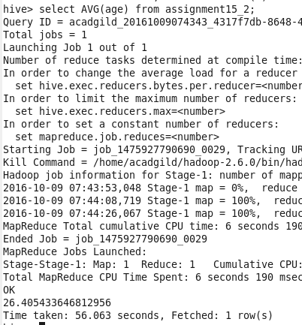

## ****DROP INDEX IF EXISTS****



## ****show formatted index****

