# Program in Java client API

package HBASE;

import java.io.IOException;  
import org.apache.hadoop.conf.Configuration;  
import org.apache.hadoop.hbase.HBaseConfiguration;  
import org.apache.hadoop.hbase.HTableDescriptor;  
import org.apache.hadoop.hbase.HColumnDescriptor;  
import org.apache.hadoop.hbase.client.HBaseAdmin;  
import org.apache.hadoop.hbase.client.HTable;  
import org.apache.hadoop.hbase.client.Put;  
import org.apache.hadoop.hbase.client.Get;  
import org.apache.hadoop.hbase.util.Bytes;  
import org.apache.hadoop.hbase.client.Result;  
import org.apache.hadoop.hbase.client.Scan;  
import org.apache.hadoop.hbase.client.ResultScanner;

// MAIN CLASS

// CREATE TABLE

public class Session18Assignment2 {

    public static void main(String args[]) throws IOException{

    @SuppressWarnings("deprecation")  
    HBaseConfiguration hconfig = new HBaseConfiguration(new Configuration());

    @SuppressWarnings("deprecation")  
    HTableDescriptor htable = new HTableDescriptor("company");  
    htable.addFamily(new HColumnDescriptor("details"));

    System.out.println("Connecting....");  
    HBaseAdmin hbase_admin = new HBaseAdmin(hconfig);

    System.out.println("Creating Table....");  
    hbase_admin.createTable(htable);

    System.out.println("Table Creation Done!!");  
    hbase_admin.close();

    Session18Assignment2 sa = new Session18Assignment2();  
    sa.insert();  
    sa.getRecords();  
    sa.display();  
    }

// PUT METHOD

public void insert() throws IOException{

    System.out.println("Inserting Rows...");  
    Configuration config = HBaseConfiguration.create();  
    HTable table = new HTable(config,"company");  
    Put p = new Put(Bytes.toBytes("rowkey1"));  
    p.add(Bytes.toBytes("details"),Bytes.toBytes("name"),Bytes.toBytes("Amazon"));  
    p.add(Bytes.toBytes("details"),Bytes.toBytes("branch"),Bytes.toBytes("India"));      
    table.put(p);  
    table.close();  
    System.out.println("Insertion Done!!");  
 }

// GET METHOD

public void getRecords() throws IOException{  
    System.out.println("Fetching Rows...");  
    Configuration config = HBaseConfiguration.create();  
    HTable table = new HTable(config,"company");  
    Get g = new Get(Bytes.toBytes("rowkey1"));  
    Result r = table.get(g);  
    byte [] value1 = r.getValue(Bytes.toBytes("details"), Bytes.toBytes("name"));  
    byte [] value2 = r.getValue(Bytes.toBytes("details"), Bytes.toBytes("branch"));  
    String valueStr1 = Bytes.toString(value1);  
    String valueStr2 = Bytes.toString(value2);  
    System.out.println("GET 1st Record - Company Name: "+valueStr1);  
    System.out.println("GET 2nd Record - Company Branch: "+valueStr2);  
    System.out.println("Fetch Done!!");  
    table.close();  
 }

// SCAN METHOD

public void display() throws IOException{  
    System.out.println("Scanning Rows...");  
    Configuration config = HBaseConfiguration.create();  
    HTable table = new HTable(config,"company");  
    Scan s = new Scan();  
    s.addColumn(Bytes.toBytes("details"), Bytes.toBytes("name"));  
    s.addColumn(Bytes.toBytes("details"), Bytes.toBytes("branch"));  
    ResultScanner scanner = table.getScanner(s);  
    for (Result rnext = scanner.next(); rnext != null; rnext = scanner.next())  
    {  
        System.out.println("Scanned row :"+rnext);  
    }  
    scanner.close();  
    table.close();  
    System.out.println("Scanning Done!!");  
  }  
}

# JAVA API OUTPUT:

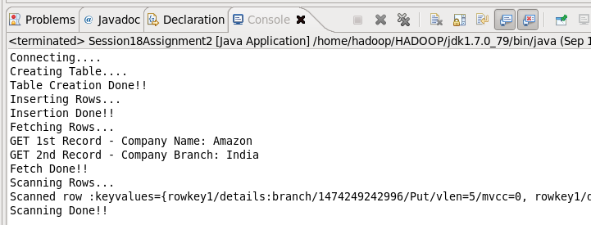

# HBASE OUTPUT:

