





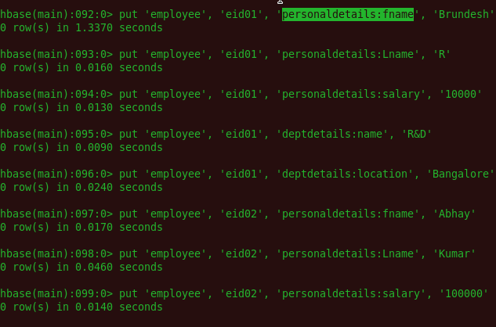



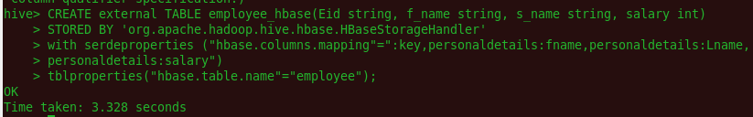

**Fetch Data from Hive Table**

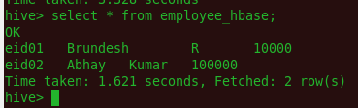

**Fetch Data from HBase Table**

