## CREATING FILE:

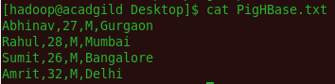

## TRANSFERRING FILE TO HDFS:



## EXPORTING JAR FILES OF HBASE TO PIG CLASSPATH



## CREATING HBASE TABLE STUDENT

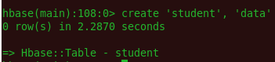

## SCANING HBASE TABLE



## CREATE ALIAS IN PIG



## VERIFY ALIAS



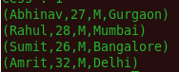

## TRANSFER DATA INSIDE HBASE BY STORE COMMAND

