## ****Move the AcadgildLocal.conf file inside flume/conf directory****



## Conf file

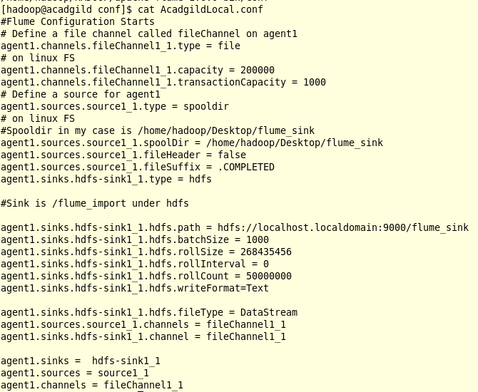

## Create HDFS directory



## Check local directory



## Run Flume Agent





## Create file test 1 in local

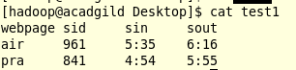

## Move file to flume_sink and check .completed

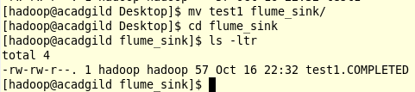

## Check file in HDFS

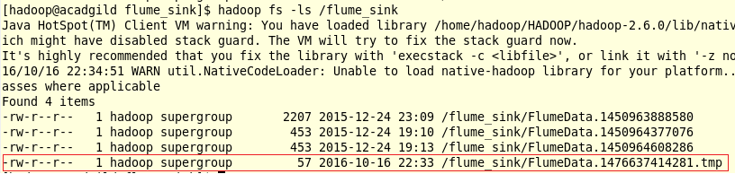

## Cat file in HDFS

