### WORD COUNT SOLUTION:



DUMP Words;

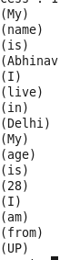

GroupWords = GROUP Words BY word;

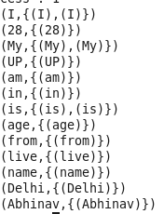

CountWords = FOREACH GroupWords GENARATE group, COUNT(Words);

DUMP CountWords;

