INITIAL STEPS

# Dataset

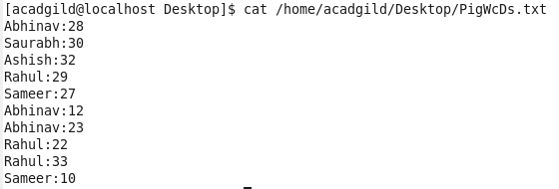

# Steps:





DUMP GroupPig1;

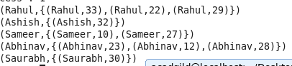

COMMANDS

## COMMAND 1 : CONCAT



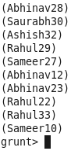

## COMMAND 2: TOKENIZE



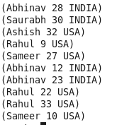



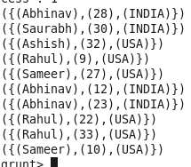

## COMMAND 3: SUM

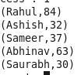

**COMMAND 4: MIN**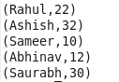

**COMMAND 5: MAX**



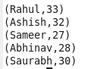

**COMMAND 6: LIMIT**



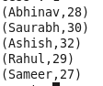

**COMMAND 7: STORE**



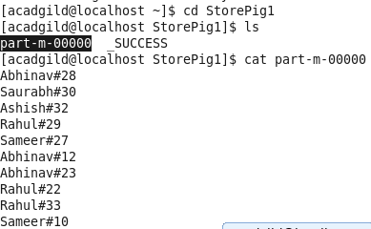

**COMMAND 8: DISTINCT**



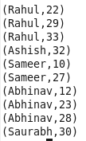

## COMMAND 9 : FLATTEN



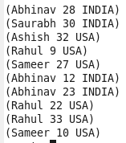

**COMMAND 10: IsEmpty**

