## INITIAL STEP FOR ALL SOLUTIONS



## Soultion 1:





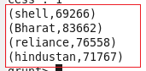

## SOLUTION 2:











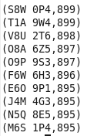

## SOLUTION 3 :











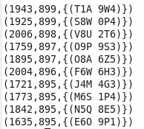

## SOLUTION 4:











DUMP LimitSortSumName;

