Asking user to input his/her choice-

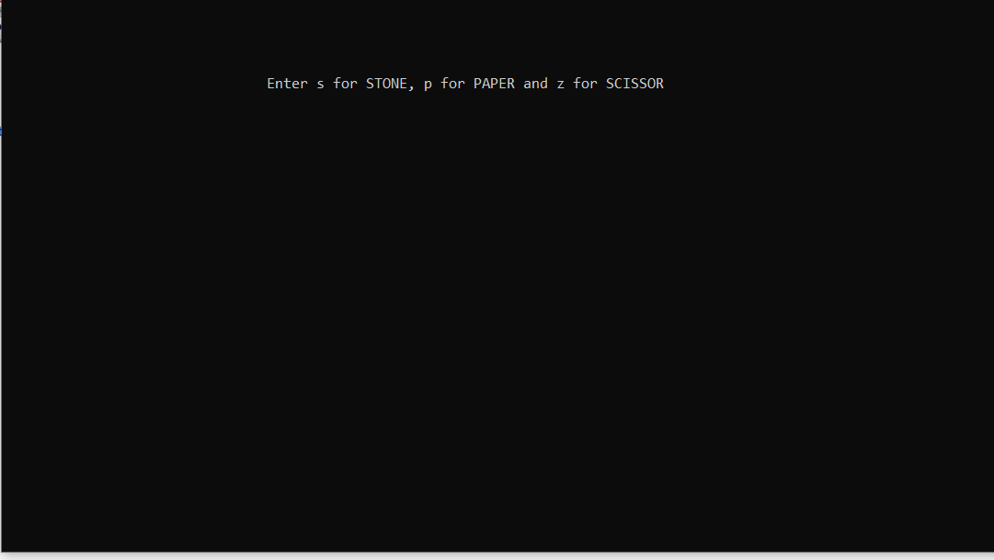

Suppose user has input s that is STONE.

Result of the game along with the choice of computer and user’s input.

