Expert Sessions Platform
Bookings, paid sessions, and live broadcast on Slike · Draft, Sep 2026 · Abhimanyu
1. Who this is for
- Anyone whose time people will pay for: a guru, an ET Markets analyst, a TOI masterclass host.
- The shape is always the same — one expert, a small team around them, an audience already watching on social.
- The first customers are waiting: Speaking Tree is already pitching digital solutions to gurus across India.
2. How they run today
- The free side works — lives on YouTube and Facebook, a growing audience, real engagement.
- The paid side is chaos — DM requests, phone calls, ad-hoc UPI transfers, someone’s notebook.
- There is no calendar, no record of who paid, and no way to charge for a live session at all.
- Demand is proven — Astrotalk made ₹1,176 Cr last year on people paying for exactly this guidance.
3. What we build: one calendar, three booking types
- 1:1 consultation — private, prepaid by UPI, the booker’s question attached before the call.
- Paid session — one hour, one agenda, many seats; people pay a small amount to join and listen.
- Free session — broadcast on the app and on social handles, the expert’s and TIL’s, for reach.
- The three feed each other: free builds reach, reach fills paid seats, paid sessions convert into 1:1s.
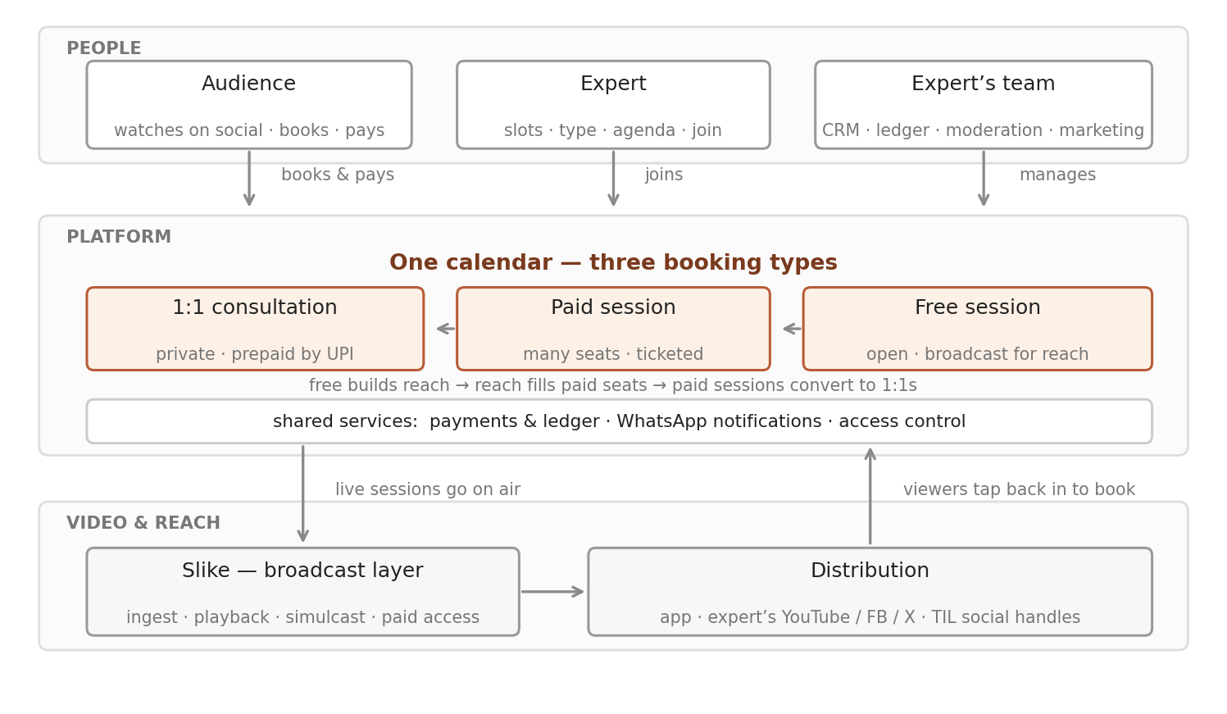
4. Who uses what
- The expert opens a minimal view — today’s slots, their type, the agenda, one tap to join. Nothing else.
- The team runs the dashboard — CRM of every booker, ledger of every rupee, event moderation, marketing.
- Slike carries the broadcast underneath — ingest, playback, simulcast to socials, paid access on tickets.
- One rule holds it together: the calendar decides who may watch and who owes what; Slike delivers the video.

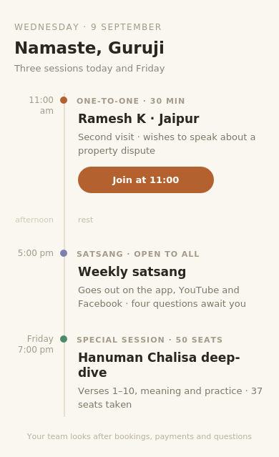  The expert’s view — mobile | 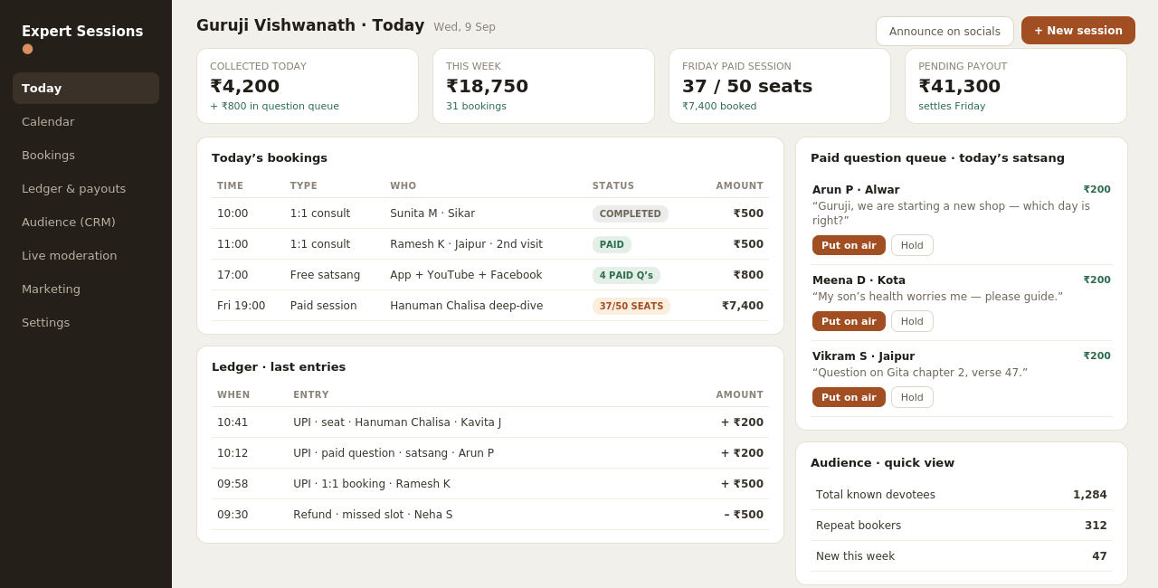  The team’s dashboard — desktop
5. One app, many tenants
- Every vendor — a guru, an ET analyst, a TOI masterclass — is a separate tenant on the same app.
- Same UI, same information architecture; only the information changes — name, sessions, prices, language.
- Open guruji’s page and you see satsangs; open the analyst’s and you see market hours — same screens underneath.
- For engineering that means one codebase and one deployment — a new vendor is configuration, not a new build.
6. Form factor: web-first, no installs in the pilot
- The audience books and watches on mobile web — the journey is a link in YouTube, WhatsApp, or a pinned comment, and nothing installs between the tap and the payment.
- That is deliberate: at ₹200–500 a ticket, an install wall before payment loses buyers; browser friction after payment is feedback we can fix.
- Payment hands off to the UPI app already on the phone; the receipt and a one-tap join link land on WhatsApp, which also nudges ten minutes before the session.
- Entry is a phone-number magic link — a paying user never sets or remembers a password.
- Playback runs on the Slike player over HLS with tokenised stream URLs — access is enforced at the stream, and a one-hour live in a mobile browser is standard territory for the player.
- The expert’s view, and a viewer’s session pass, sit as home-screen icons via PWA; the team’s dashboard is desktop web.
- A native app has an entry condition, not a date: memberships and weekly repeat viewing — the point where backgrounding, downloads, and notifications earn the cost of a second codebase.
7. The engineering build
- Booking & scheduling engine — slots, session types, reschedules; the calendar as the system of record.
- Payments & ledger — UPI collection, payouts, refunds; every calendar block backed by a payment row.
- Ticketed live with a gated stream — entitlement checked at playback, tokenised URLs on the Slike player.
- Q&A on air — a paid question queue, moderated by the team, surfaced to the expert during the live.
- Simulcast — one ingest, fan-out to YouTube, Facebook, X and the app; the stream originates with us.
- 1:1 video sessions on an off-the-shelf SDK — no reason to build calling from scratch.
- Identity & notifications — phone-number magic links; confirmations, reminders and join links on WhatsApp.
- Multi-tenant core — expert, sessions, audience and money scoped per tenant; a new vendor is configuration.
8. The monetization opportunity
- Every rupee flows through the platform, so the rails come first — the pricing model can be switched on later.
- The scale of what flows: ₹200 a seat × 150 listeners makes one expert-hour worth ₹30,000.
- Possible models, for the business to weigh: a commission per transaction (Astrotalk’s model — we earn when the expert earns).
- Or a platform fee to the expert’s team for the dashboard; or a convenience fee on the booker, as ticketing platforms do.
- And free sessions carry a brand option — a sponsor placed directly on the session, on our platform and across the social push.
- That is inventory TIL already knows how to sell: high-engagement live sessions the ad sales team can package for brands.
- Whichever model wins, the point stands: this is transaction revenue on audiences TIL monetises today only with ads.
9. The 90-day pilot
- Partners: one or two gurus from Speaking Tree’s pipeline — they own selection, onboarding, and session packaging; we own the platform end to end.
- Pilot scope: 1:1 bookings only — booking page, UPI payment and ledger, WhatsApp confirmations, the assistant’s slot screen, the expert’s calendar. Nothing else ships first.
- The booking link still rides under his lives and in his pinned comments — zero build, and it measures free→paid conversion from day one.
- Weeks 1–3 we build; weeks 4–12 the guru runs real weeks — his lives and rituals unchanged, bookings flowing through us.
- Day-90 review on four numbers: bookings per week against his WhatsApp baseline, no-show rate after prepayment, live→booking conversion, repeat bookings.
- Paid questions on air are the natural next increment — same payment rails, same console; then ticketed sessions, then the next tenants.
- To begin: a build slot on the Slike roadmap and one working session with Speaking Tree to shortlist the experts.
10. The ground it stands on: jobs, pains, landscape
- The viewer’s job: get my question in front of the person I already trust, and get his answer — the trust exists; we close the distance.
- The expert’s job: earn from my knowledge without becoming an operations manager, and grow my audience without surrendering it.
- The team’s job: run the practice without drowning, and account for every rupee.
- The pain today: no path from watching to talking — DMs sink, Superchat scrolls past with no promised reply, the ashram is far.
- And on the expert’s side: lost requests, no-shows with nothing prepaid, no record of who consulted, lives that reach thousands and earn nothing.
- Marketplaces (Astrotalk) sell strangers by the minute and keep the customer — built for finding an expert, not for keeping your own.
- Creator tools (Topmate, TagMango, SuperProfile) sell booking links to solo, English-first creators — no live broadcast, no on-air money, no distribution.
- Streaming tools (StreamYard, OBS) move video, not money. The real incumbent is WhatsApp plus a notebook.
- We are the only system putting broadcast, transactions and the relationship record together — with a sales team attached.
- Why it works: demand is proven, distribution is pre-solved, the trust is un-copyable, and the loop compounds — reach fills seats, seats fill consults, consults fill the CRM.

